Topic F
Development of Addition Fluency Within 10
1.OA.3, 1.OA.6
Focus Standard: | 1.OA.3 | Apply properties of operations as strategies to add and subtract. Examples: If 8 + 3 = 11 is known, then 3 + 8 = 11 is also known. (Commutative property of addition.) To add 2 + 6 + 4, the second two numbers can be added to make a ten, so 2 + 6 + 4 = 2 + 10 = 12. (Associative property of addition.)
 | 1.OA.6 | Add and subtract within 20, demonstrating fluency for addition and subtraction within 10. Use strategies such as counting on; making ten (e.g., 8 + 6 = 8 + 2 + 4 = 10 + 4 = 14); decomposing a number leading to a ten (e.g., 13 – 4 = 13 – 3 – 1 = 10 – 1 = 9); using the relationship between addition and subtraction (e.g., knowing that 8 + 4 = 12, one knows 12 – 8 = 4); and creating equivalent but easier or known sums (e.g., adding 6 + 7 by creating the known equivalent 6 + 6 + 1 = 12 + 1 = 13).
Instructional Days: | 4
Coherence -Links from: | GK–M4 | Number Pairs, Addition and Subtraction to 10
-Links to: | G2–M4 | Addition and Subtraction Within 200 with Word Problems to 100
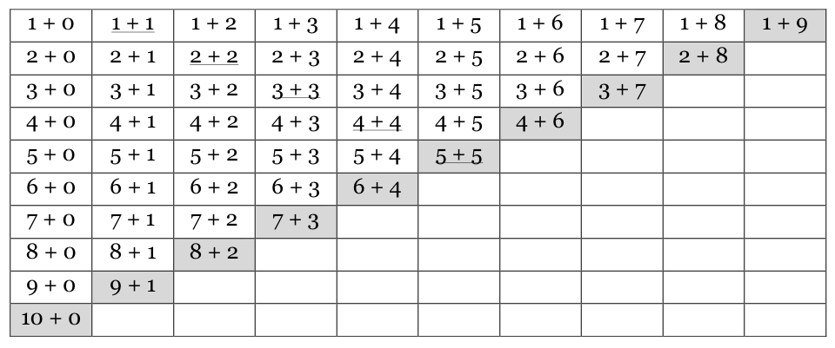
Topic F continues with the theme of more efficient strategies coupled with deep understanding to solve addition problems within 10. In Lesson 21, students begin to internalize doubles and doubles plus 1 as they work with visual representations of these problems (1.OA.6).
As students almost take a mental picture of these doubles and doubles plus 1 dot configurations, they can call on these images to quickly assist them when faced with these problems in the future. Students explore patterns on the addition chart within the context of familiar facts in Lessons 22 and 23 (MP.7, MP.8).

Lesson 22 focuses on having students look for common addends and discuss how those addends affect the total in systematic ways. For example, “I see 3 + 2 = 5, 4 + 2 = 6, 5 + 2 = 7 and 6 + 2 = 8! Even though we’re adding 2 each time and that stays the same, the totals are increasing by 1, because we’re adding a number that’s 1 more each time!” Building upon this, Lesson 23 has students using the facts they know, such as those from Topic B’s decomposition posters, to explore patterns in problems where the totals are the same. The topic closes with Lesson 24’s addition fact practice, where students actually get to practice their facts in an engaging, supportive environment with their peers (1.OA.6).
A Teaching Sequence Towards Mastery of Development of Addition Fluency Within 10
Objective 1: Visualize and solve doubles and doubles plus 1 with 5-group cards.
(Lesson 21)
Objective 2: Look for and make use of repeated reasoning on the addition chart by solving and analyzing problems with common addends.
(Lesson 22)
Objective 3: Look for and make use of structure on the addition chart by looking for and coloring problems with the same total.
(Lesson 23)
Objective 4: Practice to build fluency with facts to 10.
(Lesson 24)

