Topic B
Counting On from Embedded Numbers
1.OA.1, 1.OA.5, 1.OA.6
Focus Standard: | 1.OA.1 | Use addition and subtraction within 20 to solve word problems involving situations of adding to, taking from, putting together, taking apart and comparing, with unknowns in all positions, e.g., by using objects, drawings and equations with a symbol for the unknown number to represent the problem.
 | 1.OA.5 | Relate counting to addition and subtraction (e.g., by counting on 2 to add 2).
 | 1.OA.6 | Add and subtract within 20, demonstrating fluency for addition and subtraction within 10. Use strategies such as counting on; making ten (e.g., 8 + 6 = 8 + 2 + 4 = 10 + 4 = 14); decomposing a number leading to a ten (e.g., 13 – 4 = 13 – 3 – 1 = 10 – 1 = 9); using the relationship between addition and subtraction (e.g., knowing that 8 + 4 = 12, one knows 12 – 8 = 4); and creating equivalent but easier or known sums (e.g., adding 6 + 7 by creating the known equivalent 6 + 6 + 1 = 12 + 1 = 13).
Instructional Days: | 5
Coherence -Links from: | GK–M4 | Number Pairs, Addition and Subtraction to 10
-Links to: | G2–M4 | Addition and Subtraction Within 200 with Word Problems to 100
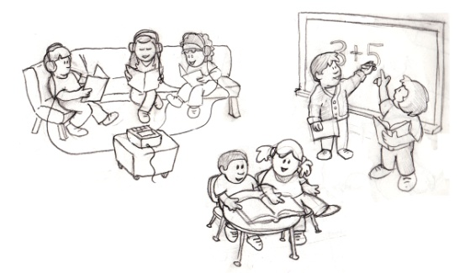
As students move into Topic B, they gain momentum with putting together, composing and decomposing, and counting on to determine the total. Students use both concrete and pictorial situations to describe all of the decompositions of 6, 7, 8, 9, and 10 (1.OA.5). Lesson 4 begins with six children posed at the front of the class. They will be put together in different ways to show the various combinations of 6, such as 2 boys and 4 girls and 3 wearing long sleeves and 3 wearing short sleeves. During this process, the put together situation will be highlighted, engaging students in counting on from one addend, or part, to find the total (1.OA.1, 1.OA.5). As students progress through the lesson, they come to see that 6 is constructed of several different decompositions, by using two-color counters and recording the decomposition in number bonds and as expressions (1.OA.1). They record each decomposition of 6, and reflect upon all of these number partners, “Look at all these ways to make 6! I can see connections between them!”
Lessons 5, 6, 7, and 8 continue this same process of putting together, composing, and decomposing. In Lesson 5, students use an engaging drawing (pictured above) to find and show ways to make 7 with 2 groups. “I see 5 kids sitting, and 2 kids standing. There are 7 kids altogether!” They use their 5-group cards to represent the partners of 7, and they record the decompositions in number bonds and expressions.
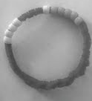
Lesson 6 has students exploring and discussing the decompositions of 8 using their 5-group cards, beginning with the numeral side first as a way to encourage counting on. In Lesson 7, students explore the partners of 9 using cubes to help them count on from the first addend. Finally, the topic ends with Lesson 8, where students make Rekenrek bracelets with 10 beads. These bracelets become tools for students to show all ways to make 10 (pictured to the right).
Rekenrek bracelet with 5 white beads and 5 red beads.
Each lesson in Topic B ends with students creating a shared chart representing all of the decompositions of each number: 6, 7, 8, 9, and 10. These charts provide a foundation for supporting understanding of addition and subtraction facts. Teachers keep the charts hanging in their classrooms and have students start portfolios. Both of these serve as references throughout the school year as students master these numerical combinations (1.OA.6).
A Teaching Sequence Towards Mastery of Counting On from Embedded Numbers
Objective 1: Represent put together situations with number bonds. Count on from one embedded number or part to totals of 6 and 7, and generate all addition expressions for each total.
(Lessons 4–5)
Objective 2: Represent put together situations with number bonds. Count on from one embedded number or part to totals of 8 and 9, and generate all expressions for each total.
(Lessons 6–7)
Objective 3: Represent all the number pairs of 10 as number bonds from a given scenario, and generate all expressions equal to 10.
(Lesson 8)

