Topic B
Composing and Decomposing Shapes
K.G.6, K.G.1, K.G.4
Focus Standard: | K.G.6 | Compose simple shapes to form larger shapes. For example, “Can you join these two triangles with full sides touching to make a rectangle?”
Instructional Days: | 4
Coherence -Links from: | GPK–M2 | Two-Dimensional and Three-Dimensional Shapes
-Links to: | G1–M5 | Identifying, Composing, and Partitioning Shapes
Thus far students have considered shapes independently, rather than in conjunction with other shapes. Topic B expands students’ thinking about shape by introducing the notion that simple shapes can be combined to compose larger shapes (K.G.6). This supports A Story of Units’ overarching theme, that smaller units can be used to make a larger unit. “These two triangles make a square! These two squares make a rectangle!”
In Lesson 5, students use pattern blocks as templates to compose other shapes and pictures. For example, they make a rectangle from two squares and use a square and a triangle to make a pentagon or “house” shape.
Lesson 6 has students explore how to decompose a flat shape into two or more flat shapes. For example, students find that a rectangle can be decomposed into two triangles, two squares, or even a square and two smaller rectangles. Students record their explorations by drawing the hidden shapes within a larger shape. The Problem Set extends puzzle work as students combine shapes to complete pattern block templates of increasing complexity (see Geometry progressions document, p. 7).
This leads into Lesson 7 wherein students cut a square to form simple three-piece puzzles and intuitively use geometric motions such as flips, turns, and slides as they work to solve one another’s puzzles. Lesson 8 hosts the Math Olympics, a culminating task that celebrates student learning from the whole year. Students complete tasks related to measurement, operations, and geometry.
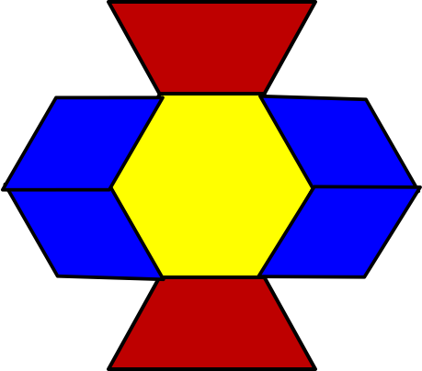
Complex
Simple

A Teaching Sequence Towards Mastery of Composing and Decomposing Shapes
Objective 1: Compose flat shapes using pattern blocks and drawings.
(Lesson 5)
Objective 2: Decompose flat shapes into two or more shapes.
(Lesson 6)
Objective 3: Compose simple shapes to form a larger shape described by an outline.
(Lesson 7)
Objective 4: Culminating task—review selected topics to create a cumulative year-end project.
(Lesson 8)

