Topic G

*One More* with Numbers 0–10

K.CC.4abc, K.CC.2, K.CC.5

|  |  |  |
| --- | --- | --- |
| Focus Standard: | K.CC.4 | Understand the relationship between numbers and quantities; connect counting to cardinality.   1. When counting objects, say the number names in the standard order, pairing each object with one and only one number name and each number name with one and only one object. 2. Understand that the last number name said tells the number of objects counted. The number of objects is the same regardless of their arrangement or the order in which they were counted. 3. Understand that each successive number name refers to a quantity that is one larger. |
| Instructional Days: | 4 |  |
| Coherence -Links from: | GPK–M3 | Counting to 10 |
| -Links to: | G1–M1 | Sums and Differences to 10 |

In the previous topics, students counted groups of three-dimensional objects, concretely seeing that numbers represented quantities of those objects. Topic G transitions to pictorially (two-dimensional objects) ordering and matching numeral and dot cards (dots are in a 10-frame format) for numbers 1–10.

In Lesson 29, students begin to learn, practice, and understand that each successive number name refers to a quantity that is 1 greater. This important insight leads later in the year, and in Grade 1, to the Level 2 stragegy of counting on, rather than counting all (**K.CC.4c**).

Lesson 30 helps children to kinesethtically internalize the concept of 1 more by building linking cube stairs. From this concrete exercise, the students are then asked to arrange, analyze, and draw 1 more up to 10 in configurations other than the stair or tower format. They might be given a group of objects to count on paper in a scattered or circular formation and then asked to add 1 more object to the group and count again.

This concept is extended in Lesson 32 as students analyze and draw sequences of quantities of 1 more, beginning with numbers other than 1. “Susan has three apples. Jerry has one more apple than Susan. Draw Jerry’s apples.”

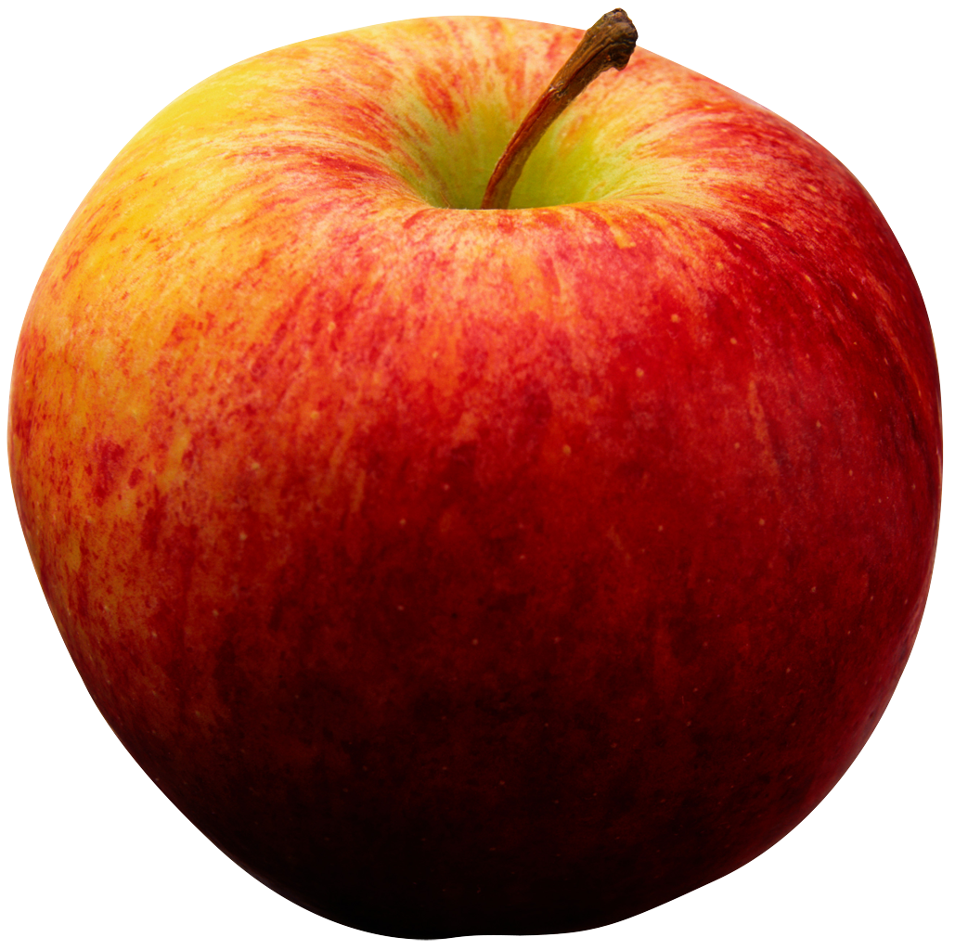



|  |
| --- |
| A Teaching Sequence Towards Mastery of *One More* with Numbers 0–10 |
| Objective 1: Order and match numeral and dot cards from 1 to 10. State 1 more than a given number. (Lesson 29) |
| Objective 2: Make math stairs from 1 to 10 in cooperative groups. (Lesson 30) |
| Objective 3: Arrange, analyze, and draw 1 more up to 10 in configurations other than towers. (Lesson 31) |
| Objective 4: Arrange, analyze, and draw sequences of quantities of 1 more, beginning with numbers other than 1. (Lesson 32) |