9.4.1 | Lesson 27

Introduction
In this lesson students are introduced to writing conclusions, and learn about clarity and cohesion in writing. Students draft their conclusions in class, and are assessed on their concluding statements that follow from and support the reasoning developed in their essays.
For homework, students revise their argument essays for cohesion and clarity.

Standards
Assessed Standard(s)
W.9-10.1.e | Write arguments to support claims in an analysis of substantive topics or texts, using valid reasoning and relevant and sufficient evidence. Explore and inquire into areas of interest to formulate an argument.  - Provide a concluding statement or section that follows from and supports the argument presented.
Addressed Standard(s)
W.9-10.1.c | Write arguments to support claims in an analysis of substantive topics or texts, using valid reasoning and relevant and sufficient evidence. Explore and inquire into areas of interest to formulate an argument.  - Use words, phrases, and clauses to link the major sections of the text, create cohesion, and clarify the relationships between claim(s) and reasons, between reasons and evidence, and between claim(s) and counterclaims.
W.9-10.4 | Produce clear and coherent writing in which the development, organization, and style are appropriate to task, purpose, and audience.

Assessment
Assessment(s)
Student learning in this lesson is assessed based on students’ first drafts of concluding statements.
- Student conclusions are assessed using W.9-10.1.e on the 9.4 Rubric and Checklist.
High Performance Response(s)
A High Performance Response should:
- Be one or two paragraphs in length.
- Restate the central claim of the argument made in the introduction.
- Briefly summarize the supporting claims in the essay that support this central claim.
- Offer a new way of thinking about the argument.
- See Model Argument Outline Tool for sample student conclusion.

Vocabulary
Vocabulary to provide directly (will not include extended instruction)
- None.*
Vocabulary to teach (may include direct word work and/or questions)
- None.*
*Because this is not a close reading lesson, there is no specified vocabulary. However, in the process of returning to the text(s), students may uncover unfamiliar words. Teachers can guide students to make meaning of these words by following the protocols described in 1E of this document http://www.engageny.org/sites/default/files/resource/attachments/9-12_ela_prefatory_material.pdf.

Lesson Agenda/Overview
Student-Facing Agenda | % of Lesson
Standards & Text:
- Standards: W.9-10.1.e, W.9-10.1.c, W.9-10.4
- Text: Sugar Changed the World and all supplementary module texts
Learning Sequence:  - Introduction of Lesson Agenda  - Homework Accountability  - Cohesion and Clarity Review  - Conclusion Instruction  - Lesson Assessment  - Closing | - 10%  - 10%  - 25%  - 20%  - 30%  - 5%

Materials
- Student copies of the 9.4 Common Core Learning Standards Tool (refer to 9.4.1 Lesson 9)
- Student copies of the 9.4 Rubric and Checklist (refer to 9.4.1 Lesson 14)
- Copies of the Conclusions Handout for each student
- Student copies of the Argument Outline Tool (refer to 9.4.1 Lesson 24)

Learning Sequence
How to Use the Learning Sequence
Symbol | Type of Text & Interpretation of the Symbol
10% | Percentage indicates the percentage of lesson time each activity should take.
no symbol | Plain text indicates teacher action.
 | Bold text indicates questions for the teacher to ask students.
 | Italicized text indicates a vocabulary word.
 | Indicates student action(s).
 | Indicates possible student response(s) to teacher questions.
 | Indicates instructional notes for the teacher.
Activity 1: Introduction of Lesson Agenda 10%
Begin by reviewing the agenda for this lesson and assessed standard: W.9-10.1.e. In this lesson, students receive instruction on cohesion and clarity in central claim development, and writing conclusion paragraphs. Students draft their conclusions in class, and revise their argument for cohesion and clarity for homework.
- Students look at the agenda.
Distribute or ask students to take out their copies of the 9.4 Common Core Learning Standards Tool. Inform students that in this lesson they begin to work with a new standard: W.9-10.1.e. Ask students to individually read this standard on their tools and assess their familiarity with and mastery of it.
- Students read and assess their familiarity with standard: W.9-10.1.e.
Instruct students to compare this new standard to the familiar standard W.9-10.2.f. Ask students to compare these two standards—how are they similar? How are they different? Lead a brief discussion about these standards.
- Student observations may include:
  - Both W.9-10.1.e and W.9-10.2.f are about providing a concluding statement
  - Both state that the concluding statement should support the information presented in the rest of the essay
  - W.9-10.1.e is about writing a conclusion for an argument essay
  - W.9-10.2.f is about writing a conclusion for an informative essay
Activity 2: Homework Accountability 10%
Instruct students to share their revised body paragraphs in pairs. Instruct students to discuss how they revised their body paragraphs for formal style, objective tone, and the development of supporting claims and counterclaims.
- Students share their body paragraphs in pairs and discuss the revision process.
Activity 3: Cohesion and Clarity Review 25%
Remind students that they have already reviewed standard W.9-10.1.c regarding the use of transitional words and phrases to create cohesion and clarity in arguments. In this lesson, students build upon this work and explore how to create clear and cohesive relationships across the central claim, supporting claims, counterclaims, evidence, and reasoning in their arguments.
Provide the following definition: cohesion means “the action or fact of forming a united whole.”
- Differentiation Consideration: Consider reviewing with students the terms used in this module to discuss argument and argument writing.
- Argument: the composition of precise claims about a topic, including relevant and sufficient evidence, and valid reasoning
- Central claim: an author or speaker’s main point about an issue in an argument
- Supporting claim: smaller, related points that reinforce or advance the central claim
- Evidence: the topical and textual facts, events, and ideas from which the claims of an argument arise, and which are cited to support those claims
- Reasoning: the logical relationships among ideas, including relationships among claims and relationships across evidence
Inform students that they have done this kind of analysis in the context of argument writing throughout the unit, when they delineated and evaluated arguments and evidence in supplementary texts. Ask students to apply these same analytical skills to their own writing. Remind students that effective argument writing not only develops supporting claims and counterclaims with evidence, but also clearly represents the reasoning that connects claims, counterclaims, and evidence.
Display the following two paragraphs for students to read:
- People in the west should not buy cheap clothes because there are workers in countries like Bangladesh who die because of the bad conditions there. Poor people in the west need to be able to buy cheap clothes. The conditions in factories will not improve if people do not stop buying cheap clothes. Everyone needs to buy ethical clothing even if it costs more money.
- Factory conditions in countries like Bangladesh are really terrible, sometimes the factories even collapse or burn down and the people that work there die. One of the reasons the factories are so run down is because people in the West want to buy cheap clothing, so the businesses that sell the clothes build cheap and unsafe factories to save money. One way to change the situation is for businesses to spend more money on safer factories and charge more for their clothes to make up for it. However, some people in the West argue that they can only afford to buy cheap clothes because they are living in poverty, but ultimately access to cheap clothing is not as important as preventing the deaths of the people who work in these factories.
- Differentiation Consideration: Consider reading the two paragraphs aloud for students.
After students have read the examples, post or project the following questions for students to answer in pairs.
Which paragraph is more cohesive?
- The second paragraph is more cohesive. The first paragraph is choppy and disconnected, and the ideas do not flow together as a unified whole.
What about the first paragraph makes it less cohesive?
- The first paragraph makes a series of statements, but does not connect them or explain why they go together in the same paragraph. The author’s argument is not clearly organized or developed into a united whole. The first paragraph does not use transitional words or phrases at all.
What about the second paragraph makes it more cohesive?
- The second paragraph is more organized and has clear relationships between the claims, evidence, supporting claims, counterclaims and reasoning. The second paragraph uses transitional words and phrases like “one of the reasons,” and “however” to connect claims, counterclaim and reasoning.
Share with students that, in a way, writing an argument essay is like participating in a debate: writers persuade the audience that their argument is strongest by presenting and refuting counterclaims. To do this, students must begin by establishing the central claim of their argument, and then clearly explain, step by step with supporting claims, why that central claim is stronger than possible opposing claims or counterclaims.
Explain to students that cohesion comes as the result the revision and editing process. Remind students of their previous work with standard W.9-10.4, which requires that students produce clear and coherent writing in which the development, organization, and style are appropriate to task, purpose, and audience.
How does the second paragraph refute the counterclaim that it presents?
- The second paragraph refutes the counterclaim that people living in poverty in the U.S. can only afford to buy cheap clothing by making this counterclaim seem less important that the supporting claim by comparing the need for cheap clothes to human lives. That makes the counterclaim seem less important because clothes are not a matter of life or death.
Lead a brief whole-class discussion of student responses.
Activity 4: Conclusion Instruction 20%
Inform students that a crucial component of cohesion and clarity in an argument essay is writing a conclusion and introduction that work together. An effective introduction introduces a central idea, and an effective conclusion restates this central idea.
Inform students that they will write a first draft of their conclusion today in class. Direct students to turn to the checklist for substandard W.9-10.1.e in their 9.4 Rubric and Checklist. Remind students to refer to this checklist while writing their conclusions.
- Students read substandard W.9-10.1.e on their 9.4 Rubric and Checklist.
Ask students to identify the elements that contribute to a strong conclusion.
- Student responses may include:
  - An effective conclusion restates the central claim of the essay.
  - An effective conclusion summarizes select pieces of evidence that support this claim.
  - An effective conclusion offers a new way of thinking about the issue.
- Students may recall their work with W.9-10.2.f and writing conclusions in their research papers in 9.3.
- Differentiation Consideration: Consider reviewing the difference between “repeating” and “restating” with students: to repeat something means to say something again, while to restate means to say something again in a different way.
Inform students that an effective conclusion of an argument piece contains similar elements as those they included in their argument essays. Explain that after moving from the more general ideas of the introduction to the more specific claims and counterclaims that make up the body of the essay, the conclusion will move back to more general ideas. An effective conclusion in an argument piece will:
- Restate the central claim of the argument and why this is important.
- Summarize the supporting claims.
- Summarize counterclaims and briefly address their limitations.
- Potentially include a call to action or offer a brief overview of possibilities for the future.
- Information in this section adheres to MLA style conventions and is modeled after instruction on the Conclusions Handout from: http://owl.english.purdue.edu
Instruct students to outline their concluding statement on their Argument Outline Tool.
- Students write down ideas for their conclusion on their Argument Outline Tool.
Activity 5: Lesson Assessment 30%
Instruct students to independently draft their conclusions for the lesson assessment, based on the ideas they wrote on their Argument Outline Tool. Remind students that this is a first draft, and while they should be focusing on the conventions established, they will have an opportunity to edit and refine their writing in the next lesson. Inform students that this assessment will be evaluated using W.9-10.1.e on the 9.4 Rubric and Checklist. Remind students to refer to the checklist as they are writing their conclusions.
- Students independently draft the conclusion of their essays on their Argument Outline Tool.
- Differentiation Consideration: Consider having students email their conclusions to the teacher, upload them to a cloud for teacher access, or hand in a paper copy for assessment.
- See the High Performance Response at the beginning of this lesson.
Activity 6: Closing 5%
Display and distribute the homework assignment. For homework, instruct students to review and revise the complete first draft of their argument essay for cohesion and clarity. Remind students to refer to substandard W.9-10.1.c on the 9.4 Rubric and Checklist to guide their revisions.
- Students follow along.

Homework
Review and revise the complete first draft of your argument essay for cohesion and clarity using W.9-10.1.c on the 9.4 Rubric and Checklist to guide their revisions.

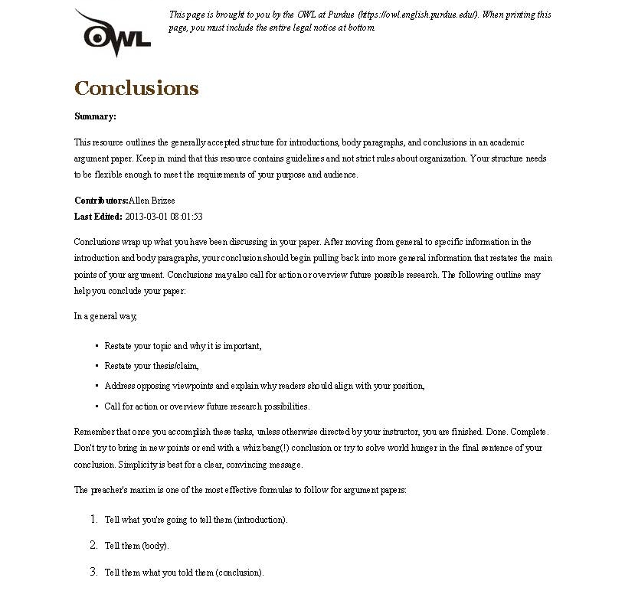

Copyright ©1995-2014 by The Writing Lab & The OWL at Purdue and Purdue University. All rights reserved. This material may not be published, reproduced, broadcast, rewritten, or redistributed without permission. Use of this site constitutes acceptance of our terms and conditions of fair use.

Model Argument Outline Tool
Name: |  | Class: |  | Date:

[Introduction]
Question: Who bears the most responsibility for ensuring that goods are ethically produced? Provide evidence from Sugar Changed the World and at least two additional texts in your response.
Central Claim: Consumers bear the responsibility for the ethical production of goods.
[Body] Supporting Claim: Consumers who buy cheap clothes are responsible for the exploitation of the workers who make these cheap clothes.
Evidence: “The reason we have fast fashion is…working in safe and legal conditions.” (“How Your Addiction to Fast Fashion Kills”)  Reasoning: How does the evidence support your claim?  The production of cheap clothes is made possible only by denying fair wages and safe labor conditions to the people who make them. Therefore, consumers who choose to buy cheap clothes support the exploitation of workers.  Strengths and Limitations: What are the strengths of this claim? The limitations of this claim?  The strength of this claim is that it draws a clear connection between the demands of the consumer and the exploitation of workers. The limitations of this claim is that it does not take into account the role of businesses in the supply and demand relationship. | Evidence: “in 2005 the U.S. government lifted quotas on imports… helped fuel the explosion of fast fashion.” (“How Your Addiction to Fast Fashion Kills”)  Reasoning: How does the evidence support the counterclaim?  If the government had not lifted quotas on imports, then there would be a check on how much cheap clothing could be bought and sold.  Strengths and Limitations What are the strengths of this counterclaim? The limitations of this counterclaim?  A strength of this counterclaim is that it appeals to authority and adds nuance to the topic. A limitation of this counterclaim is that it does not address the role of businesses in this relationship.
Supporting Claim: Consumers have an ethical responsibility to seek out and buy ethically produced goods, even if it costs more. | Counterclaim: Consumers who live on the poverty line need access to inexpensive goods.
Evidence: “Scafidi and Cline believe consumers would pay a little bit more…peace of mind knowing that shirt was made by workers treated not just humanely, but fairly?” (“How Your Addiction to Fast Fashion Kills”)  Reasoning: How does the evidence support your claim?  The evidence supports this claim because it shows that the way people are treated is as important to consumers as what they are buying.  Strengths and Limitations: What are the strengths of this claim? The limitations of this claim?  A strength of this claim is that it is ethically sound because it cares more about people than things. A limitation of this claim is the assumption that people would prefer to pay more to buy ethically manufactured clothes -- people do buy a lot of fast fashion, so there is no proof to support Scafidi and Cline’s claim that people would actually spend more to buy ethical clothes. | Evidence: “Especially in a recession, cheap clothing is a welcome industry for many. People in western countries living on the poverty line need to buy clothes for their children.” (“Bangladesh Factory Collapse: Who Really Pays for our Cheap Clothes” p. 2)  Reasoning: How does the evidence support this counterclaim?  This evidence supports the idea that there are people in western countries who are also in desperate financial situations, and rely on fast fashion to clothe their children.  Strengths and Limitations: What are the strengths of this counterclaim? The limitations of this counterclaim?  The strength of this counterclaim is that it calls into question the idea that all consumers can realistically choose to abstain from buying cheap clothing. The limitation of this counterclaim is that it does not address the alternate solution of reused and recycled clothing sold at cheap prices (like from thrift stores or vintage shops).
Supporting Claim: Consumers should boycott companies that do not make their goods ethically. | Counterclaim: Sweatshops provide important jobs for poor people in poor countries, and boycotts will just make those factories shut down and take away those jobs.
Evidence: “Slave labor was valuable because it produced cheap sugar...some 400,000 English people stopped buying the sugar that slaves grew and harvested.” (Sugar Changed the World, 78)  Reasoning: How does the evidence support your claim?  This evidence supports the claim because it shows that boycotting was something that was used historically, and can be a model for consumer activism in contemporary times.  Strengths and Limitations: What are the strengths of this claim? The limitations of this claim?  The strength of this claim is that it uses a successful boycott in the past as evidence that similar boycotts could be successful now. The limitation of this claim is that it does not explain where consumers will get their goods once they boycott an unethical source. | Evidence: “The best way to help people in the poorest countries isn’t to campaign against sweatshops but to promote manufacturing there.” (“Where Sweatshops are a Dream”)  Reasoning: How does the evidence support this counterclaim?  This evidence supports the counterclaim because it asserts that providing people in need with jobs is the ethical choice—rather than taking away their jobs and ability to make money, we should provide them with more jobs.  Strengths and Limitations: What are the strengths of this counterclaim? The limitations of this counterclaim?  The strength of this counterclaim is that it offers an ethical explanation for providing jobs to workers. The limitation of this counterclaim is that it does not address the exploitation of workers that is widespread at factories—how would creating more factories address these abuses?
[Conclusion]
As consumers of fast fashion we bear the most responsibility for stopping the exploitation of workers that is going on in garment factories, because it is our demand for these clothes that causes this exploitation in the first place. Everyone in the world deserves to have a fair chance at having a good job and life. By making individual ethical choices about the clothes we buy as well as organizing and participating in large scale boycotts, someday we will be able to buy clothes at any store and feel good about where they came from and how they were made.
From Outline Tool, by Odell Education, www.odelleducation.com. Copyright (2012) by Odell Education. Adapted with permission under an Attribution-NonCommercial 3.0 Unported license: http://creativecommons.org/licenses/by-nc/3.0/.

