9.4.1 | Lesson 25

Introduction
In this lesson, students begin the process of drafting the body paragraphs of their evidence-based argument essay. The writing process is guided by the organization and analysis of the claims and counterclaims students developed on their Argument Outline Tool in 9.4.1 Lesson 24. Students begin this lesson by completing the final sections of their Argument Outline Tool, analyzing how the evidence they selected supports each claim and counterclaim and assessing the strengths and limitations of each claim. Students then begin to draft their body paragraphs, focusing on cohesion in their writing, both within and between paragraphs.
For homework, students complete a draft of the body paragraphs of their argument essay.

Standards
Assessed Standard(s)
W.9-10.1.a, b | Write arguments to support claims in an analysis of substantive topics or texts, using valid reasoning and relevant and sufficient evidence. Explore and inquire into areas of interest to formulate an argument.  - Introduce precise claim(s), distinguish the claim(s) from alternate or opposing claims, and create an organization that establishes clear relationships among claim(s), counterclaims, reasons, and evidence.  - Develop claim(s) and counterclaims fairly, supplying evidence for each while pointing out the strengths and limitations of both in a manner that anticipates the audience’s knowledge level and concerns.
Addressed Standard(s)
W.9-10.1.c | Write arguments to support claims in an analysis of substantive topics or texts, using valid reasoning and relevant and sufficient evidence. Explore and inquire into areas of interest to formulate an argument.  - Use words, phrases, and clauses to link the major sections of the text, create cohesion, and clarify the relationships between claim(s) and reasons, between reasons and evidence, and between claim(s) and counterclaims.
W.9-10.4 | Produce clear and coherent writing in which the development, organization, and style are appropriate to task, purpose, and audience.
W.9-10.5 | Develop and strengthen writing as needed by planning, revising, editing, rewriting, or trying a new approach, focusing on addressing what is most significant for a specific purpose and audience.
L.9-10.3.a | Apply knowledge of language to understand how language functions in different contexts, to make effective choices for meaning or style, and to comprehend more fully when reading or listening.  a. Write and edit work so that it conforms to the guidelines in a style manual (e.g., MLA Handbook, Turabian’s Manual for Writers) appropriate for the discipline and writing type.

Assessment
Assessment(s)
Student learning is assessed via students’ first draft of a body paragraph.
High Performance Response(s)
A High Performance Response should:
- Adhere to the organization structure in the Argument Outline Tool.
- Trace the relationship between claim and counterclaim.
- Support claim and counterclaim with evidence from the text.
See the Model Argument Outline Tool for examples of claims, counter claims, and supporting evidence.
- Consider displaying the model response to the End-of-Unit Assessment so that students can read the model body paragraphs. The model response is located in Lesson 29.

Vocabulary
Vocabulary to provide directly (will not include extended instruction)
- None.*
Vocabulary to teach (may include direct word work and/or questions)
- None.*
*Because this is not a close reading lesson, there is no specified vocabulary. However, in the process of returning to the texts, students may uncover unfamiliar words. Teachers can guide students to make meaning of these words by following the protocols described in 1E of this document http://www.engageny.org/sites/default/files/resource/attachments/9-12_ela_prefatory_material.pdf.

Lesson Agenda/Overview
Student-Facing Agenda | % of Lesson
Standards & Text:
- Standards: W.9-10.1.a-c, W.9-10.4, W.9-10.5, L.9-10.3.a
- Text: Sugar Changed the World and all supplementary module texts
Learning Sequence:  - Introduction of Lesson Agenda  - Homework Accountability  - Connecting Ideas and Citation  - Analyzing Evidence and Reasoning  - Lesson Assessment  - Closing | - 10%  - 15%  - 15%  - 25%  - 25%  - 10%

Materials
- Student copies of the 9.4 Common Core Learning Standards Tool (refer to 9.4.1 Lesson 9)
- Copies of the Connecting Ideas Handout for each student
- Copies of the MLA Citation Handout for each student
- Student copies of the Argument Outline Tool (refer to 9.4.1 Lesson 24)
- Student copies of the 9.4 Rubric and Checklist (refer to 9.4.1 Lesson 14)

Learning Sequence
How to Use the Learning Sequence
Symbol | Type of Text & Interpretation of the Symbol
10% | Percentage indicates the percentage of lesson time each activity should take.
no symbol | Plain text indicates teacher action.
 | Bold text indicates questions for the teacher to ask students.
 | Italicized text indicates a vocabulary word.
 | Indicates student action(s).
 | Indicates possible student response(s) to teacher questions.
 | Indicates instructional notes for the teacher.
Activity 1: Introduction of Lesson Agenda 10%
Begin by reviewing the agenda and assessed standard for this lesson: W.9-10.1.a, b. Explain that in this lesson students complete the final sections of their Argument Outline Tool, analyzing how the evidence they selected in 9.4.1 Lesson 24 supports each claim and counterclaim, and assessing the strengths and limitations of each claim. Students then draft their first body paragraphs.
- Students look at the agenda.
Distribute or ask students to take out their copies of the 9.4 Common Core Learning Standards Tool. Inform students that in this lesson they begin to work with a new standard: W.9-10.1.c. Ask students to individually read the standard on their tools and assess their familiarity with and mastery of the standard.
- Students read and assess their understanding of standard W.9-10.1.c.
Instruct students to talk in pairs about what they think the standard means. Lead a brief discussion about the standard.
- Student responses should include:
  - Use words and phrases to connect sections of an essay.
  - Use words and phrases to make sure ideas flow together.
  - Use words and phrases to show the relationships between claims and reasons, reasons and evidence, and claims and counterclaims.
Explain to students that they are to identify examples of these transition words and phrases and then practice using them in this lesson.
Activity 2: Homework Accountability 15%
Instruct students to form pairs and share their introduction drafts with one another. Post or project the following questions to frame students’ conversations.
How does the introduction grab the reader’s attention? How effective is this method?
What is the central claim of this argument essay? Is the central claim clearly stated in the introduction?
- Students share and discuss their introductions in their pairs.
Call on several students or student pairs to share out with the whole class.
- Students share their introductions with the full class.
Activity 3: Connecting Ideas and Citation 15%
Distribute copies of the Connecting Ideas Handout. Remind students of the work they did to create organized and cohesive papers in Module 9.3. Inform students that effective argument writing also uses logical organization, as required by standard W.9-10.4, and transitions between sentences and paragraphs, as required by standard W.9-10.1.c. Additionally, strong argument writing demonstrates clear connections between claims and counterclaims. Instruct students to review the Connecting Ideas Handout and ask students:
What transitional words and phrases make the most sense to connect a claim and a counterclaim?
- The transitional words and phrases in the “Contrast Ideas or Show How They are Different” portion of the handout such as on the other hand, in contrast, on the contrary, etc. make the most sense to connect a claim and a counterclaim.
What transitional words and phrases make the most sense to connect a claim with reasoning?
- The transitional words and phrases in the “Explain How One Thing Causes Another” portion or the “Explain the Effect or Result of Something” portion of the handout such as consequently, as a result, for that reason, etc. make the most sense to connect a claim with reasoning.
- Students have worked with these transitional words and phrases and the Connecting Ideas Handout in 9.3.3, but it may be helpful to spend additional time reviewing these concepts.

Distribute copies of the MLA Citation Handout. Remind students of the work they did with citation in Module 9.3. Instruct students that while citation is particularly important for research and information writing, it is also necessary whenever students incorporate multiple text evidence sources in their writing. Instruct students that since the End-of-Unit Assessment prompt asks students to use evidence from at least two supplementary texts as well as Sugar Changed the World, students need to cite these sources correctly.
- Consider reminding students that their work with citation supports their engagement with substandard L.9-10.3.a, which requires that students write and edit work so that it conforms to the guidelines in a style manual (e.g., MLA Handbook).
Remind students that someone can plagiarize by copying and pasting the exact words from a source without quoting it but also by using different words to express the same idea as another author (e.g., if someone takes the central claim and evidence from another essay and writes it with different words, it is still considered plagiarism if the source is not cited). Remind students that even though they might have similar opinions or views as the author of one of their sources, they must create an original argument based on all the evidence available to them and cite sources wherever possible.
- The goal of this essay is for students to construct their own argument and support it with the claims made in supplementary texts like “How Fast Fashion Kills,” not for students to repeat the arguments of these texts verbatim.
- Students listen, and review the MLA Citation Handout.
Activity 4: Analyzing Evidence and Reasoning 25%
Instruct students to take out their Argument Outline Tools. Remind students that the portion of the outline they completed in the previous lesson is the frame for the essay’s introduction (which introduces the central claim) and the body (which presents the claims, counterclaims and evidence that support the central claim). Instruct students to look at the first supporting claim on the Argument Outline Tool. Explain that they need to be able to analyze the evidence that they chose to support each supporting claim in the body of their essay. Students must briefly write how this evidence supports each supporting claim or corresponding counterclaim. Additionally, students must analyze the strengths and limitations of each supporting claim or counterclaim. Inform students that this analysis is the starting point for each body paragraph.
- Students follow along.
Instruct students to form pairs to discuss their ideas about how the evidence supports their claims, and possible strengths and limitations of their claim or counterclaim. Then students should record their thinking by completing the “analysis” and “reasoning” portions of the Argument Outline Tool.
- Students discuss their ideas in pairs and fill in the Argument Outline Tool.
- See the Model Argument Outline Tool for examples of analysis of evidence.
Activity 5: Lesson Assessment 25%
Inform students that are now to independently draft their first body paragraph for the lesson assessment, using the outline they have established on the Argument Outline Tool. Remind students that this is a first draft, and while they should be focusing on the conventions established, they are to edit and refine their writing in later lessons. Inform students that their lesson assessment is to complete a draft of the first body paragraph and that they shall have additional time for homework to complete their other body paragraphs.
Remind students to consider the use of transitional words and phrases and rhetorical techniques as they draft their body paragraph. Remind students that they should also employ the MLA citation techniques from their MLA Citation Handout to properly cite their sources.
Inform students that this assessment is evaluated using W.9-10.1.a-b on the 9.4 Rubric and Checklist. Remind students to refer to this as they are writing their body paragraph.
- The process of writing an argument essay involves drafting, peer review, editing, and revising. If access to technology is available, consider using a cloud or electronic storage system (MS Word, Google Drive, etc.) that allows each student to write and track changes using a word processing program. If technological resources are not available, use the established classroom protocols for drafting, editing, and revising hard copies.
- Students independently draft the first body paragraph of their essay.
- Consider having students email their body paragraph to the teacher, uploading them to a cloud for teacher access, or handing in a hardcopy for assessment.
- See the High Performance Response at the beginning of this lesson.
Activity 6: Closing 10%
Display and distribute the homework assignment. For homework, instruct students to continue drafting their body paragraphs based on the outline they established on their Argument Outline Tool. Students should continue to employ the MLA citation techniques from their MLA Citation Handout to properly credit their evidence sources. Students should also use strong transitional words and phrases from their Connecting Ideas Handout. Students should come to the next lesson prepared to share their body paragraph drafts.
- Students follow along.

Homework
Continue drafting body paragraphs based on the outline established on the Argument Outline Tool, properly citing sources and connecting claims and counterclaims with transitional language.

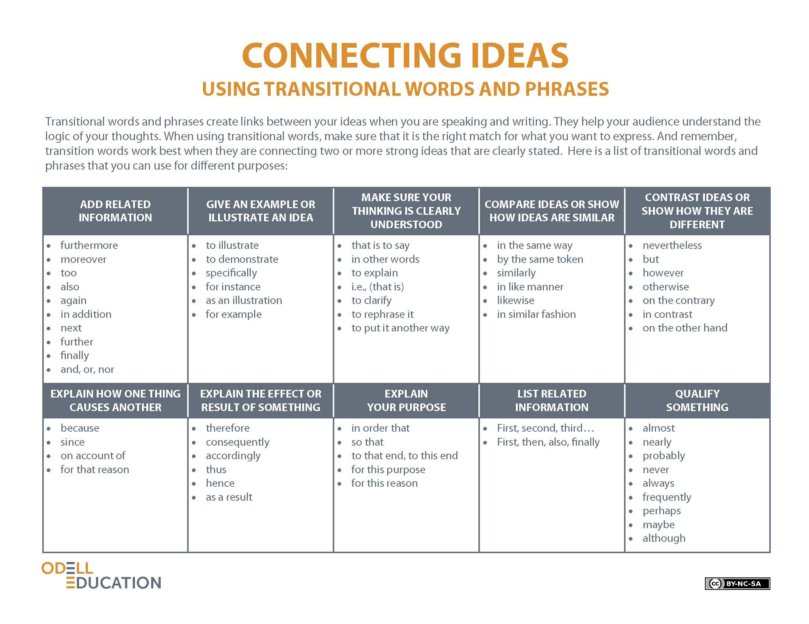
MLA Citation Handout
Name: |  | Class: |  | Date:

In-Text Citations
For in-text citations, use the following as examples:
“People and animals are supposed to be together.” (Grandin, p. 5)
Grandin says, “People and animals are supposed to be together” (p. 5).
Works-Cited Page
Here are the different citation methods for various forms of media:

Book
Basic format:
Last Name, First Name. Title of Book. Place of Publication: Publisher, Year of Publication. Medium of Publication.
Example:
Smith, Joe. Joe Smith’s Theory of the Universe. New York: Books Limited, 2013. Print.
Magazine/Journal
Basic Format:
Author(s). "Title of Article." Title of Periodical Day Month Year: Pages. Medium of Publication.
Example:
Smith, Joe. “Joe Smith’s Theory of the Universe.” Universe Theories. 20 Apr. 1989: pp. 100–109. Print.

Website
Basic Format:
Editor, Author or Compiler Name (if available). Name of Site. Version Number. Name of Institution/Organization Affiliated with the Site (Sponsor or Publisher), Date of Resource Creation (if available). Medium of Publication. Date of Access.
Example:
Smith, Joe. Guide to My Theory of the Universe. UniverseBlogs. 16 Apr. 2001. Web. 19 Dec 2013.
Motion Picture
Basic Format:
Title of Motion Picture. Director. If relevant, list performers using ‘perf.’ to distinguish them from director. Distributor. Date of Release. Medium.
Example:
Theories of the Universe. Dir. Joe Smith. Perf. Joe Smith, Jane Smith, Robert Smith. Touchstone. 2012. DVD.

Adapted from The Purdue OWL Family of Sites. The Writing Lab and OWL at Purdue and Purdue University, 2008. Web. 1 Dec. 2013.

Model Argument Outline Tool
Name: |  | Class: |  | Date:

[Introduction]
Question: Who bears the most responsibility for ensuring that goods are ethically produced? Provide evidence from Sugar Changed the World and at least two additional texts in your response.
Central Claim: Consumers bear the responsibility for the ethical production of goods.
[Body] Supporting Claim: Consumers who buy cheap clothes are responsible for the exploitation of the workers who make these cheap clothes. | Counterclaim: The U.S. Government’s lift on the quota of imports is responsible for the exploitation of the workers who make cheap clothes.
Evidence: “The reason we have fast fashion is …working in safe and legal conditions.” (“How Your Addiction to Fast Fashion Kills,” paragraph 4)  Reasoning: How does the evidence support your claim?  The production of cheap clothes is made possible only by denying fair wages and safe labor conditions to the people who make them. Therefore, consumers who choose to buy cheap clothes support the exploitation of workers.  Strengths and Limitations What are the strengths of this claim? The limitations of this claim?  The strength of this claim is that it draws a clear connection between the demands of the consumer and the exploitation of workers. The limitation of this claim is that it does not take into account the role of businesses in the supply and demand relationship. | Evidence: “in 2005 the U.S. government lifted quotas on imports… helped fuel the explosion of fast fashion” (“How Your Addiction to Fast Fashion Kills,” paragraph 6)  Reasoning: How does the evidence support the counterclaim?  If the government had not lifted quotas on imports, then there would be a check on how much cheap clothing could be bought and sold.  Strengths and Limitations: What are the strengths of this counterclaim? The limitations of this counterclaim?  A strength of this counterclaim is that it appeals to authority and adds nuance to the topic. A limitation of this counterclaim is that it does not address the role of businesses in this relationship.
Supporting Claim: Consumers have an ethical responsibility to seek out and buy ethically produced goods, even if it costs more. | Counterclaim: Consumers who live on the poverty line need access to inexpensive goods.
Evidence: “Scafidi and Cline believe consumers would pay a little bit more …peace of mind knowing that shirt was made by workers treated not just humanely, but fairly?” (“How Your Addiction to Fast Fashion Kills,” paragraph 13)  Reasoning: How does the evidence support your claim?  The evidence supports this claim because it shows that the way people are treated is as important to consumers as what they are buying.  Strengths and Limitations: What are the strengths of this claim? The limitations of this claim?  A strength of this claim is that it is ethically superior because it cares more about people than things. A limitation of this claim is the assumption that people would prefer to pay more to buy ethically manufactured clothes—people do buy a lot of fast fashion, so there is no proof to support Scafidi and Cline’s claim that people would actually spend more to buy ethical clothes. | Evidence: “Especially in a recession, cheap clothing is a welcome industry for many. People in western countries living on the poverty line need to buy clothes for their children.” (“Who Really Pays for our Cheap Clothes,” paragraph 10)  Reasoning: How does the evidence support this counterclaim?  This evidence supports the idea that there are people in western countries who are also in desperate financial situations and rely on fast fashion to clothe their children.  Strengths and Limitations: What are the strengths of this counterclaim? The limitations of this counterclaim?  The strength of this counterclaim is that it calls into question the idea that all consumers can realistically choose to abstain from buying cheap clothing. The limitation of this counterclaim is that it does not address the alternate solution of reused and recycled clothing sold at cheap prices (like from thrift stores or vintage shops).
Supporting Claim: Consumers should boycott companies that do not make their goods ethically. | Counterclaim: Sweatshops provide important jobs for poor people in poor countries, and boycotts will just make those factories shut down and take away those jobs.
Evidence: “Slave labor was valuable because it produced cheap sugar... some 400,000 English people stopped buying the sugar that slaves grew and harvested.” (Sugar Changed the World, p. 78)  Reasoning: How does the evidence support your claim?  This evidence supports the claim because it shows that boycotting was something that was used historically, and can be a model for consumer activism in contemporary times.  Strengths and Limitations: What are the strengths of this claim? The limitations of this claim?  The strength of this claim is that it uses a successful boycott in the past as evidence that similar boycotts could be successful now. The limitation of this claim is that it does not explain where consumers will get their goods once they boycott an unethical source. | Evidence: “The best way to help people in the poorest countries isn’t to campaign against sweatshops but to promote manufacturing there.” (“Where Sweatshops are a Dream,” paragraph 14)  Reasoning: How does the evidence support this counterclaim?  This evidence supports the counterclaim because it asserts that providing people in need with jobs is the ethical choice—rather than taking away their jobs and ability to make money, we should provide them with more jobs.  Strengths and Limitations: What are the strengths of this counterclaim? The limitations of this counterclaim?  The strength of this counterclaim is that it offers an ethical approach to the exploitation of workers. The limitation of this counterclaim is that it does not address the exploitation of workers that is widespread at factories—how would creating more factories address these abuses?
[Conclusion]

From Outline Tool, by Odell Education, www.odelleducation.com. Copyright (2012) by Odell Education. Adapted with permission under an Attribution-NonCommercial 3.0 Unported license: http://creativecommons.org/licenses/by-nc/3.0/.

