9.4.1 | Lesson 6

Introduction
In this lesson students read and analyze “A Cycle of Death and Sweetness” (pp. 35–41) from Sugar Changed the World, which details the horrific working conditions of eighteenth century sugar plantations. Students consider the cumulative effect of words and phrases on the tone of this section as they read a detailed and evocative description of sugar work on eighteenth century plantations. Students work in groups to collaboratively generate a list of phrases that contribute to the tone and meaning of this passage. Students complete this lesson with a Quick Write that prompts students to consider the effect of specific phrases on meaning and tone in this passage.
For homework, students read “The Spherical Trade” (p. 37) and respond in writing to a prompt that asks them to return to their understanding of globalization. Additionally, students continue their Accountable Independent Reading (AIR).

Standards
Assessed Standard(s)
RI.9-10.4 | Determine the meaning of words and phrases as they are used in a text, including figurative, connotative, and technical meanings; analyze the cumulative impact of specific word choices on meaning and tone (e.g., how the language of a court opinion differs from that of a newspaper).
Addressed Standard(s)
SL.9-10.1 | Initiate and participate effectively in a range of collaborative discussions (one-on-one, in groups, and teacher-led) with diverse partners on grades 9–10 topics, texts, and issues, building on others’ ideas and expressing their own clearly and persuasively.

Assessment
Assessment(s)
Student learning is assessed via a Quick Write at the end of the lesson. Students respond to the following prompt, citing textual evidence to support analysis and inferences drawn from the text.
- Choose two of the phrases identified during the collaborative quote activity and analyze how they contribute to cumulative tone of the passage.
High Performance Response(s)
A High Performance Response should:
- Choose two phrases to analyze. The phrases identified by students may vary. This section of text is rich with examples of strong language and examples of phrases that contribute to the cumulative tone. Some examples include:
  - “The painstaking work had just one aim: to plant a crop that would end up taking the life of every worker who touched it.” (p. 36)
  - “A weeder spent ten to fourteen hours a day bent over with a hoe, digging out the unwanted growths at the base of the knobby cane stalks, ignoring the rats that might scuttle over his or her feet or the bladelike leaves that slashed at the worker’s wrists and arms.” (p. 38)
  - “The cutters worked brutal, seemingly endless shirts during the harvest—for the hungry mills crushed cane from four in the afternoon to ten the next morning, stopping only in the midday heat.” (p. 39)
  - “’People the color of the very night, working briskly and moaning at the same time without a moment of peace or rest, whoever sees all the confused and noisy machinery…will say that this indeed is the image of Hell.’” (p. 40)
  - “Over and over again the liquid had to be strained and purified, even as it kept boiling, boiling, boiling in the copper vats.” (p. 41)
- Make a statement about the cumulative tone of this passage (e.g., that the tone of this passage is meant to convey the difficult and brutal lives of people who worked on sugar plantations).
- Analyze how the two phrases they chose contribute to that cumulative tone.

Vocabulary
Vocabulary to provide directly (will not include extended instruction)
- repose (n.) – the state of being at rest
- vermin (n.) – disgusting animals, especially of small size, such as rats
- machete (n.) – a large heavy knife
- granule (n.) – a small grain
Vocabulary to teach (may include direct word work and/or questions)
- None.
- The vocabulary in this section is accessible at grade level; students will analyze the figurative and connotative meanings of words in this section (e.g., the authors’ ironic use of “lucky” on p. 39), rather than determining vocabulary definitions.

Lesson Agenda/Overview
Student-Facing Agenda | % of Lesson
Standards & Text:
- Standards: RI.9-10.4, SL.9-10.1
- Text: “A Cycle of Death and Sweetness” (pp. 35–41) from Sugar Changed the World
Learning Sequence:  - Introduction of Lesson Agenda  - Homework Accountability  - Masterful Reading  - Reading and Discussion  - Collaborative Quote Activity  - Quick Write  - Closing | - 5%  - 10%  - 15%  - 25%  - 30%  - 10%  - 5%

Materials
- Student copies of the Short Response Rubric and Checklist (refer to 9.4.1 Lesson 1)
- Chart Paper

Learning Sequence
How to Use the Learning Sequence
Symbol | Type of Text & Interpretation of the Symbol
10% | Percentage indicates the percentage of lesson time each activity should take.
no symbol | Plain text indicates teacher action.
 | Bold text indicates questions for the teacher to ask students.
 | Italicized text indicates a vocabulary word.
 | Indicates student action(s).
 | Indicates possible student response(s) to teacher questions.
 | Indicates instructional notes for the teacher.
Activity 1: Introduction of Lesson Agenda 5%
Begin by reviewing the agenda and the assessed standard for this lesson: RI.9-10.4. In this lesson, students read a portion of Sugar Changed the World and consider the impact of words and phrases on the cumulative tone of the passage they will read. Students participate in a collaborative activity and complete a Quick Write for assessment.
- Students look at the agenda.
Activity 2: Homework Accountability 10%
Instruct students to share and discuss their responses to the homework questions in pairs.
- Students discuss and share their responses to the homework questions.
What value did sugar have for the Europeans?
- For the Europeans sugar was as valuable as “gold” (p. 31). Sugar may have been even more valuable than gold, since when the Spanish went off to find actual gold, the Europeans kept farming sugar (p. 32).
What factors contributed to Brazil’s position in the sugar production cycle?
- The rich soil and ideal ocean currents (p. 32) contributed to Brazil’s position in the sugar trade.
What was a result of the growing sugar trade?
- The results of the growing sugar trade were growth of the slave trade (p.32), the expanding economies of Europe (p. 35), or and the change in sugar’s availability (p. 35) so that it was no longer the luxury item it had been for the Muslim rulers (p. 17) or scarce like it was for King Henry III (p. 24).
Instruct students to briefly share the geographic details they have recorded on their Mapping Sugar Tool with the class.
- Students share the work they have done on their Mapping Sugar Tool.
- See Model Mapping Sugar Tool for sample student responses.
Activity 3: Masterful Reading 15%
Have students listen to a masterful reading of “A Cycle of Death and Sweetness” (pp. 35–41).
- Students will be assigned “The Spherical Trade” (p. 37) as homework; it is not necessary to include this passage in the masterful reading.
- Students follow along, reading silently.
Activity 4: Reading and Discussion 25%
Instruct students to form pairs. Post or project the following questions for students to answer in pairs.
What is the cumulative effect of the authors’ use of “you” in this section of the text, starting on page 36?
- The use of “you” draws the reader into the life of the sugar worker because the authors are writing this section as if the reader was the one doing the work.
Provide students with the following definitions: repose means “the state of being at rest” and vermin means “disgusting animals, especially of small size, such as rats.”
- Students write the definitions of repose and vermin on their copy of the text or in a vocabulary journal.
What might it mean for the authors to use the word “lucky” (p. 39) in the context of sugar labor?
- The use of “lucky” does not give the same meaning as it is normally used. The life of a sugar worker was hard and dangerous, and to be “lucky” would mean that it was only a little bit less hard since they would get “a little more to eat, a few moments more rest” (p. 39) with some potential for “personal pleasure” (p. 39), but this is not a big improvement since they were not “any less a slave” (p. 39).
Provide students with the following definitions: machete means “a large heavy knife,” and granule means “a small grain.”
- Students write the definitions of machete and granule on their copy of the text or in a vocabulary journal.
What attitude do the authors have toward sugar work? How is this attitude reflected in the tone of this passage?
- The authors have the attitude that sugar work is dangerous and “brutal” (p. 36), “painstaking” (p. 36), scary and “bladelike” (p. 38) because one’s “arm could be hacked off” (p. 40), and difficult because there was “no rest” (p. 40), “this was not the end” (p. 41). This is reflected in the tense and ominous tone of the passage.
How does the tone of this passage compare to the description of sugar work in “The Problem with Sugar Cane” (pp. 26–29)?
- The tone in this passage is much more graphic and frightening than the tone of “The Problem With Sugar Cane,” which was a shorter, more simple explanation of the work in general without the human element of the dangers of that work.
- If necessary, allow time for students to briefly return to “The Problem with Sugar Cane” before responding to this question.
- Differentiation Consideration: If students struggle, consider posing the following scaffolding question:
What might the authors be implying with the phrases “or the anger of brutalized slaves” (p. 38) and “but for some also their weapons” (p. 39)?
- The authors are implying that the slaves might be angry and do things on purpose (like burn the sugar fields) to hurt the people who enslaved them.
- Consider drawing students’ attention to the authors’ use of foreshadowing. In lessons 15 and 16 students will read and analyze passages of Sugar Changed the World that detail revolutions in Haiti and around the world. It may be a rich extension to stop and have students consider the foreshadowing that occurs in this section, or return to this section after they have encountered passages detailing these events.
Lead a brief whole-class discussion of student responses.

Activity 5: Collaborative Quote Activity 30%
Group students into five pre-established groups. Assign each group a page from the excerpt and chart paper labeled with the assigned excerpt:
- Group One: from “The Millions of Africans taken to work in sugar” through “could hardly rest even when their day was done” (pp. 35–36).
- Group Two: from “Their huts, which ought to be well covered” through “a roaring blaze would engulf the fields” (p. 38).
- Group Three: from “You might be lucky enough to be trained” through “then the sugar cane would dry up” (p. 39).
- Group Four: from “Cutting cane was hard work” through “he or she could slip into a bubbling vat” (p. 40).
- Group Five: from “Mammoth fires burned in the ‘mouths,’” through “whitest sugar from less valuable brown granules” (p. 41).
- Prepare the chart paper with reading assignments recorded on the top before class.
Instruct student groups to identify and record at least three phrases from their assigned portion of the text that contribute to the cumulative tone of this passage.
- Students work in groups to identify and record three phrases that contribute to the cumulative tone of this passage.
- Student responses may vary. See assessment box at the beginning of this lesson for examples of phrases students may identify.
- Consider reminding students of their previous work with standard SL.9-10.1, which requires that students participate in collaborative discussions, building on each other’s ideas and expressing their own clearly and persuasively.
After students have had time to find and record at least three phrases that contribute to the cumulative tone of this passage, instruct students to move clockwise around the room to the next group’s chart paper, read the phrases, and identify one of those phrases that best exemplifies the cumulative tone of this passage. Students may vote individually for their choice of phrase by placing a dot on the chart paper, or make a group decision and vote together.
- Students move clockwise in their groups, working to identify the phrase that best exemplifies the tone of this passage.
- Depending on time, consider stopping this activity after two or three rotations.
After students have had time to read the phrases and identify one that they feel best exemplifies the tone of this passage, instruct student groups to share out with the full class which phrase they chose and why.
- Students share the phrase they chose, as well as their reasoning behind that choice.
Record and display the five phrases identified by student groups. Instruct students to choose from and analyze two of these five phrases for their Quick Write.
Activity 6: Quick Write 10%
Instruct students to respond briefly in writing to the following prompt:
Choose two of the phrases identified during the collaborative quote activity and analyze how they contribute to cumulative tone of the passage.
- Display the phrases for student reference during this Quick Write.
Instruct students to look at their annotations to find evidence. Ask students to use this lesson’s vocabulary wherever possible in their written responses. Remind students to use the Short Response Rubric and Checklist to guide their written responses.
- Students listen and read the Quick Write prompt.
- Display the prompt for students to see, or provide the prompt in hard copy.
Transition to independent Quick Write.
- Students independently answer the prompt, using evidence from the text.
- See the High Performance Response at the beginning of this lesson.
Activity 7: Closing 5%
Display and distribute the homework assignment. For homework, instruct students to read “The Spherical Trade” (p. 37) and respond in writing to the following prompt:
How does this description of “the spherical trade” compare to your understanding of globalization?
Remind students to use the Short Response Rubric and Checklist to guide their written responses. Ask students to use this lesson’s vocabulary wherever possible in their written responses.
Additionally, ask students to continue to read their AIR text through the lens of a focus standard of their choice and prepare for a 3–5 minute discussion of that text based on that standard.
- Students follow along.

Homework
Read “The Spherical Trade” (p. 37) and respond in writing to the following prompt:
How does this description of “the spherical trade” compare to your understanding of globalization?
Use this lesson’s vocabulary wherever possible in your written responses.
Continue AIR through the lens of a focus standard of your choice and prepare for a 3–5 minute discussion of your text based on that standard.
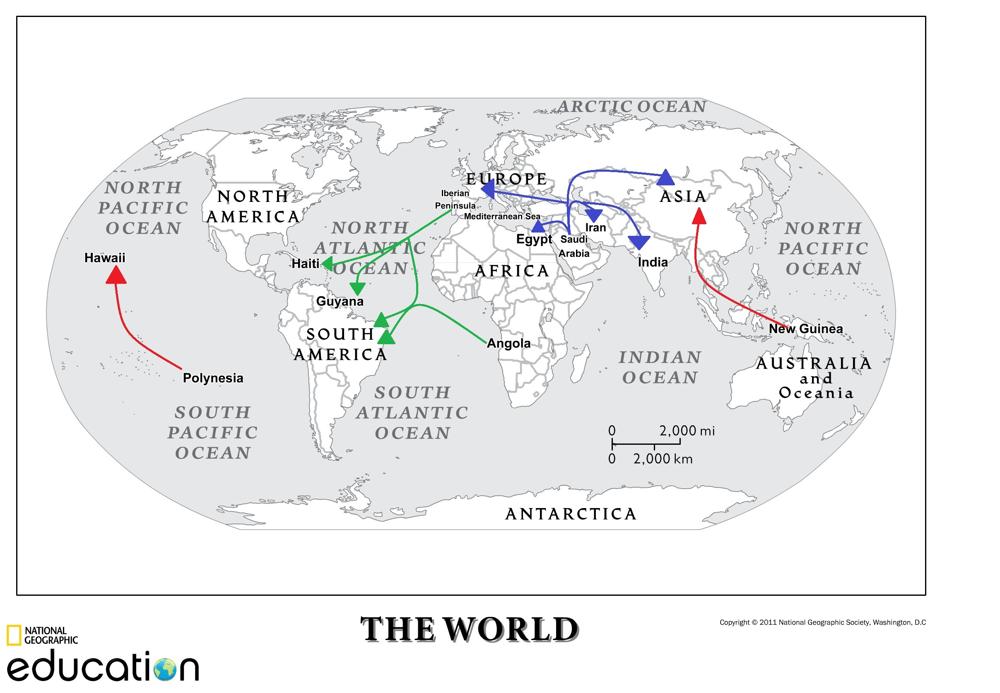
Model Mapping Sugar Tool
Map courtesy National Geographic. National Geographic does not review or endorse content added to this map by others

