9.4.1 | Lesson 3

Introduction
In this lesson, students read and analyze “Storm of God” (pp. 16–18). This section of Sugar Changed the World explores the relationship between the spread of Islam and the expansion of the sugar trade in 600 A.D.
Student engagement with this passage is structured around their work with the Unfolding Analysis Tool. This tool prompts students to identify key ideas presented in this passage and how they are organized and connected. Throughout their analysis of this passage, students shape and refine their understanding of the relationship between the growth of the sugar trade and the spread of ideas. Student analysis culminates in a written response to the lesson assessment prompt: How do the authors unfold a series of events in order to make connections between ideas in this passage?
For homework, students independently read “Fortress Europe” and “The Champagne Fairs” (pp. 18–24), and respond to three homework prompts.

Standards
Assessed Standard(s)
RI.9-10.3 | Analyze how the author unfolds an analysis or series of ideas or events, including the order in which the points are made, how they are introduced and developed, and the connections that are drawn between them.
Addressed Standard(s)
L.9-10.4.a | Determine or clarify the meaning of unknown and multiple-meaning words and phrases based on grades 9–10 reading and content, choosing flexibly from a range of strategies.  - Use context (e.g. the overall meaning of a sentence, paragraph or text; a word’s position or function in a sentence) as a clue to the meaning of a word or phrase.

Assessment
Assessment(s)
Student learning is assessed via a Quick Write at the end of the lesson. Students respond to the following prompt, citing textual evidence to support analysis and inferences drawn from the text.
- How do the authors unfold a series of events in order to make connections between ideas in this passage?
High Performance Response(s)
A High Performance Response should:
- Identify and demonstrate an understanding of a series of events that unfold in this passage. (e.g., Islam spread across large portions of the globe as it “won over nearly all the lands of the ancient world” (p. 17), the Muslims were “masters of sugar,” and so they spread knowledge about sugar to the lands they conquered (p. 17), sugar became a way for “Muslim ruler[s]” and nobility to demonstrate their “wealth” (p. 17), The nobles wanted sugar to be as “pure, sweet, and white as possible,” so the Egyptians developed a processing method to meet this need (p. 18)).
- Identify how the authors use the unfolding of a series of events to make connections between ideas (e.g., the authors unfold this series of events to connect the expansion of Islam with the expansion of sugar. Therefore, the authors are crafting a connection between the spread of a commodity (sugar) and the spread of ideas (Islam)).

Vocabulary
Vocabulary to provide directly (will not include extended instruction)
- pagan (n.) – person who believes in more than one god
- conversion (n.) – change from one religion, political belief, viewpoint, etc., to another
- conquest (n.) – the act or state of acquiring by force of arms
- lavish (adj.) – using or giving in great amounts
Vocabulary to teach (may include direct word work and/or questions)
- prophet (n.) – a person who speaks for a god

Lesson Agenda/Overview
Student-Facing Agenda | % of Lesson
Standards & Text:
- Standards: RI.9-10.3, L.9-10.4.a
- Text: “Storm of God” (pp. 16–18) from Sugar Changed the World
Learning Sequence:  - Introduction of Lesson Agenda  - Homework Accountability  - Masterful Reading  - Mapping the Spread of Islam Activity  - Unfolding Analysis Tool  - Quick Write  - Closing | - 5%  - 10%  - 10%  - 40%  - 20%  - 10%  - 5%

Materials
- Student copies of the Mapping Sugar Tool (refer 9.4.1 Lesson 1)
- Student copies of the Short Response Rubric and Checklist (refer 9.4.1 Lesson 1)
- Student copies of the Image Analysis Tool (refer 9.4.1 Lesson 2)
- Copies of the Unfolding Analysis Tool: Connecting Ideas for each student

Learning Sequence
How to Use the Learning Sequence
Symbol | Type of Text & Interpretation of the Symbol
10% | Percentage indicates the percentage of lesson time each activity should take.
no symbol | Plain text indicates teacher action.
 | Bold text indicates questions for the teacher to ask students.
 | Italicized text indicates a vocabulary word.
 | Indicates student action(s).
 | Indicates possible student response(s) to teacher questions.
 | Indicates instructional notes for the teacher.
Activity 1: Introduction of Lesson Agenda 5%
Begin by reviewing the agenda and the assessed standard for this lesson: RI.9-10.3. In this lesson, students determine how Aronson and Budhos unfold a series of events in order to make connections between ideas in “The Storm of God” section of Sugar Changed the World.
- Students look at the agenda.
Activity 2: Homework Accountability 10%
Instruct students to talk in pairs about how they applied their focus standard to their AIR text from the previous lesson’s homework. Lead a brief share out on the previous lesson’s AIR homework assignment. Select several students (or student pairs) to explain how they applied their focus standard to their AIR text.
- Students (or student pairs) discuss how they applied their focus standard to their AIR text from the previous lesson’s homework.
Return the Image Analysis Tools students completed for the previous lesson’s assessment. Ask students to share how the different images they chose to analyze develop a central idea of the “The World’s First True University.”
- Students share their observations with the class.
- See Model Image Analysis Tools from Lesson 2 for sample student responses.
Activity 3: Masterful Reading 10%
Have students listen to a masterful reading of “The Storm of God” (pp.16–18) in its entirety (from “When the prophet Muhammed began preaching” through “Europe had gone the opposite way: Isolation”). Instruct students to read along in their texts.
- Students follow along, reading silently.
- Differentiation Consideration: Consider reviewing and displaying the following annotation codes established in Module 9.1 with students:
- Box unfamiliar words.
- Star (*) important or repeating ideas.
- Put a question mark (?) next to a section you’re questioning or confused about.
- Use an exclamation point (!) for ideas that strike you or surprise you in some way.
Share with students that, besides using the codes, marking the text with their thinking related to the codes is important.
Instruct students to reread “The Storm of God” and annotate according to these established codes.
Activity 4: Mapping the Spread of Islam Activity 40%
Have students form pairs. Instruct students to read aloud paragraphs 1 and 2 in their pairs.
Have students take out their Mapping Sugar Tools. Instruct students to work in their pairs to identify the countries and continents through which Islam spread. Students should record their observations on their Mapping Sugar Tools with a line or arrow. Remind students to mark the spread of Islam with a distinct marker (such as a different color or a dashed line) to distinguish the spread of Islam from the movement of sugar that they tracked for Lesson homework (blue was used on the model tool to identify the movement of Islam).
- Students identify countries and continents through which Islam spread, and mark them on their Mapping Sugar Tools.
- See Model Mapping Sugar Tool.
Ask students to volunteer the countries and continents that they have identified.
- Thus far, students have used the Mapping Sugar Tool to trace the path of sugar as it has been imported/exported. Mapping the spread of Islam on the same map as the spread of sugar encourages students to continue to shape their understanding of the relationship between the spread of knowledge and ideas (in this case religion), and the growth of the sugar trade.
Pose the following question for whole-class discussion:
How do the geographic details you have marked on your Mapping Sugar Tool further shape a central idea of the text?
- The maps illustrate that the spread of ideas (in this case Islam) creates a global network, just like the spread of a commodity like sugar.
- This question encourages students to make a connection between the geographic details describing the spread of Islam that they have marked on their map and the authors’ unfolding analysis of the relationship between the spread of ideas (in this case, the ideas of Islam) and the spread of a commodity that students established in Lesson 2.
- Differentiation Consideration: If students require more scaffolding in their analysis of “The Storm of God” before beginning pair work on the Unfolding Analysis Tool, consider posing the following questions to guide students through this passage before they begin work on the Unfolding Analysis Tool.
What words and phrases can help you to make meaning of the word “prophet” in this context?
- The word “disciples” and the phrase “began preaching” (p. 16) indicate that “prophet” means a person who speaks for god[s].
- Consider drawing students’ attention to their application of standard L.9-10.4.a through the process of using context to make meaning of a word.
- Students who are familiar with the prophet Muhammed may call upon background knowledge to answer this question. Encourage students to support answers derived from background knowledge with other words and phrases from the text.
What two forces do the authors identify as being responsible for the spread of Islam (p. 16)?
- The references to “Muslim conquerors” and the “Muslim faithful” indicate that the authors are suggesting that both the Muslim “armies” and the “arguments” (p. 16) of those who believe in Islam were powerful forces in the spread of this religion.

Instruct students to answer the following questions in their pairs.
What claim do the authors make about the Muslim world at the beginning of paragraph 2?
- The authors’ claim that the “Muslim world was wonderful for the growth of knowledge” (p. 17).
How do the authors support their claim?
- Student responses may include:
  - The Muslims translated ancient Greek texts, and so had access to the “advanced,” “practical experience and technical understanding” of the Greeks (p. 17).
  - The Muslims learned about the concept of zero from India (p. 17).
  - Because the Koran was written in Arabic, all Muslim scholars learned to read Arabic and could share their knowledge (p. 17).
What do these details suggest about the environment necessary for the “growth of knowledge”
(p. 17)?
- All of these details emphasize the free exchange of ideas between cultures (the Muslims expanded their knowledge through contact with the texts of ancient Greeks, and through contact with Indian scholars). Students may also suggest that this exchange is fostered by comprehension of other languages (Greek), as well as the prevalence of a shared language to aid in communication (Arabic).
What connection do the authors make between the spread of Islam and the spread of sugar in paragraph 2?
- The authors describe Jundi Shapur as the connection between the spread of Islam and the spread of sugar (p. 17). According to the authors, the spread of Islam resulted in the exchange of knowledge between cultures. When the Muslim armies came across Jundi Shapur, they learned “the secrets of sugar” that those at the university possessed, and as the armies continued to move across the globe and conquer more countries, they spread this knowledge of sugar with them (p. 17).
How does the word “laboratory” refine your understanding of Egypt’s role in the spread of sugar
(p. 17)?
- “Laboratory” suggests that sugar had to be invented through a series of experiments, and that Egypt had the knowledge and technology to perform these experiments.
Lead a brief whole-class discussion of student responses.
Activity 5: Unfolding Analysis Tool 20%
Introduce and distribute the Unfolding Analysis Tool. Explain that students are using this tool in order to trace how the authors unfold their analysis in this passage. Instruct students to work in pairs to identify and record the main ideas of each paragraph on this tool, and analyze how these ideas are connected. Inform students that they will respond individually to the Quick Write prompt.
Model completing the first row of the Unfolding Analysis Tool with students (See Model Unfolding Analysis tool). Remind students that they will not be able to fill out the “connections” column for the first paragraph because there are no previous paragraphs to connect to.
- Differentiation Consideration: If students struggle with the analysis required by the connections column, explain that it may be helpful to begin each statement with “because.” Using “because” prompts students to express the interconnectedness of events and ideas.
Provide students with the following definitions: pagan means “a person who believes in more than one god,” conversion means “change from one religion, political belief, viewpoint, etc., to another,” conquest means “the act or state of acquiring by force of arms,” lavish means “using or giving in great amounts.”
- Students write the definitions of pagan, conversion, conquest, and lavish on their copy of the text or in a vocabulary journal.
- Students work with the Unfolding Analysis Tool in their pairs.
- See Model Unfolding Analysis Tool.
- The Unfolding Analysis Tool supports student’s engagement with RI.9-10.3. Variations of this tool appear in Lessons 11, 15, and 22. The structure of and questions in this tool vary based on the section of text under analysis, including its placement in the text as a whole, and whether students analyze a series of ideas or a series of events.
Circulate and support pair work.
Activity 6: Quick Write 10%
Introduce the Quick Write assessment by reminding students of the assessed standard for this lesson: RI.9-10.3. Instruct students to respond briefly in writing to the following prompt:
How do the authors unfold a series of events in order to make connections between ideas in this passage?
Instruct students to look at their annotations and details from the tool to find evidence. Ask students to use this lesson’s vocabulary wherever possible in their written responses. Remind students to use the Short Response Rubric and Checklist to guide their written responses.
- Students listen and read the Quick Write prompt.
- Display the prompt for students to see, or provide the prompt in hard copy.
Transition students to the independent Quick Write.
- Students independently answer the prompt, using details from the tool to support their response.
- See the High Performance Response at the beginning of this lesson.
Activity 7: Closing 5%
Display and distribute the homework assignment. For homework, instruct students to independently read the next section of Sugar Changed the World, “Fortress Europe” and “The Champagne Fairs” (pp. 18–24). Display the following prompts for students to respond to after they have read the text:
How do the authors’ descriptions of Europe compare to their descriptions of the Muslim world?
How were Europeans exposed to sugar?
Define “globalization.” Look up a definition, and record in the space below.
Ask students to use this lesson’s vocabulary wherever possible in their written responses.
- Students follow along and record the homework prompts.
- The homework reading and the corresponding prompts will establish that global trade has existed throughout history. This prepares students to engage with the Lesson 4 text, “Globalization,” an informative article exploring historical and contemporary globalization.

Homework
Independently read “Fortress Europe” and “The Champagne Fairs” (pp. 18–24), and respond to the following prompts:
How do the authors’ descriptions of Europe compare to their descriptions of the Muslim world?
How were Europeans exposed to sugar?
Define “globalization.” Look up a definition, and record.

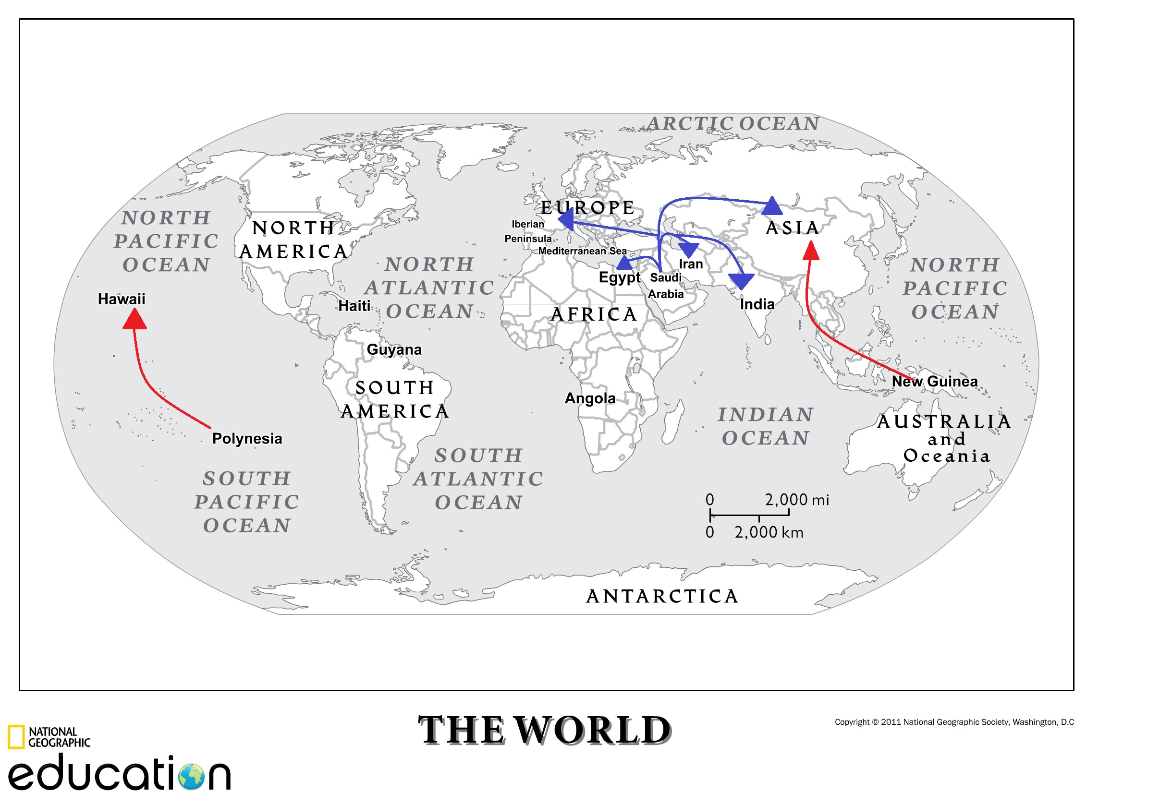
Model Mapping Sugar Tool
Map courtesy National Geographic. National Geographic does not review or endorse content added to this map by others

Unfolding Analysis Tool: Connecting Ideas
Name: |  | Class: |  | Date:

Paragraph | Identify the main idea. | How does the main idea in this paragraph connect to the previous paragraphs?
Paragraph 1
Paragraph 2
Paragraph 3
Paragraph 4
Paragraph 5
Paragraph 6

Model Unfolding Analysis Tool: Connecting Ideas
Name: |  | Class: |  | Date:

Paragraph | Identify the main idea. | How does the main idea in this paragraph connect to the previous paragraphs?
Paragraph 1 | Islam spread across large portions of the globe because Muslim armies took over countries and because people were persuaded to change their religious beliefs (p. 17). | New idea, new section
Paragraph 2 | Muslims learned about sugar, so they spread knowledge about sugar to the lands they conquered (p. 17). | Because Islam spread all over the globe, knowledge of sugar spread all over the globe.
Paragraph 3 | Sugar became a way for Muslim rulers and nobility to demonstrate their wealth (p. 17). | Because knowledge of sugar became widespread, Muslim rulers started using it to demonstrate their wealth.
Paragraph 4 | The nobles wanted sugar to be as white and pure as possible, so the Egyptians developed a processing method to meet this need (p. 18). | Because sugar became a status symbol, new methods of making “better” and more pure sugar were required.
Paragraph 5 | Egypt became world famous for having the whitest and purest sugar (p. 18). | Because Egypt developed a better method of making sugar, it became famous.
Paragraph 6 | As the Islamic world spread across the globe, so did knowledge of and demand for sugar (p. 18). | Because the Islamic world spread knowledge of sugar, it also spread the demand for sugar.

