9.3.2 | Lesson 11

Introduction
In this lesson, students organize, analyze, and synthesize their claims (Forming Evidence-Based Claims Tools) from the previous lesson to develop comprehensive claims about each inquiry path in the Research Frame.
Students begin the lesson by organizing the claims they created in the previous lesson by physically arranging the Forming Evidence-Based Claims (EBC) Tools according to the inquiry paths they address. Students analyze and make connections between these specific claims and the research evidence to develop comprehensive claims about each inquiry path. Students use Organizing Evidence-Based Claims Tools to write the comprehensive claims about each inquiry path. Students then work in small groups to peer review one Organizing Evidence-Based Claims Tool using an Evidence-Based Claims Criteria Checklist. For the lesson assessment, students synthesize the information from an Organizing Evidence-Based Claims Tool into a paragraph explaining the claim and the evidence that supports it.
This work directly prepares students for developing and writing an Evidence-Based Perspective for the End-of-Unit Assessment in the next lesson. Students build on the claims created in the previous lesson to develop comprehensive claims that reflect a deeper understanding of the inquiry paths and the research question/problem itself. For homework, students review all of their Organizing Evidence-Based Claims Tools using the Evidence-Based Claims Criteria Checklist. Students will revise their claims, if necessary, to prepare for the next lesson’s End-of-Unit Assessment.

Standards
Assessed Standard(s)
W.9-10.4 | Produce clear and coherent writing in which the development, organization, and style are appropriate to task, purpose, and audience.
W.9-10.7 | Conduct short as well as more sustained research projects to answer a question (including a self-generated question) or solve a problem; narrow or broaden the inquiry when appropriate; synthesize multiple sources on the subject, demonstrating understanding of the subject under investigation.
Addressed Standard(s)
W.9-10.9 | Draw evidence from literary or informational texts to support analysis, reflection, and research.
SL.9-10.1 | Initiate and participate effectively in a range of collaborative discussions (one-on-one, in groups, and teacher-led) with diverse partners on grades 9–10 topics, texts, and issues, building on others’ ideas and expressing their own clearly and persuasively.

Assessment
Assessment(s)
The learning in this lesson will be captured through a Quick Write at the end of the lesson. Students will craft a response to the following prompt using an Organizing Evidence-Based Claims Tool from the lesson.
- Develop a claim about an inquiry path or your research question/problem and support it using specific evidence and details from your research.
- The Quick Write will be assessed using the Evidence-Based Claims Criteria Checklist.
High Performance Response(s)
A high performance response may include the following:
- Researchers can measure animal intelligence by observing qualities of intelligence that are shared by humans, but they must design experiments that consider the animal’s perspective. Animals share traits of intelligence with humans, specifically social awareness skills. Scientists can also measure animal intelligence by observing social awareness skills—the same skills humans exhibit. For example, chimpanzees are able to “fake laugh,” a skill that humans can also do. Researchers were able to show that chimpanzees “engaged in ‘laugh replications’ that lacked the full acoustic structure of spontaneous laughter.” This shows that chimpanzees were engaging in fake laughing with fellow chimpanzees, a social awareness skill that demonstrates an advanced mental capacity. Even though researchers can measure animal intelligence by observing similar human-like skills or qualities, they must maintain the animal’s perspective if they are to get accurate measurements or research. Animal intelligence researchers have shifted their attitudes and believe that “meeting animals on their own terms instead of treating them like furry (or feathery) humans” will result in the most accurate and relevant animal intelligence research. And, researchers are designing experiments that “provide other ways for animals to disclose their intelligence to us.” Even though animals cannot speak, there may be other ways that show us how smart animals truly are.
- *The evidence in this high performance response comes from the following model sources: Source #3 “Think You’re Smarter Than Animals? Maybe Not,” Source #2 “Animal Minds: Minds of Their Own,” and Source #1 “The Brains of the Animal Kingdom.”

Vocabulary
Vocabulary to provide directly (will not include extended instruction)
- comprehensive (adj.) – of large scope, covering or involving much, inclusive
- clarity (n.) – the state of being clear or transparent
- thoroughness (adj.) – complete, extremely attentive to accuracy and detail
- objectivity (n.) – the state or quality of not being influenced by personal feelings or prejudice
Vocabulary to teach (may include direct word work and/or questions)
- None.*
*Because this is not a close reading or research lesson, there is no specified vocabulary. However, in the process of returning to the source texts, students may uncover unfamiliar words. Teachers can guide students to make meaning of these words by following the protocols described in 1E of this document http://www.engageny.org/sites/default/files/resource/attachments/9-12_ela_prefatory_material.pdf.

Lesson Agenda/Overview
Student-Facing Agenda | % of Lesson
Standards & Text:
- Standards: W.9-10.4, W.9-10.7, W.9-10.9, SL.9-10.1
Learning Sequence:  - Introduction of Lesson Agenda  - Homework Accountability and Research Process Check-In  - Organizing and Developing Comprehensive Claims  - Peer Review: Assessing Claims  - Quick Write  - Closing | - 5%  - 10%  - 40%  - 25%  - 15%  - 5%

Materials
- Copies of Organizing Evidence-Based Claims Tools for each student (one point, two point and three point)
- Model Research Frame (refer to 9.3.2 Lesson 6)
- Student copies of Evidence-Based Claims Criteria Checklist (refer to 9.3.2 Lesson 10)
- Research Portfolios (students have these)
- Student copies of Forming Evidence-Based Claims Tools (refer to 9.3.2 Lesson 10)

Learning Sequence
How to Use the Learning Sequence
Symbol | Type of Text & Interpretation of the Symbol
10% | Percentage indicates the percentage of lesson time each activity should take.
no symbol | Plain text indicates teacher action.
 | Bold text indicates text dependent questions.
 | Italicized text indicates a vocabulary word.
 | Indicates student action(s).
 | Indicates possible student response(s) to teacher questions.
 | Indicates instructional notes for the teacher.
Activity 1: Introduction of Lesson Agenda 5%
Begin by reviewing the agenda and the assessed standards for this lesson: W.9-10.4 and W.9-10.7. Explain that in this lesson, students use the Organizing Evidence-Based Claims Tool to make comprehensive claims by identifying connections between the specific claims and evidence from the previous lesson (Forming Evidence-Based Claims Tools). Students then peer review one Organizing Evidence-Based Claims Tool using the Evidence-Based Claims Criteria Checklist. Finally, students synthesize the information from an Organizing Evidence-Based Claims Tool into a written paragraph. This work directly prepares students for developing and writing an Evidence-Based Perspective for the End-of-Unit Assessment in the next lesson.
- Students look at the agenda.
Activity 2: Homework Accountability and Research Process Check-In 10%
Distribute the lesson assessment from the previous lesson (use two Forming Evidence-Based Claims Tools to make claims about one inquiry question) and have students take out their homework from the previous lesson (use at least two Forming Evidence-Based Claims Tools to make claims about each inquiry path).
- Students examine the previous lesson’s assessment and take out their homework.
Instruct students to take out the Student Research Plan and journal about their research progress and next steps in the research journal, based on the work completed in the previous lesson (Lesson 10). Instruct students to look specifically at Part 3: Organizing and Synthesizing Research on the Student Research Plan to reflect on the research activity they did in the last lesson: forming evidence-based claims about inquiry paths.
- Students journal about their research progress and next steps.
- Student responses will vary by individual research question/problem. Look for students to use the language of the Student Research Plan and evidence from their research process for research journal responses.
- The lesson assessment from the previous lesson required students to use two Forming Evidence-Based Claims Tools. Hand these tools back to each student with feedback. This assessment was evaluated using the Evidence-Based Claims Criteria Checklist.
- While students are journaling about their research progress and next steps, circulate around the room to monitor students’ homework completion.
- The research journal was started in Lesson 2 and will be completed in this lesson.

Instruct students to physically arrange all of their Forming EBC Tools by inquiry path on their desks.
- Students should have at least six Forming EBC Tools, two for each inquiry path.
- Students are not engaging in pair discussion for homework accountability because they will work together on their Forming EBC Tools later in the lesson.
Activity 3: Organizing and Developing Comprehensive Claims 40%
Explain that students will build on the claims-making process they started in the previous lesson by analyzing and synthesizing comprehensive claims about each inquiry path in the Research Frame. They will use the claims made in the previous lesson as a foundation to analyze and develop comprehensive claims for an entire inquiry path.
- Students listen.
Share the definition of the word comprehensive (“of large scope, covering or involving much, inclusive”). Explain that in this lesson students will combine the claims made in the previous lesson to create claims with a larger scope for each inquiry path. Explain that these new claims will be more global and inclusive of multiple pieces of evidence.
- Students listen.
Distribute a blank Organizing Evidence-Based Claims Two Point Tool to each student. Display the model Research Frame for students to see. Instruct students to examine the Research Frame and read Inquiry Path #1: How is animal intelligence measured?
- Students examine the Organizing Evidence-Based Claims Two Point Tool and read Inquiry Path #1 on the Model Research Frame.
- The Model Research Frame was created in Lesson 6.
Explain to students that in the previous lesson, the class developed these two claims about this inquiry path:
- The animal’s perspective is essential to consider if experiments are going to accurately measure their intelligence.
- Animal intelligence can be measured by observing social awareness skills.
- Students listen.
- The Model Forming EBC Tools used in this part of the lesson are located in Lesson 10, the previous lesson.
- The first claim was formally modeled in the previous lesson. The second claim was not formally modeled during the previous lesson, but was included as an additional example.
Explain that students will analyze and make connections between the claims they made about their inquiry questions (the work from the previous lesson). Students will organize, analyze, and make connections between the Forming EBC Tools completed for each inquiry path to create a comprehensive claim on an Organizing EBC Tool.
- Students listen.
Model how to complete an Organizing EBC Two Point Tool based on the model inquiry path discussed above (How is animal intelligence measured?) Display the tool, and explain to students that the Two Point Tool is the most appropriate one to use because in this case they are working with two points (claims).
Explain to students that they can make a larger claim by connecting these two claims.
Continue modeling by writing one of the claims in the Point One section and the other in the Point Two section, and writing the supporting evidence for each point (claim).
- See the Model Organizing EBC Two Point Tool at the end of the lesson.
Explain that students can connect these two claims to create a new claim, and model it. Write the new claim at the top of the tool: Animal intelligence can be measured by observing qualities of intelligence that are shared by humans, but experiments must be designed considering the animal’s perspective. Explain that the research evidence supports these two claims as well as the connection we just made between them.
- Students follow along with the modeling.

Distribute blank Organizing EBC Tools to each student, giving students the appropriate tool for the number of claims they have. Students should have one tool for each inquiry path.
- Some students might use a One, Two, or Three Point tool depending on how many claims they made about each inquiry path in the previous lesson. For example, if students completed three Forming EBC Tools for one inquiry path, they should use a Three Point Organizing EBC Tool to connect the three claims into one comprehensive claim about the inquiry path.
Instruct students to use an Organizing EBC Tool to develop a comprehensive claim about each inquiry path on their Research Frame. They should use the six Forming EBC Tools they completed in the previous lesson. Remind students they have completed at least two of these tools for each inquiry path.
- Students use their Organizing EBC Tools to form comprehensive claims about each inquiry path.
- Circulate around the room to monitor student progress.
- Some students may be able to use an Organizing EBC Tool to complete a comprehensive claim about the research question/problem, in addition to the inquiry paths.
Activity 4: Peer Review: Assessing Claims 25%
Explain that students will now assess one of their claims using the Evidence-Based Claims Criteria Checklist. Students will work in small groups to assess if one of the claims they developed on the Organizing EBC Tool is appropriately supported.
Distribute the Evidence-Based Claims Criteria Checklist to all students.
- Students examine the Evidence-Based Claims Criteria Checklist.
Model how to use the Evidence-Based Claims Criteria Checklist by using it to assess the Model Organizing EBC Tool created in the previous activity. Remind students of the model claim from the previous activity: Animal intelligence can be measured by observing qualities of intelligence that are shared by humans, but experiments must be designed considering the animal’s perspective. Read through each criterion in the “Content and Analysis” section, check off boxes that apply, and write model comments. Explain the following:
- I can check off the first box for the “Content and Analysis” section, Clarity of the Claim, because the claim is clearly stated and understandable. Clarity means “the state of being clear or transparent.”
- I can check off the second box for the “Content and Analysis” section, Conformity to the Text, because I created the claim directly from the textual evidence and ideas I read. For example, the quote “Experiments with animals have long been handicapped by our anthropocentric attitude” directly supports the part of the claim that says experiments must be designed with the animal’s perspective in mind.
- I can check off the third box for the “Content and Analysis” section, Understanding of the Topic, because my claim demonstrates sound thinking about the topic of animal intelligence. The idea is not abstract and there is evidence to support it.
- Students listen and follow along with the modeling.
- Display the Evidence-Based Claims Criteria Checklist for all students to see.
- Differentiation Consideration: Consider pointing out to students that the word conformity means that the claim is based upon the text, as indicated by the phrase “directly based upon” in the checklist.
Ask students to give their assessment of the Model Organizing EBC Tool for the next three sections of the Checklist: Command of Evidence, Coherence and Organization, and Thoroughness and Objectivity. Remind students to explain their thinking. Write students’ thoughts on the Evidence-Based Claims Criteria Checklist that is displayed.
- Students assess the Model Organizing EBC Tool as a whole class, using the next three sections of the Evidence-Based Claims Criteria Checklist as a guide.
- Student responses may include the following:
  - Command of Evidence: The claim has specific evidence supporting it, as demonstrated by the text quotes on the tool itself. Each piece of evidence can be used to directly support the claim. For example, the quote “Scientists are now finally meeting animals on their own terms” shows that researchers understand they must design animal experiments with the animal perspective in mind.
  - Coherence and Organization: The specific points on the tool group the evidence; the evidence is easy to understand and follows a logical pattern, directly supporting each point and laying a clear foundation for the claim itself.
  - Thoroughness and Objectivity: There are eight quotes, and each quote aims to support the overall claim. For example, the quote “This is the larger lesson of animal cognition research: It humbles us. We are not alone in our ability to invent or plan or to contemplate ourselves—or even to plot and lie” demonstrates the major idea of the claim that animal intelligence can be measured by looking at qualities of intelligence that are shared by humans.
- Differentiation Consideration: If students struggle with responses for Thoroughness and Objectivity, consider explaining the definition of thoroughness (“complete; attentive to detail and accuracy”) and objectivity (“the state or quality of not being influenced by personal feelings or prejudice”). Students will encounter the term objective tone in the next unit, Unit 3, when learning how to write objectively about research.

Instruct students to transition into small groups.
- Students form small groups.
- Place students in heterogeneous groups of four to five that will remain consistent throughout the module. Consider forming groups ahead of time to maximize the range of different research topics and questions within each group. The goal of these groups is to create small communities of inquiry/research teams that provide support and accountability to each other. Students should know about their teammates’ topics, research questions, central claims, etc. Students should share claims and evidence that arise from their individual inquiry and learn from each other’s research processes, which they may use to potentially refine their own inquiry topics and questions.
Explain to students that in this lesson, they will continue the work of collaborative discussion outlined in SL.9-10.1, to which students were previously introduced. Remind students these discussion strategies have been taught in previous modules.
- Consider reminding students of the skills inherent in the sub-standards of Standard SL.9-10.1, to which students were previously introduced.

Explain to students that for this activity, each student will give one Organizing EBC Tool to a peer in the small group (each student should have one Organizing EBC Tool to review). Each student in the group will lead the group in an assessment of their peer’s tool, using the Criteria Checklist.
- Students exchange Organizing EBC Tools within their group, and review them with the group using the Evidence-Based Claims Criteria Checklist.
Direct students to return the Organizing EBC Tool to their peers once the review is complete.
Activity 5: Quick Write 15%
Instruct students to respond briefly in writing to the following prompt:
Develop a claim about an inquiry path or your research question/problem and support it using specific evidence and details from your research.
Instruct students to develop their written response from the Organizing EBC Tools. Remind students to use the Evidence-Based Claims Criteria Checklist to guide their response.
- Display the prompt for students to see, or provide the prompt in hard copy.
- Students independently answer the prompt, using the Organizing EBC Tools and the Evidence-Based Claims Criteria Checklist to guide their response.
- See the High Performance Response at the beginning of this lesson.
Activity 6: Closing 5%
Display and distribute the homework assignment. For homework, instruct students to review all of their Organizing EBC Tools using the Evidence-Based Claims Criteria Checklist. Students revise their claims, if necessary, to prepare for the next lesson’s End-of-Unit Assessment.
Remind students that revising the Organizing Evidence-Based Claims Tool might lead to a final round of research and analysis of annotated sources and Taking Notes Tools to find the most relevant and useful evidence possible.
- Students follow along.

Homework
Review all of the Organizing Evidence-Based Claims Tools using the Evidence-Based Claims Criteria Checklist. Revise claims, if necessary, to prepare for the next lesson’s End-of-Unit Assessment.

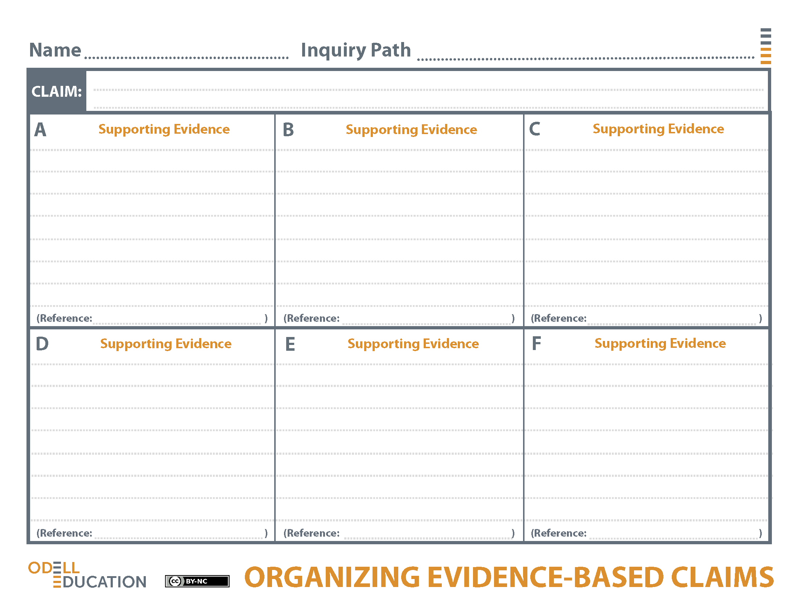

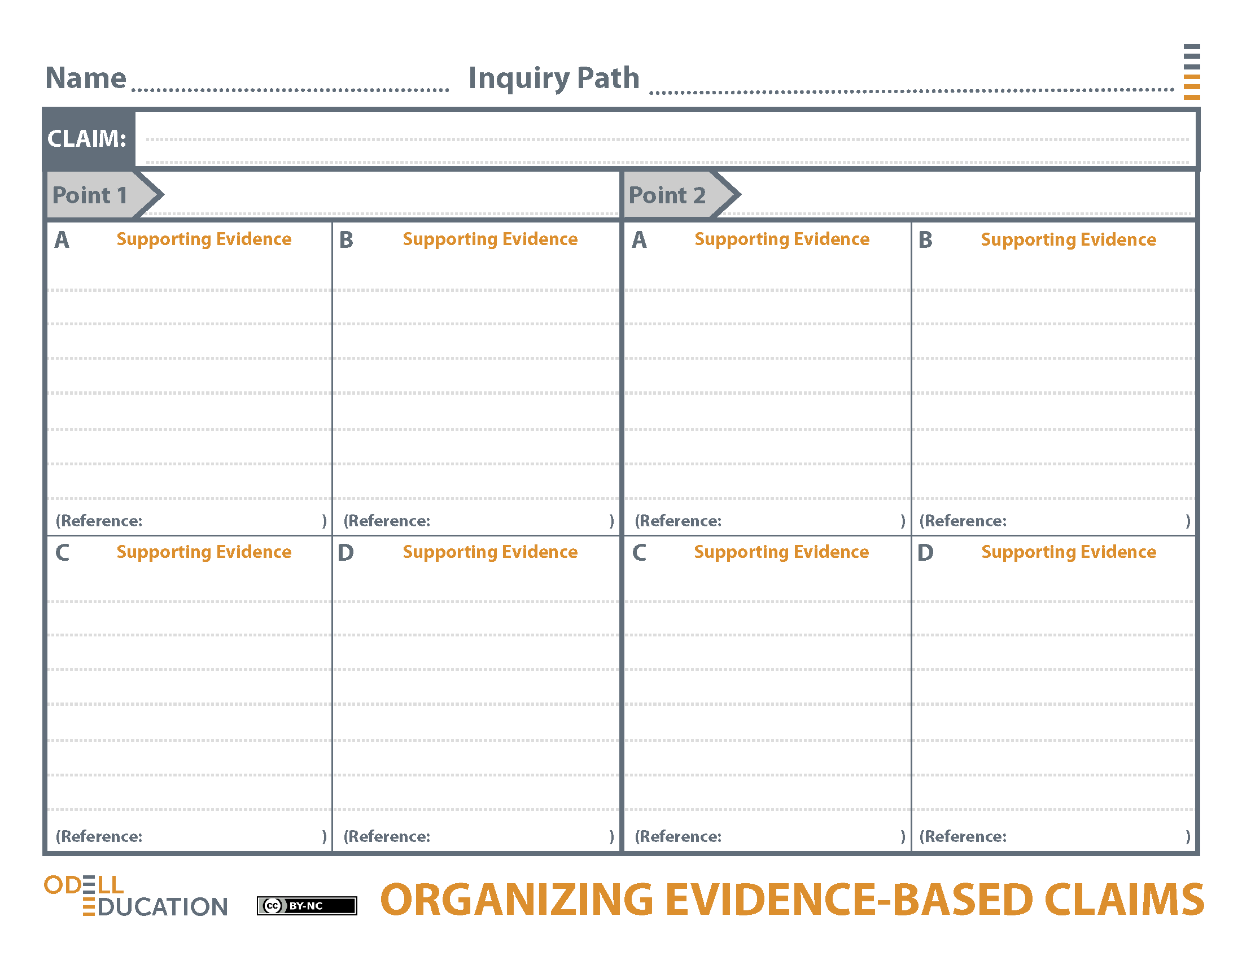

1
2
2
3
1
5
3
Today's researchers are proceeding to fashion shrewd behavioral tests that provide other ways for animals to disclose their intelligence to us. Although animals may not use human words, we may be able to provide other ways for animals to disclose their intelligence to us.
This is the larger lesson of animal cognition research: It humbles us. We are not alone in our ability to invent or plan or to contemplate ourselves - or even to plot and lie.
"Although imitation was once regarded as a simpleminded skill, in recent years cognitive scientists have revealed that it's extremely difficult...actions that imply an awareness of one's self."
"Scientists are now finally meeting animals on their own terms instead of treating them like furry (or feathery) humans, and this shift is fundamentally reshaping our understanding."
Animal intelligence can be measured by observing qualities of intelligence that are shared by humans, but experiments must be designed considering the animal's perspective.
"We suggest a simple answer: by pursuing animal cognition with the methods of natural science." "...but careful and impartial experimentation alone can yield incontestable evidence of animal cognition."
"Experiments with animals have long been handicapped by our anthropocentric attitude: We often test them in ways that work fine with humans but not so well with other species."
"The researchers discovered that when one chimp laughed others sometimes engaged in "laugh replications" that lacked the full acoustic structure of spontaneous laughter. In other words, they were fake-laughing."
"A few recent research papers describe animal competence at social and cognitive tasks that humans often struggle with — mastering conversational etiquette..."
How is animal intelligence measured?
Student Response
Animal intelligence can be measured by observing social awareness skills.
The animal's perspective is essential to consider if experiments are going to accurately measure their intelligence.
