9.3.2 | Lesson 10

Introduction
In this lesson, students analyze and synthesize their research to begin making claims about inquiry questions within an inquiry path. Students use at least two Forming Evidence-Based Claims (EBC) Tools to develop claims about all inquiry paths on the Research Frame.
Students begin by choosing the inquiry path that yielded the richest research. Then students narrow the focus down to a single inquiry question. Students then reread/skim their research associated with that inquiry question, including annotated sources and the Taking Notes Tools. Students highlight the pertinent evidence directly on the annotated sources or the Taking Notes Tools. Students then select details from the highlighted evidence to make claims about the inquiry path by completing Forming Evidence-Based Claims Tools. These initial claims serve as the foundation for the Evidence-Based Perspective students will develop in Lessons 11 and 12. At the end of this lesson, students are assessed on their Forming Evidence-Based Claims Tools using the Evidence-Based Claims Criteria Checklist. For homework, students continue the process introduced in the lesson by analyzing and synthesizing their research and completing at least two Forming EBC Tools for all inquiry paths on the Research Frame.

Standards
Assessed Standard(s)
W.9-10.7 | Conduct short as well as more sustained research projects to answer a question (including a self-generated question) or solve a problem; narrow or broaden the inquiry when appropriate; synthesize multiple sources on the subject, demonstrating understanding of the subject under investigation.
W.9-10.9 | Draw evidence from literary or informational texts to support analysis, reflection, and research.
Addressed Standard(s)
RI.9-10.7 | Analyze various accounts of a subject told in different mediums, determining which details are emphasized in each account.

Assessment
Assessment(s)
The learning in this lesson will be captured on the Forming Evidence-Based Claims Tools:
- Students use at least two Forming Evidence-Based Claims Tools to develop claims about one inquiry path.
- Assess the tools using the Evidence-Based Claims Criteria Checklist.
High Performance Response(s)
A high performance response may include the following:
- Individual student tools will vary by the individual’s research question/problem. See the model Forming Evidence-Based Claims Tool at the end of the lesson for model student responses.

Vocabulary
Vocabulary to provide directly (will not include extended instruction)
- yielded (v.) – gave forth or produced
Vocabulary to teach (may include direct word work and/or questions)
- None.*
*Students will encounter domain-specific vocabulary related to their individual research question/problem by reading, annotating, and recording notes on various sources. Students will track some of this vocabulary in their Vocabulary Journal when conducting independent searches during class and for homework.

Lesson Agenda/Overview
Student-Facing Agenda | % of Lesson
Standards & Text:
- Standards: W.9-10.7, W.9-10.9, RI.9-10.7

Learning Sequence:  - Introduction of Lesson Agenda  - Homework Accountability and Research Check-In  - Analyzing Research  - Synthesizing Research (Lesson Assessment)  - Closing | - 5%  - 15%  - 50%  - 25%  - 5%

Materials
- At least six copies of Forming Evidence-Based Claims Tools for each student
- Copies of Evidence-Based Claims Criteria Checklist for each student
- Research Portfolios (students have these)
- Highlighters (one for every student)

Learning Sequence
How to Use the Learning Sequence
Symbol | Type of Text & Interpretation of the Symbol
10% | Percentage indicates the percentage of lesson time each activity should take.
no symbol | Plain text indicates teacher action.
 | Bold text indicates text dependent questions.
 | Italicized text indicates a vocabulary word.
 | Indicates student action(s).
 | Indicates possible student response(s) to teacher questions.
 | Indicates instructional notes for the teacher.
Activity 1: Introduction of Lesson Agenda 5%
Begin by reviewing the agenda and sharing the assessed standards for this lesson: W.9-10.7 and W.9-10.9. In this lesson, students choose an inquiry path that yielded rich research and then narrow down the focus to a single inquiry question. Students then reread/skim their research associated with that inquiry question, including annotated sources and the Taking Notes Tools. Students highlight the important evidence directly on the annotated sources or the Taking Notes Tools. Students then select details from the highlighted evidence to make claims about the inquiry path by completing Forming Evidence-Based Claims Tools. These initial claims serve as the foundation for the Evidence-Based Perspective students develop in Lessons 11 and 12.
- Students look at the agenda.
Activity 2: Homework Accountability and Research Check-In 15%
Inform students that they will discuss the previous lesson’s assessment and homework. Distribute the previous lesson’s assessment (completed research tools) to each student.
- Students examine the assessment from the previous lesson.
- The assessment for Lesson 9 was the following: Completed research tools, including Potential Sources Tools, Taking Notes Tools, and a current Research Frame. All of these materials should be redistributed to the students at this time. Prior to this lesson, all of these materials should be assessed using the Conducting Independent Searches Checklist (located in Lesson 8), focusing on Criteria #5 and #6 only.
Instruct students to take out the homework from the previous lesson, including their completed research and the organized research from their Research Portfolios.
- Students take out their completed research and organized research in the Research Portfolio.
- The previous lesson’s homework was the following: Continue conducting searches independently, following the steps taught in Lessons 3–5 and organize all research notes, annotated sources, and tools by inquiry path.
Instruct students to examine the organized Research Portfolio and previous lesson’s work and Turn-and-Talk in pairs about which inquiry paths from their Research Frame yielded the richest information from the source materials.
- Students Turn-and-Talk in pairs about which inquiry paths from their Research Frame yielded the richest information from the source materials.
- Consider defining the word yielded (“gave forth or produced”). Explain that students should be looking for inquiry paths that produced the most useful and ample information based on the searches.
- Student responses may include the following:
  - I noticed that I had several relevant and useful resources for Inquiry Path #1. These references provided some answers to each of the inquiry questions within this path. So, Inquiry Path #1 seems to be the richest path in terms of information across multiple sources.
  - I noticed that I was able to answer several questions within each inquiry path but not address all the inquiry questions within one path. My research is scattered across
multiple paths.
- Circulate around the room to monitor student progress and hold students accountable for the previous lesson’s homework by listening for students to use evidence from their research.

Instruct students to take out the Student Research Plan from the front of the Research Portfolio and examine Part 2: Gathering Information. Instruct students to journal about their research progress and next steps based on Part 2: Gathering Information in their Research Journal.
- Student responses will vary by individual research question/problem but look for students to use the language of the Student Research Plan and evidence from their specific research.
- The Student Research Plan and research journal was introduced in Lesson 2.
Instruct students to organize and file the Student Research Plan, Research Journal, and the other homework and assessment materials in the Research Portfolio.
- Students organize and file their materials in their Research Portfolios.
Activity 3: Analyzing Research 50%
Explain to students that they have been focused on gathering and analyzing specific research sources for the individual questions in their inquiry paths. Explain that students will now take a more global perspective on their research by returning to the Research Frame and rereading and analyzing evidence across multiple sources to see if they can answer some of their inquiry questions. Inform students the goal of this activity is to think about the understanding that is developing about each inquiry path now that the research is mostly complete.
- Students listen.
- After this lesson’s activities, some students will continue researching if they have yet to find enough evidence to directly support a claim about each inquiry path.
Explain to students that they will follow specific steps to analyze the research in order to think about their developing understanding about each inquiry path. Display and explain each step:
- Step #1: Review the Research Frame and analyze each inquiry path. Choose an inquiry path that surfaced the richest research across multiple sources. This inquiry path will now become your focus inquiry path.
- Step #2: Analyze the focus inquiry path and circle inquiry questions within the path that led to the most useful and relevant research.
- Step #3: Choose one of the circled inquiry questions and reread/skim all the research associated with that one inquiry question by highlighting evidence and details that answer the chosen inquiry question. This step may include reading/skimming across multiple sources for one inquiry question.
- Exception to Step #3: If five or more inquiry questions are circled within one inquiry path, then an optional step can be to choose the inquiry path question itself to reread and analyze the research associated with that path.
- Step #4: Continue to repeat this process for each inquiry path (even for inquiry paths that did not yield the most interesting or rich research).
- Students listen and examine the steps.
Display the model Research Frame (from Lesson 6) for students to see.
- Students examine the model Research Frame.
- The model Research Frame is located in Lesson 6 and has been used throughout the unit to model content for students.
Model for students how to follow the research analysis steps. Explain to students that Step #1 states: Review the Research Frame and analyze each inquiry path. Choose an inquiry path that surfaced the richest research across multiple sources. This inquiry path will now become your focus inquiry path. Explain to students that after examining all the inquiry paths, you decided that two paths yielded the richest research: Inquiry Path #1: How is animal intelligence measured? and Inquiry Path #2: How do animals display intelligence? Most of the resources addressed both of these paths. However, when looking at the questions within each path, Inquiry Path #1’s questions led to the most relevant and useful information, so Inquiry Path #1 should be the focus path for this first analysis process.
- Students listen and follow along with the modeling.
Model for students how to complete Step #2: Analyze the focus inquiry path and circle inquiry questions within the path that led to the most useful and relevant research. Explain to students that you are examining the focus inquiry path (Inquiry Path #1) and all the questions within it, and thinking about the independent searches previously conducted. Explain to students that many of the inquiry questions within Inquiry Path #1 were answered through research including the following: What experiments could be used to reveal animal intelligence? How is animal intelligence measured differently for various kinds of animals? How have our attempts to measure animal intelligence evolved over time? Is it possible to measure animal intelligence without anthropomorphizing animals? To what extent are animal experiments valid if they do not take place in the animal’s natural environment? Circle the questions for students to see.
- Students listen and follow along with the modeling.
Explain to students that Step #3 in the research analysis process is to choose one of the circled inquiry questions, reread/skim all the research associated with the chosen inquiry question, and highlight evidence and details that answer the chosen inquiry question. This step may include reading across multiple sources for one inquiry question. Explain to students that since more than five inquiry questions were circled on the model Research Frame, the inquiry path question itself can be used as the question to focus the rereading and analysis of the associated research. Circle the inquiry path question itself: How is animal intelligence measured?
- Students listen.
Model for students how to use the inquiry path question itself to guide the research analysis: How is animal intelligence measured? Demonstrate how to skim through a source to find, read, and highlight key evidence associated with the chosen inquiry question. Skim through Source #1 “The Brains of the Animal Kingdom” and discuss which evidence to highlight for the chosen inquiry question: How is animal intelligence measured?
- Students listen and follow along with the modeling.
- Possible highlighted evidence to model from Source #1 “The Brains of the Animal Kingdom” is the following: “Experiments with animals have long been handicapped by our anthropocentric attitude: We often test them in ways that work fine with humans but not so well with other species” and “Scientists are now finally meeting animals on their own terms instead of treating them like furry (or feathery) humans, and this shift is fundamentally reshaping our understanding.”
- Prior to this lesson, students have annotated and recorded notes on all their sources; they will not need to read every source closely again but can skim through for key evidence and details associated with the chosen inquiry question. Consider modeling how to skim if students struggle with this skill.
- The source “The Brains of the Animal Kingdom” is used to model how to find evidence related to specific inquiry questions. Feel free to use any source to model this skill.

Instruct students to look at their individual Research Frames and follow the first three steps of the research analysis process by choosing one inquiry path to focus on, circling inquiry questions, and finally choosing one focus inquiry question. Remind students to circle questions within the inquiry path that led to relevant and useful research.
- Students look at their individual Research Frames and choose a rich inquiry path to focus on, circle inquiry question(s) within the path, and choose one focus inquiry question.
- Again, students can choose the inquiry path question itself to guide their research analysis. It is dependent on how many inquiry questions were circled within one inquiry path. See the exception in the research analysis process steps above.
- Instruct students to highlight evidence and details that answer the chosen inquiry question using highlighters. Remind students they are looking for how the multiple pieces of research answer the chosen inquiry question.
- Circulate while students are working to monitor their progress. If students struggle with the analysis process, consider modeling with an individual student’s chosen inquiry question to highlight evidence and details that answer the question.
Activity 4: Synthesizing Research (Lesson Assessment) 25%
Inform students they are now going to use a Forming Evidence-Based Claims Tool to synthesize or combine their highlighted evidence associated with their focus inquiry question. Explain to students that it is important to think about how the multiple pieces of research connect and what the research is saying about the focus inquiry question. Explain that this work will help students develop a deeper understanding of the research itself and its connections to the research question/problem (area of investigation). Inform students that this work will be the foundation for developing a perspective about their research question/problem in subsequent lessons.
- Students listen.
- Students were introduced to making claims in Module 9.2.
- Differentiation Consideration: Consider reminding students of the definition of synthesize (“to combine into a single or unified entity”) for students.
Distribute several copies (at least six) of the Forming Evidence-Based Claims Tool to all students.
- Students examine the Forming EBC Tool.
Display a model Forming EBC Tool for all students to see. Model for students how to complete the top portion of the Forming EBC Tool by writing the model source numbers: 1 and 5, and the model Inquiry Question: How is animal intelligence measured?
- Students follow along with the modeling.
Instruct students to complete the top portion of their blank Forming EBC Tool, writing their chosen inquiry question and the numbers of the sources they analyzed in the previous activity.
- Students complete the top portion of their blank Forming EBC Tool using the analysis work from the previous activity.
- The source numbers have been labeled on the Potential Sources Tools and the Taking Notes Tools as students independently searched in Lessons 7–9. These tools were introduced in Lessons 3–5.
Model for students how to select details from the highlighted research analysis to complete the “Selecting Details” portion of the Forming EBC Tool. Show students several highlighted pieces of evidence from Sources 1 and 5. Explain to students that they should choose the most important evidence that answers the focus inquiry question. Model for students how to choose the most important evidence from model highlighted evidence. Then write these details on the model Forming EBC Tool for students to see. Explain to students that these specific examples all have to do with how animal intelligence is measured now and why that makes it successful. These should include the following:
- “Experiments with animals have long been handicapped by our anthropocentric attitude: We often test them in ways that work fine with humans but not so well with other species” (Source #1).
- “We suggest a simple answer: by pursuing animal cognition with the methods of natural science.”
“… but careful and impartial experimentation alone can yield incontestable evidence of animal cognition” (Source #5).
- “Scientists are now finally meeting animals on their own terms instead of treating them like furry (or feathery) humans, and this shift is fundamentally reshaping our understanding” (Source #1).
- Model Source #1 is “The Brains of the Animal Kingdom” and model Source #5 is “Animal Intelligence: How We Discover How Smart Animals Really Are.”
- Students listen and follow along with the model.
- The sources “The Brains of the Animal Kingdom” and “Animal Intelligence: How We Discover How Smart Animals Really Are” are used in the model Forming Evidence-Based Claims Tool. Feel free to use any source to model using the Forming Evidence-Based Claims Tool.
Instruct students to analyze the highlighted evidence from their research and select the most important details to answer their chosen inquiry question. Instruct students to write the selected details on the Forming EBC Tool in the “Selecting Details” section. Remind students to write the source’s number on the reference line so they do not separate the resource from the evidence.
- Students analyze the highlighted evidence from their research and write the most important details on the Forming EBC Tool.
- Circulate and monitor student progress during this guided practice.

Model for students how to complete the “Analyzing and Connecting Details” section of the Forming EBC Tool. Ask students to consider what the details say about the chosen inquiry question and how connections can be made among the details when considering the chosen inquiry question. Model this thinking and write on the model Forming EBC Tool in the “Analyzing and Connecting Details“ section for students to see.
- The details suggest that past animal intelligence research has been limited because of human influence on the research experiments. In the past, human-designed animal experiments have not worked well for animals and may not show an animal’s true intelligence potential. Animal research has shifted. The animal’s perspective as well as their environment is considered as an integral part of successful experiments. This shift in thinking has produced more research that shows evidence of animal intelligence.
- Students follow along with the modeling.
Instruct students to practice on their own Forming EBC Tool by thinking about their details and how they are connected in light of their chosen inquiry question. Instruct students to write their thinking in the “Analyzing and Connecting Details” section on the Forming EBC Tool.
- Students make connections between the important details and write these connections in the “Analyzing and Connecting Details” section on the Forming EBC Tool.

Model for students how to develop a claim that answers the chosen inquiry question by completing the “Making a Claim” section on the Forming EBC Tool. Ask students to think about what conclusions or answers they are developing based on their detail analysis. Write the following claim on the model Forming EBC Tool in the “Making a Claim” section for students to see: The animal’s perspective is essential to consider if experiments are going to accurately measure their intelligence.
- Students follow along with the modeling.
Instruct students to develop their own claim and write it on their Forming EBC Tool in the “Making a Claim” section.
- Students develop a claim in the “Making a Claim” section on the Forming EBC Tool.

Explain to students that for the previous analysis, they only chose one inquiry question within the path
or the inquiry path question itself. Either way, they can analyze the rest of their research evidence and
develop more claims about their other inquiry questions.
- Students listen.
Instruct students to review their focused inquiry path with the circled inquiry questions. Inform students that they will continue to use Forming EBC Tools to develop claims about all the circled questions within the inquiry path. Instruct students to begin developing claims for their focus inquiry path.
- Students use Forming EBC Tools to develop claims about the circled inquiry questions within the chosen inquiry path.
- This is the lesson assessment. Instruct students to turn in at least two completed Forming EBC Tools at the lesson’s closing.
- If students have chosen the inquiry path question itself, they should still be able to complete multiple Forming EBC Tools, as they should have plenty of evidence to analyze and make a variety of claims about the inquiry path question itself. (See the model responses at the end of the lesson for an example of this.)
Activity 5: Closing 5%
Instruct students to turn in two completed Forming EBC Tools for assessment purposes.
- Students turn in two completed Forming EBC Tools.
- Assess the completed Forming EBC Tools using the EBC Criteria Checklist.
Display and distribute the homework assignment. For homework, instruct students to complete the process introduced in the lesson by organizing, analyzing, and synthesizing their research and using at least two Forming EBC Tools to develop claims about all inquiry paths on the Research Frame.
- Students follow along.
- This homework requires students to take home the Research Portfolio.

Homework
Continue to complete the process introduced in the lesson by organizing, analyzing, and synthesizing your research and using at least two Forming EBC Tools to develop claims about all inquiry paths on the Research Frame.

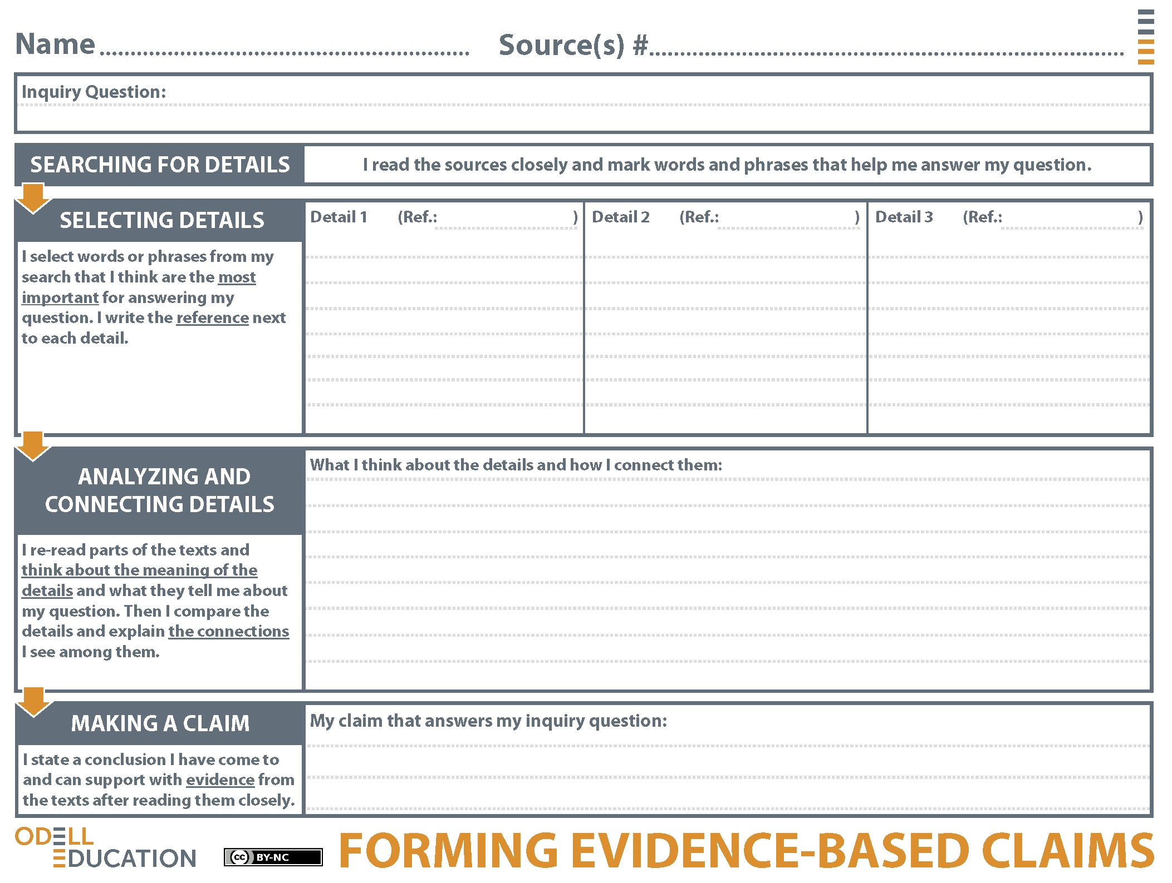
Student Response
1 and 5
How is animal intelligence successfully measured?
"Experiments with animals have long been handicapped by our anthropocentric attitude: We often test them in ways that work fine with humans but not so well with other species."
"We suggest a simple answer: by pursuing animal cognition with the methods of natural science." "...but careful and impartial experimentation alone can yield incontestable evidence of animal cognition."
"Scientists are now finally meeting animals on their own terms instead of treating them like furry (or feathery) humans, and this shift is fundamentally reshaping our understanding."
1
5
1
The details suggest that past animal intelligence research has been limited because of human influence on the research experiments. In the past, human-designed animal experiments have not worked well for animals and may not show an animal's true intelligence potential. Animal research has shifted. The animal's perspective as well as their environment is considered as an integral part of successful experiments. This shift in thinking has produced more research that shows evidence of animal intelligence.
The animal's perspective is essential to consider if experiments are going to accurately measure their intelligence.
3 and 2
How is animal intelligence measured?
"The researchers discovered that when one chimp laughed others sometimes engaged in ‘laugh replications’ that lacked the full acoustic structure of spontaneous laughter. In other words, they were fake-laughing."
"A few recent research papers describe animal competence at social and cognitive tasks that humans often struggle with—mastering conversational etiquette..."
"Although imitation was once regarded as a simpleminded skill, in recent years cognitive scientists have revealed that it's extremely difficult...actions that imply an awareness of one's self."
The details suggest that animal intelligence research can assess animal intelligence by observing certain skills like social awareness and imitation. The chimp's "fake-laugh" is a great example of an animal following social codes and acting in a way that demonstrates intelligence. This is not mindless copying and also shows that the human perspective of the research is also important when studying animal intelligence.
Animal intelligence can be measured by observing social awareness skills.
3
2
2
Student Response
