9.3.2 | Lesson 6

Introduction
In this lesson, students construct a frame (Research Frame Tool) to guide their research by establishing inquiry paths that allow them to explore various aspects of their research question/problem. Students group their inquiry questions thematically and then frame their research formally using the Research Frame Tool.
Students begin the lesson by refining inquiry questions from Lesson 2, based on search results from Lessons 3–5. The teacher introduces the concept of inquiry paths by modeling how to group inquiry questions thematically. The teacher then shows students how to complete a Research Frame Tool as a way to plan research using grouped inquiry questions. Students organize, categorize, and refine their inquiry questions by inquiry path and independently develop a detailed, organized Research Frame. For homework, students select one to two of their strongest inquiry questions to begin pursuing through independent research by following the research steps outlined in Lessons 3–5 (plan for searches, assess sources, annotate sources, and record notes) using the appropriate tools for each of the search activities. Additionally, students should continue to add new vocabulary learned through the research process to the Vocabulary Journal.

Standards
Assessed Standard(s)
W.9-10.7 | Conduct short as well as more sustained research projects to answer a question (including a self-generated question) or solve a problem; narrow or broaden the inquiry when appropriate; synthesize multiple sources on the subject, demonstrating understanding of the subject under investigation.
Addressed Standard(s)
W.9-10.8 | Gather relevant information from multiple authoritative print and digital sources, using advanced searches effectively; assess the usefulness of each source in answering the research question; integrate information into the text selectively to maintain the flow of ideas, avoiding plagiarism, and following a standard format for citation.
L.9-10.4 a-d | Determine or clarify the meaning of unknown and multiple-meaning words and phrases based on grades 9–10 reading and content, choosing flexibly from a range of strategies.  a. Use context (e.g., the overall meaning of a sentence, paragraph, or text; a word’s position or function in a sentence) as a clue to the meaning of a word or phrase.  c. Consult general and specialized reference materials (e.g., dictionaries, glossaries, thesauruses), both print and digital, to find the pronunciation of a word or determine or clarify its precise meaning, its part of speech, or its etymology.  d. Verify the preliminary determination of the meaning of a word or phrase (e.g., by checking the inferred meaning in context or in a dictionary).

Assessment
Assessment(s)
The learning in this lesson will be captured through the completion of the Research Frame Tool. Students will submit completed Research Frames during the lesson’s closing.
- This assessment will be evaluated using the criteria articulated in the High Performance Response below.
High Performance Response(s)
A High Performance Response may include the following:
- See the model Research Frame Tool located at the end of the lesson.
Use the following criteria to assess individual student’s Research Frames:
- Are the inquiry paths high-level?
- Is there a range of inquiry paths regarding content and coverage of the research question/problem?
- Are the inquiry paths distinct from one another?
- Do the inquiry paths seem to be equally important?
- Do the questions within the inquiry paths vary and address appropriate scope and utility?

Vocabulary
Vocabulary to provide directly (will not include extended instruction)
- thematically (adv.) – in a manner characterized by a unifying or dominant idea
- static (adj.) – showing little or no change; lacking movement
Vocabulary to teach (may include direct word work and/or questions)
- None*
*Students will encounter domain-specific vocabulary related to their individual research question/problem by reading, annotating, and recording notes on various sources. Students will track some of this vocabulary in their Vocabulary Journal when conducting independent searches during class and for homework.

Lesson Agenda/Overview
Student-Facing Agenda | % of Lesson
Standards & Text:
- Standards: W.9-10.7, W.9-10.8, L.9-10.4.a, c, d
Learning Sequence:  - Introduction of Lesson Agenda  - Homework Accountability  - Inquiry Paths and the Research Frame  - Research Frame Tool: Independent Work  - Closing | - 5%  - 10%  - 35%  - 40%  - 10%

Materials
- Copies of the Research Frame Tool for each student
- Research Portfolios (students have these)

Learning Sequence
How to Use the Learning Sequence
Symbol | Type of Text & Interpretation of the Symbol
10% | Percentage indicates the percentage of lesson time each activity should take.
no symbol | Plain text indicates teacher action.
 | Bold text indicates questions for the teacher to ask students.
 | Italicized text indicates a vocabulary word.
 | Indicates student action(s).
 | Indicates possible student response(s) to teacher questions.
 | Indicates instructional notes for the teacher.
Activity 1: Introduction of Lesson Agenda 5%
Begin by reviewing the agenda and the assessed standard for this lesson: W.9-10.7. Explain that students begin the lesson by refining inquiry questions from Lesson 2, based on search results from Lessons 3–5. The teacher then introduces the concept of inquiry paths by modeling how to group inquiry questions thematically. The teacher shows students how to complete a Research Frame Tool as a way to plan/frame research using grouped inquiry questions. Students then organize, categorize, and refine their inquiry questions by inquiry path and independently develop a detailed, organized Research Frame.
- Students listen.
Activity 2: Homework Accountability 10%
Instruct students to take out the homework from the previous lesson, which was: Annotate and take notes on a Taking Notes Tool from two more sources from the previous lesson’s Potential Sources Tools. Additionally, record vocabulary from these preliminary searches in the Vocabulary Journal.
- Students take out their homework.
Instruct students to form pairs with a classmate for a Turn-and-Talk about the annotation and taking notes processes. Specifically, instruct pairs to discuss two details from the close reading of at least one source by discussing how the details address a selected inquiry question.
- Students do a Turn-and-Talk.
- Consider circulating during the Turn-and-Talk to monitor students’ discussions.
Lead a brief share out of students’ discussions.
- Student responses will vary by individual research question/problem. An example response may sound like the following:
  - In Source # 1, the author says, “Certain skills are considered key signs of higher mental abilities.” This detail is important for addressing my inquiry question about measuring animal intelligence; researchers measure animal intelligence using these characteristics.
  - In Source # 1, the author points to the hard work that the researcher did in order to establish the credibility of the study. This is okay for establishing credibility of the source, but I need more about animal intelligence.
Activity 4: Inquiry Paths and the Research Frame 35%
Introduce students to the Research Frame. Explain that based on what they learned about conducting independent searches (planning for searches, assessing sources, and annotating sources/recording notes), students will now construct a Research Frame to guide the independent searches they will do in the next three lessons (Lessons 7–9). The Research Frame is a formal plan or guide used to list potential inquiry paths and corresponding inquiry questions. Explain that before they can build the Research Frame, students need to refine the inquiry questions developed in Lesson 2 based on the research they have done thus far.
- Students listen.
Instruct students to take out their specific inquiry questions from Lesson 2.
- These are located in Section 1 of the Research Portfolio.
Ask students to reflect on the preliminary searches conducted in Lessons 3–5 by thinking about the search results in relation to the specific inquiry questions. Instruct students to consider the following questions:
How do the preliminary search results affect your current inquiry questions?
What new inquiry questions are emerging as a result of the preliminary searches? What inquiry questions might need to be eliminated already?
How can the inquiry questions be refined to reflect the search results?
- Students listen.
Instruct students to apply the guiding questions just discussed and refine the specific inquiry questions from Lesson 2.
- Students work independently to refine their inquiry questions from Lesson 2.
- Consider referring students back to the vetting process taught in Lesson 2 if students need more support.

Explain to students that the next step is to categorize the refined inquiry questions into inquiry paths. Explain that an inquiry path is an overarching problem or question that organizes your research questions.
- Students listen.
Explain that inquiry questions can be grouped thematically. Ask students to define the word thematically using the root word. Remind students that they should look for common themes or patterns among the various inquiry questions.
- Differentiation Consideration: If students cannot define the word thematically using the root, consider providing them with the root theme and asking them how it helps define the word.
Explain to students that they must first group the questions thematically to create an inquiry path. Then they can label this inquiry path with an overarching question.
- Students listen.
Display the following model inquiry questions:
- What technology is used to measure animal intelligence?
- How is animal intelligence measured differently for various kinds of animals?
- To what extent are animal experiments valid if they do not take place in the animal’s natural environment?
- What does animal intelligence tell us about human intelligence?
- Where does our perspective on animal intelligence come from?
- Students examine the model inquiry questions.
Model for students how to analyze the inquiry questions for common themes or patterns. Explain to students that the first three questions focus on experiments and measuring animal intelligence. The last two questions seem to focus on the human perspective of animal intelligence research. Suggest that the inquiry path for the first three questions might be: How is animal intelligence measured or researched? Explain to students that this is an aspect of the research question/problem because in order to compare animal intelligence to human intelligence it is important to know the animal intelligence is measured. Inform students that the inquiry path for the last two questions might be: Why research animal intelligence?
- Students follow along with the modeling.
Instruct students to determine themes or patterns among their inquiry questions and categorize them accordingly. Instruct students to write possible inquiry path questions/problems for the categorized inquiry questions.
- Students work independently to create and record inquiry paths from their inquiry questions.
- Student responses will vary by individual research question/problem and research conducted. See the Model Research Frame Tool at the end of the lesson for sample responses.
- Students can do this by physically arranging questions on their desk or using paper to take notes.

Distribute blank Research Frame Tools to each student.
- Students examine the blank Research Frame Tool
Model for students how to complete the Research Frame Tool. On the top, under “Topic,” write “animal intelligence” and under “Area of Investigation” write the question: “How does animal intelligence compare to human intelligence?”
- Students follow along with the modeling.
- The area of investigation is the same as the research question/problem.
Instruct students that the next step is to group their inquiry questions (areas of investigation) thematically and then create an inquiry path by giving the path a title that is expressed in the form of a question or a problem.
- Students listen.
Model how to begin completing the Research Frame Tool using the model inquiry questions and inquiry paths discussed above.
- Students follow along with the modeling.
Instruct students to label each Inquiry Path with a reference number once they have created a Research Frame. This reference number will be important in subsequent lessons for aligning various sources to one Inquiry Path.
- Students listen.
Activity 5: Research Frame Tool: Independent Work 40%

Instruct students to complete a Research Frame Tool independently by grouping or categorizing inquiry questions by themes or patterns, labeling each group with an Inquiry Path question or problem, and writing reference numbers for the Inquiry Paths. Inform students that they will submit the Research Frame for assessment today. When they get them back in the next lesson, they will file them in Section 2: Gathering and Analyzing Information of their Research Portfolios.
- Students independently complete a Research Frame Tool.
- Circulate, offering students help with this task. Confirm that they grasp each step and that they are grouping their inquiry questions thematically. Some students may be tempted to first come up with the path and then group their questions accordingly. Point out that when they do that, they ignore their own research and their paths will not be motivated by their findings. Some students may still have problems organizing their questions; you may choose to group these students with classmates who are researching similar topics to work together to form inquiry paths.
- Consider reminding students that the Research Frame is not static (“showing little or no change; lacking movement”). The Research Frame will continue to evolve as the research evolves with future searches. Remind students this is the iterative and cyclical nature of inquiry-based research.
Activity 6: Closing 10%
Display and distribute the homework assignment. For homework, instruct students to select one to two of their strongest inquiry questions to begin pursuing through independent research by following the research steps outlined in Lessons 3–5 (plan for searches, assess sources, annotate sources, and record notes) using the appropriate tools for each of the search activities. Additionally, students should continue to add new vocabulary learned through the research process to the Vocabulary Journal.
- Students follow along.
- Consider drawing students’ attention to their application of standard L.9-10.4.a, c, d by using context to make meaning of a word; consulting reference materials to clarify its precise meaning; verifying the preliminary determination of its meaning.
Distribute additional search tools (Potential Sources Tool, Assessing Sources Tool, Taking Notes Tool) for the homework.
Instruct students to select and copy one to two of their strongest inquiry questions from the Research Frame Tool and to record these on a separate sheet of paper to take home for homework purposes.
- Students select and copy one to two of their strongest inquiry questions from the Research Frame Tool.
Collect initial Research Frame for assessment purposes.

Homework
Select one to two of your strongest inquiry questions to begin pursuing through independent research by following the research steps outlined in Lessons 3–5 (plan for searches, assess sources, annotate sources, and record notes) using the appropriate tools for each of the search activities. Additionally, continue to add new vocabulary learned through the research process to the Vocabulary Journal.

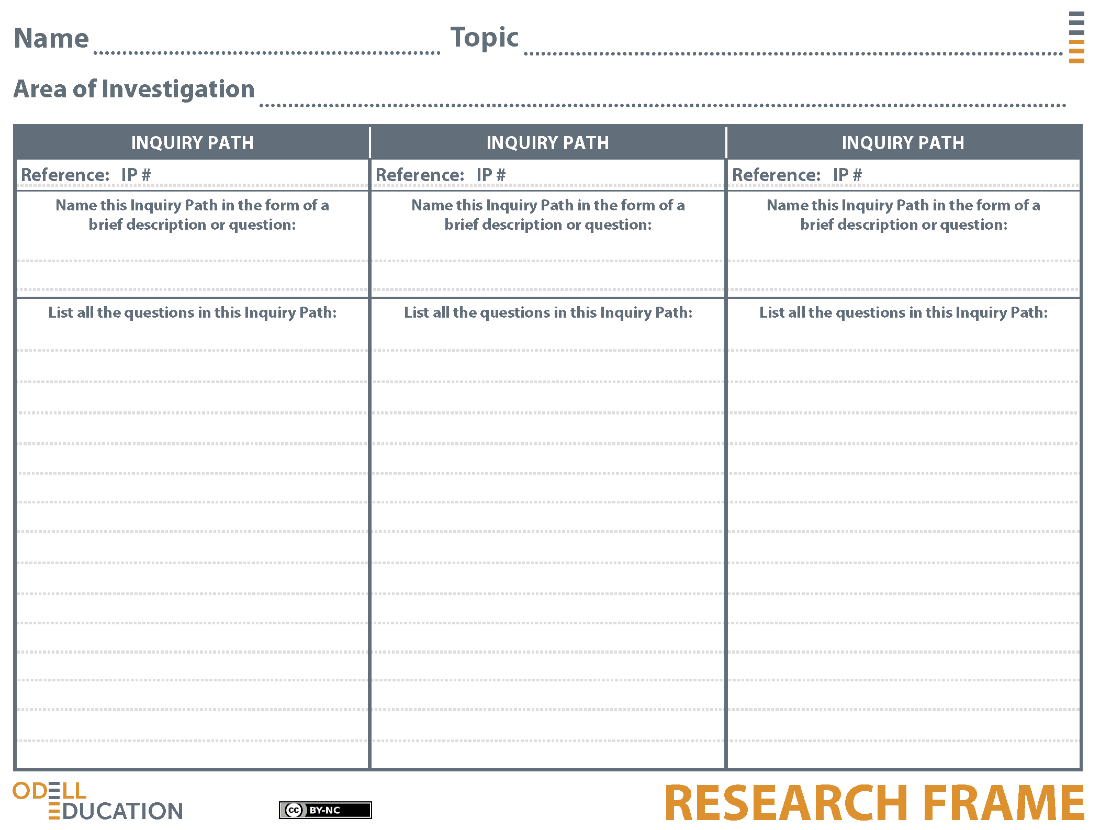
`
Sample Student Response
Animal Intelligence
How does animal intelligence compare to human intelligence?
1
2
3
How is animal intelligence measured?
How do animals display intelligence?
Why research animal intelligence?
What technology is used to measure animal intelligence?
What experiments could be used to reveal animal intelligence?
How is animal intelligence measured differently for various kinds of animals?
How have our attempts to measure animal intelligence evolved over time?
Is it possible to measure animal intelligence without anthrophormizing animals?
How do animals show their "thinking" in experiments?
To what extent are animal experiments valid if they do not take place in the animal's natural environment?
How do we measure the difference between instincts and higher thinking?
How do we define animal intelligence?
How are behavior and intelligence related?
What animal is the most "intelligent"?
What is the difference between instincts and thoughts?
What are some ways that animals show they are making decisions?
Does behavior imply thought?
How do animals show they are thinking?
What qualities of intelligence do animals share with humans?
Do animals have the capacity for language?
Is learning a sign of intelligence?
What does animal intelligence look like and how is it different than human intelligence?
How can animal intelligence be used to benefit humans?
How do humans view animal intelligence research?
Where does our perspective on animal intelligence come from?
How do humans use animal intelligence research?
What does animal intelligence tell us about human intelligence?
What can animal intelligence research tell us about humans with disabilities?
How does of our understanding of animal intelligence affect the way we treat animals?

