9.3.2 | Lesson 5

Introduction
In this lesson, students learn how to close read important sources for selected inquiry questions through annotation and taking notes. Students learn how reading closely for information is different than annotating and taking notes on literary texts.
Students begin the lesson by engaging in a research project check-in where they review the Student Research Plan by journaling about their own research progress and next steps. Then, using the model source, “Animal Minds: Minds of Their Own,” by Virginia Morell, the teacher discusses and models how to use an inquiry question to annotate for information and how to record notes using the Taking Notes Tool. Independently, students annotate their sources and record key information by completing a Taking Notes Tool.
To assess their learning in this lesson, students choose one annotated source and corresponding Taking Notes Tool and discuss briefly in writing how the information in the source and the tool address a specific inquiry question/problem. For homework, students annotate and take notes on a Taking Notes Tool from two more sources from the previous lesson’s Potential Sources Tools. Additionally, students continue to record vocabulary from these preliminary searches in the Vocabulary Journal.

Standards
Assessed Standard(s)
W.9.10.8 | Gather relevant information from multiple authoritative print and digital sources, using advanced searches effectively; assess the usefulness of each source in answering the research question; integrate information into the text selectively to maintain the flow of ideas, avoiding plagiarism and following a standard format for citation.
Addressed Standard(s)
W.9-10.7 | Conduct short as well as more sustained research projects to answer a question (including a self-generated question) or solve a problem; narrow or broaden the inquiry when appropriate; synthesize multiple sources on the subject, demonstrating understanding of the subject under investigation.
L.9-10.4.a, c, d | Determine or clarify the meaning of unknown and multiple-meaning words and phrases based on grades 9–10 reading and content, choosing flexibly from a range of strategies.  a. Use context (e.g., the overall meaning of a sentence, paragraph, or text; a word’s position or function in a sentence) as a clue to the meaning of a word or phrase.  c. Consult general and specialized reference materials (e.g., dictionaries, glossaries, thesauruses), both print and digital, to find the pronunciation of a word or determine or clarify its precise meaning, its part of speech, or its etymology.  d. Verify the preliminary determination of the meaning of a word or phrase (e.g., by checking the inferred meaning in context or in a dictionary).

Assessment
Assessment(s)
The learning in this lesson will be captured through a Quick Write at the end of the lesson. Students will answer the following prompt based on their Taking Notes Tools:
- Choose one annotated source and corresponding Taking Notes Tool and discuss how the information in the source and tool address a specific inquiry question or component of the research question/problem.
- Students will turn in one completed Taking Notes Tool.
- This assessment will be evaluated using the following criteria:
- Assesses sources for credibility; identifies the usefulness of a particular source and explains why a particular source does or does not help respond to an inquiry question.
- Marks key information in sources, takes notes of initial impressions and identifies additional research needs.
- Reads sources closely, analyzes details and ideas, and records notes for each source to determine how it addresses inquiry questions.
High Performance Response(s)
A high performance response may include the following:
- Source #1’s information specifically addresses the inquiry question: How do researchers measure animal intelligence? The source discusses how parrots, through verbal communication, are showing “higher mental abilities.” The researcher says that she went against convention and conducted experiments on parrots because of their talking abilities. It is through this communication that the parrot is showing its “good memory” and understanding of symbols. This type of research, teaching parrots how to talk and recognize symbols and relationships between words and ideas, is revealing how research can measure animal intelligence.
- Students will also be evaluated on the Taking Notes Tool: See a sample tool at the end of the lesson.

Vocabulary
Vocabulary to provide directly (will not include extended instruction)
- analyze (v.) – to examine carefully and critically in detail so as to bring out the essential elements or give the essence of
Vocabulary to teach (may include direct word work and/or questions)
- None.*
*Students will encounter domain-specific vocabulary related to their individual research question/problem by reading, annotating, and recording notes on various sources. Students will track some of this vocabulary in their Vocabulary Journal when conducting independent searches during class and for homework.

Lesson Agenda/Overview
Student-Facing Agenda | % of Lesson
Standards & Text:
- Standards: W.9-10.8, W.9-10.7, L.9-10.4.a, c, d
- Model Source Text: “Animal Minds: Minds of Their Own,” by Virginia Morell

Learning Sequence:  - Introduction of Lesson Agenda  - Homework Accountability/Research Process Check-In  - Annotating and Taking Notes on Rich Sources  - Annotating and Taking Notes Independently  - Quick Write  - Closing | - 5%  - 15%  - 40%  - 25%  - 10%  - 5%

Materials
- Copies of the Taking Notes Tool for each student
- Research Portfolios (students have these)
- Student copies of Potential Sources Tool (refer to 9.3.1 Lesson 8)
- Printed Sources (from the previous lesson’s searches and homework)
- Student copies of model source, “Animal Minds: Minds of Their Own” (refer to 9.3.2 Lesson 4)

Learning Sequence
How to Use the Learning Sequence
Symbol | Type of Text & Interpretation of the Symbol
10% | Percentage indicates the percentage of lesson time each activity should take.
no symbol | Plain text indicates teacher action.
 | Bold text indicates questions for the teacher to ask students.
 | Italicized text indicates a vocabulary word.
 | Indicates student action(s).
 | Indicates possible student response(s) to teacher questions.
 | Indicates instructional notes for the teacher.
Activity 1: Introduction of Lesson Agenda 5%
Begin by reviewing the agenda and the assessed standard for this lesson: W.9-10.8. Explain that students will begin the lesson by engaging in a research project check-in where they will review the Student Research Plan by journaling about their own research progress and next steps. Then, using the model source, “Animal Minds: Minds of Their Own,” by Virginia Morell, the teacher will discuss and model how to use an inquiry question to annotate for information and how to record notes using the Taking Notes Tool. Independently, students will annotate their sources and record key information by completing a Taking Notes Tool.
- Students look at agenda.
Activity 2: Homework Accountability/Research Process Check-In 15%
Instruct students to take out the homework from the previous lesson and form pairs to discuss the sources they discovered and the sources’ ratings according to the Assessing Sources and Potential Sources Tools. Instruct students to specifically share one successful search and one obstacle they may have encountered conducting research at home, based on their tools.
- Students form pairs and discuss the homework from the previous lesson by sharing one successful search and one obstacle.
Lead a brief share out of students’ research experiences.
- Students responses may include the following:
  - My biggest challenge is the long essays that I find. How do I manage to read all of them?
  - I learned how to skim and that helps with the long essays; I am making progress there. I am able to read closely the parts that help answer my inquiry research questions.
  - I find the ideas interesting, but how do I remember the details?
  - I highlight stuff that I like or find interesting.
  - My challenge is finding answers to my inquiry questions.
  - Answering all the questions on the Assessing Tools Handout can be time-consuming.
  - I found a source and the title looked good but it turned out it was not about my topic at all. It was also written in academic language I could not understand.
- Students are likely to encounter similar experiences; hearing from peers will reassure them that researchers go through similar challenges. In this formal research process, a conversation among the students will alert both students and the teacher to possible obstacles that might need addressing.

Distribute the previous lesson’s assessment (with feedback).
- Students examine the teacher’s feedback on the previous lesson’s assessment.
- The previous lesson’s assessment was the following:
- Choose two sources from your Potential Sources Tool and using the Assessing Sources Tool work, discuss your evaluation of them. Why did the sources earn their specific rates for accessibility, credibility, and relevance? Explain using information from your sources, your inquiry questions, and the criteria outlined on the Assessing Sources Handout.
- Based on today’s work, what are your next steps? Are you going to need to find more sources? What sources do you need to look for? What holes remain in your research so far?
Instruct students to take out the Student Research Plan from their Research Portfolios.
- The Student Research Plan should be located in the front of each student’s Research Portfolio.
Instruct students to review the Research Plan, Part 2 where it discusses planning for searches (Lesson 3) and assessing sources (Lesson 4). Instruct students to use the previous lesson’s homework and assessment to journal about their research progress and next steps.
- Instruct students to continue the Research Journal started in Lesson 3; students can write on separate sheets of paper or in a notebook and keep the Research Journal in the Research Portfolio.
- Students review the Student Research Plan and write in their Research Journals.
- Student responses will vary by individual research question/problem but look for students to use the language of the Student Research Plan when reflecting on their research progress and next steps.
Instruct students to file the Student Research Plan in the front section of the Research Portfolio and organize the tools from the previous lesson in Section 2: Gathering and Analyzing Information.
Ask students to take out the printed sources and the Potential Sources Tools from the previous lesson’s homework.
- Students file away their Research Plans and take out the printed sources and the Potential Sources Tools from the previous lesson’s homework.
- The printed sources and Potential Sources Tools will be needed for the next activity.
Activity 4: Annotating and Taking Notes on Rich Sources 40%
Introduce the Quick Write assessment (choose one annotated source and corresponding Taking Notes Tool and discuss how the information in the source and tool address a specific inquiry question or component of the research question/problem). Explain to students that this is the lesson assessment and the focus for this activity.
- Students read the assessment and listen.
- Display the Quick Write assessment for students to see.

Share with students that once researchers have identified and assessed several sources that have relevant, credible, and accessible information, they begin reading the texts closely. Close reading for the purpose of gathering and analyzing information is often done in two steps: annotating and taking notes. Remind students of the standard that is assessed in this lesson (W.9-10.8) and discuss how the standard states, “assess the usefulness of each source in answering the research question.” Both annotating and taking notes aid in further assessing the usefulness of each source. Students have preliminarily assessed their sources by skimming. Now students will read their sources closely to determine if a source is truly useful in addressing an aspect of the research question/problem.
- Students listen.
Inform students that they will begin by focusing on how to annotate informational text. Explain to students that annotating informational text for research purposes is different than annotating literature.
Explain to students that when conducting research they annotate for:
- Key words and concepts
- Information that will answer inquiry questions
- Initial impressions of the information
- Areas for possible further exploration
- Connections to other sources
Explain to students that annotating informational text for research may be different but the annotations codes used in previous modules remain the same.
Review the annotation codes from the previous modules:
- Box or circle unfamiliar words and phrases and rewrite a word or phrase you might have figured out
- Star (*) important or repeating ideas
- Put a question mark (?) next to a section you are questioning or confused about
- Use an exclamation point (!) for areas that remind you of another text or ideas that strike you or surprise you in some way
Remind students that besides using the codes, marking the text with thinking related to the codes is important.
- Students listen.
Introduce two new annotation codes specifically for informational text:
- Underline areas that represent major points. Use vertical lines in the margin to denote longer statements that may be too long to underline.
- Use numbers in the margin to indicate a sequence of points to trace the development of an argument.
- Students listen.
- Consider displaying all annotation codes for students to see.

Distribute an excerpt from the model source “Animal Minds: Minds of Their Own,” by Virginia Morell and read the excerpt aloud from “’That’s why I started my studies with Alex,’ Pepperberg said” to “And Alex the parrot turned out to be a surprisingly good talker.” Instruct students to follow along.
- Students follow along, reading silently.
Explain that you will annotate this text for a specific inquiry question: How do researchers measure animal intelligence? Model how to annotate the informational text by coding and writing thoughts directly on the text, pausing after each annotation, and explaining the choice.
- Star near “They were clearly a team.” – An interesting comment; the relationship between the researcher and the parrot; “team” implies that they are equal.
- Exclamation point and star near “and because of their work, the notion that animals can think is no longer so fanciful.” – The study will succeed in proving that animals can think.
- Underline the sentence: “Certain skills are considered key signs of higher mental abilities: good memory, a grasp of grammar and symbols, self-awareness, understanding others’ motives, imitating others, and being creative.” – These are key details about what scientists look for when measuring animal intelligence; this information directly connects to my inquiry question.
- Box around the word “ingenious experiments.” – Unsure about what the word ingenious means but maybe new or interesting experiments is what it is saying.
- Star near “Bit by bit, in ingenious experiments, researchers have documented these talents in other species.” – Researchers are able to see intelligence in animals that humans share. This might contribute to how they measure animal intelligence.
- Exclamation point near “Alex the parrot turned out to be a surprisingly good talker.” – The parrot is a good talker; an important detail since the researcher was able to teach the parrot, revealing that animals can exhibit intelligences like learning how to communicate.
- Students listen and follow along with the modeling.
- Consider creating an annotated text in advance and distributing copies to the students for support.
- Consider displaying the model annotation notes for students to see.

Instruct students to form pairs and practice annotating the model source by reading from “Thirty years after the Alex studies began” to “Nevertheless, this is not the same thing as having an animal look up at you, open his mouth, and speak.” Remind students to mark their thinking directly on the source, next to their coding, and to keep the inquiry question in mind as they annotate: How do researchers measure animal intelligence?
- Students form pairs and annotate the model source.
- Differentiation Consideration: Consider giving students highlighters to annotate.

Lead a brief share out of the annotation practice to confirm that students identify important details, record initial impressions, establish connections, and identify other areas of research.
- Student responses may include the following:
  - Star near “She let the store’s assistant pick him out because she didn’t want other scientists saying later that she’d deliberately chosen an especially smart bird for her work.” – The researcher is trying to prove her authority or credibility. This shows the actual source is credible because of the researcher’s own integrity.
  - Box around the word “futile.” – I think this word means that it was not going to succeed or achieve anything.
  - Star near “most researchers thought Pepperberg’s interspecies communication study would be futile.” – The researcher was encountering resistance; this comment also reminds me of the opposition to Grandin’s ideas. I wonder how she will measure the animal’s intelligence?
  - Write the number 1 near “Nevertheless, this is not the same thing as having an animal look up at you, open his mouth, and speak.” – It sounds like the researcher is going to prove animal intelligence through the parrot’s talking as opposed to other researchers who have yet to do this with other animals. This seems to be her first point.

Share with students that they will now analyze the annotation just completed and write key details and their own thinking about those details. Explain that this is the beginning of analyzing the research and that taking notes is the next step in the close reading process.
- Students listen.
- Consider defining analysis for students (“to examine carefully and critically in detail so as to bring out the essential elements or give the essence of”).
Distribute the Taking Notes Tools to each student.
Model using the Taking Notes Tool with students. Ask students to write the inquiry question in the top portion of the tool: How do researchers measure animal intelligence? Instruct students to record the source number as it appears on their Potential Sources Tool under the column marked “Reference.” Explain that students should try to write where the detail comes from in the actual text. Model for students by writing “Source #1 and Paragraph #4.” Remind students that when writing research papers they have to cite sources. Inform them that in Unit 3 they will learn more about how to cite sources, but they will need to know the source and the page number for all the research information for right now.
- Students follow along with the modeling.
Explain the next two columns of the tool by modeling how to record notes on the Taking Notes Tool. Inform students that one of the richest and most interesting details for the inquiry question “How do researchers measure animal intelligence?” came from paragraph four, where it described the characteristics of intelligence that researchers are looking for. Model for students by writing the textual detail under the column “Details.” Explain that the “Comments” section is for commenting on that textual detail by thinking about (analyzing) how it relates to the inquiry question or the overarching research question/problem.
Reference | Details | Comments
Source #1 and Paragraph #4 | “Certain skills are considered key signs of higher mental abilities: good memory, a grasp of grammar and symbols, self-awareness, understanding others’ motives, imitating others, and being creative.” | These are characteristics scientists look for when measuring animal intelligence. Humans also have these abilities or characteristics. So, researchers are comparing the same “intelligences” between humans and animals when conducting animal intelligence research.
- Students follow along with the modeling.
- Differentiation Consideration: Consider sharing another model example if time allows.
Instruct students to form the same pairs from the previous annotation activity and practice completing one detail and comment for the model source from the annotation previously completed on a Taking Notes Tool.
- Student responses may include the following:
Reference | Details | Comments
Source #1 and Paragraph #8 | “Nevertheless, this is not the same thing as having an animal look up at you, open his mouth, and speak.” | This source is proving animal intelligence through a parrot talking. This is one way to measure animal intelligence: verbal communication.
Source #1 and Paragraph #6 | “She let the store’s assistant pick him out because she didn’t want other scientists saying later that she’d deliberately chosen an especially smart bird for her work.” | The researcher’s study on the parrot is credible. This is credible research that shows animal intelligence.
- Circulate around the room and monitor student progress.
Activity 5: Annotating and Taking Notes Independently 25%
Instruct students to select one of their sources (from the previous lesson’s Potential Sources Tools) and begin close reading by annotating and taking notes using the Taking Notes Tool.
Explain to students that to write successful essays they need many notes that are rich in content. If they read an essay or an article they originally thought was relevant, but once they read it closer they find very little to annotate, they should determine that it is not rich enough and move on to the next source.
- Students select one of their sources and begin close reading by annotating and taking notes using the Taking Notes Tool.
- Circulate and confirm that the students are annotating and then taking notes. Make sure they do not skip the annotation step.
- Students need hard copies of their sources in order to annotate. Students should have brought these to the lesson as directed in the previous lesson’s homework.
- Remind students to keep all the annotated sources and Taking Notes Tools in Section 2 of the Research Portfolio.
Activity 6: Quick-Write 10%
Instruct students to respond briefly in writing to the following prompt:
Choose one annotated source and corresponding Taking Notes Tool and discuss how the information in the source and tool address a specific inquiry question or component of the research question/problem.
- Display the prompt for students to see, or provide the prompt in hard copy.
- Students independently answer the prompt using the annotated sources and Taking Notes Tools from the lesson.
- See the High Performance Response at the beginning of this lesson.
Instruct students to turn in one completed Taking Notes Tool and the Quick Write.
- Consider assessing each Quick Write using the Taking Notes Tool collected with it.
Activity 6: Closing 5%
Display and distribute the homework assignment. Distribute additional Taking Notes Tools to each student. For homework, instruct students to annotate and take notes on a Taking Notes Tool for two more sources from the previous lesson’s Potential Sources Tools. Additionally, students will continue to record vocabulary from these preliminary searches in the Vocabulary Journal.
- Students follow along.
- IN*Consider drawing students’ attention to their application of standard L.9-10.4.a,c,d by using context to make meaning of a word; consulting reference materials to clarify its precise meaning; verifying the preliminary determination of its meaning.

Homework
Annotate and take notes on a Taking Notes Tool for two more sources from the previous lesson’s Potential Sources Tools. Additionally, continue to record vocabulary from these preliminary searches in the Vocabulary Journal.

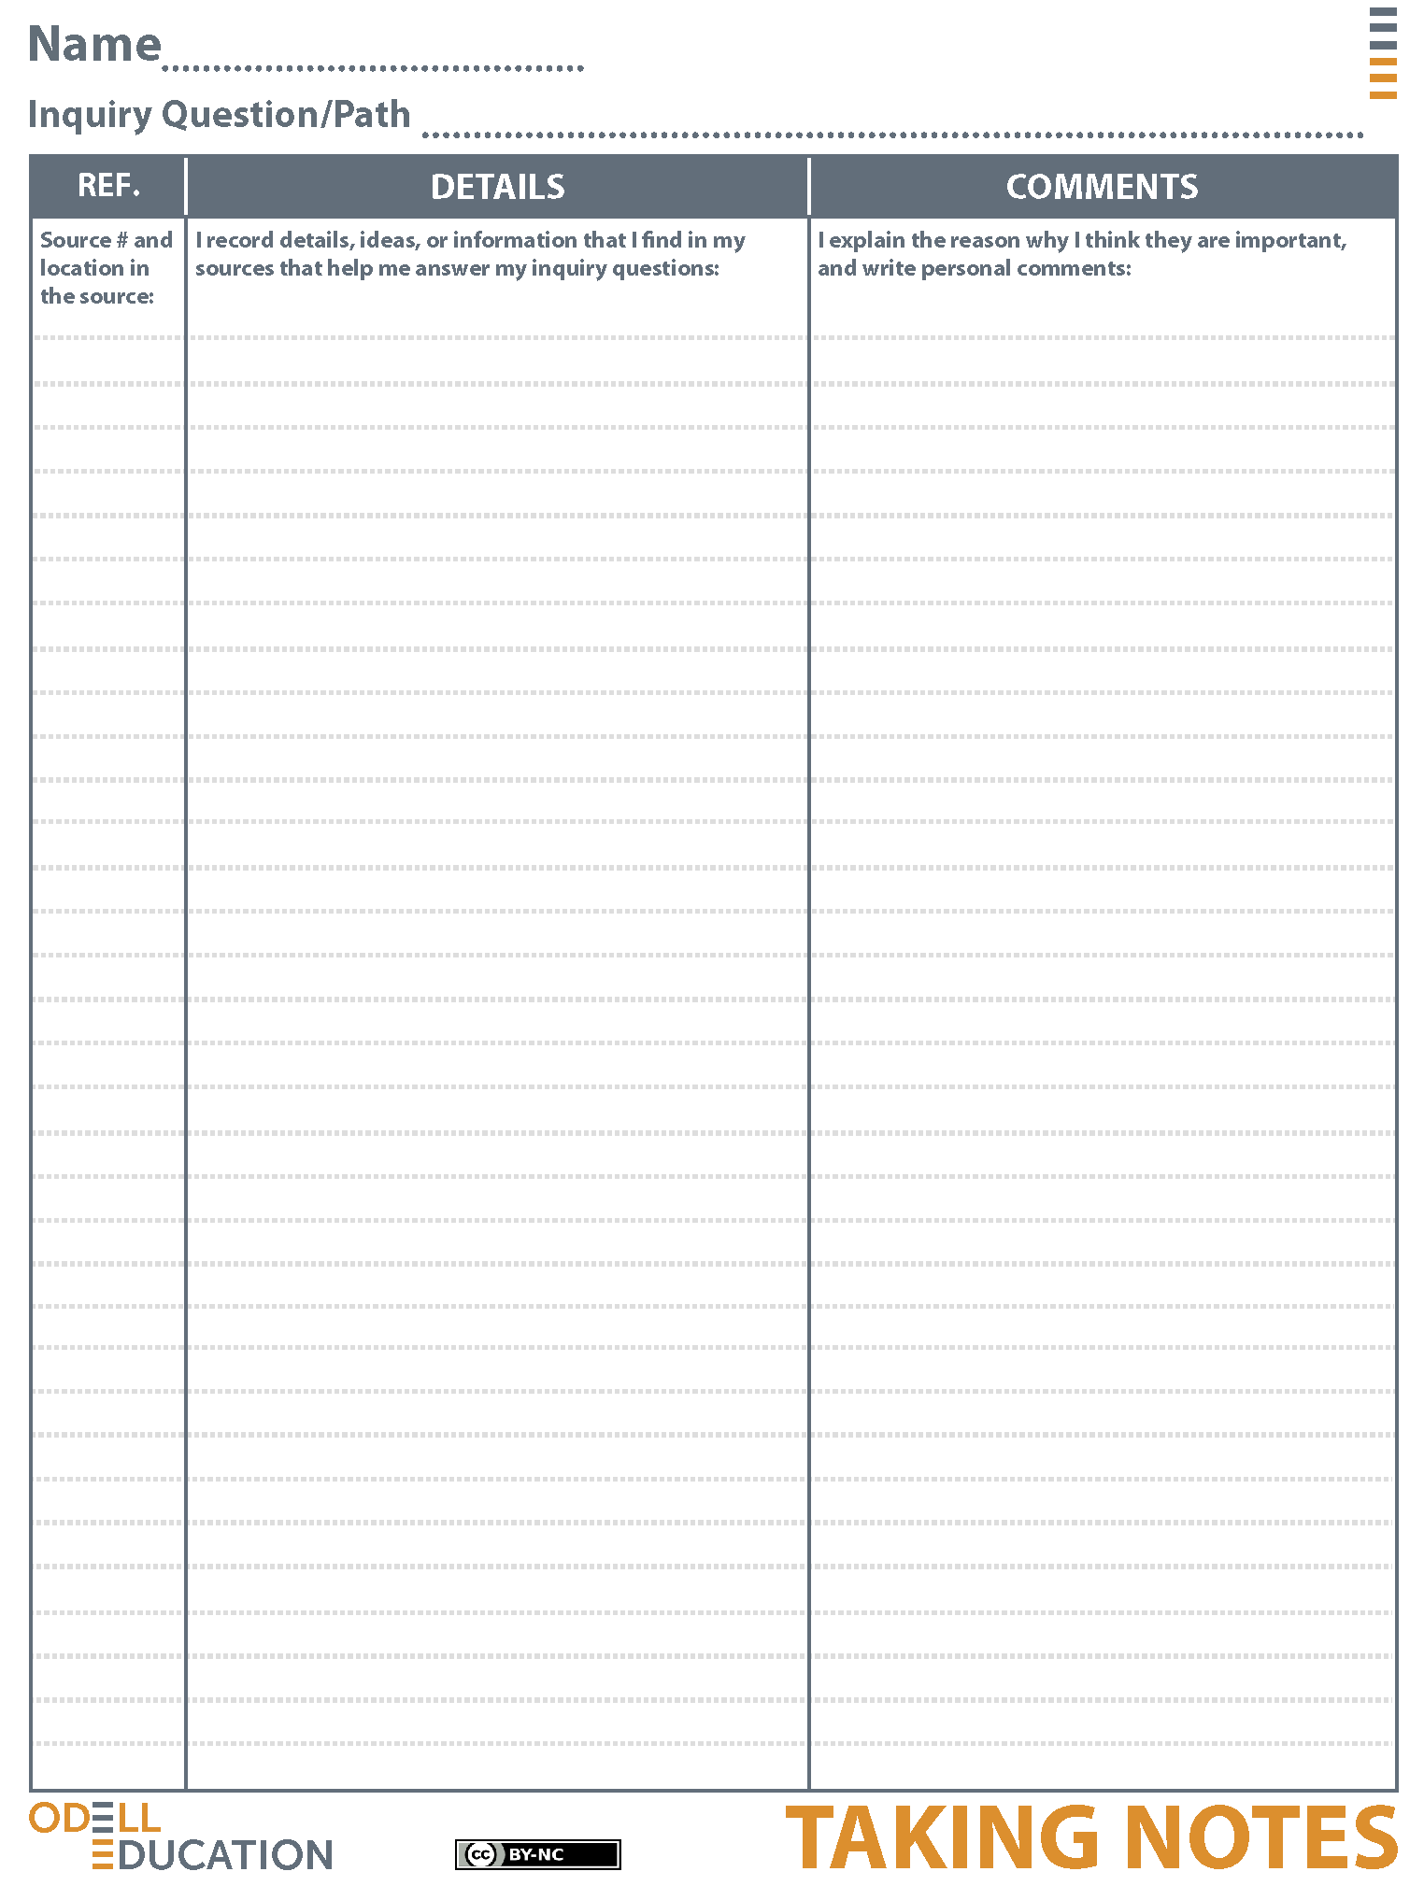

Sample Student Responses
How do researchers measure animal intelligence?
“Certain skills are considered key signs of higher mental abilities: good memory, a grasp of grammar and symbols, self- awareness, understanding others’ motives, imitating others, and being creative.”
Source
#2 and Paragraph #4
These are characteristics scientists look for when measuring animal intelligence. Humans also have these abilities or characteristics. So, researchers are comparing the same “intelligences” between humans and animals when conducting animal intelligence research.

Source#2 and Paragraph#8
“Nevertheless, this is not the same thing as having an animal look up at you, open his mouth, and speak.”
This source is proving animal intelligence through a parrot talking. This is one way to measure animal intelligence: verbal communication.
Source
#2 and Paragraph #6
“She let the store’s assistant pick him out because she didn’t want other scientists saying later that she’d deliberately chosen an especially smart bird for her work.”
The researcher’s study on the parrot is credible. This is credible research that shows animal intelligence.
Source
#1,
Second Page
"Experiments with animals have long been handicapped by our anthropocentric attitude: We often test them in ways that work fine with humans but not so well with other species. Scientists are now finally meeting animals on their own terms instead of treating them like furry (or feathery) humans, and this shift is fundamentally reshaping our understanding."
This is saying that animal intelligence research design has to be from the animal's point of view. This is what Grandin was saying in Animals in Translation; animals are different than humans and research must think about that.

