9.3.2 | Lesson 4

Introduction
In this lesson, students continue to learn how to assess sources more extensively. Students were introduced to the practice in Lesson 3 by beginning to identify credible and relevant resources. In this lesson, they go deeper and learn why it is important to assess sources and how to identify credible, relevant, and accessible sources to prepare for conducting searches independently.
The teacher models the next steps in assessing sources using the Assessing Sources Handout and returning to the Potential Sources Tool from Lesson 3. In a classroom with technology access, students learn how to assess the sources they found in the previous lesson’s activities and homework by answering in-depth questions. Independently, students use the Assessing Sources Tool to assess one source for credibility, relevance, accessibility and interest. For homework, students continue looking for three more sources based on selected inquiry questions from Lesson 2. Students rate the sources on the Potential Sources Tool using the Assessing Sources Handout and Tool. Additionally, students record new vocabulary from these preliminary searches in the Vocabulary Journal.

Standards
Assessed Standard(s)
W.9-10.8 | Gather relevant information from multiple authoritative print and digital sources, using advanced searches effectively; assess the usefulness of each source in answering the research question; integrate information into the text selectively to maintain the flow of ideas, avoiding plagiarism and following a standard format for citation.
Addressed Standard(s)
W.9-10.7 | Conduct short as well as more sustained research projects to answer a question (including a self-generated question) or solve a problem; narrow or broaden the inquiry when appropriate; synthesize multiple sources on the subject, demonstrating understanding of the subject under investigation.
L.9-10.4.a, c, d | Determine or clarify the meaning of unknown and multiple-meaning words and phrases based on grades 9–10 reading and content, choosing flexibly from a range of strategies.  a. Use context (e.g., the overall meaning of a sentence, paragraph, or text; a word’s position or function in a sentence) as a clue to the meaning of a word or phrase.  c. Consult general and specialized reference materials (e.g., dictionaries, glossaries, thesauruses), both print and digital, to find the pronunciation of a word or determine or clarify its precise meaning, its part of speech, or its etymology.  d. Verify the preliminary determination of the meaning of a word or phrase (e.g., by checking the inferred meaning in context or in a dictionary).

Assessment
Assessment(s)
The learning in this lesson will be captured through a Quick Write at the end of the lesson. Students will answer the following prompt:
- Choose two sources from your Potential Sources Tool and, using the Assessing Sources Tool work, discuss your evaluation of them. Why did the sources earn their specific rates for accessibility, credibility, and relevance? Explain using information from your sources, your inquiry questions, and the criteria outlined on the Assessing Sources Handout.
- Based on today’s work, what are your next steps? Are you going to need to find more sources? What sources do you need to look for? What holes remain in your research so far?
- This assessment will be evaluated using the Assessing Sources Tool.
High Performance Response(s)
A high performance response may include the following:
- Source #3: “Think You’re Smarter Than Animals? Maybe Not,” by Alexandra Horowitz and Ammon Shea, The New York Times, August 20, 2011. I was able to find this article from The New York Times. When I read the first few lines it became clear that the article is relevant to my research because the authors begin by making the statement: “Humans have long been fascinated by animal intelligence” which relates to my area of investigation regarding animal intelligence. I know that The New York Times is a well-known newspaper that people trust and the writers have extensive credentials and use research to support their writing. I even Googled The New York Times, and I found out that it has been publishing since 1851. Additionally under the title of the article, it offers information about the two authors. Both of them have published before and Alexandra Horowitz has written a book about dogs and their intelligence. When I read the first part closely, I saw that this article is actually a review of a few studies that analyze animal behavior. This type of article, a review of studies, can lead me to other sources as well. I am not sure I can get these other studies online, but I will try. I concluded that this review is very relevant to my research. I will certainly rate it high for all categories because I understood the text, it’s extremely relevant to my research question/problem, and the authors are credible as revealed in their background on animal intelligence.
- Source #4: “Monkeys Can Perform Mental Addition,” a science news report. At first I was not sure if this article was credible. There is no author. But then I read carefully what is written under the title and I realized that the source is probably credible because they are researchers from Duke University. I think that usually one can trust universities because universities have a stake in producing quality research. The title is what drew me to this report at first; it directly suggests that animals, in this case, monkeys, can perform intelligent acts, like addition. I was also interested in reading on because in my question, I ask about how scientists can measure animal intelligence. Overall, I rank this source high for credibility and accessibility. It seems short, and the information is limited, so for richness I will only rank it medium.
- Next Steps: I will try to find some of the sources that these two articles reference. I may need some help in the library. If I cannot find these, I will continue to search for sources that discuss actual experiments that show how scientists measure intelligence. I think that these types of sources will help me write a strong essay. I should also make a greater effort to find essays that may disagree with the idea that you can compare animal to human intelligence to have a different perspective.

Vocabulary
Vocabulary to provide directly (will not include extended instruction)
- credentials (n.) – evidence of authority
- extensive (adj.) – far-reaching, broad, comprehensive, or thorough
Vocabulary to teach (may include direct word work and/or questions)
- accessibility (adj.) – easy to approach, enter, read, or use

Lesson Agenda/Overview
Student-Facing Agenda | % of Lesson
Standards & Text:
- Standards: W.9-10.8, W.9-10.7, L.9-10.4.a, c, d
- Text: “Animal Minds: Minds of Their Own” by Virginia Morell (paragraphs 1–2)

Learning Sequence:  - Introduction to Lesson Agenda  - Homework Accountability  - Assessing Sources: Next Steps  - Assessing Sources Independently  - Quick Write  - Closing | - 5%  - 10%  - 30%  - 40%  - 10%  - 5%

Materials
- Student copies of the Potential Sources Tool (refer to 9.3.1 Lesson 8)
- Copies of the Assessing Sources Handout for each student
- Copies of the Assessing Sources Tool for each student
- Copies of the article “Animal Minds: Minds of Their Own” by Viginia Morell (excerpt) for each student

Learning Sequence
How to Use the Learning Sequence
Symbol | Type of Text & Interpretation of the Symbol
10% | Percentage indicates the percentage of lesson time each activity should take.
no symbol | Plain text indicates teacher action.
 | Bold text indicates questions for the teacher to ask students.
 | Italicized text indicates a vocabulary word.
 | Indicates student action(s).
 | Indicates possible student response(s) to teacher questions.
 | Indicates instructional notes for the teacher.
Activity 1: Introduction to Lesson Agenda 5%
Begin by reviewing the agenda and the assessed standard for this lesson: W.9-10.8. Students learn how to assess the sources they found in the previous lesson’s activities and homework by answering in-depth questions to assess their potential sources. Independently, students use the Assessing Sources Tool to assess one source for credibility, relevance, accessibility, and interest.
- Students look at the agenda.

Activity 2: Homework Accountability 10%
Instruct students to take out their Potential Sources Tool from the homework assignment from Lesson 3. Direct students to form pairs and discuss the results of the research they conducted at home by explaining the inquiry question selected, the search location, and key words/phrases used to find the three potential sources that are credible and relevant.
- Student responses will vary by individual research question/problem but may sound like the following:
  - I selected the inquiry question: How do animals show their “thinking” in experiments?
  - I couldn’t figure out a specific location to search so I searched on Google for the following key phase: animals and thinking.
  - I could not find any relevant or credible sources, so I tried searching Google by typing in the actual inquiry question and found three potential sources.
Activity 3: Assessing Sources: Next Steps 30%
Introduce the Quick Write assessment (1. Choose two sources from your Potential Sources Tool and, using the Assessing Sources Tool work, discuss your evaluation of them. Why did the sources earn their specific rates for accessibility, credibility, and relevance? Explain using information from your sources, your inquiry questions, and the criteria outlined on the Assessing Sources Handout. 2. Based on today’s work, what are your next steps? Are you going to need to find more sources? What sources do you need to look for? What holes remain in your research so far?) Explain that this is the lesson assessment and the focus for this activity.
- Students read the assessment and listen.
- Display the Quick Write assessment for students to see.

Explain to students that the previous lesson’s work focused on planning for searches and beginning to examine sources for relevancy and credibility. Explain that today’s work focuses on assessing sources more deeply to ensure that sources are accessible, credible, relevant, and worth researching. Explain that it is important to assess sources first before reading them closely so students do not waste time on reading sources that do not contribute to a deeper understanding of the research question/problem.
- Students listen.
Instruct students to keep out their Potential Sources Tools from the previous activity and lesson. Distribute the Assessing Sources Handout and ask students to read it.
Ask students to do a Turn-and-Talk about the Potential Sources Tool and the Assessing Sources Handout by considering the following questions:
What details are similar in the tool and the handout?
What details are different?
How do these differences inform your understanding of assessing sources?
Lead a share-out to ensure that students realize that the Assessing Sources Handout leads to a deeper or more extensive assessment of the sources.
- Students responses may include the following:
  - The Potential Sources Tool asks for general information or first impressions.
  - The Assessing Sources Handout asks for many more details about every section. For example in the Potential Sources Tool, all I have to do is just write the date, but in the Assessing Sources Handout I also have to think about how the date of publication is relevant to my research.
  - Another type of detail that the Assessing Sources Handout goes more in depth is the “scope and richness” part. I think that requires me to read the text a lot closer than just a quick scan or read.
- Consider defining the word extensive (“far-reaching, broad, comprehensive, or thorough”) for students.

Distribute the Assessing Sources Tool to each student and instruct them to put the Potential Sources Tool aside for now. Instruct students to have the Assessing Sources Tool and Assessing Sources Handout side by side on their desks.
Explain to students that the Assessing Sources Tool is a replica of the Assessing Sources Handout and is a place for students to record their assessment of sources using the Assessing Sources Handout. Model how to use the Assessing Sources Tool by using the article from the previous lesson, “Animal Minds: Minds of Their Own” by Virginia Morrell. Distribute an excerpt from the article to each student.
- Students listen and examine the article excerpt.
Read aloud the first two paragraphs of the article (from “In 1977 Irene Pepperberg, a graduate student” to “about the world and act on it?”) and instruct students to consider the top section (Assessing a Source Text’s Credibility) of the Assessing Sources Tool as they listen. Remind them that even though they have already recorded some of the information in the Potential Sources Tool, the Assessing Sources Tool requires a deeper assessment of the source.
- Students follow along with the read aloud and consider the top section of the Assessing Sources Tool.
Model for students how to complete the top section of the Assessing Sources Tool using the excerpt just read aloud by writing the following notes on a Model Assessing Sources Tool. Show students how to use the Assessing Sources Handout to complete the Assessing Sources Tool.
- Students follow along with the modeling.
Assessing a Source Text’s Credibility
Publisher | Date | Author | Type
• National Geographic publishes many articles about science topics like animal intelligence.  • The publisher has a stake in producing articles that are supported by real research since it is considered an academic nonfiction magazine. | • March 2008  • The date indicates that the information is current.  • The topic seems to have a longer history as indicated by the research date first discussed in the opening paragraph (1977), but 2008 is relatively recent so there might be current research in the article. | • It says at the end of the article that the author, Virginia Morell, is a science writer who often writes for National Geographic.  • It seems that she is not a scientist but someone who has a general interest in the topic.  • The author gets paid to write the article but that seems to be it. | • This is an article. It is an informational text that includes reporting on studies.  • The purpose of this article is to illustrate the intelligence of animals and therefore relates to the research question, How does animal intelligence compare to human intelligence?
- Consider displaying the model Assessing Sources Tool for students to see the notes.
- Explain to students that some of the questions, for example the “economic stake” or “political stake” may not always be relevant and leaving it open is okay. Consider reminding students that “economic stake” was relevant, for example, in Gradin’s work since many farmers benefitted from her discoveries.
- Consider defining the word credentials (“evidence of authority”) for students. Inform students that this word relates to the idea of authoritative resources discussed in standard W.9-10.8.

Model for students how to complete the second section of the Assessing Sources Tool using the Assessing Sources Handout as a guide by writing the following notes on a model tool.
- Students follow along with the modeling.
Assessing a Source Text’s Accessibility and Interest Level
Accessibility to You as a Reader | Interest and Meaning for You as a Reader
• The text seems accessible. The reference to dogs and people makes it easier to relate to.  • The short paragraphs help.  • From this excerpt it seems that I will comprehend the whole essay because I understand most of the words and I can look up the rest that I do not understand. | • Very interesting. I always thought parrots only repeat people and now it seems they actually think for themselves.  • One of my inquiry questions was: How do scientists measure animal intelligence? This essay addresses this question directly.
- Inform students that at this point they do not have to address the Inquiry Path question and that later in the unit they will be looking closely at the concept.
Ask students the following question:
What could the word accessibility mean based on the questions and answers just modeled?
- It means how easy it is to read, comprehend, or approach.

Model for students how to complete the bottom section (Assessing a Source Text’s Relevance and Richness) of the Assessing Sources Tool by using the Assessing Sources Handout as a guide.
- Students follow along with the modeling.
Assessing a Source Text’s Relevance and Richness
Relevance to Topic & Purpose | Relevance to Area to Investigation | Scope and Richness
• This article provides information about animal intelligence and specific experiments used to measure animal intelligence.  • Since my research involves both human and animal intelligence it will help my research because it will give me more insight into animal intelligence.  • Since the article is from a credible source and reputable studies are used to support the information then I can assume that the information is accurate. | • It deals with measuring animal intelligence and therefore relates to my area of investigation and several inquiry questions.  • The inquiry questions that this article might help me answer are: How do scientists measure animal intelligence? and Which animals do scientists study? | • This is a long article (10 pages). I skimmed the article first and I realized that she talks about human intelligence and the way that Darwin approaches it.  • The article provides a lot of details, especially discussing a variety of experiments.  • Most of the texts about animal intelligence use studies to support their point of view.
- Consider introducing the practice of skimming. It is an important skill to teach at this stage of the process. It serves two important purposes: it allows the reader to quickly identify if a source is relevant and it also enables the reader to select excerpts rather than read every word when completing tools like the Potential Sources Tool.
Activity 4: Assessing Sources Independently 40%
Instruct students to put aside the excerpt and take out one of their Potential Sources Tools from the previous lesson. Remind students that in the previous lesson they did not complete Step 3 of the tool. Today, following the assessment of sources, they will complete this section.
- Students put aside the excerpt and take out one of their Potential Sources Tools from the previous lesson.
Instruct students to independently assess one of the sources from the Potential Sources Tool using the Assessing Sources Handout as a guide and by completing an Assessing Sources Tool.
- Students locate a source and assess it by completing the Assessing Sources Tool.
- See the end of the lesson for model student responses.
Instruct students to then complete Step 3 in the Potential Sources Tool for the source just assessed.
- Students individually complete Step 3 in the Potential Sources Tool for the source they just assessed.
- Students need access to their sources. Unless students are able to print material, this activity will take place either in the library or a classroom with computers. Consider having the school’s librarian and/or media specialist help students use the technology. However, since students will need to annotate material in later lessons, printing the material is recommended.
- Circulate around the room to monitor student progress. Check that students are using the Assessing Sources Handout when they assess their sources. Make sure they go back to the Potential Sources Tool and complete Step 3.
Activity 5: Quick Write 10%
Instruct students to briefly respond to the following prompts:
Choose two sources from your Potential Sources Tool and, using the Assessing Sources Tool work, discuss your evaluation of them. Why did the sources earn their specific rates for accessibility, credibility, and relevance? Explain using information from your sources, your inquiry questions, and the criteria outlined on the Assessing Sources Handout.
Based on today’s work, what are your next steps? Are you going to need to find more sources? What sources do you need to look for? What holes remain in your research so far?
Remind students to use the Potential Sources Tool and Assessing Sources Tool to guide their written responses.
- Display the prompt for students to see, or provide the prompt in hard copy.
- Students independently answer the prompt using the Potential Sources Tool and the Assessing Sources Tool work from the previous activity.
- See High Performance Response at the beginning of the lesson.
- This assessment will be evaluated using the Assessing Sources Tool.
Activity 6: Closing 5%
Display and distribute the homework assignment. Distribute additional Assessing Sources Tools to each student. For homework, instruct students to continue looking for three more sources based on selected inquiry questions from Unit 2, Lesson 2. Instruct students to rate the sources on the Potential Sources Tool using the Assessing Sources Handout and Tool. Additionally, students will record vocabulary from these preliminary searches in the vocabulary journal.
- Students follow along.
- Consider instructing students to use notebooks or additional paper for the vocabulary journal. The notebook or additional paper can be kept in the Research Portfolio throughout the research process.
- Instruct students to print hard copies of sources to bring to the following lesson, if possible.
- Consider drawing students’ attention to their application of standard L.9-10.4.a,c,d by using context to make meaning of a word; consulting reference materials to clarify its precise meaning; verifying the preliminary determination of its meaning.

Homework
Continue looking for three more sources based on selected inquiry questions from Unit 2, Lesson 2. Rate the sources on the Potential Sources Tool using the Assessing Sources Handout and Tool. Additionally, record vocabulary from these preliminary searches in the Vocabulary Journal.

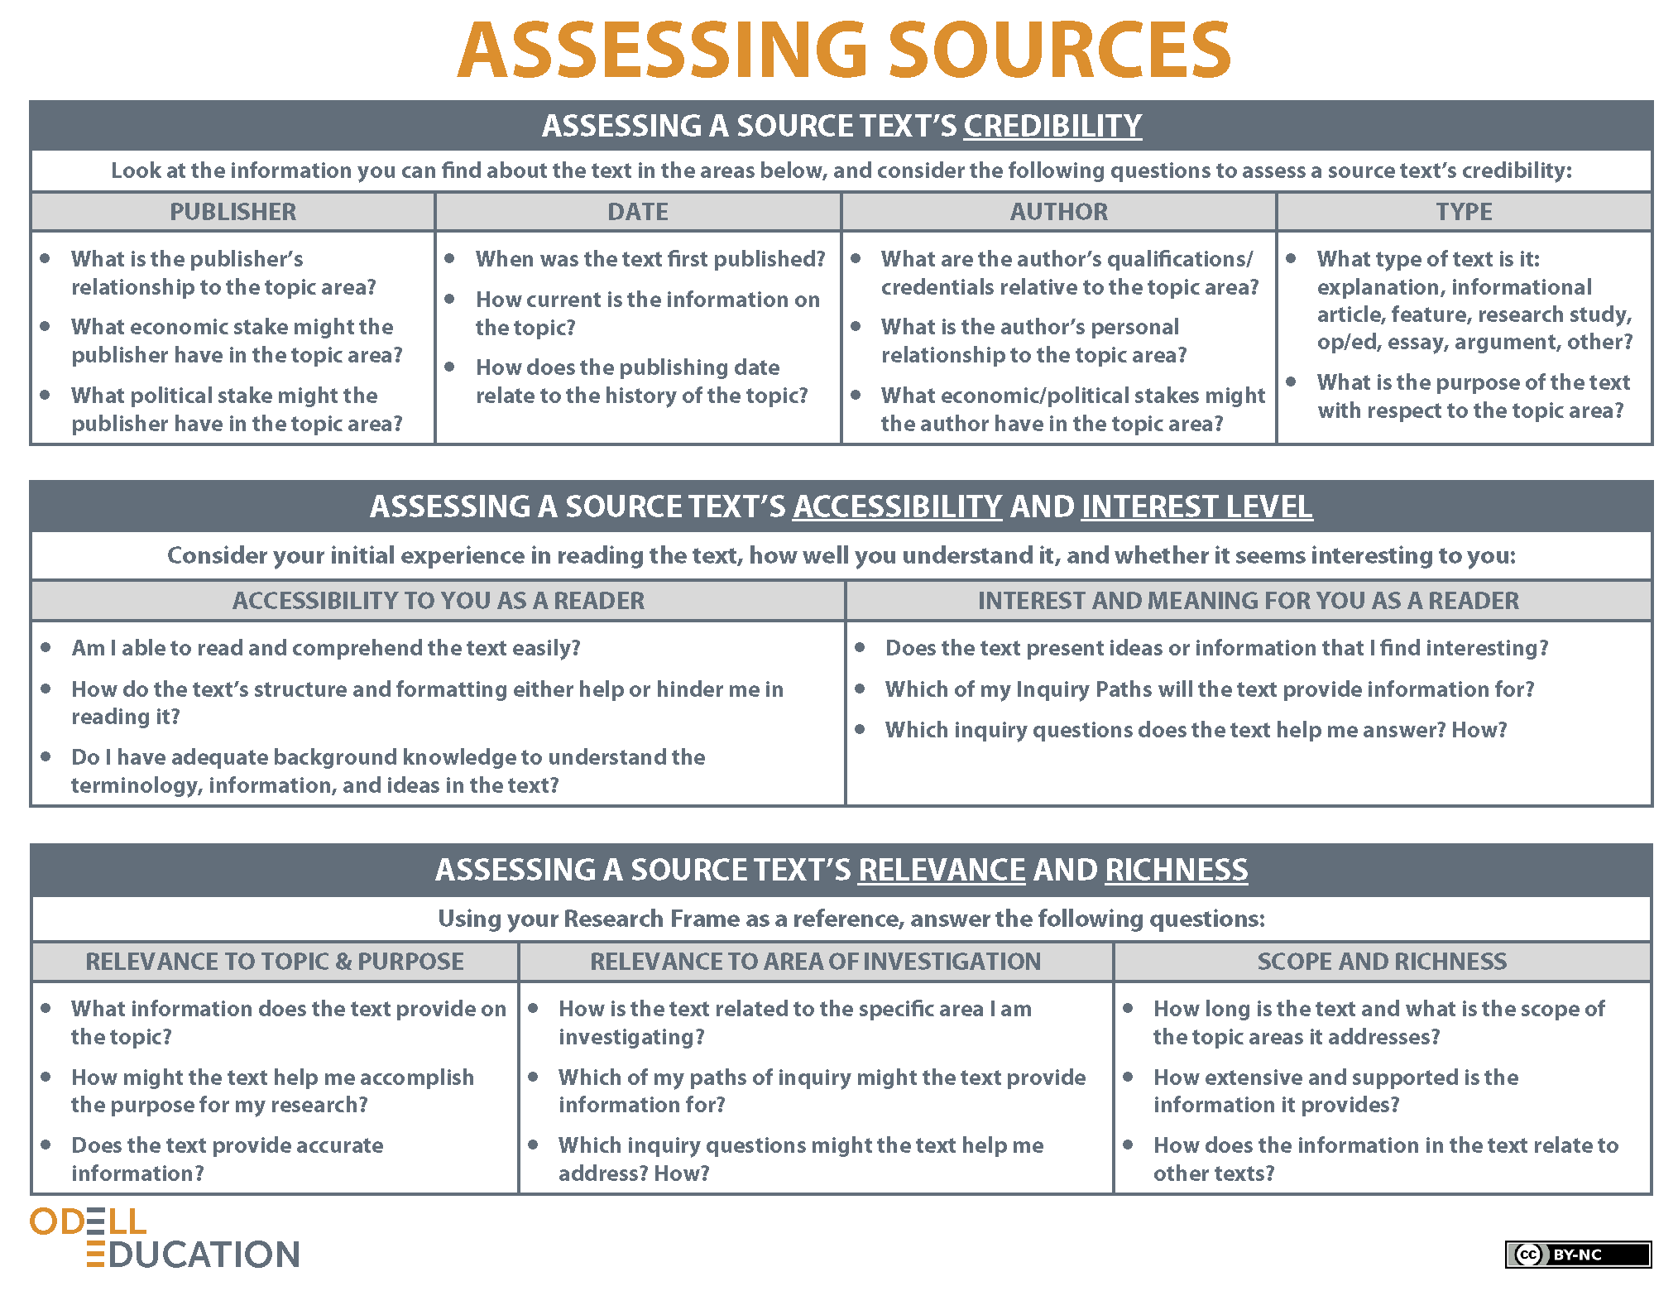

Assessing Sources Tool
Name: |  | Class: |  | Date:

Assessing a Source Text’s Credibility
Publisher | Date |  | Author |  | Type
Assessing a Source Text’s Accessibility and Interest Level
Accessibility to You as a Reader |  |  | Interest and Meaning for You as a Reader
Assessing a Source Text’s Relevance and Richness
Relevance to Topic & Purpose |  | Relevance to Area of Investigation |  | Scope and Richness
From Assessing Sources Handout, by Odell Education, www.odelleducation.com. Copyright (2012) by Odell Education. Adapted with permission under an Attribution-NonCommercial 3.0 Unported license: http://creativecommons.org/licenses/by-nc/3.0/.

Model Assessing Sources Tool (for Source #2)
Name: |  | Class: |  | Date:

Assessing a Source Text’s Credibility
Publisher | Date |  | Author |  | Type
• National Geographic publishes many articles about science topics like animal intelligence.  • The publisher has a stake in producing articles that are supported by real research since it is considered an academic nonfiction magazine. | • March 2008  • The date indicates that the information is current.  • The topic seems to have a longer history as indicated by the research date first discussed in the opening paragraph (1977), but 2008 is relatively recent so there might be current research in the article. |  | • It says at the end of the article that the author, Virginia Morell, is a science writer who often writes for National Geographic.  • It seems that she is not a scientist but someone who has a general interest in the topic.  • The author gets paid to write the article but that seems to be it. |  | • This is an article. It is an informational text that includes reporting on studies.  • The purpose of this article is to illustrate the intelligence of animals and therefore relates to the research question, How does animal intelligence compare to human intelligence?
Assessing a Source Text’s Accessibility and Interest Level
Accessibility to You as a Reader |  |  | Interest and Meaning for You as a Reader
• The text seems accessible. The reference to dogs and people makes it easier to relate to.  • The short paragraphs help.  • From this excerpt it seems that I will comprehend the whole essay because I understand most of the words and I can look up the rest that I do not understand. |  |  | • Very interesting. I always thought parrots only repeat people and now it seems they actually think for themselves.  • One of my inquiry questions was: How do scientists measure animal intelligence? This essay addresses this question directly.
Assessing a Source Text’s Relevance and Richness
Relevance to Topic & Purpose |  | Relevance to Area of Investigation |  | Scope and Richness
• This article provides information about animal intelligence and specific experiments used to measure animal intelligence.  • Since my research involves both human and animal intelligence it will help my research because it will give me more insight into animal intelligence.  • Since the article is from a credible source and reputable studies are used to support the information then I can assume that the information is accurate. |  | • It deals with measuring animal intelligence and therefore relates to my area of investigation and several inquiry questions.  • The inquiry questions that this article might help me answer are: How do scientists measure animal intelligence? And another one is: Which animals do scientists study? |  | • This is a long article (10 pages). I skimmed the article first and I realized that she talks about human intelligence and the way that Darwin approaches it.  • The article provides a lot of details, especially discussing a variety of experiments.  • Most of the texts about animal intelligence bring studies to support their point of view.
From Assessing Sources Handout, by Odell Education, www.odelleducation.com. Copyright (2012) by Odell Education. Adapted with permission under an Attribution-NonCommercial 3.0 Unported license: http://creativecommons.org/licenses/by-nc/3.0/.

