9.3.1 | Lesson 10

Introduction
In this lesson, the End-of-Unit Assessment, students will complete a two-part assessment. First, students will synthesize and compose a multi-paragraph response tracing the development and refinement of a central idea from Chapter 1 of Animals in Translation. In part two, students will write about two or three areas of investigation that emerged from Animals in Translation, explaining how and from where the areas emerged.
This lesson asks students to apply standards RI.9-10.2 and W.9-10.4 as they examine the development of a central idea in the text itself. This lesson also assesses students’ comprehension of the research process that has been introduced in this unit. Students will use their areas of investigation to guide their research in the following unit. For homework, students will continue to read sources found during pre-searches and identify, record, and use vocabulary strategies to define unknown words in their Vocabulary Journal.

Standards
Assessed Standard(s)
RI.9-10.2 | Determine a central idea of a text and analyze its development over the course of the text, including how it emerges and is shaped and refined by specific details; provide an objective summary of the text.
W.9-10.4 | Produce clear and coherent writing in which the development, organization, and style are appropriate to task, purpose, and audience.
W.9-10.9 | Draw evidence from literary or informational texts to support analysis, reflection, and research.
Addressed Standard(s)
None.

Assessment
Assessment(s)
The assessment in this lesson is the End-of-Unit Assessment. This assessment will encompass Animals in Translation, Chapter 1 as well as the research component introduced in this unit.
- Part 1: How does Grandin develop and refine a central idea in the text? In a response of 3–4 paragraphs, identify a central idea from Chapter 1 of Animals in Translation and trace its development and refinement in the text. Use at least four details from the text in your response.
- For Part 1, use the Text Analysis Rubric and Checklist to assess student responses.
- Part 2: Articulate in writing 2–3 areas of investigation and describe how and where each area emerged from the Grandin text. Consult the Topic Tracking Tool and Exploring a Topic Tool as well as notes from the Grandin text.
- For Part 2, use the Area Evaluation Checklist to assess student responses.
High Performance Response(s)
A high performance response may include the following:
Part 1 response:
- A central idea from Chapter 1 of Animals in Translation is Grandin’s claim that her autism provided her with a unique perspective and insight into animal behavior: “Autism made school and social life hard but it made animals easy” (p. 1). Grandin develops this idea throughout the chapter in several ways. First, she explains her own background, her autism as well as her experience and love for animals: “Animals saved me” (p. 4). Grandin also studied psychology and used principles of behaviorism and ethology to discover what has escaped other animal researchers. Grandin further develops this central idea through her clarification of what it means to be a visual thinker: she “actually think[s] in pictures” (p. 17). Grandin refines and supports her claim by illustrating her success in the meatpacking industry.
- Temple Grandin says plainly, “I’m different from every other professional who works with animals” (p. 6). Grandin is different because she is autistic, but she has used autism to her advantage: “Autism is kind of a way station on the road from animals to human” (p. 6). She explains that she has a “special connection to animals” and that she is now able to comprehend the emotionally disturbed horses that resided at her former boarding school because she understands “the way animals think” (p. 1).
- In this chapter, Grandin provides some background in animal psychology focusing on behaviorial and ethology theories. Grandin writes that behaviorists “made a big mistake declaring the brain off-limits” (p. 11). When behaviorists, as well as ethologists, ruled out study of the brain, they focused solely on environment. Both stressed that “anthropomorphizing an animal was wrong” (p. 14). Grandin noticed that she had a lot of problems that did not come from her environment and was suspicious of this way of thinking. Her idea that it is important not to think of an animal as a human but to “think about the animal’s point of view” (p. 15) was central to her understanding of animal behavior.
- Grandin was easily able to see from an animal’s point of view because she is a visual thinker: “During my thinking process I have no words in my head at all, just pictures” (p. 17). Her natural inclinations toward visual thinking lead her to try to process animal thinking through a completely visual lens: “Since I was a visual thinker I assumed cows were, too. The difference was I happened to be right” (p. 18). She notes that not everyone is a visual thinker, and most people without autism have a tendency to overlook or not even register the visual. Grandin’s visual thinking is a key point that underscores her central idea, and her success in the meatpacking industry is evidence that her claim has merit.
- Grandin writes about her ability to see from an animal’s perspective, but she has had practical success as well: “Half the cattle in the United States and Canada are handled in human slaughter systems I’ve designed” (p. 7). She continues to explain her success in the field characterized by her numerous accomplishments, including “over three hundred scientific papers” published. This success clearly demonstrates that Grandin’s claim is well supported and she truly does have a unique perspective on animal behavior because of her autism.
Part 2 response:
(Topic) Areas of Investigation
- (Animal Intelligence) Area of Investigation: How does animal intelligence compare to human intelligence?
  - One area of investigation from Animals in Translation is: How does animal intelligence compare to human intelligence? This area of investigation came from page 8 of Animals in Translation: “Animal genius is invisible to the naked eye.” Grandin writes a lot about animal intelligence, but it would be fascinating to know more about smart animals. Also it would be interesting to understand how scientists know when an animal is intelligent and how animal intelligence compares to human intelligence. If animal genius is hard to see then there may be interesting ways that researchers have developed to identify animal intelligence and compare it with human intelligence.
- (Autism) Area of Investigation: What is the history of the diagnosis and treatment of autism?
  - What is the history of the diagnosis and treatment of autism? What have people called it in the past, and how have they worked with children diagnosed with autism? This area of investigation came from Animals in Translation, as Grandin discusses many of her own self-developed treatments that helped her cope with the disorder. For example, Grandin discusses her instinct to work with animals and how it helped her. She also describes her “squeeze machine,” which many people thought was crazy at the time but ended up being very useful in the treatment of autism.
- (Meatpacking Industry) Area of Investigation: What are some current problems with the meatpacking industry, and what are people doing to help?
  - The final area of investigation from Animals in Translation is: What are some current problems in the meatpacking industry, and what are people doing to help? This came from Grandin’s discussion of the inefficiency she witnessed in the meatpacking industry and the accidental cruelty toward animals. Grandin has helped many companies in the meatpacking industry become “a lot more efficient” and more respectful toward animals by reducing environmental stresses and the need for prods. However, it is still worth thinking about what more could be done, and if anyone is as actively involved as Grandin in trying to find solutions to problems in the meat industry.
- These areas of investigation should be kept after assessment, as they will be redistributed to students in 9.3.2, Lesson 1.

Vocabulary
Vocabulary to provide directly (will not include extended instruction)
- None.*
Vocabulary to teach (may include direct word work and/or questions)
- None.*
*Because this is not a close reading or a research lesson, there is no specified vocabulary. However, in the process of returning to the text, students may uncover unfamiliar words. Teachers can guide students to make meaning of these words by following the protocols described in 1E of this document http://www.engageny.org/sites/default/files/resource/attachments/9-12_ela_prefatory_material.pdf.

Lesson Agenda/Overview
Student-Facing Agenda | % of Lesson
Standards & Text:
- Standards: RI.9-10.2, W.9-10.4, W.9-10.9
- Text: Animals in Translation, Chapter 1
Learning Sequence:  - Introduction of Lesson Agenda  - Homework Accountability  - End-of-Unit Assessment Part 1: Animals in Translation  - End-of-Unit Assessment Part 2: Areas of Investigation  - Closing | - 5%  - 10%  - 50%  - 30%  - 5%

Materials
- Copies of the End-of-Unit Assessment for each student
- Copies of the Text Analysis Rubric and Checklist for each student
- Student copies of the Topic Tracking Tool (refer to 9.3.1 Lesson 2)
- Student copies of the Exploring a Topic Tool (refer to 9.3.1 Lesson 6)
- Copies of the Area Evaluation Checklist and Model for each student

Learning Sequence
How to Use the Learning Sequence
Symbol | Type of Text & Interpretation of the Symbol
10% | Percentage indicates the percentage of lesson time each activity should take.
no symbol | Plain text indicates teacher action.
 | Bold text indicates text dependent questions.
 | Italicized text indicates a vocabulary word.
 | Indicates student action(s).
 | Indicates possible student response(s) to teacher questions.
 | Indicates instructional notes for the teacher.
Activity 1: Introduction of Lesson Agenda 5%
Begin by introducing the lesson agenda and assessed standards for this lesson: RI.9-10.2, W.9-10.4 and W.9-10.9. Inform students they will be completing a two-part End-of-Unit Assessment: a multi-paragraph response analyzing the development and refinement of a central idea in Animals in Translation as well as an analysis of 2–3 areas of investigation that have emerged from Animals in Translation.
- Students follow along and read the agenda.
Activity 2: Homework Accountability 10%
Instruct students to form pairs and do a Turn-and-Talk to discuss their review of the Grandin text and their annotations—as well as their notes from the previous lesson’s fishbowl discussion—in preparation for the End-of-Unit Assessment.
- Students form pairs and discuss their review of the Grandin text.
- Students will be held accountable for the second part of the previous lesson’s homework—to look over their sources and solidify their area of investigation—when they articulate their area of investigation in Activity 4.
Activity 3: End-of-Unit Assessment Part 1: Animals in Translation 50%
Display and introduce the End-of-Unit Assessment writing prompt:
How does Grandin develop and refine a central idea in the text? In a response of 3–4 paragraphs, identify a central idea from Chapter 1 of Animals in Translation and trace its development and refinement in the text. Use at least four details from the text in your response.
Ask students if they have remaining questions about the assessment prompt.
- Students examine the End-of-Unit Assessment prompt and ask remaining questions.
Remind students to use the Text Analysis Rubric to guide their written response.
Distribute and review the Text Analysis Rubric. Remind students to revisit the rubric once they are finished with the assessment to ensure they have fulfilled all the criteria.
- Students review the Text Analysis Rubric.
Instruct students to compose a multi-paragraph response to the writing prompt. Remind students as they write to refer to the notes, tools, and annotated text from the previous lessons.
- Students independently compose their multi-paragraph response.
- See the High Performance Response at the beginning of this lesson.
Activity 4: End-of-Unit Assessment Part 2: Areas of Investigation 30%
Display and introduce the second portion of the End-of-Unit Assessment:
Articulate in writing 2–3 areas of investigation and describe how and where each area emerged from the Grandin text. Consult the Topic Tracking Tool and Exploring a Topic Tool as well as notes from the Grandin text.
Ask students if they have remaining questions about the assessment prompt.
- Students examine the End-of-Unit Assessment prompt and ask remaining questions.
Inform students that they may use their Tracking Topics Tool, Exploring a Topic Tool, and notes to assist them with composing this portion of the End-of-Unit Assessment. Students should use their notes from the Grandin text to describe how the area of investigation emerged from the text. Remind students that they already have all the information needed to answer this prompt; reaching back to these tools helps support students in their synthesis of this information.
- Students listen.
Distribute the Area Evaluation Checklist to students. Inform students that as they articulate their areas of investigation, they should use this checklist as a reference to ensure their areas are sufficient in terms of coherence, scope, relevance, and interest. Students should consult this checklist as they respond to the prompt but understand there is no need to fill it out.
- Differentiation Consideration: For further support, consider having students fill in the Area Evaluation Checklist independently, using their Tracking Topics Tool, Exploring a Topic Tool, and notes to assist them. When students have completed the Area Evaluation Checklist, instruct them to begin working directly on the prompt, translating the information compiled in the checklist into a coherent response to the prompt.
- Students independently write the second part of the End-of-Unit Assessment.
- See the High Performance Response at the beginning of this lesson.
- These areas of investigation should be kept after assessment, as they will be redistributed to students in 9.3.2, Lesson 1.
Activity 5: Closing 5%
Display and distribute the homework assignment. For homework, instruct students to continue to read the sources they found during their pre-searches and identify, record, and define unknown vocabulary using their Vocabulary Journals. Ask students to check the definitions for at least five unknown vocabulary words. Remind students to be prepared to discuss this vocabulary and the definitions they found for these words in the following lesson.
- The Vocabulary Journal is introduced in 9.3.1 Lesson 8.
- Students follow along.

Homework
Continue to read the sources you found during your pre-searches and identify, record, and define unknown vocabulary using your Vocabulary Journal. Check the definitions of at least five unknown vocabulary words. Be prepared to discuss these words and their definitions in the following lesson.

End-of-Unit Assessment (9.3.1 Lesson 10)

Part 1: Text-Based Response

Your Task: Rely on your close reading of Animals in Translation to write a well-crafted multi-paragraph response to the following prompt.

How does Grandin develop and refine a central idea in the text? In a response of 3–4 paragraphs, identify a central idea from Chapter 1 of Animals in Translation and trace its development and refinement in the text. Use at least four details from the text in your response.
Your writing will be assessed using the Text Analysis Rubric.
Guidelines:
Be sure to:
- Closely read the prompt
- Respond directly to all parts of the prompt
- Paraphrase, quote, and reference relevant evidence to support your analysis
- Organize your ideas in a cohesive and coherent manner
- Use precise language appropriate for your task
- Follow the conventions of standard written English
CCLS: RI.9-10.2; W.9-10.4
Commentary on the Task:
This task measures RI.9-10.2 because it demands that students:
  - Determine a central idea of a text and analyze its development over the course of the text
  - Analyze how a central idea emerges and is shaped and refined by specific details
This task measures W.9-10.4 because it demands that students:
  - Produce clear and coherent writing in which the development, organization, and style are appropriate to task, purpose, and audience

End-of-Unit Assessment (9.3.1 Lesson 10)

Part 2: Articulating Areas of Investigation

Your Task: Rely on your Topic Tracking Tool and Exploring a Topic Tool along with your notes from Animals in Translation to write a well-crafted multi-paragraph response to the following prompt.

Articulate in writing 2–3 areas of investigation and describe how and where each area emerged from the Grandin text. Consult the Topic Tracking Tool and Exploring a Topic Tool as well as notes from the Grandin text.
Your writing will be assessed using the Area Evaluation Checklist.
Guidelines:
Be sure to:
- Closely read the prompt
- Respond directly to all parts of the prompt
- Paraphrase, quote, and reference relevant evidence to support your analysis
- Organize your ideas in a cohesive and coherent manner
- Use precise language appropriate for your task
- Follow the conventions of standard written English
CCLS: W.9-10.4, W.9-10.9
Commentary on the Task:
This task measures W.9-10.9 because it demands that students:
- Draw evidence from informational texts to support analysis, reflection, and research.
This task measures W.9-10.4 because it demands that students:
  - Produce clear and coherent writing in which the development, organization, and style are appropriate to task, purpose, and audience

Text Analysis Rubric /16
Criteria | 4 – Responses at this Level: | 3 – Responses at this Level: | 2 – Responses at this Level: | 1 – Responses at this Level:
Content and Analysis: The extent to which the response conveys complex ideas and information clearly and accurately in order to respond to the task and support an analysis of the text.  (W.9-10.2, W.9-10.9, R.9-10.2, R.9-10.5) | Introduce a well-reasoned claim regarding the development of a central idea. | Introduce a clear and focused claim regarding the development of a central idea. | Introduce a claim regarding the development of a central idea. | Introduce a confused or incomplete claim.  and/or
 | Demonstrate a thoughtful analysis of the author’s use of specific details to shape and refine the central idea. | Demonstrate an appropriate analysis of the author’s use of specific details to shape and refine the central idea. | Demonstrate a superficial and/or mostly literal analysis of the author’s use of specific details to shape and refine the central idea. | Demonstrate a minimal analysis of the author’s use of details to shape and refine the central idea
 | and/or | and/or | and/or | and/or
 | Demonstrate a thoughtful analysis of how the structure of texts, including how specific sentences, paragraphs, and larger portions of the text relate to each other and the whole. | Demonstrate an appropriate analysis of how the structure of texts, including how specific sentences, paragraphs, and larger portions of the text relate to each other and the whole. | Demonstrate a superficial and/or mostly literal analysis of how the structure of texts, including how specific sentences, paragraphs, and larger portions of the text relate to each other and the whole. | Demonstrate a minimal analysis of how the structure of texts, including how specific sentences, paragraphs, and larger portions of the text relate to each other and the whole.
Command of Evidence: The extent to which the response presents evidence from the provided text to support analysis.  (W.9-10.2.a, W.9-10.9) | Present ideas clearly and consistently, making effective use of specific and relevant evidence to support analysis. | Present ideas sufficiently, making adequate use of relevant evidence to support analysis. | Present ideas inconsistently, inadequately, and/or inaccurately in an attempt to support analysis, making use of some evidence that may be irrelevant. | Present little or no evidence from the text.
Coherence, Organization, and Style: The extent to which the response logically organizes complex ideas, concepts, and information using formal style and precise language.  (W.9-10.2.b, e; W.9-10.9) | Exhibit logical organization of ideas and information to create a cohesive and coherent response. | Exhibit acceptable organization of ideas and information to create a coherent response. | Exhibit inconsistent organization of ideas and information, failing to create a coherent response. | Exhibit little organization of ideas and information.
 | Establish and maintain a formal style, using precise language and sound structure. | Establish and maintain a formal style, using appropriate language and structure. | Lack a formal style, using language that is basic, inappropriate, or imprecise. | Use language that is predominantly incoherent, inappropriate, or copied directly from the task or text.
 |  |  |  | Are minimal, making assessment unreliable.
Control of Conventions: The extent to which the response demonstrates command of conventions of standard English grammar, usage, capitalization, punctuation, and spelling.  (L.9-10.1, L.9-10.2) | Demonstrate control of the conventions with infrequent errors. | Demonstrate partial control of conventions with occasional errors that do not hinder comprehension. | Demonstrate emerging control of conventions with some errors that hinder comprehension. | Demonstrate a lack of control of conventions with frequent errors that make comprehension difficult.
 |  |  |  | Are minimal, making assessment of conventions unreliable.
- A response that is a personal response and makes little or no reference to the task or text can be scored no higher than a 1.
- A response that is totally copied from the text with no original writing must be given a 0.
- A response that is totally unrelated to the task, illegible, incoherent, blank, or unrecognizable as English must be scored as a 0.
Text Analysis Checklist
Assessed Standard:

 | Does my writing… | ✔
Content and Analysis | Introduce a well-reasoned claim regarding the development of a central idea?
Demonstrate a thoughtful analysis of the author’s use of specific details to shape and refine the central idea?
and/or
Demonstrate a thoughtful analysis of how the structure of texts, including how specific sentences, paragraphs, and larger portions of the text relate to each other and the whole?
Command and Evidence | Present ideas clearly and consistently, making effective use of specific and relevant evidence to support analysis?
Coherence, Organization, and Style | Exhibit logical organization of ideas and information to create a cohesive and coherent response?
 | Establish and maintain a formal style, using precise language and sound structure?
Control of Conventions | Demonstrate control of the conventions with infrequent errors?

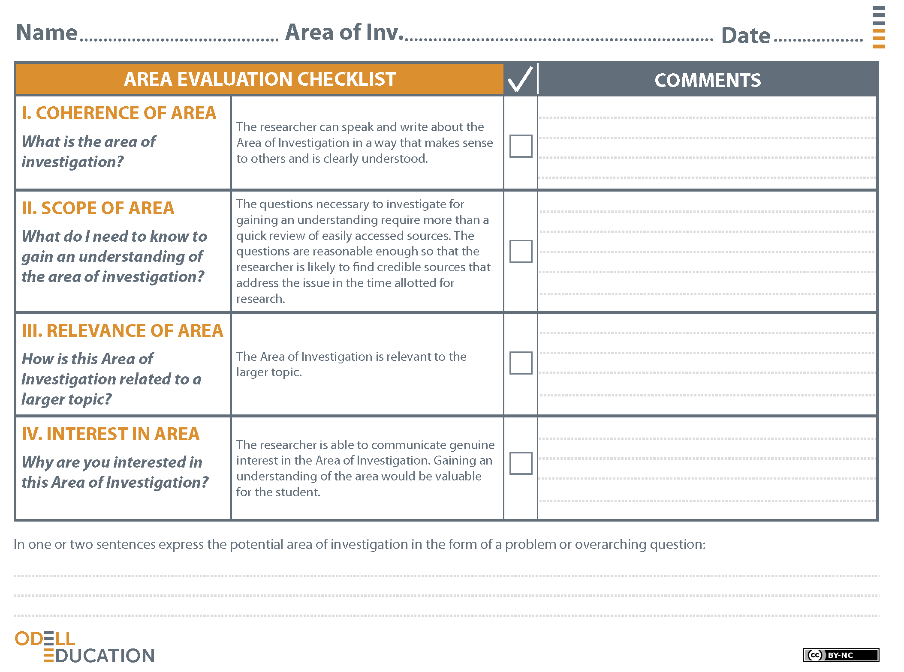

Sample
Animal Intelligence
The area of investigation is comparing human and animal intelligence.
I need to find information about how people have tested animal intelligence. I also need to find out if there have been experiments that have compared humans and animals doing the same task and who is smarter.
This area of investigation is related to animal intelligence. This larger topic came out of Animals of Translation because Temple Grandin writes about using animal intelligence to benefit animals and humans.
I am interested in this because I think animals are more intelligent than most people think they are. I think there are many ways humans can benefit from knowing more about animal intelligence.

In this area of investigation I need to figure out whether humans or animals are more intelligent. How does animal intelligence compare with human intelligence?

