9.3.1 | Lesson 8

Introduction
In this lesson, students will engage in a pre-search activity in order to begin gathering sources for further research in future lessons, as well as develop students’ proficiency for posing general and specific questions. This process will also help students to validate their own interest in their proposed topic. Students will use the Pre-Search Tool to record relevant information about the sources they find (author’s name, topic, source, location, publication date, and general content/key ideas). This activity will help to develop students’ ability to find relevant sources on their own, as well as to navigate through a wide pool of potential research sources. This activity will also help students confirm that there is enough information available about their topic to warrant further research.
For an assessment, students will refine or rewrite their inquiry questions based on what they found today in order to help them further explore the topic; they will then explain their choice. For homework, students will continue with their pre-searches and find three more potential sources.

Standards
Assessed Standard(s)
RI.9-10.1.a | Cite strong and thorough textual evidence to support analysis of what the text says explicitly as well as inferences drawn from the text.  a. Develop factual, interpretive, and evaluative questions for further exploration of the topic(s).
Addressed Standard(s)
RI.9-10.4 | Determine the meaning of words and phrases as they are used in a text, including figurative, connotative, and technical meanings; analyze the cumulative impact of specific word choices on meaning and tone (e.g., how the language of a court opinion differs from that of a newspaper).
L.9-10.4.a,c,d | Determine or clarify the meaning of unknown and multiple-meaning words and phrases based on grades 9–10 reading and content, choosing flexibly from a range of strategies.  a. Use context (e.g., the overall meaning of a sentence, paragraph, or text; a word’s position or function in a sentence) as a clue to the meaning of a word or phrase.  c. Consult general and specialized reference materials (e.g., dictionaries, glossaries, thesauruses), both print and digital, to find the pronunciation of a word or determine or clarify its precise meaning, its part of speech, or its etymology.  d. Verify the preliminary determination of the meaning of a word or phrase (e.g., by checking the inferred meaning in context or in a dictionary).

Assessment
Assessment(s)
The learning in this lesson is captured through a series of brief responses to the following prompt.
Refine or rewrite your inquiry questions based on what you found today. Explain in 2–3 sentences what changes you have made to your question, and what about your sources led you to make the change. If you feel a change is unnecessary, write 2–3 brief sentences explaining how the sources you have found validate your initial question.
Before responding, students should consider the following questions:
  - Do these sources point your research in a different direction?
  - After reading through several potential sources, how could you refine your inquiry question to sharpen your research?
  - Do any of these sources make you curious about something else?
High Performance Response(s)
A high performance response may include the following:
Initial Question: What is the history of studying animal intelligence?
Revised Question: How has the definition and study of animal cognition changed over the course of history?
The sources I found, using my first inquiry question, made me realize that the “history of studying animal intelligence” is more specifically the history of the definition and study of animal “cognition” or thinking. Animal cognition was once believed to not exist, and only very recently have people begun to think more seriously about the way animals think. One source I found discussed how the ways we measure animal intelligence are still changing.

Vocabulary
Vocabulary to provide directly (will not include extended instruction)
validate (v.) – check or prove the accuracy of something
etymology (n.) – the study of the origin of words and the way in which their meanings have changed throughout history
Vocabulary to teach (may include direct word work and/or questions)
None.

Lesson Agenda/Overview
Student-Facing Agenda | % of Lesson
Standards & Text:
Standards: RI.9-10.1.a, RI.9-10.4, L.9-10.4.a,c,d
Learning Sequence:  - Introduction of Lesson Agenda  - Homework Accountability  - Inquiry Question Peer Feedback  - Vocabulary Journal Introduction  - Pre-Search  - Assessment  - Closing | - 5%  - 10%  - 15%  - 15%  - 40%  - 10%  - 5%

Materials
Copies of the Vocabulary Journal Template for each student
Copies of the Pre-Search Tool and Model for each student
Copies of the Potential Sources Tool for each student

Learning Sequence
How to Use the Learning Sequence
Symbol | Type of Text & Interpretation of the Symbol
10% | Percentage indicates the percentage of lesson time each activity should take.
no symbol | Plain text indicates teacher action.
 | Bold text indicates questions for the teacher to ask students.
 | Italicized text indicates a vocabulary word.
 | Indicates student action(s).
 | Indicates possible student response(s) to teacher questions.
 | Indicates instructional notes for the teacher.
Activity 1: Introduction of Lesson Agenda 5%
Begin by reviewing the agenda and the assessed standard for this lesson: RI. 9-10.1.a. Inform students that today they will be using the inquiry questions they developed in the previous lesson. They will begin the pre-search for sources and record relevant information on the Potential Sources Tool. For homework, students will continue with their pre-searches and find three more potential sources.
- Students look at the lesson agenda.
Activity 2: Homework Accountability 10%
Ask student volunteers to share out the inquiry questions they developed for homework. Instruct students that, when sharing, they should clarify the area of investigation to which the question relates.
- Student volunteers share their inquiry questions aloud.
- Student responses may include the following:
Area of Investigation | Inquiry Question
Autism | What is the history of autism?
Meatpacking Industry | What are some current problems with the meatpacking industry, and what are people doing to help?
Animal Intelligence | What is the history of studying animal intelligence?
Activity 3: Inquiry Question Peer Feedback 15%
Once several students have completed a share out of their inquiry questions, ask students to work in pairs to discuss their inquiry questions in more detail. Explain to students that they should ask one another about their thought process, with questions such as:
Why do you want to know about this topic? How did you come up with this question? Will the answer to this question satisfy your curiosity?
Instruct students to use questions like this to help them gain an understanding of their classmate’s curiosity and research goals. Then, if they see a more useful way to ask the question, or if they think there is another direction in which to take the research, they should offer that feedback. Inform students this is not a peer review or assessment but rather a chance for students to work with one another to construct meaningful inquiry questions before searching for sources.
- Students work in pairs to explain and refine their inquiry questions.
Activity 4: Vocabulary Journal Introduction 15%
Share with students that this research process exposes them to new vocabulary through the reading of a wide variety of academic texts. Instruct students to keep track of vocabulary learned by using a Vocabulary Journal. Students should also use the Vocabulary Journal to record their reflections on the strategies employed to learn the vocabulary.
- Students listen.
- Because the following lessons in this module are not close-reading lessons, the Vocabulary Journal will ensure the application of vocabulary strategies modeled thus far.
Explain to students that the vocabulary they track in the Vocabulary Journal should be words they come across in their searches that are proving to be an obstacle to understanding the text. Additionally, the words should fit into one of two categories. One category is words that are found across multiple texts, in a variety of classes; these are words that might appear in all of their content classes like science, math, English, and social studies. Examples are words like plagiarism, relevant, and assess. The second category of words is vocabulary that is specific to one content area or class. These are words like behaviorism, ethologist, and operant conditioning. Ask students to record any words that prove to be an obstacle and fit into one of the above categories in their Vocabulary Journal.
- Share with students the purpose of differentiating between these words—that one type of words are those they are likely to encounter often with texts as they proceed with the remainder of high school, college, and their civic life; the other are types of words that may be specific to the domain of their research. For example, verify, metaphor, and complex are words that they may see in their arts, science, and social studies texts; cerebellum, psychosomatic, and neurological are words they may encounter in a science article that would be a potential source related to their area of investigation.
- Students listen.
- Remind students that the volume of unknown words should not prove such an obstacle that the text is largely inaccessible. The Potential Sources Tool should vet for this type of issue.
Share with students the following strategies that can be employed to determine the meaning of unknown words or phrases:
Use context (e.g., the overall meaning of a sentence, paragraph, or text; a word’s position or function in a sentence) as a clue to the meaning of a word or phrase.
Verify the meaning of the word or phrase (by checking the inferred meaning in context or in a dictionary).
Identify and correctly use patterns of word changes that indicate different meanings or parts of speech (e.g., analyze, analysis, analytical). How do changes in prefixes and suffixes affect word meaning?
Consult general and specialized reference materials (e.g., dictionaries, glossaries, thesauruses) to find the pronunciation of a word or determine or clarify its precise meaning, its part of speech, or its etymology.
Inform students that etymology can be an important part of learning vocabulary. Etymology is the study of the origin of words and the way in which their meanings have changed throughout history.
- Students listen.
- Consider displaying the strategies for students to see.
- Consider reviewing how to use reference materials (dictionaries, glossaries, thesauruses) to determine word meaning if students need more support.
- These strategies come directly from standard L.9-10.4. Consider drawing students’ attention to their application of standard L.9-10.4.a,c,d by using context to make meaning of a word; consulting reference materials to clarify its precise meaning; verifying the preliminary determination of its meaning.
Instruct students on how to complete the Vocabulary Journal when it is assigned for homework in a lesson by explaining the following:
Describe where you encountered the word/phrase in the research and why it is proving problematic.
Discuss how you tried to figure out the meaning of the word/phrase.
Confirm the word’s meaning as it is used in the research text by using a reference source (dictionary, encyclopedia, etc.).
- Students listen.
- Consider instructing students to use notebooks or additional paper for the Vocabulary Journal. The notebook or additional paper can be kept in the Research Portfolio throughout the research process.
Activity 5: Pre-Search 40%
Now that students have developed their inquiry questions and received peer feedback, instruct them to use one of these questions to guide preliminary research. Inform students that the nature of this lesson’s pre-search is not to fully answer their inquiry questions, but to ensure there is enough source material to begin doing more in-depth research.
Ask students to also use this lesson’s pre-search exercise to refine their inquiry questions even further before beginning more detailed research. Finally, inform students to use this pre-search to confirm their interest in the topic, as well as the direction in which their question leads them.
- Students listen.
Instruct students to use the Pre-Search Tool to record general information about the sources they find, including author’s name, topic, source, location, publication date, and general content/key ideas. Explain to students that this process helps them keep track of their sources for later.
Instruct students to use the resources available to them (the Internet, library, librarian/media specialist, etc.) to begin independently searching for sources. Inform students that, at this point, they should not read closely and annotate the sources they find; instead, they should record general information on the Pre-Search Tool and read enough of the potential source to confirm that it is relevant. The students’ goal should be to confirm that there is enough available information on this topic to warrant further research.
As they search, students should consider:
Do these sources point your research in a different direction?
After reading through several potential sources, how could you refine your inquiry question to sharpen your research?
Do any of these sources make you curious about something else?
- Consider the school’s resources and model a search for sources. Model a search for cattle and antibiotics. (In the absence of a computer in class, prepare a presentation in advance, or coordinate with the school’s librarian/media specialist in advance to ensure computer access for students.)
Instruct students to record basic information about the sources that they identify in the Potential Sources Tool.
- Consider taking the students to the school library to use the physical and technological resources available to them there. Encourage students to discuss their pre-searches with a media specialist or librarian.
Pause for questions and clarification. Circulate and assist students as they conduct their pre-search.
- Differentiation Consideration: If students are not yet prepared to begin searching independently, or if they would benefit from working in pairs, consider organizing students by topic into small groups of two to four. Students could work alongside one another and share with the group the sources they find individually. This helps students articulate general information about the source as they explain it to the rest of the group.
- Students use the resources available to them to begin independently searching for sources, recording what they find on the Pre-Search Tool.
Activity 6: Assessment 10%
Once students have found several sources, ask them to reconsider their initial inquiry questions. Have students consider the following questions:
Do these sources point your research in a different direction?
After reading through several potential sources, how could you refine your inquiry question to sharpen your research?
Do any of these sources make you curious about something else?

For an assessment, instruct students to respond to the following prompt:
Refine or rewrite your inquiry questions based on what you found today. Explain in 2–3 sentences what changes you have made to your question, and what about your sources led you to make the change. If you feel a change is unnecessary, write 2–3 brief sentences explaining how the sources you have found validate your initial question.
Inform students that validate means to prove the accuracy or worthiness of something.
- Display the prompt for students to see, or provide the prompt in hard copy.
- Students independently answer the prompt using evidence from the text.
- See the High Performance Response at the beginning of the lesson.
- Assess students’ inquiry questions for clarity and their potential to result in meaningful research. Assess students’ 2–3 sentence explanations on their thoughtfulness and as evidence that students engaged with the material they found during their pre-search.
Activity 7: Closing 5%
Display and distribute the homework assignment. For homework, instruct students to continue with their pre-searches. Ask students to find three more potential sources and record the same information they recorded today in class: author’s name, topic, source, location, publication date, and general content/key ideas.
- Students follow along.

Homework
Continue with your pre-search. Find three more potential sources and record the same information you recorded today in class: author’s name, topic, source, location, publication date, and general content/key ideas.

Vocabulary Journal Template
Name: |  | Class: |  | Date:

Word
Describe where you encountered the word/phrase in the research and why it is problematic.
Discuss how you tried to figure out the meaning of the word/phrase in context.
Confirm the word’s meaning as it is used in the research text by using a reference source (dictionary, encyclopedia, etc.).
Word
Describe where you encountered the word/phrase in the researchand why it is problematic.
Discuss how you tried to figure out the meaning of the word/phrase in context.
Confirm the word’s meaning as it is used in the research text by using a reference source (dictionary, encyclopedia, etc.).

Pre-Search Tool
Name: |  | Class: |  | Date:

Source Notes | How does this source connect to your potential area of investigation?
Source # 1
Title:
Location:

Author:
Source # 2
Title:
Location:

Author:
Source # 3
Title:
Location:

Author:
Is there enough source information to research this potential area of investigation?

From Pre-Search Tool, by Odell Education, www.odelleducation.com. Copyright (2012) by Odell Education. Adapted with permission under an Attribution-NonCommercial 3.0 Unported license: http://creativecommons.org/licenses/by-nc/3.0/
Model Pre-Search Tool
Name: |  | Class: |  | Date:

Source Notes | How does this source connect to your potential area of investigation?
Source # 1  Title: “The History of Autism”  Location: http://www.english.certec.lth.se/autism/kunskap_e.html  Author: No author. | This source explains the history of how autism was diagnosed and what the outlook for people with autism has been over the last several decades.
Source # 2  Title: “Autism at 70, From Kanner to DSM-5”  Location: http://www.autismspeaks.org/science/science-news/autism-70-%E2%80%93-kanner-dsm-5  Author: No author. | This source provides a timeline of the history of autism and how it was diagnosed.
Source # 3  Title: “Some Key Dates in Autism History”  Location: http://www.washingtonpost.com/wp-dyn/content/article/2008/06/27/AR2008062703062.html  Author: Brittney Johnson | This source provides another timeline of key dates in the history of autism.
Is there enough source information to research this potential area of investigation?
There is enough source information to research the history of autism, but I need to redefine what I mean by “history of autism.”
From Pre-Search Tool, by Odell Education, www.odelleducation.com. Copyright (2012) by Odell Education. Adapted with permission under an Attribution-NonCommercial 3.0 Unported license: http://creativecommons.org/licenses/by-nc/3.0/

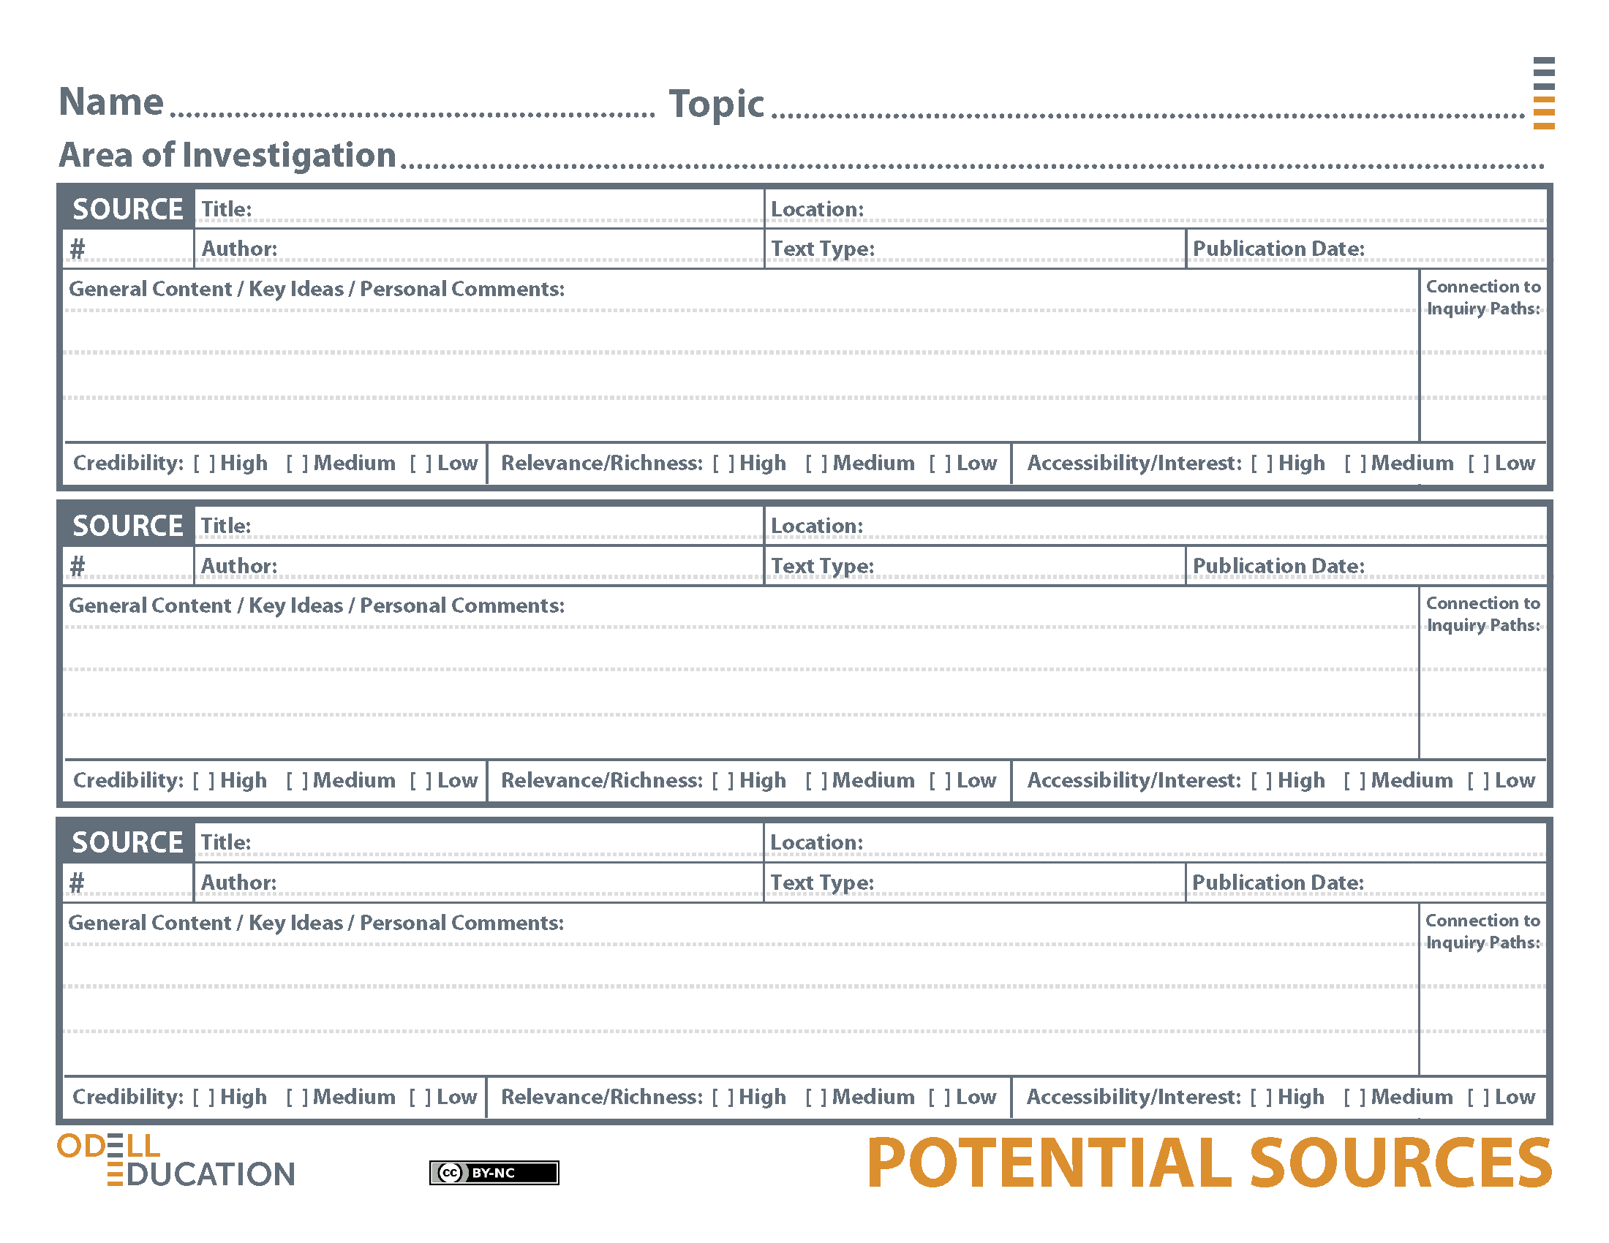
How does animal intelligence compare to human intelligence?
Student Sample
Animal Intelligence
Animal Minds: Minds of Their Own
National Geographic Magazine Online
Virginia Morell
Article
March 2008
The article is relevant because it is about researching animals’ intelligence, which is my focus inquiry question. Also, it seems credible because at the beginning the writer cites a study conducted by a Harvard graduate, which shows the writer is looking at research to compose the article.
The Brains of the Animal Kingdom
Wall Street Journal Online
Waal
Article
2013
This article is relevant because it is about measuring animal intelligence using different kinds of experiments that showcase animal intelligence. This article seems credible because it comes from a notable news source (Wall Street Journal) and the author is a professor and has written a book on the topic.
Think You're Smarter Than Animals? Maybe Not
New York Times Online
Alexandra Horowitze and Ammon Shea
Article
8/20/11
This article seems relevant because it has several studies on animal intelligence where animals show how smart they truly are. It also begins to compare animal and human intelligence. The article seems credible because it comes from a notable news source (New York Times) and the authors have written books on animal intelligence.

