Topic C
Fraction Comparison
4.NF.2
Focus Standard: | 4.NF.2 | Compare two fractions with different numerators and different denominators, e.g., by creating common denominators or numerators, or by comparing to a benchmark fraction such as 1/2. Recognize that comparisons are valid only when the two fractions refer to the same whole. Record the results of comparisons with symbols >, =, or <, and justify the conclusions, e.g., by using a visual fraction model.
Instructional Days: | 4
Coherence -Links from: | G3–M5 | Fractions as Numbers on the Number Line
-Links to: | G5–M3 | Addition and Subtraction of Fractions
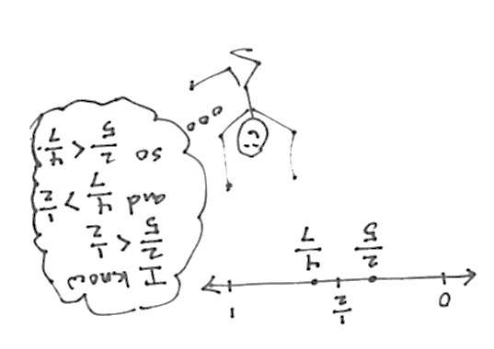
In Topic C, students use benchmarks and common units to compare fractions with different numerators and different denominators. The use of benchmarks is the focus of Lessons 12 and 13 and is modeled using a number line. Students use the relationship between the numerator and denominator of a fraction to compare to a known benchmark (e.g., 0, $\frac{1}{2}$, or 1) and then use that information to compare the given fractions. For example, when comparing $\frac{\text{4}}{\text{7}}$ and $\frac{\text{2}}{\text{5}}$, students reason that 4 sevenths is more than 1 half, while 2 fifths is less than 1 half. They then conclude that 4 sevenths is greater than 2 fifths.
In Lesson 14, students reason that they can also use like numerators based on what they know about the size of the fractional units. They begin at a simple level by reasoning, for example, that 3 fifths is less than 3 fourths because fifths are smaller than fourths. They then see, too, that it is easy to make like numerators at times to compare, e.g., $\frac{\text{2}}{\text{5}}\text{ < }\frac{\text{4}}{\text{9}}$ because $\frac{\text{2}}{\text{5}}\text{=}\frac{\text{4}}{\text{10}}$, and $\frac{\text{4}}{\text{10}} \text{<} \frac{\text{4}}{\text{9}}$ because $\frac{\text{1}}{\text{10}}\text{ < }\frac{\text{1}}{\text{9}}.$ Using their experience with fractions in Grade 3, they know the larger the denominator of a unit fraction, the smaller the size of the fractional unit. Like numerators are modeled using tape diagrams directly above each other, where one fractional unit is partitioned into smaller unit fractions. The lesson then moves to comparing fractions with related denominators, such as $\frac{\text{2}}{\text{3}}$ and $\frac{\text{5}}{\text{6}}$ , wherein one denominator is a factor of the other, using both tape diagrams and the number line.
In Lesson 15, students compare fractions by using an area model to express two fractions, wherein one denominator is not a factor of the other, in terms of the same unit using multiplication, e.g., $\frac{\text{2}}{\text{3}} \text{<} \frac{\text{3}}{\text{4}}$because $\frac{\text{2}}{\text{3}}\text{=}\frac{\text{2 × 4}}{\text{3 × 4}}\text{=}\frac{\text{8}}{\text{12}}$ and $\frac{\text{3}}{\text{4}}\text{=}\frac{\text{3 × 3}}{\text{4 × 3}}\text{=}\frac{\text{9}}{\text{12}}$ and $\frac{\text{8}}{\text{12}} \text{<} \frac{\text{9}}{\text{12}}$. The area for $\frac{\text{2}}{\text{3}}$ is partitioned vertically, and the area for $\frac{\text{3}}{\text{4}}$ is partitioned horizontally.
To find the equivalent fraction and create the same size units, the areas are decomposed horizontally and vertically, respectively. Now, the unit fractions are the same in each model or equation, and students can easily compare. The topic culminates with students comparing pairs of fractions and, by doing so, deciding which strategy is either necessary or efficient: reasoning using benchmarks and what they know about units, drawing a model (such as a number line, a tape diagram, or an area model), or the general method of finding like denominators through multiplication.

A Teaching Sequence Toward Mastery of Fraction Comparison
Objective 1: Reason using benchmarks to compare two fractions on the number line.
(Lessons 12–13)
Objective 2: Find common units or number of units to compare two fractions.
(Lessons 14–15)

