Topic H
Multiplication of Two-Digit by Two-Digit Numbers
4.NBT.5, 4.OA.3, 4.MD.3
Focus Standard: | 4.NBT.5 | Multiply a whole number of up to four digits by a one-digit whole number, and multiply two two-digit numbers, using strategies based on place value and the properties of operations. Illustrate and explain the calculation by using equations, rectangular arrays, and/or area models.
Instructional Days: | 5
Coherence -Links from: | G3–M1 | Properties of Multiplication and Division and Solving Problems with Units of 2–5 and 10
-Links to: | G3–M3 | Multiplication and Division with Units of 0, 1, 6–9, and Multiples of 10
 | G5–M2 | Multi-Digit Whole Number and Decimal Fraction Operations
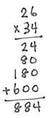
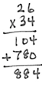
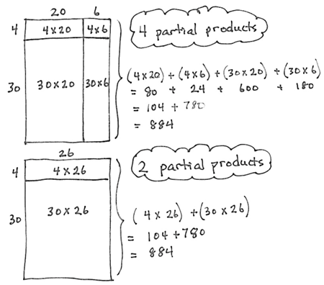
Module 3 closes with Topic H as students multiply two-digit by two-digit numbers.
Lesson 34 begins this topic by having students use the area model to represent and solve the multiplication of two-digit multiples of 10 by two-digit numbers using a place value chart. Practice with this model helps to prepare students for two-digit by two-digit multiplication and builds the understanding of multiplying units of 10. In Lesson 35, students extend their learning to represent and solve the same type of problems using area models and partial products.
In Lesson 36, students make connections to the distributive property and use both the area model and four partial products to solve problems. Lesson 37 deepens students’ understanding of multi-digit multiplication by transitioning from four partial products with representation of the area model to two partial products with representation of the area model and finally to two partial products without representation of the area model.

Topic H culminates at the most abstract level with Lesson 38 as students are introduced to the multiplication algorithm for two-digit by two-digit numbers. Knowledge from Lessons 34–37 provides a firm foundation for understanding the process of the algorithm as students make connections from the area model to partial products to the standard algorithm (4.NBT.5). Students see that partial products written vertically are the same as those obtained via the distributive property: 4 twenty-sixes + 30 twenty-sixes = 104 + 780 = 884.
A Teaching Sequence Towards Mastery of Multiplication of Two-Digit by Two-Digit Numbers
Objective 1: Multiply two-digit multiples of 10 by two-digit numbers using a place value chart.
(Lesson 34)
Objective 2: Multiply two-digit multiples of 10 by two-digit numbers using the area model.
(Lesson 35)
Objective 3: Multiply two-digit by two-digit numbers using four partial products.
(Lesson 36)
Objective 4: Transition from four partial products to the standard algorithm for two-digit by two-digit multiplication.
(Lessons 37–38)

