Topic G
Division of Thousands, Hundreds, Tens, and Ones
4.OA.3, 4.NBT.6, 4.NBT.1
Focus Standard: | 4.OA.3 | Solve multistep word problems posed with whole numbers and having whole-number answers using the four operations, including problems in which remainders must be interpreted. Represent these problems using equations with a letter standing for the unknown quantity. Assess the reasonableness of answers using mental computation and estimation strategies including rounding.
 | 4.NBT.6 | Find whole-number quotients and remainders with up to four-digit dividends and one-digit divisors, using strategies based on place value, the properties of operations, and/or the relationship between multiplication and division. Illustrate and explain the calculation by using equations, rectangular arrays, and/or area models.
Instructional Days: | 8
Coherence -Links from: | G3–M1 | Properties of Multiplication and Division and Solving Problems with Units of 2–5 and 10
-Links to: | G3–M3 | Multiplication and Division with Units of 0, 1, 6–9, and Multiples of 10
 | G5–M2 | Multi-Digit Whole Number and Decimal Fraction Operations
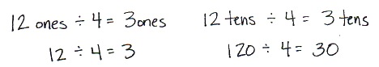
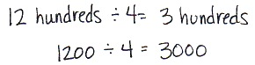
Topic G extends to division with three- and four-digit dividends using place value understanding. Students begin the topic by connecting multiplication of 10, 100, and 1,000 by single-digit numbers from Topic B to division of multiples of 10, 100, and 1,000 in Lesson 26. Using unit language, students find their division facts allow them to divide much larger numbers.

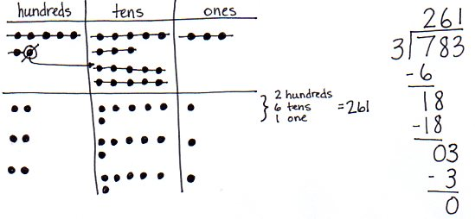
In Lesson 27, place value disks support students visually as they decompose each unit before dividing. This lesson contains a first-use script on the steps of solving long division using place value disks and the algorithm in tandem for three- and four-digit dividends (4.NBT.6). Take note how patterning develops with these larger numbers.

Students then move to the abstract level in Lessons 28 and 29, recording long division with place value understanding, first of three-digit, then four-digit numbers using small divisors. In Lesson 30, students practice dividing when zeros are in the dividend or in the quotient.
Lessons 31 and 32 give students opportunities to apply their understanding of division by solving word problems (4.OA.3). In Lesson 31, students identify word problems as number of groups unknown or group size unknown, modeled using tape diagrams. Lesson 32 allows students to apply their place value understanding of solving long division using larger divisors of 6, 7, 8, and 9. Concluding this topic, Lesson 33 has students make connections between the area model and the standard algorithm for long division.
A Teaching Sequence Towards Mastery of Division of Thousands, Hundreds, Tens, and Ones
Objective 1: Divide multiples of 10, 100, and 1,000 by single-digit numbers.
(Lesson 26)
Objective 2: Represent and solve division problems with up to a three-digit dividend numerically and with place value disks requiring decomposing a remainder in the hundreds place.
(Lesson 27)
Objective 3: Represent and solve three-digit dividend division with divisors of 2, 3, 4, and 5 numerically.
(Lesson 28)
Objective 4: Represent numerically four-digit dividend division with divisors of 2, 3, 4, and 5, decomposing a remainder up to three times.
(Lesson 29)
Objective 5: Solve division problems with a zero in the dividend or with a zero in the quotient.
(Lesson 30)
Objective 6: Interpret division word problems as either number of groups unknown or group size unknown.
(Lesson 31)
Objective 7: Interpret and find whole number quotients and remainders to solve one-step division word problems with larger divisors of 6, 7, 8, and 9.
(Lesson 32)
Objective 8: Explain the connection of the area model of division to the long division algorithm for three- and four-digit dividends.
(Lesson 33)

