Topic E
Division of Tens and Ones with Successive Remainders
4.NBT.6, 4.OA.3
Focus Standard: | 4.NBT.6 | Find whole-number quotients and remainders with up to four-digit dividends and one-digit divisors, using strategies based on place value, the properties of operations, and/or the relationship between multiplication and division. Illustrate and explain the calculation by using equations, rectangular arrays, and/or area models.
Instructional Days: | 8
Coherence -Links from: | G3–M1 | Properties of Multiplication and Division and Solving Problem with Units of 2–5 and 10
-Links to: | G3–M3 | Multiplication and Division with Units of 0, 1, 6–9, and Multiples of 10
 | G5–M2 | Multi-Digit Whole Number and Decimal Fraction Operations
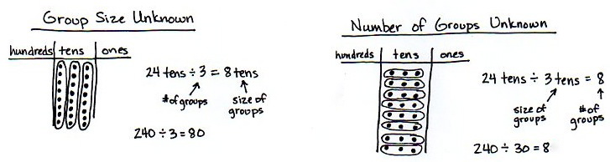
In Topic E, students synthesize their Grade 3 knowledge of division types (group size unknown and number of groups unknown) with their new, deeper understanding of place value.

Students focus on interpreting the remainder within division problems both in word problems and long division (4.OA.3). A remainder of 1, as exemplified below, represents a left over flower in the first situation and a remainder of 1 ten in the second situation.

While we have no reason to subdivide a remaining flower, there are good reasons to subdivide a remaining ten. Students apply this simple idea to divide two-digit numbers unit by unit: dividing the tens units first, finding the remainder (the number of tens unable to be divided), and decomposing remaining tens into ones to then be divided.
Lesson 14 begins Topic E by having students solve division word problems involving remainders. In Lesson 15, students deepen their understanding of division by solving problems with remainders using both arrays and the area model. Students practice dividing two-digit dividends with a remainder in the ones place using place value disks in Lesson 16 and continue that modeling in Lesson 17 where the remainder in the tens place is decomposed into ones.
The long division algorithm is introduced in Lesson 16 by directly relating the steps of the algorithm to the steps involved when dividing using place value disks. Introducing the algorithm in this manner helps students to understand how place value plays a role in the steps of the algorithm. The same process of relating the standard algorithm to the concrete representation of division continues in Lesson 17.
Lesson 18 moves students to the abstract level by requiring them to solve division problems numerically without drawing. In Lesson 19, students explain the successive remainders of the algorithm by using place value understanding and place value disks. Finally, in Lessons 20 and 21, students use the area model to solve division problems and then compare the standard algorithm to the area model (4.NBT.6). Lesson 20 focuses on division problems without remainders, while Lesson 21 involves remainders.

Quotients and remainders are independent of each other, but must both be included to give a complete response. A quotient and a remainder cannot be recorded after an equal sign because the symbol R or the words with a remainder of are invalid in an equation. Therefore, a quotient and a remainder can be written as a statement such as seven divided by two is three with a remainder of one, or the quotient is three and the remainder is one. It is mathematically correct to record the quotient and the remainder together at the top of the long division algorithm.

A Teaching Sequence Towards Mastery of Division of Tens and Ones with Successive Remainders
Objective 1: Solve division word problems with remainders.
(Lesson 14)
Objective 2: Understand and solve division problems with a remainder using the array and area models.
(Lesson 15)
Objective 3: Understand and solve two-digit dividend division problems with a remainder in the ones place by using place value disks.
(Lesson 16)
Objective 4: Represent and solve division problems requiring decomposing a remainder in the tens.
(Lesson 17)
Objective 5: Find whole number quotients and remainders.
(Lesson 18)
Objective 6: Explain remainders by using place value understanding and models.
(Lesson 19)
Objective 7: Solve division problems without remainders using the area model.
(Lesson 20)
Objective 8: Solve division problems with remainders using the area model.
(Lesson 21)

Note that care must be taken in the interpretation of remainders. Consider the fact that 7 ÷ 3 is not equal to 5 ÷ 2 because the remainder of 1 is in reference to a different whole amount ($2\frac{1}{3}$ is not equal to $2\frac{1}{2}$).
Students become fluent with the standard division algorithm in Grade 6 (6.NS.2). For adequate practice in reaching fluency, students are introduced to, but not assessed on, the division algorithm in Grade 4 as a general method for solving division problems.

