Topic D
Multiplication Word Problems
4.OA.1, 4.OA.2, 4.OA.3, 4.NBT.5
Focus Standard: | 4.OA.1 | Interpret a multiplication equation as a comparison, e.g., interpret 35 = 5 × 7 as a statement that 35 is 5 times as many as 7 and 7 times as many as 5. Represent verbal statements of multiplicative comparisons as multiplication equations.
 | 4.OA.2 | Multiply or divide to solve word problems involving multiplicative comparison, e.g., by using drawings and equations with a symbol for the unknown number to represent the problem, distinguishing multiplicative comparison from additive comparison. (See CCLS Glossary, Table 2.)
 | 4.OA.3 | Solve multistep word problems posed with whole numbers and having whole-number answers using the four operations, including problems in which remainders must be interpreted. Represent these problems using equations with a letter standing for the unknown quantity. Assess the reasonableness of answers using mental computation and estimation strategies including rounding.
 | 4.NBT.5 | Multiply a whole number of up to four digits by a one-digit whole number, and multiply two two-digit numbers, using strategies based on place value and the properties of operations. Illustrate and explain the calculation by using equations, rectangular arrays, and/or area models.
Instructional Days: | 2
Coherence -Links from: | G3–M1 | Properties of Multiplication and Division and Solving Problems with Units of 2–5 and 10
-Links to: | G3–M3 | Multiplication and Division with Units of 0, 1, 6–9, and Multiples of 10
 | G5–M2 | Multi-Digit Whole Number and Decimal Fraction Operations
Topic D gives students the opportunity to apply their new multiplication skills (4.NBT.5). In Lesson 12, students extend their work with multiplicative comparison from Topic A to solve real world problems (4.OA.2). As shown below, students use a combination of addition, subtraction, and multiplication to solve multi-step problems in Lesson 13 (4.OA.3).

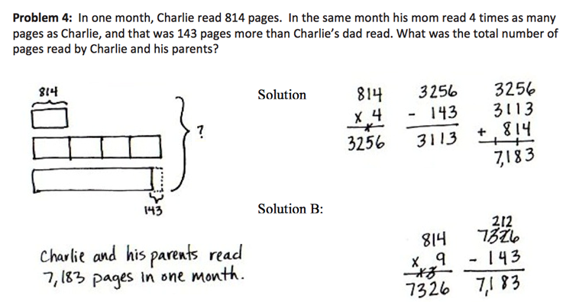
Solution B:
Solution A:

A Teaching Sequence Towards Mastery of Multiplication Word Problems
Objective 1: Solve two-step word problems, including multiplicative comparison.
(Lesson 12)
Objective 2: Use multiplication, addition, or subtraction to solve multi-step word problems.
(Lesson 13)

