Topic C
Multiplication of up to Four Digits by Single-Digit Numbers
4.NBT.5, 4.OA.2, 4.NBT.1
Focus Standard: | 4.NBT.5 | Multiply a whole number of up to four digits by a one-digit whole number, and multiply two two-digit numbers, using strategies based on place value and the properties of operations. Illustrate and explain the calculation by using equations, rectangular arrays, and/or area models.
Instructional Days: | 5
Coherence -Links from: | G3–M1 | Properties of Multiplication and Division and Problem Solving with Units of 2–5 and 10
-Links to: | G3–M3 | Multiplication and Division with Units of 0, 1, 6–9, and Multiples of 10
 | G5–M2 | Multi-Digit Whole Number and Decimal Fraction Operations
Building on their work in Topic B, students begin in Topic C decomposing numbers into base ten units in order to find products of single-digit by multi-digit numbers. Students practice multiplying by using models before being introduced to the standard algorithm. Throughout the topic, students practice multiplication in the context of word problems, including multiplicative comparison problems.
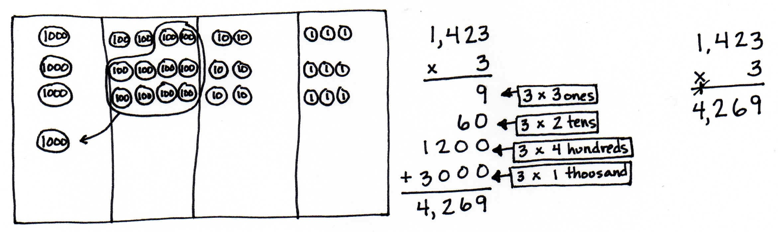
In Lessons 7 and 8, students use place value disks to represent the multiplication of two-, three-, and four-digit numbers by a one-digit whole number.

Lessons 9 and 10 move students to the abstract level as they multiply three- and four-digit numbers by one-digit numbers using the standard algorithm.
Finally, in Lesson 11, partial products, the standard algorithm, and the area model are compared and connected via the distributive property (4.NBT.5).
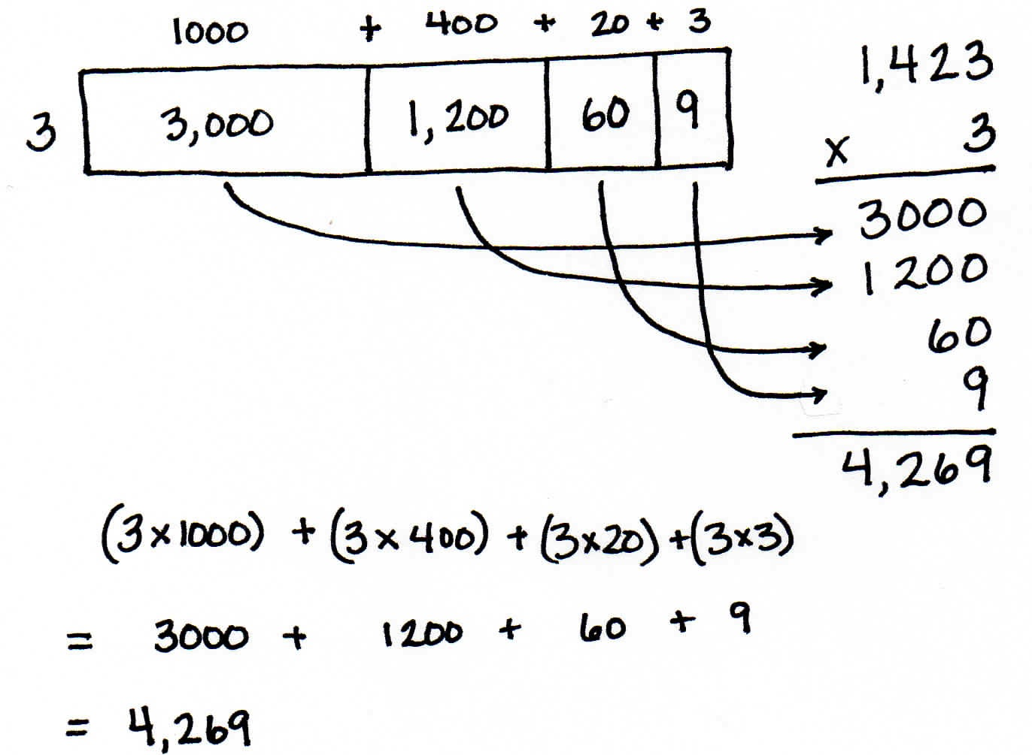

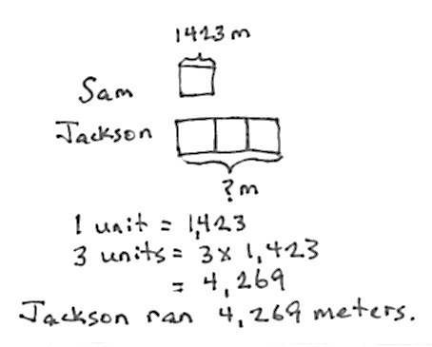

These calculations are then contextualized within multiplicative comparison word problems.
Jackson’s younger brother, Sam, ran 1,423 meters. Jackson ran 3 times as far as Sam. How far did Jackson run?
A Teaching Sequence Towards Mastery of Multiplication of Up to Four Digits by Single-Digit Numbers
Objective 1: Use place value disks to represent two-digit by one-digit multiplication.
(Lesson 7)
Objective 2: Extend the use of place value disks to represent three- and four-digit by one-digit multiplication.
(Lesson 8)
Objective 3: Multiply three- and four-digit numbers by one-digit numbers applying the standard algorithm.
(Lessons 9–10)
Objective 4: Connect the area model and the partial products method to the standard algorithm.
(Lesson 11)

