Topic B
Multiplication by 10, 100, and 1,000
4.NBT.5, 4.OA.1, 4.OA.2, 4.NBT.1
Focus Standard: | 4.NBT.5 | Multiply a whole number of up to four digits by a one-digit whole number, and multiply two two-digit numbers, using strategies based on place value and the properties of operations. Illustrate and explain the calculation by using equations, rectangular arrays, and/or area models.
Instructional Days: | 3
Coherence -Links from: | G3–M1 | Properties of Multiplication and Division and Problem Solving with Units of 2–5 and 10
-Links to: | G5–M1 | Place Value and Decimal Fractions
In Topic B, students examine multiplication patterns when multiplying by 10, 100, and 1,000. Reasoning between arrays and written numerical work allows students to see the role of place value units in multiplication (as pictured below). Students also practice the language of units to prepare them for multiplication of a single-digit factor by a factor with up to four digits. Teachers also continue using the phrase “____ is ____ times as much as ____” (e.g., 120 is 3 times as much as 40). This carries forward multiplicative comparison from Topic A, in the context of area, to Topic B, in the context of both calculations and word problems.
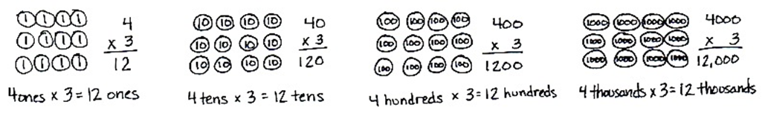

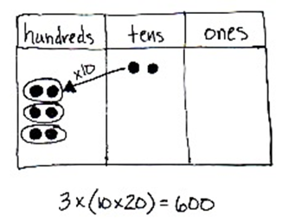
In preparation for two-digit by two-digit multiplication, students practice the new complexity of multiplying two two-digit multiples of 10. For example, students have multiplied 20 by 10 on the place value chart and know that it shifts the value one place to the left, 10 × 20 = 200. To multiply 20 by 30, the associative property allows for simply tripling the product, 3 × (10 × 20), or multiplying the units, 3 tens × 2 tens = 6 hundreds (alternatively, (3 × 10) × (2 × 10) = (3 × 2) × (10 × 10)).

Introducing this early in the module allows students to practice this multiplication during fluency so that by the time it is embedded within the two-digit by two-digit multiplication in Topic H, both understanding and procedural fluency have been developed.
In Lesson 4, students interpret and represent patterns when multiplying by 10, 100, and 1,000 in arrays and numerically. Next, in Lesson 5, students draw disks to multiply single-digit numbers by multiples of 10, 100, and 1,000. Finally, in Lesson 6, students use disks to multiply two-digit multiples of 10 by two-digit multiples of 10 (4.NBT.5) with the area model.
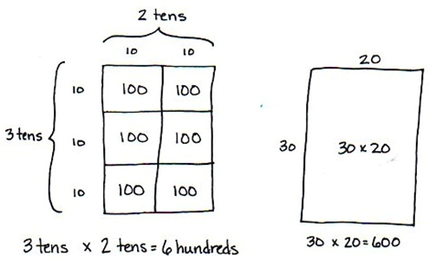

A Teaching Sequence Towards Mastery of Multiplication by 10, 100, and 1,000
Objective 1: Interpret and represent patterns when multiplying by 10, 100, and 1,000 in arrays and numerically.
(Lesson 4)
Objective 2: Multiply multiples of 10, 100, and 1,000 by single digits, recognizing patterns.
(Lesson 5)
Objective 3: Multiply two-digit multiples of 10 by two-digit multiples of 10 with the area model.
(Lesson 6)

