Topic A
Multiplicative Comparison Word Problems
4.OA.1, 4.OA.2, 4.MD.3, 4.OA.3
Focus Standard: | 4.OA.1 | Interpret a multiplication equation as a comparison, e.g., interpret 35 = 5 × 7 as a statement that 35 is 5 times as many as 7 and 7 times as many as 5. Represent verbal statements of multiplicative comparisons as multiplication equations.
 | 4.OA.2 | Multiply or divide to solve word problems involving multiplicative comparison, e.g., by using drawings and equations with a symbol for the unknown number to represent the problem, distinguishing multiplicative comparison from additive comparison. (See CCLS Glossary, Table 2.)
 | 4.MD.3 | Apply the area and perimeter formulas for rectangles in real world and mathematical problems. For example, find the width of a rectangular room given the area of the flooring and the length, by viewing the area formula as a multiplication equation with an unknown factor.
Instructional Days: | 3
Coherence -Links from: | G3–M4 | Multiplication and Area
-Links to: | G3–M7 | Geometry and Measurement Word Problems
 | G5–M5 | Addition and Multiplication with Volume and Area
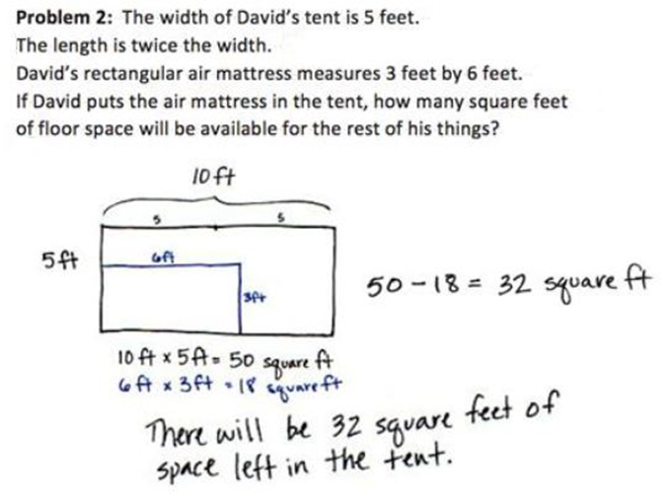
Students begin Topic A by investigating the formulas for area and perimeter. In Lesson 1, they use those formulas to solve for area and perimeter and to find the measurements of unknown lengths and widths. In Lessons 2 and 3, students use their understanding of the area and perimeter formulas to solve multiplicative comparison problems including the language of times as much as with a focus on problems using area and perimeter as a context (e.g., “A field is 9 feet wide. It is 4 times as long as it is wide. What is the perimeter of the field?”) (4.OA.2, 4.MD.3). Students create diagrams to represent these problems as well as write equations with symbols for the unknown quantities.

Multiplicative comparison is foundational for understanding multiplication as scaling in Grade 5 and sets the stage for proportional reasoning in Grade 6. Students determine, using times as much as, the length of one side of a rectangle as compared to its width. Beginning this Grade 4 module with area and perimeter allows students to review their multiplication facts, apply them to new and interesting word problems, and develop a deeper understanding of the area model as a method for calculating with larger numbers.
A Teaching Sequence Towards Mastery of Multiplicative Comparison Word Problems
Objective 1: Investigate and use the formulas for area and perimeter of rectangles.
(Lesson 1)
Objective 2: Solve multiplicative comparison word problems by applying the area and perimeter formulas.
(Lesson 2)
Objective 3: Demonstrate understanding of area and perimeter formulas by solving multi-step real world problems.
(Lesson 3)

