Topic E
Multi-Digit Whole Number Subtraction
4.OA.3, 4.NBT.4, 4.NBT.1, 4.NBT.2
Focus Standard: | 4.OA.3 | Solve multistep word problems posed with whole numbers and having whole-number answers using the four operations, including problems in which remainders must be interpreted. Represent these problems using equations with a letter standing for the unknown quantity. Assess the reasonableness of answers using mental computation and estimation strategies including rounding.
 | 4.NBT.4 | Fluently add and subtract multi-digit whole numbers using the standard algorithm.
Instructional Days: | 4
Coherence -Links from: | G3–M2 | Place Value and Problem Solving with Units of Measure
-Links to: | G5–M1 | Place Value and Decimal Fractions
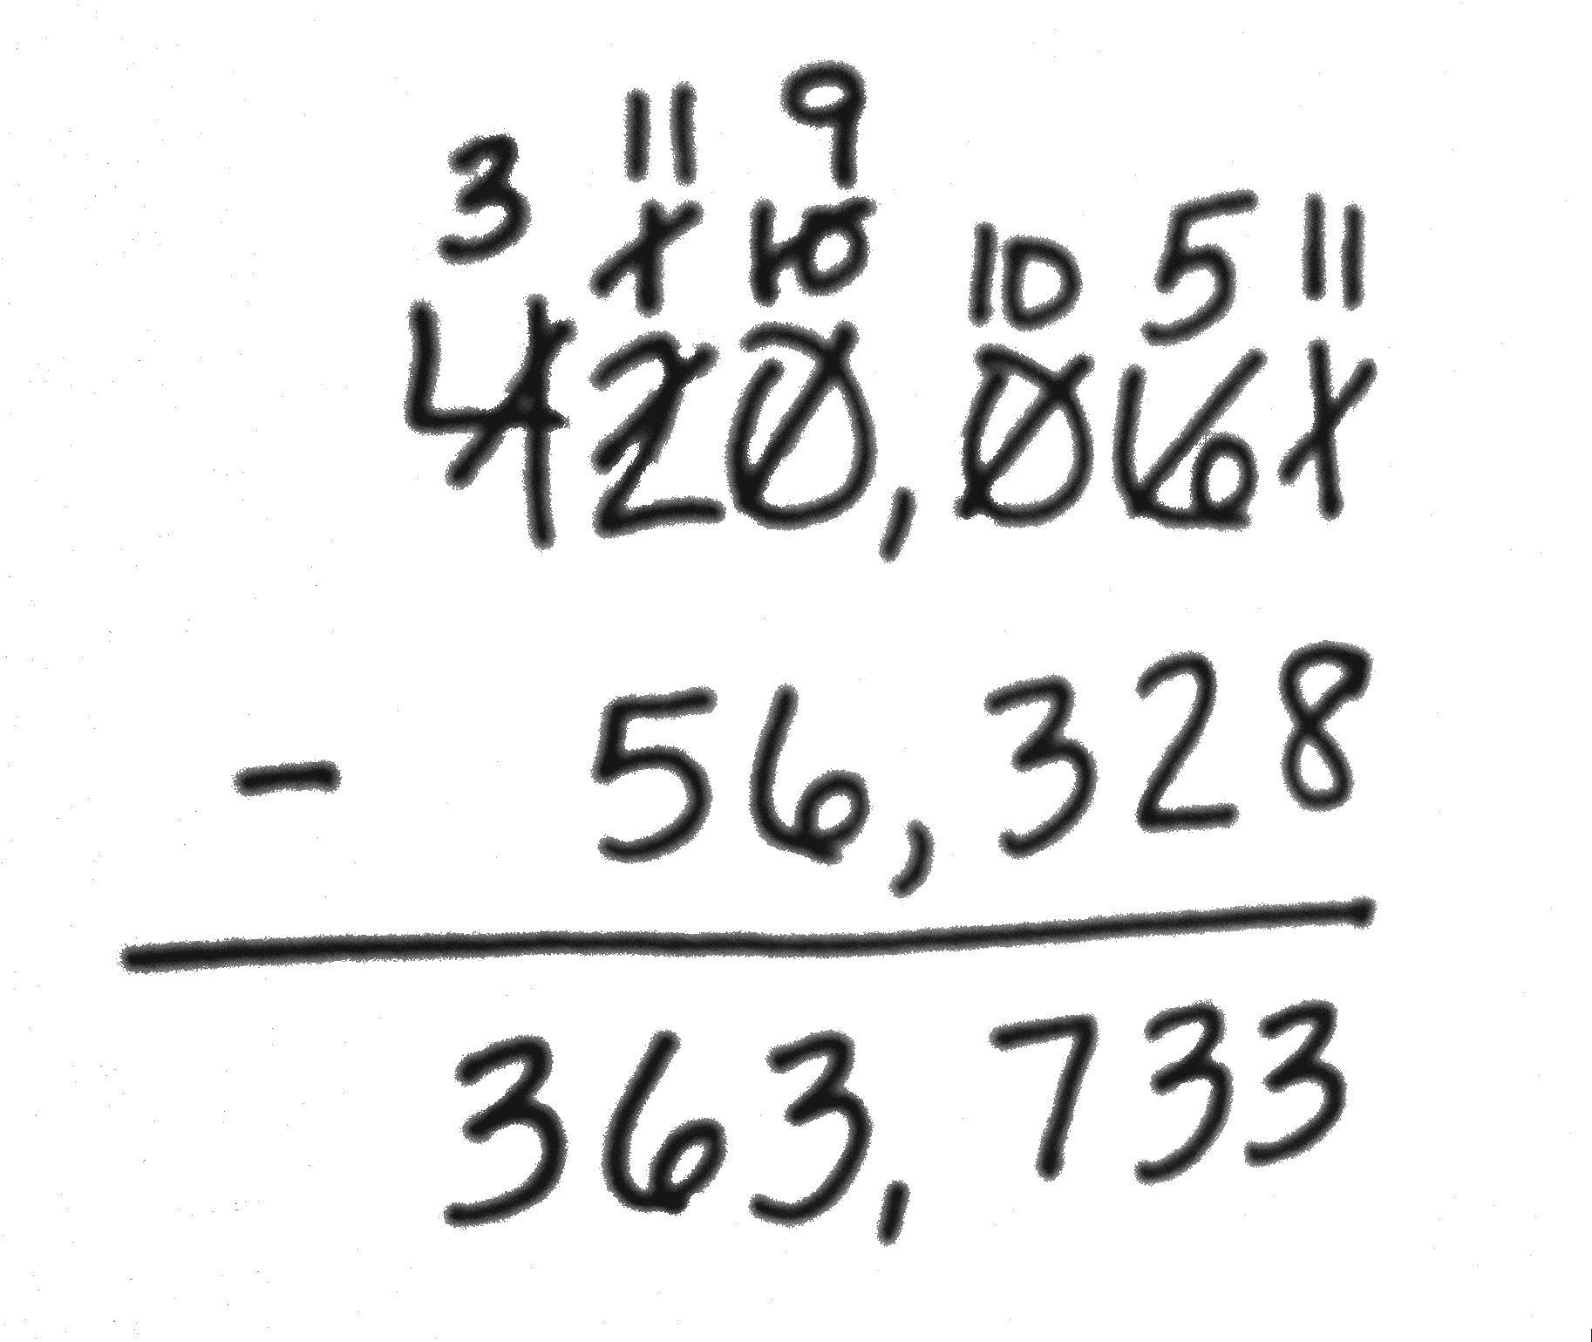
Following the introduction of the standard algorithm for addition in Topic D, the standard algorithm for subtraction replaces special strategies for subtraction in Topic E. Moving slowly from smaller to larger minuends, students practice decomposing larger units into smaller units. First, only one decomposition is introduced, where one zero may appear in the minuend. As in Grades 2 and 3, students continue to decompose all necessary digits before performing the algorithm, allowing subtraction from left to right, or, as taught in the lessons, from right to left. Students use the algorithm to subtract numbers from 1 million allowing for multiple decompositions (4.NBT.4). The topic concludes with practicing the standard algorithm for subtraction in the context of two-step word problems where students have to assess the reasonableness of their answers by rounding (4.OA.3). When using tape diagrams to model word problems, students use a variable to represent the unknown quantity.

A Teaching Sequence Towards Mastery of Multi-Digit Whole Number Subtraction
Objective 1: Use place value understanding to decompose to smaller units once using the standard subtraction algorithm, and apply the algorithm to solve word problems using tape diagrams.
(Lesson 13)
Objective 2: Use place value understanding to decompose to smaller units up to 3 times using the standard subtraction algorithm, and apply the algorithm to solve word problems using tape diagrams.
(Lesson 14)
Objective 3: Use place value understanding to fluently decompose to smaller units multiple times in any place using the standard subtraction algorithm, and apply the algorithm to solve word problems using tape diagrams.
(Lesson 15)
Objective 4: Solve two-step word problems using the standard subtraction algorithm fluently modeled with tape diagrams, and assess the reasonableness of answers using rounding.
(Lesson 16)

