Topic D
Multi-Digit Whole Number Addition
4.OA.3, 4.NBT.4, 4.NBT.1, 4.NBT.2
Focus Standard: | 4.OA.3 | Solve multistep word problems posed with whole numbers and having whole-number answers using the four operations, including problems in which remainders must be interpreted. Represent these problems using equations with a letter standing for the unknown quantity. Assess the reasonableness of answers using mental computation and estimation strategies including rounding.
 | 4.NBT.4 | Fluently add and subtract multi-digit whole numbers using the standard algorithm.
Instructional Days: | 2
Coherence -Links from: | G3–M2 | Place Value and Problem Solving with Units of Measure
-Links to: | G5–M1 | Place Value and Decimal Fractions
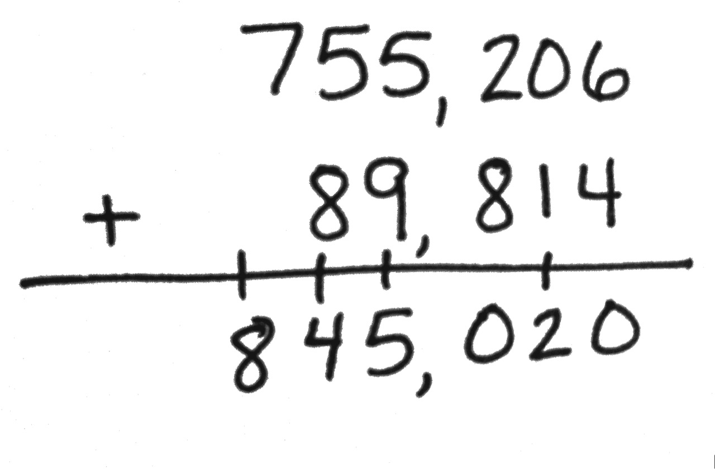
Moving away from special strategies for addition, students develop fluency with the standard addition algorithm (4.NBT.4). Students compose larger units to add like base ten units, such as composing 10 hundreds to make 1 thousand and working across the numbers unit by unit (ones with ones, thousands with thousands). Recording of regrouping occurs on the line under the addends as shown to the right. For example, in the ones column, students do not record the 0 in the ones column and the 1 above the tens column, instead students record 10, writing the 1 under the tens column and then a 0 in the ones column. They practice and apply the algorithm within the context of word problems and assess the reasonableness of their answers using rounding (4.OA.3). When using tape diagrams to model word problems, students use a variable to represent the unknown quantity.
A Teaching Sequence Towards Mastery of Multi-Digit Whole Number Addition
Objective 1: Use place value understanding to fluently add multi-digit whole numbers using the standard addition algorithm, and apply the algorithm to solve word problems using tape diagrams.
(Lesson 11)
Objective 2: Solve multi-step word problems using the standard addition algorithm modeled with tape diagrams, and assess the reasonableness of answers using rounding.
(Lesson 12)

