Topic C
Making Like Units Numerically
5.NF.1, 5.NF.2
Focus Standard: | 5.NF.1 | Add and subtract fractions with unlike denominators (including mixed numbers) by replacing given fractions with equivalent fractions in such a way as to produce an equivalent sum or difference of fractions with like denominators. For example, 2/3 + 5/4 = 8/12 + 15/12 = 23/12. (In general, a/b + c/d = (ad + bc)/bd.)
 | 5.NF.2 | Solve word problems involving addition and subtraction of fractions referring to the same whole, including cases of unlike denominators, e.g., by using visual fraction models or equations to represent the problem. Use benchmark fractions and number sense of fractions to estimate mentally and assess the reasonableness of answers. For example, recognize an incorrect result 2/5 + 1/2 = 3/7, by observing that 3/7 < 1/2.
Instructional Days: | 5
Coherence -Links from: | G4–M5 | Fraction Equivalence, Ordering, and Operations
-Links to: | G5–M1 | Place Value and Decimal Fractions
 | G5–M4 | Multiplication and Division of Fractions and Decimal Fractions
In Topic C, students use the number line when adding and subtracting fractions greater than or equal to 1. The number line helps students see that fractions are analogous to whole numbers. The number line makes it clear that numbers on the left are smaller than numbers on the right, which leads to an understanding of integers in Grade 6. Using this tool, students recognize and manipulate fractions in relation to larger whole numbers and to each other. For example, “Between which two whole numbers does the sum of $1\frac{2}{3}$ and $5\frac{3}{4}$ lie?”

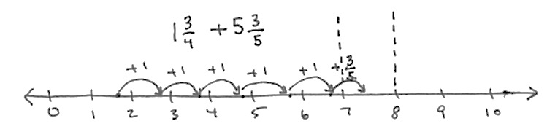
___< 1$\frac{3}{4}$ + 5 $\frac{3}{5}$ < ___

This leads to an understanding of and skill with solving more complex problems often embedded within multi-step word problems:
Cristina and Matt’s goal is to collect a total of $3\frac{1}{2}$ gallons of sap from the maple trees. Cristina collected $1\frac{3}{4}$gallons. Matt collected $5\frac{3}{5}$ gallons. By how much did they beat their goal?
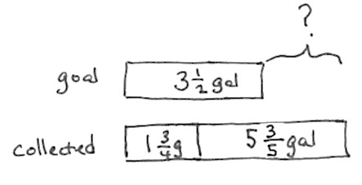
$$1\frac{3}{4} gal + 5\frac{3}{5} gal- 3\frac{1}{2}gal=3+\left(\frac{3×5}{4×5}\right)+\left(\frac{3×4}{5×4}\right)-\left(\frac{1×10}{2×10}\right)$$

$$=3+ \frac{15}{20}+ \frac{12}{20}- \frac{10}{20} = 3 \frac{17}{20} gal$$

Cristina and Matt beat their goal by 3 $\frac{17}{20}$ gallons.

Word problems are a part of every lesson. Students are encouraged to utilize tape diagrams, which facilitate analysis of the same part–whole relationships they have worked with since Grade 1.
A Teaching Sequence Toward Mastery of Making Like Units Numerically
Objective 1: Add fractions to and subtract fractions from whole numbers using equivalence and the number line as strategies.
(Lesson 8)
Objective 2: Add fractions making like units numerically.
(Lesson 9)
Objective 3: Add fractions with sums greater than 2.
(Lesson 10)
Objective 4: Subtract fractions making like units numerically.
(Lesson 11)
Objective 5: Subtract fractions greater than or equal to 1.
(Lesson 12)

