Lesson 34
Objective: Design and construct boxes to house materials for summer use.

Suggested Lesson Structure
 Fluency Practice (12 minutes)
 Application Problem (5 minutes)
 Concept Development (33 minutes)
 Student Debrief (10 minutes)
Total Time (60 minutes)
Fluency Practice (12 minutes)
- Multiply 5.NBT.5 (4 minutes)
- Divide by Two-Digit Numbers 5.NBT.6 (4 minutes)
- Find the Volume 5.MD.5 (4 minutes)
Multiply (4 minutes)
Materials: (S) Personal white boards
Note: This drill reviews year-long fluency standards.
T: Solve 97 $\text{×}$ 64 using the standard algorithm.

NOTES ON
MULTIPLE MEANS OF EXPRESSION:
Rather than dictate a solution strategy for the calculation, allow students to choose to use a mental strategy or the algorithm. Students might solve $\frac{163}{12}$ by adding another 12 to 12 twelves, and finding 7 more is needed to get to 163. Likewise there are 5 fifty-ones in 255 with 23 more needed to get to 278.

S: (Write 97 $\text{×}$ 64 = 6,208 using the standard algorithm.)
Continue the process for 897 $\text{×}$ 64, 89 $\text{×}$ 67, 789 $\text{×}$ 67, and
698 $\text{×}$ 86.
Divide by Two-Digit Numbers (4 minutes)
Materials: (S) Personal white boards
Note: This fluency activity reviews content from G5–Modules 2 and 4.
T: (Write $\frac{163}{12}$.) Write the quotient as a mixed number.
S: (Write $\frac{163}{12}$ =$\text{13}\frac{7}{12}$.)
Repeat the process from G5–M2–Lesson 21 for the following possible sequence: $\frac{278}{51}$ and $\frac{741}{23}$.
Find the Volume (4 minutes)
Materials: (S) Personal white boards
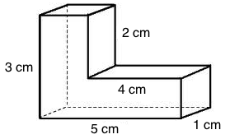
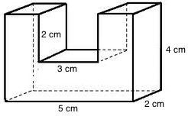
Note: This fluency activity reviews G5–Module 5 content.
T: Say the formula for finding the volume of a rectangular prism.
S: Length times width times height.
T: (Project composite figure.) Sketch the composite figure.
S: (Sketch.)
T: Draw a line that breaks the figure into 2 rectangular prisms.
S: (Draw line..)
T: Find the volume of the composite figure by adding the volumes of each rectangular prism.
S: (Write 3 cm $\text{×}$ 1 cm $\text{×}$ 1 cm = 3 cubic cm. 4 cm $\text{×}$ 1 cm $\text{×}$ 1 cm = 4 cubic cm. 3 cubic cm + 4 cubic cm = 7 cubic cm.)
Continue the process for the other composite figure.
Application Problem (5 minutes)
Steven is a _____________________ who had $280. He spent $\frac{1}{4}$ of his money on a ___________and $\frac{5}{6}$ of the remainder on a __________. How much money did he spend altogether?
Note: As this is the last day of lessons, you might bring some humor into the word problem by having students determine Steven’s identity and the items purchased using a science fiction, futuristic, or fantastical setting.
Concept Development (33 minutes)
Materials: (S) Rulers, Problem Set (same page printed on 2 sides), G5–M6–Lesson 33 Problem Set
Begin by giving students time to assemble the notes and tools they created in G5–M6–Topic F lessons in their boxes. You might also want to give time for finishing designs or personalizing touches started in G5–M6–Lesson 33. Remind students that these are boxes of resources they can use to practice Grade 5 skills over the summer. In this lesson, their boxes will be evaluated to see how well they house the materials and meet the criteria below.
- Boxes must store all summer materials.
- Box 1’s base must measure 19 cm by 13 cm.
- Box 2 must fit inside Box 1 when Box 1 is closed.
- The lid for Box 1 must fit snugly to protect the contents.
T: (Divide the class into groups of four students.) Your job today is to evaluate your group members’ boxes to assess how well their materials fit inside.
T: Each student will review two other group members’ boxes. Take a moment to decide with your group who will review which boxes.
S: (Divide the review work.)
Distribute the Problem Set.
T: Use a ruler to measure the dimensions of your friend’s boxes and lid, and then calculate the volume of the boxes. You’ll record that information on the Problem Set, and then assess the suitability of the boxes for the job of storing summer materials. What things will you look for to decide whether the box is suitable?
S: We can see how organized the materials are in the boxes. If the materials stick out or get squished inside, then Box 2 may not have been thought out well. We could check to see if the lids are tight enough to stay on and keep everything safe inside.
T: In the final column, you’re asked to make suggestions for improvement of each box or lid. Be as specific as possible. For example, rather than saying, “The lid should be smaller,” you might make a comment like, “The width of the lid should be 3 tenths centimeter smaller so that it fits more snugly.”

NOTES ON
MULTIPLE MEANS OF ENGAGEMENT:
Students may react differently to having their work critiqued. Therefore, it is important to discuss with students what types of comments or critiques are appropriate for their evaluation. Students might benefit from working as a class to develop a list of specific characteristics which should be commented upon.

S: (Evaluate one another’s work.)
T: Debrief your evaluation with the creator of the boxes and lid. Work together to compare your measurements with the ones they recorded on their G5–M6–Lesson 33 Problem Set. Then, discuss the points you made about suitability and improvements. If your suggestions are easily implemented, go ahead and make adjustments together.
S: (Debrief evaluations together.)
Mixed Review Fluency Activities
If time permits after students evaluate their two boxes, invite them to play the games from G5–M6–Lesson 28 again in groups using the materials inside their boxes.
Student Debrief (10 minutes)
Lesson Objective: Design and construct boxes to house materials for summer use.
The Student Debrief is intended to invite reflection and active processing of the total lesson experience. Invite students to review their solutions for the Problem Set. They should check work by comparing answers with a partner before going over answers as a class. Look for misconceptions or misunderstandings that can be addressed in the Debrief. Guide students in a conversation to debrief the Problem Set and process the lesson.
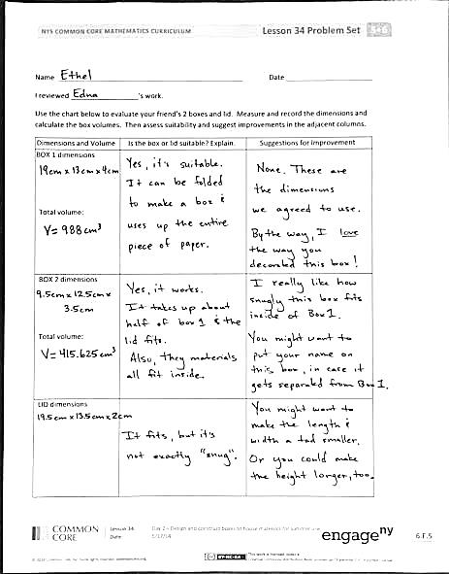
- (Have students share their boxes.) What designs did you choose to put on your box? Why?
- What was your favorite math topic in Grade 5?
- What models or manipulatives helped you with new concepts?
- What was your biggest accomplishment in math this year?
- What are some ways you can keep your math skills sharp during the summer?
Reflection (3 minutes)
In G5–M6–Topic F, to close their elementary experience, the Exit Ticket is set aside and replaced by a brief opportunity to reflect on the mathematics done that day as it relates to their broader experience of math.
Name Date
I reviewed _________________’s work.
Use the chart below to evaluate your friend’s two boxes and lid. Measure and record the dimensions and calculate the box volumes. Then, assess suitability and suggest improvements in the adjacent columns.
Dimensions and Volume | Is the box or lid suitable? Explain. | Suggestions for Improvement
BOX 1 dimensions:

Total volume:

BOX 2 dimensions:

Total volume:

LID dimensions:

Name Date
What are you most looking forward to learning about in Grade 6 or in math in your future?

