Lesson 33
Objective: Design and construct boxes to house materials for summer use.

Suggested Lesson Structure
 Fluency Practice (12 minutes)
 Concept Development (38 minutes)
 Student Debrief (10 minutes)
Total Time (60 minutes)
Fluency Practice (12 minutes)

NOTES ON
MULTIPLE MEANS OF ENGAGEMENT:
Have four different students call out the solutions to the Sprint, one quadrant at a time or have all students call out the solutions to the problems. As the end of the year is approaching, let the students release some energy during the Sprint! In this way, excitement and academics become associated.

- Sprint: Divide Decimals 5.NBT.7 (9 minutes)
- Find the Volume 5.MD.3 (3 minutes)
Sprint: Divide Decimals (9 minutes)
Materials: (S) Divide Decimals Sprint
Note: This Sprint reviews G5–Module 4 concepts.
Find the Volume (3 minutes)
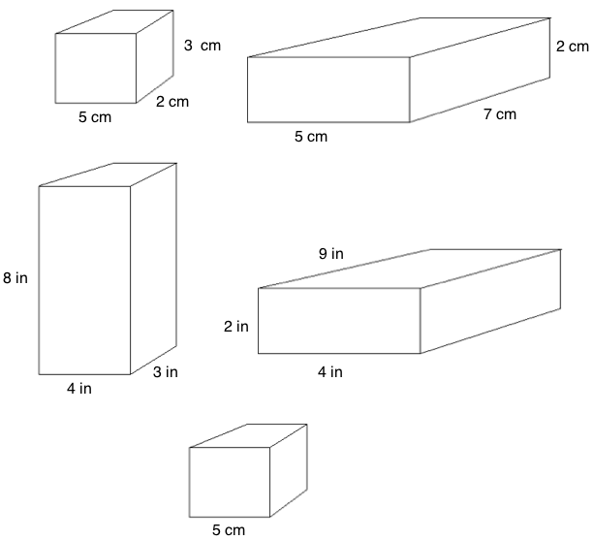
Materials: (S) Personal white boards
Note: This fluency activity reviews G5–Lesson 5.
T: On your boards, write the formula for finding the volume of a rectangular prism.
S: (Write V = l $\text{×}$ w $\text{×}$ h.)
T: (Write V = l × w × h. Project rectangular prism with a length of 5 cm, width of 2 cm, and height of 3 cm. Point to the length.) Say the length.
S: 5 cm.
T: (Point to the width.) Say the width.
S: 2 cm.
T: (Point to the height.) Say the height.
S: 3 cm.
T: On your boards, write a multiplication sentence to express the volume of the rectangular prism.
S: (Beneath V = l × w × h, write V = 5 cm × 2 cm × 3 cm. Beneath it, write V = 30 cm³.)
Continue the process for other rectangular prisms.
T: (Project cube with side lengths equal to 5 cm.) Name the prism.
S: Cube.
T: What’s the length of the each side of the cube?
S: 5 cm.
T: On your boards, write a multiplication sentence to show the volume of the cube.
S: (Write V = 5 cm × 5 cm × 5 cm. Beneath it, write V = 125 cm³.)
Concept Development (38 minutes)
Materials: (S) Problem Set, 3 pieces of 8½" × 11" cardstock paper trimmed to 27 cm by 21 cm, scissors, tape, ruler, summer practice materials
Note: In this lesson the time for the Application Problem has been allocated to the Concept Development.
Part 1: Establish the criteria for the boxes, and model constructing Box 1.
T: Today you’ll put your math sense and geometric skills to work as you design and create two different size boxes and one lid to house your summer fluency materials. These are the criteria:
- Boxes must store all summer materials.
- Box 1’s base must measure 19 cm by 13 cm.
- Box 2 must fit inside Box 1 when Box 1 is closed.
- The lid for Box 1 must fit snugly to protect the contents.
T: (Distribute one piece of card stock.) Here is the paper you will use to make Box 1. What are its measurements? (Allow students time to measure.)
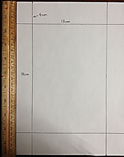
S: 21 centimeters by 27 centimeters.
Sample Base

T: Talk to your partner. Since the base of Box 1 is 19 centimeters by 13 centimeters, what does that mean about the height of Box 1?
S: The height has to be the same all the way around the base or the sides won’t match up. If the sides are 3 centimeters high that means adding 6 centimeters to 19 centimeters and 6 centimeters to 13 centimeters. I would have to trim off some paper. If you make the height of the sides 4 centimeters, it works perfectly; 19 + (2 $\text{× 4})$= 27 and 13 + (2 $\text{×} \text{4})$= 21.
T: By making the height of the box 4 centimeters, the measurements do work out perfectly. Watch as I model the four steps to make Box 1. (Consider posting the steps.)
- Measure and mark two points 4 centimeters in from the edge on each side.
- Connect those marked points to draw the lines of the 19 cm × 13 cm base. (Shown on the previous page.)
- Cut out the small rectangles in each corner.
- Fold up the sides and tape the corners together.
Part 2: Determine the dimensions of Box 2 and the lid.
Distribute the Problem Set, rulers, and the other pieces of cardstock.
T: You’ll decide on the exact dimensions of Box 2 and the lid for Box 1. What will you use to guide your decisions?
S: First, I’ll think about the materials that have to go inside. I’ll think about making Box 2 fit inside of Box 1. Box 2 can’t be taller than Box 1 if the lid is going to fit. The lid has to be just a tiny bit longer than Box 1 so it fits nicely.
T: To complete the project, you each will receive three 27 centimeter by 21 centimeter pieces of cardstock, one to make Box 1, one to make its lid, and one more to make Box 2. After you fold the edges of the cardstock to make the box or lid, will the inner dimensions still be 27 by 23 centimeters?
S: No, they’ll be smaller than that.
T: Take a moment to talk with your partner about how the different sizes of your summer materials will influence the dimensions of Box 2.
S: We have Problem Sets, which are pretty big, and fluency cards and vocabulary cards that are smaller. We might want the vocabulary cards to go in Box 2. Problem Sets can still go at the bottom of the bigger box, and smaller things can go in the smaller box.
T: Use a ruler to measure your summer practice materials and decide how you’ll store them. Will they be rolled, folded, or flat? Then, decide on reasonable whole number dimensions for Box 2.
MP.1

NOTES ON
MULTIPLE MEANS OF ENGAGEMENT:
Some students will benefit from loosely folding the boxes into shape to find dimensions. It may be helpful to have scratch paper at the ready for visual and kinesthetic learners who prefer to manipulate in this way as they work. Also consider having more than enough paper on hand for the inevitable do-overs.

T: In order to make the lid fit snugly, you’ll need to make it only slightly larger than the box. Record the dimensions of each box and the lid on your Problem Set, along with your reasoning about why those dimensions make sense. Work with a partner if you choose.
S: (Manipulate and measure summer practice materials, then decide on dimensions and record.)
Part 3: Construct the boxes and lid.
T: As you assemble your boxes and lid, if you find that you need to make adjustments to the dimensions as you work, record your updated thinking in the space remaining on your Problem Set, or on a separate sheet of paper.
S: (Draw dimensions and assemble boxes and lids, making adjustments to each if needed.)
Have students decorate and personalize their boxes with designs that show what concepts they have learned in math this year. They will have some time to complete their designs and place their summer practice materials inside the boxes during G5–M6–Lesson 34.
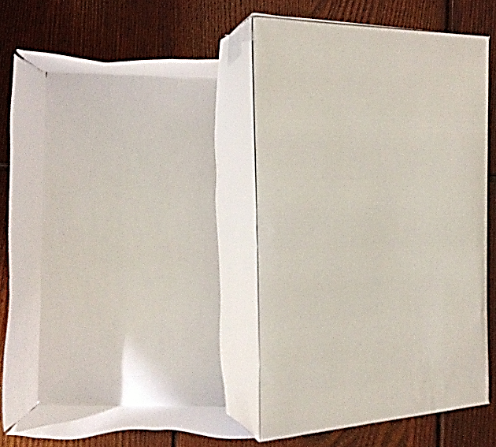
Sample Folded Box 1 and Lid
Sample Box 2 Inside of Box 1

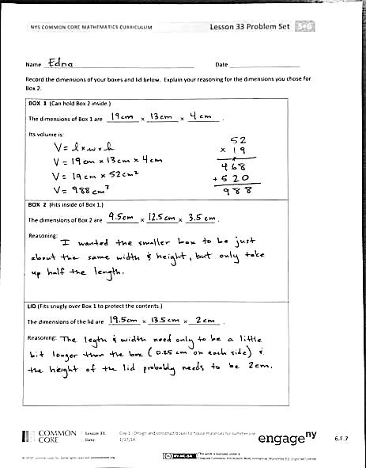
Student Debrief (10 minutes)
Lesson Objective: Design and construct boxes to house materials for summer use.
The Student Debrief is intended to invite reflection and active processing of the total lesson experience.
Invite students to review their solutions for the Problem Set. They should check work by comparing answers with a partner before going over answers as a class. Look for misconceptions or misunderstandings that can be addressed in the Debrief. Guide students in a conversation to debrief the Problem Set and process the lesson. You may choose to use any combination of the questions below to lead the discussion.
- What were the most important factors to consider as you decided on the dimensions of your boxes? Why did those things matter so much?
- To design these boxes we considered the materials that they would store. What specifically did we take into account? Volume, area, length, width, height? When would it be appropriate to consider other properties?
- What boxes do you see that have been designed for a specific purpose? What are some of the choices that were made to best serve that purpose?
- What was your biggest challenge in designing your boxes? Explain.
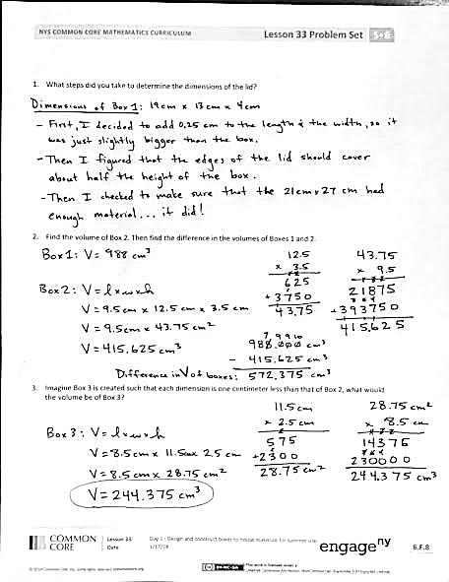
Reflection (3 minutes)
In G5–M6–Topic F, to close their elementary experience, the Exit Ticket is set aside and replaced by a brief opportunity to reflect on the mathematics done that day as it relates to their broader experience of math.

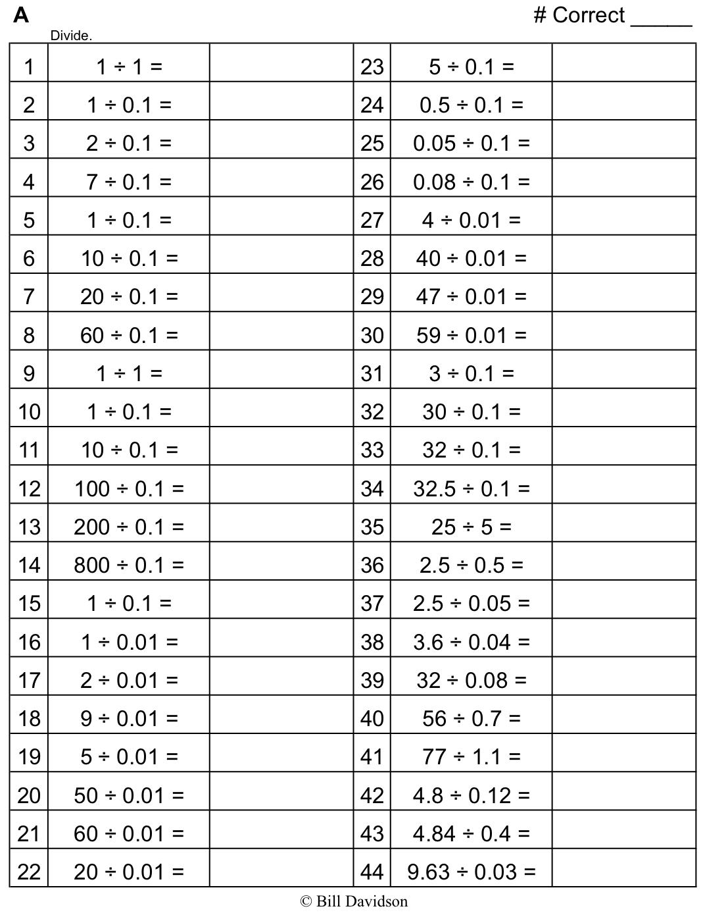
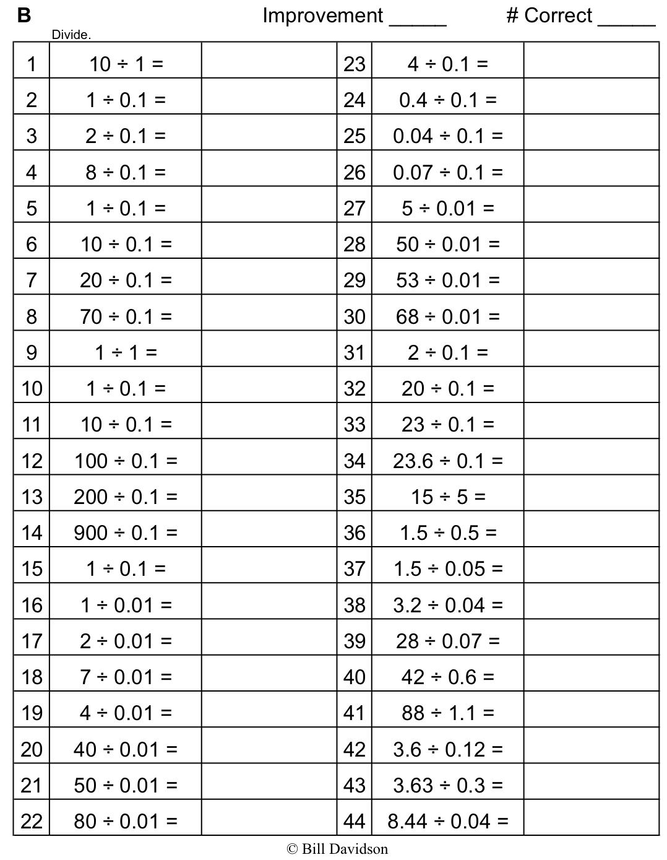

Name Date
Record the dimensions of your boxes and lid below. Explain your reasoning for the dimensions you chose for Box 2.
BOX 1 (Can hold Box 2 inside.)

The dimensions of Box 1 are __________ $×$ __________ $×$ __________ .

Its volume is __________.

BOX 2 (Fits inside of Box 1.)

The dimensions of Box 2 are __________ $×$ __________$×$ _________ .

Reasoning:

LID (Fits snugly over Box 1 to protect the contents.)

The dimensions of the lid are __________ $×$ __________ $×$__________ .

Reasoning:

- What steps did you take to determine the dimensions of the lid?

- Find the volume of Box 2. Then, find the difference in the volumes of Boxes 1 and 2.

- Imagine Box 3 is created such that each dimension is 1 cm less than that of Box 2, what would the volume of Box 3 be?

Name Date
Today you made a box for a special purpose. It shows one way that math is used all the time to create containers. When might there be other opportunities for you to use the math you have learned in elementary school?

Name Date
- Find various rectangular boxes at your home. Use a ruler to measure the dimensions of each box to the nearest centimeter. Then, calculate the volume of each box. The first one has been done for you.
Item | Length | Width | Height | Volume
Juice Box | 11 cm | 2 cm | 5 cm

- The dimensions of a small juice box are 11 cm by 4 cm by 7 cm. The super-size juice box has the same height of 11 cm, but double the volume. Give two sets of the possible dimensions of the super-size juice box and the volume.

