Lesson 32
Objective: Explore patterns in saving money.

Suggested Lesson Structure
 Fluency Practice (12 minutes)
 Application Problem (6 minutes)
 Concept Development (32 minutes)
 Student Debrief (10 minutes)
Total Time (60 minutes)
Fluency Practice (12 minutes)
- Multiply 5.NBT.5 (4 minutes)
- Quotients as Mixed Numbers 5.NBT.6 (4 minutes)
- The Fibonacci Sequence 5.NBT.7 (4 minutes)

Multiply (4 minutes)
Materials: (S) Personal white boards
Note: This fluency activity reviews year-long fluency standards.
T: (Write 6 tens 8 ones $\text{×}$ 4 ten 3 ones = __ $\text{×}$ __ = __.) Write the multiplication sentence in standard form.
S: (Write 68 $\text{×}$ 43 = __.)
T: Solve 68 $\text{×}$ 43 using the standard algorithm.
S: (Write 68 $\text{×}$ 43 = 2,924 using the standard algorithm.)
Continue the process for 368 $\text{×}$ 43, 76 $\text{×}$ 54, 876 $\text{×}$ 54, and 978 $\text{×}$ 86.

Quotients as Mixed Numbers (4 minutes)
Materials: (S) Personal white boards, calculator
Note: This fluency activity reviews G5–Module 2 content and directly leads into today’s lesson, in which students use calculators to find quotients and uncover patterns.
T: (Write $\frac{87}{31}$.) On your boards, demonstrate how to estimate the quotient.
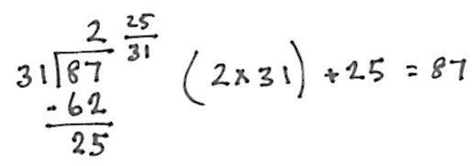
S: (Write $\frac{90}{30}$ = 3.)
T: Solve. Express the quotient as a mixed number.
T: Check the answer.
S: (Solve and check as shown to the right.)
Repeat the process using the following possible sequence: 82 ÷ 23 and 95 ÷ 27.
The Fibonacci Sequence (4 minutes)
Materials: (S) Personal white boards
Note: This fluency activity reviews G5–M6–Lesson 31 and leads into today’s lesson.
T: For 90 seconds, write as many numbers in the Fibonacci sequence as you can. Take your mark, get set, go.
S: (Write.)
T: Stop! Check your sequence with a partner for one minute.
S: (Check.)
T: Write down the last number you wrote at the top of your board. Now, see if you can get farther than you did before. Take 90 seconds to write the sequence again. Take your mark, get set, go!
S: (Write.)
T: Raise your hand if you were able to write more numbers in the sequence this time.
Application Problem (6 minutes)
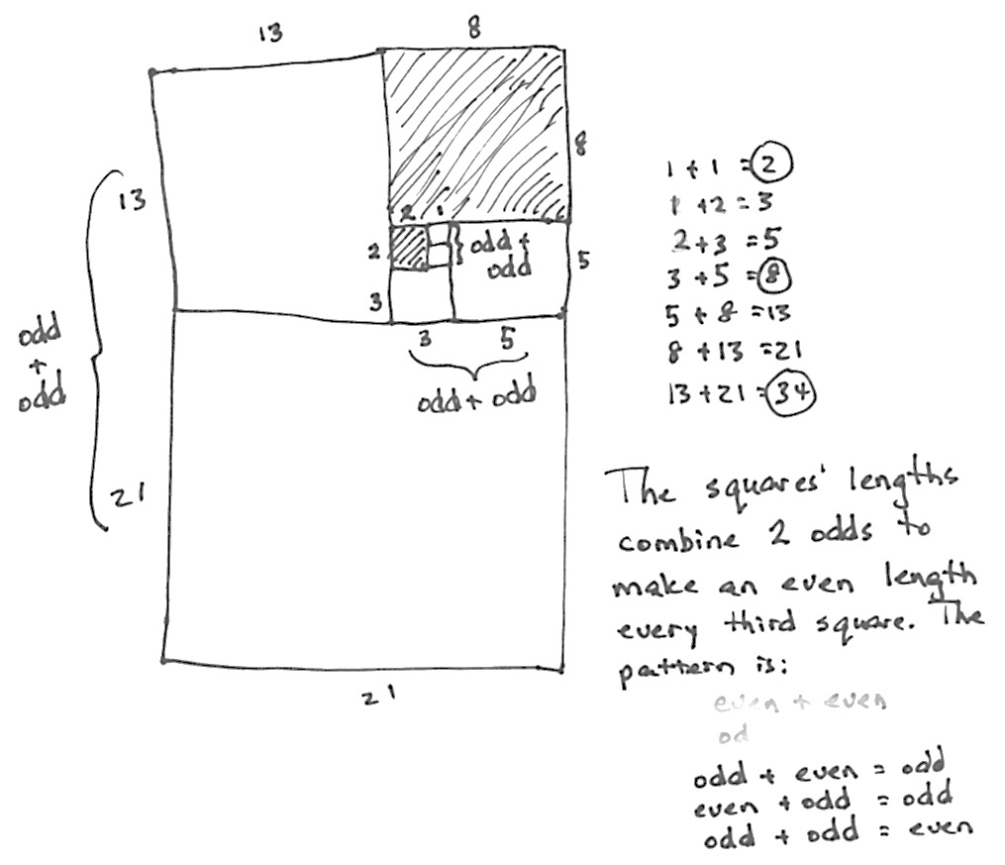
Look at the Fibonacci sequence you just wrote. Analyze which numbers are even.
Is there a pattern to the even numbers? Why? Think about the spiral of squares that you made yesterday.
Note: This Application Problem allows students the opportunity to analyze the sequence further.
Concept Development (32 minutes)
Materials: (T/S) Problem Set
Note: Today’s Problem Set is completed during instruction.
Problem 1: Ashley decides to save money, but she wants to build it up over a year. She starts with $1.00 and adds 1 more dollar each week. Complete the table to show how much she will have saved after a year.
T: Let’s read the problem together.
Read the problem chorally, or select a student to read the problem.
T: This is an interesting strategy for saving money. Have you ever tried to save money toward a goal?
S: Yes, but not with a number pattern. My parents pay for everything. No, but I want to try.
T: Work with a partner to fill in the table. When you are finished, answer the question at the top.
Circulate as students work. Ensure students participate equally and that each fill in their own tables. Have students who finish early check their numbers with other pairs.

NOTES ON
MULTIPLE MEANS OF ENGAGEMENT:
Some students may not have a realistic sense of what this amount of money can buy. Take the opportunity to discuss the cost of a car, for example, if that is one that comes up. If the class has Internet access, show or assign students to look prices up online.

T: How much will Ashley have saved?
S: $1,378!
T: Are you surprised? That seems like a lot of money, doesn’t it? What are some things Ashley could do with her savings?
S: She could buy a computer. She could go to Disney World. She could save it up to help with college.
T: Let’s see what happens in this next situation where Carly saves a little less at a time.
Problem 2: Carly wants to save money too, but she has to start with the smaller denomination of quarters. Complete the second chart to show how much she will have saved by the end of the year if she adds a quarter more each week.

NOTES ON
MULTIPLE MEANS OF EXPRESSION:
As students see varied growth patterns related to saving money, their number sense is supported. To expedite Problem 3, have students use a calculator. This will allow them to get to the finish line more quickly and compare the results of the three options of increasing the amount saved.
Have students complete the table as in Problem 1. When they have finished working, ask questions such as those suggested below:
- Do you think it’s worth it to save $344.50 in a year?
- What would you do if you saved that money?
- At what point might it be difficult for you to increase the daily amount you save by another quarter? (Amount of allowance and money they earn are possible limitations.)
- How much more money did Ashley save than Carly?
- How many of you would like to try saving as Carly did?
Problem 3: David decides he wants to save even more money than Ashley did. He does so by adding the next Fibonacci number instead of adding $1.00 each week. Use your calculator to fill in the chart and find out how much money he will have saved by the end of the year.
T: Is this amount of savings realistic for most people? Explain your answer.
If students are unable to finish this page, they may pack the charts into their summer boxes to finish later and to motivate their personal savings program.
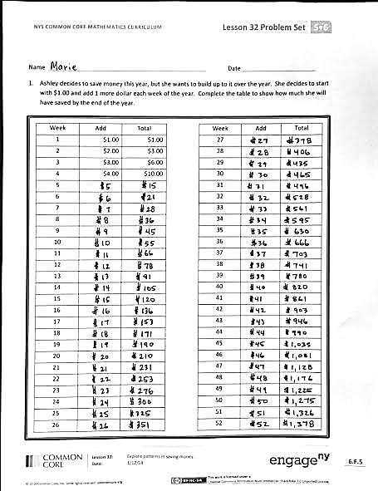
Student Debrief (10 minutes)
Lesson Objective: Explore patterns in saving money.
The Student Debrief is intended to invite reflection and active processing of the total lesson experience.
Invite students to review their solutions for the Problem Set. They should check work by comparing answers with a partner before going over answers as a class. Look for misconceptions or misunderstandings that can be addressed in the Debrief. Guide students in a conversation to debrief the Problem Set and process the lesson.
You may choose to use any combination of the questions below to lead the discussion.
- Why were the differences between the three totals so extreme?
- Which pattern is most realistic for fifth-grade students to do?
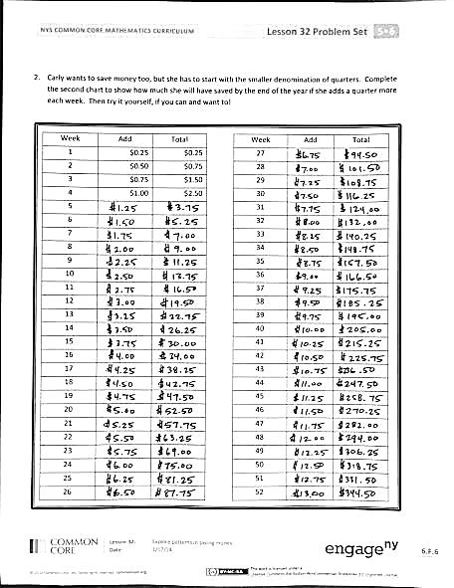
- What changes might you have to make in order to save like Carly did?
- Why is David’s approach not realistic for most people?
- What pattern did you notice between the total amount David has saved and the Fibonacci numbers?
- At which point did you have to start using a calculator to figure out David’s money?

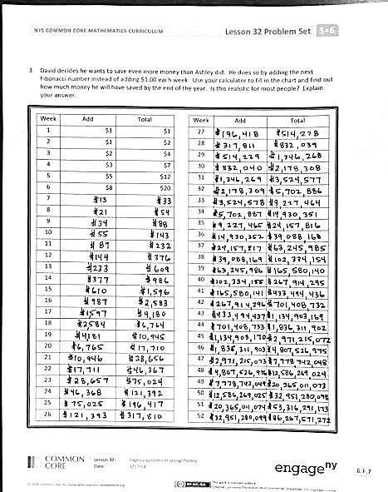
Reflection (3 minutes)
In G5–M6–Topic F, to close their elementary experience, the Exit Ticket is set aside and replaced by a brief opportunity to reflect on the mathematics done that day as it relates to the students’ broader experience of math.

Name Date
- Ashley decides to save money this year, but she wants to build it up over the year. She decides to start with $1.00 and add 1 more dollar each week of the year. Complete the table to show how much she will have saved by the end of the year.

Week | Add | Total |  | Week | Add | Total
1 | $1.00 | $1.00 |  | 27
2 | $2.00 | $3.00 |  | 28
3 | $3.00 | $6.00 |  | 29
4 | $4.00 | $10.00 |  | 30
5 |  |  |  | 31
6 |  |  |  | 32
7 |  |  |  | 33
8 |  |  |  | 34
9 |  |  |  | 35
10 |  |  |  | 36
11 |  |  |  | 37
12 |  |  |  | 38
13 |  |  |  | 39
14 |  |  |  | 40
15 |  |  |  | 41
16 |  |  |  | 42
17 |  |  |  | 43
18 |  |  |  | 44
19 |  |  |  | 45
20 |  |  |  | 46
21 |  |  |  | 47
22 |  |  |  | 48
23 |  |  |  | 49
24 |  |  |  | 50
25 |  |  |  | 51
26 |  |  |  | 52
- Carly wants to save money too, but she has to start with the smaller denomination of quarters. Complete the second chart to show how much she will have saved by the end of the year if she adds a quarter more each week. Try it yourself, if you can and want to!

Week | Add | Total |  | Week | Add | Total
1 | $0.25 | $0.25 |  | 27
2 | $0.50 | $0.75 |  | 28
3 | $0.75 | $1.50 |  | 29
4 | $1.00 | $2.50 |  | 30
5 |  |  |  | 31
6 |  |  |  | 32
7 |  |  |  | 33
8 |  |  |  | 34
9 |  |  |  | 35
10 |  |  |  | 36
11 |  |  |  | 37
12 |  |  |  | 38
13 |  |  |  | 39
14 |  |  |  | 40
15 |  |  |  | 41
16 |  |  |  | 42
17 |  |  |  | 43
18 |  |  |  | 44
19 |  |  |  | 45
20 |  |  |  | 46
21 |  |  |  | 47
22 |  |  |  | 48
23 |  |  |  | 49
24 |  |  |  | 50
25 |  |  |  | 51
26 |  |  |  | 52

- David decides he wants to save even more money than Ashley did. He does so by adding the next Fibonacci number instead of adding $1.00 each week. Use your calculator to fill in the chart and find out how much money he will have saved by the end of the year. Is this realistic for most people? Explain your answer.

Week | Add | Total |  | Week | Add | Total
1 | $1 | $1 |  | 27
2 | $1 | $2 |  | 28
3 | $2 | $4 |  | 29
4 | $3 | $7 |  | 30
5 | $5 | $12 |  | 31
6 | $8 | $20 |  | 32
7 |  |  |  | 33
8 |  |  |  | 34
9 |  |  |  | 35
10 |  |  |  | 36
11 |  |  |  | 37
12 |  |  |  | 38
13 |  |  |  | 39
14 |  |  |  | 40
15 |  |  |  | 41
16 |  |  |  | 42
17 |  |  |  | 43
18 |  |  |  | 44
19 |  |  |  | 45
20 |  |  |  | 46
21 |  |  |  | 47
22 |  |  |  | 48
23 |  |  |  | 49
24 |  |  |  | 50
25 |  |  |  | 51
26 |  |  |  | 52

Name Date
Today, we watched how savings can grow over time, but we didn’t discuss how the money saved was earned. Have you ever thought about how math skills might help you to earn money? If so, what are some jobs that might require strong math skills? If not, think about it now. How might you make a living using math skills?
Name Date
- Jonas played with the Fibonacci sequence he learned in class. Complete the table he started.
1 | 2 | 3 | 4 | 5 | 6 | 7 | 8 | 9 | 10
1 | 1 | 2 | 3 | 5 | 8
11 | 12 | 13 | 14 | 15 | 16 | 17 | 18 | 19 | 20

- As he looked at the numbers, Jonas realized he could play with them. He took two consecutive numbers in the pattern and multiplied them by themselves, then added them together. He found they made another number in the pattern. For example, (3$\text{×}$3) + (2$\text{×}$2) = 13, another number in the pattern. Jonas said this was true for any two consecutive Fibonacci numbers. Was Jonas correct? Show your reasoning by giving at least two examples of why he was or was not correct.

3. Fibonacci numbers can be found in many places in nature. For example, the number of petals in a daisy, the number of spirals in a pine cone or a pineapple, and even the way branches grow on a tree. Find an example of something natural where you can see a Fibonacci number in action and sketch it here.

