Lesson 31
Objective: Explore the Fibonacci sequence.

Suggested Lesson Structure
 Application Problem (10 minutes)
 Fluency Practice (10 minutes)
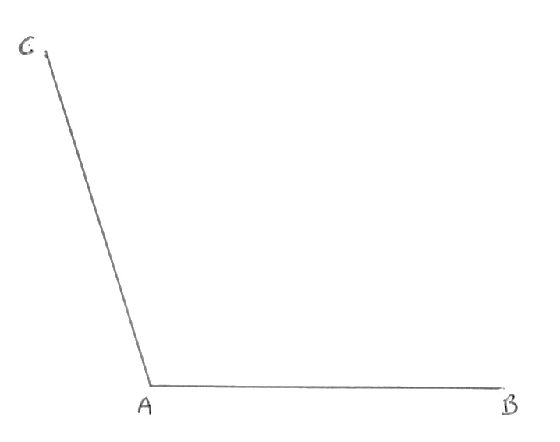
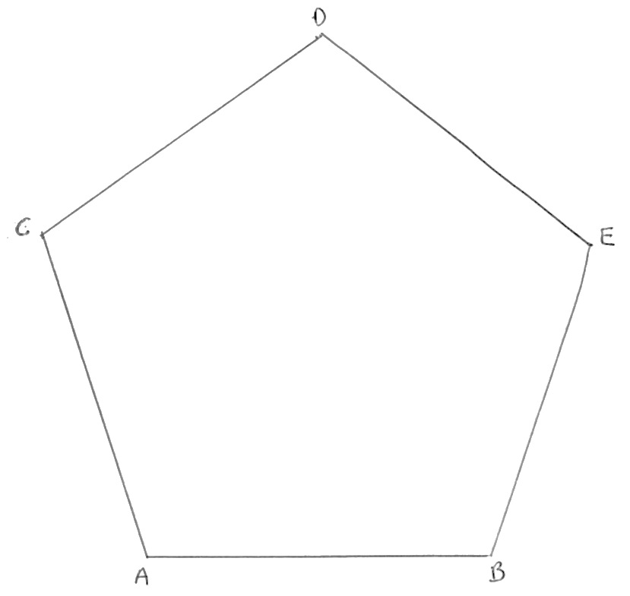
 Concept Development (30 minutes)
 Student Debrief (10 minutes)
Total Time (60 minutes)
Application Problem (10 minutes)
Materials: (S) Protractor, white paper, ruler
- Draw $\overline{AB}$ 3 inches long centered near the bottom of a blank piece of paper.
- Draw $\overline{AC}$ 3 inches long, such that $∠BAC$ measures 108$°.$
- Draw $\overline{CD}$ 3 inches long, such that $∠ACD$ measures 108$°.$
- Draw $\overline{DE}$ 3 inches long, such that $∠CDE$ measures 108$°.$
- Draw $\overline{EB}$.
- Measure $\overline{EB}$.

NOTES ON
MULTIPLE MEANS OF EXPRESSION:
Have early finishers or those enamored of drawing try to create other regular polygons by repeating other angle measures such as 60$°, 90°$, 120$°,$ 135$°$ in a similar, systematic way. Challenge them to construct triangles, squares, hexagons, and octagons. Some students simply love to draw. Challenge them to try constructing other shapes at home.

T: What is the length of $\overline{EB}?$
S: 3 inches.
T: What shape have you drawn?
S: Pentagon.
Note: Students apply their skill with angle measurement from G5–Module 5 to further explore polygons and experience the beauty and joy of geometry.
Fluency Practice (10 minutes)
- Divide Whole Numbers by Unit Fractions and
Unit Fractions by Whole Numbers 5.NF.7 (4 minutes)
- Quotients as Mixed Numbers 5.NBT.6 (6 minutes)
Divide Whole Numbers by Unit Fractions and Unit Fractions by Whole Numbers (4 minutes)
Materials: (S) Personal white boards
Note: This fluency activity reviews G5–Module 4 concepts.
T: (Write 2 ÷ $\frac{\text{1}}{\text{5}}$.) Say the division sentence.
S: 2 ÷ $\frac{\text{1}}{\text{5}}$ = 10.
T: (Write 2 ÷ $\frac{\text{1}}{\text{5}}$ = 10. Beneath it, write 3 ÷ $\frac{\text{1}}{\text{5}}$.) Say the division sentence.
S: 3 ÷ $\frac{\text{1}}{\text{5}}$ = 15.
T: (Write 3 ÷ $\frac{\text{1}}{\text{5}}$ = 15. Beneath it, write 7 ÷ $\frac{\text{1}}{\text{5}}$.) On your boards, complete the division sentence.
S: (Write 7 ÷ $\frac{\text{1}}{\text{5}}$ = 35.)
Continue the process with 4 ÷ $\frac{\text{1}}{\text{4}}$, 8 ÷ $\frac{\text{1}}{\text{3}}$, 1 ÷ $\frac{\text{1}}{\text{10}}$, 2 ÷ $\frac{\text{1}}{\text{10}}$, 9 ÷ $\frac{\text{1}}{\text{10}}$, and 10 ÷ $\frac{\text{1}}{\text{10}}$.
T: (Write $\frac{\text{1}}{\text{5}}$ ÷ 3.) Say the division sentence.
S: $\frac{\text{1}}{\text{5}}$ ÷ 3 = $\frac{\text{1}}{\text{15}}$.
T: (Write $\frac{\text{1}}{\text{5}}$ ÷ 3 = $\frac{\text{1}}{\text{15}}$. Beneath it, write $\frac{\text{1}}{\text{4}}$ ÷ 4.) Say the division sentence.
S: $\frac{\text{1}}{\text{4}}$ ÷ 4 = $\frac{\text{1}}{\text{16}}$.
T: (Write $\frac{\text{1}}{\text{4}}$ ÷ 4 = $\frac{\text{1}}{\text{16}}$. Beneath it, write $\frac{\text{1}}{\text{8}}$ ÷ 6.) On your boards, write the division sentence.
S: (Write $\frac{\text{1}}{\text{8}}$ ÷ 6 = $\frac{\text{1}}{\text{48}}$.)
T: (Write $\frac{\text{1}}{\text{6}}$ ÷ 3.) Say the division sentence.
S: $\frac{\text{1}}{\text{6}}$ ÷ 3 = $\frac{1}{18}$.
Continue the process with 9 ÷ $\frac{\text{1}}{\text{4}}$, $\frac{\text{1}}{\text{4}}$ ÷ 9, 5 ÷ $\frac{\text{1}}{\text{8}}$, $\frac{\text{1}}{\text{8}}$ ÷ 5, $\frac{\text{1}}{\text{6}}$ ÷ 9, and 8 ÷ $\frac{\text{1}}{\text{9}}$.

Quotients as Mixed Numbers (6 minutes)
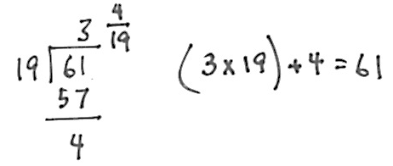
Materials: (S) Personal white board, calculator
Note: This fluency activity reviews G5–Module 2 content and directly leads into today’s lesson where students use a calculator to find quotients in order to see patterns.
T: (Write $\frac{61}{19}$.) On your boards, demonstrate how to estimate the quotient.
S: (Write $\frac{60}{20}$= 3.)
T: Solve. Express the quotient as a mixed number.
T: Check the answer.
S: (Solve and check as exemplified in the illustration.)
Repeat the process using the following possible sequence: 79 ÷ 22 and 97 ÷ 31.
Concept Development (30 minutes)
Materials: (T) Collection of pine cones, flowers, “Doodling in Math: Spirals, Fibonacci, and Being a Plant” by Vi Hart (http://youtu.be/ahXIMUkSXX0) (S) Problem Set, red crayon, ruler or straightedge, calculator per student or pair
Note: The Problem Set will be used for the construction of the Fibonacci spiral in today’s lesson.
Part 1: Construct a spiral of squares on grid paper.
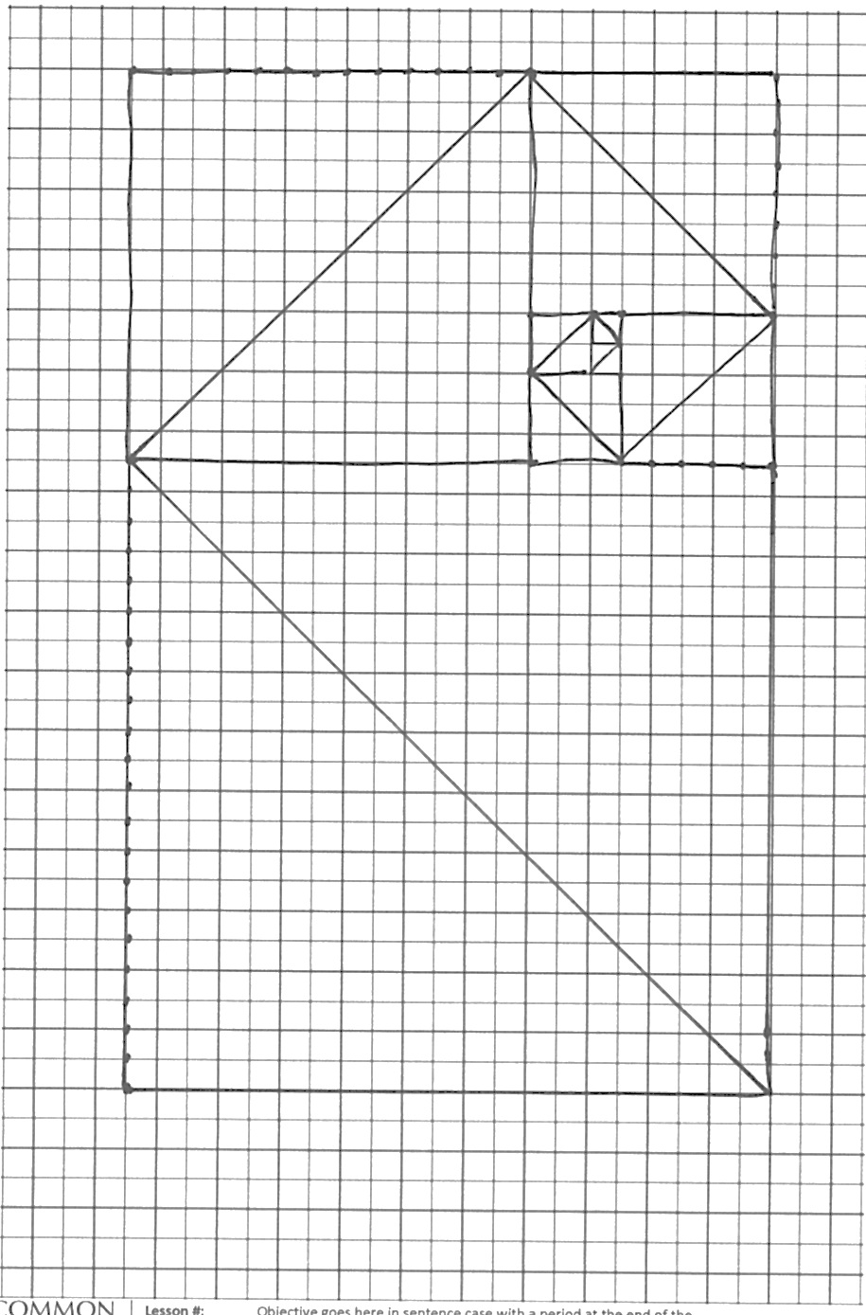
T: (Distribute Problem Set [grid paper with grey square].) Let’s create a beautiful pattern of squares. Draw another square that shares a side length above the grey square. (Allow students time to draw.)
T: Draw a diagonal across the first square from the bottom, left to the top right vertex. Next, draw a diagonal across your new square from the bottom, right to the top left vertex. (Allow students time to draw.)
T: This 2 by 1 rectangle has a longer side length of…?
S: 2 units.
T: Draw a new square that shares the side length of 2 units on the left of this rectangle. (Point up and down the left vertical side length of the 2 by 1 rectangle. Allow students time to draw.)
T: Draw a diagonal across your new 2-by-2 square starting where the last one left off—at the top right vertex and going to the bottom left vertex. (Allow students time to draw.)
T: What is the length of the longer side of this rectangle that we’ve now drawn?
S: 3 units.
T: Draw a new square that shares the side length of 3 units on bottom of this rectangle. (Point along the horizontal base of the 3-by-2 rectangle.) Draw the diagonal starting where the last one left off. (Allow students time to draw.)
T: Discuss with your partner where you think the next square will be and what its dimensions will be.
S: I know it is going to start where the diagonal left off. That is the side length of the 5-by-3 rectangle it will share, so the new square is going to be 5 by 5. Its side length is found by adding 3 + 2 = 5. The side length of the new square is going to be the sum of the last two squares’ side lengths.
T: Yes, it is going to the right. Go ahead and draw your new square and its diagonal.
S: (Draw.)
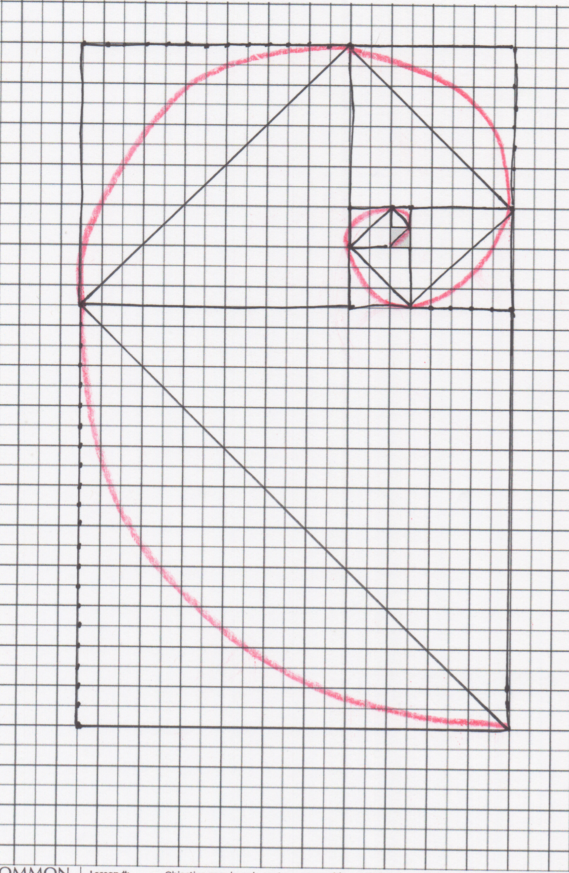
Continue through the squares, supporting as necessary. Many students will see the pattern and be able to work in partners or independently. It is suggested that students use rulers to draw the diagonals starting with the 8-by-8 square.
Part 2: Analyze the sequence of a square’s dimensions to generate the Fibonacci sequence.
T: Below your grid, write down the sequence of side lengths of the squares. Work with your partner to see if you can figure out what the next numbers in the sequence would be if we had a really large piece of graph paper.
S: (Write and talk.) 1, 1, 2, 3, 5, 8, 13, 21, 34, 55, 89, 144, 233, 377, 610, 987….
T: Stop. Check your sequence with another pair and explain your thinking.
S: We realized that the sum of the last two side lengths was the new length. The next number in the pattern was the sum of the two numbers right before it in the pattern.
T: This pattern is called the Fibonacci sequence.
T: Do you see the spiral you started to draw formed by the diagonals? Let’s round that out a bit more so that the lines are no longer straight. Use a red crayon. (Model as shown to the right.)
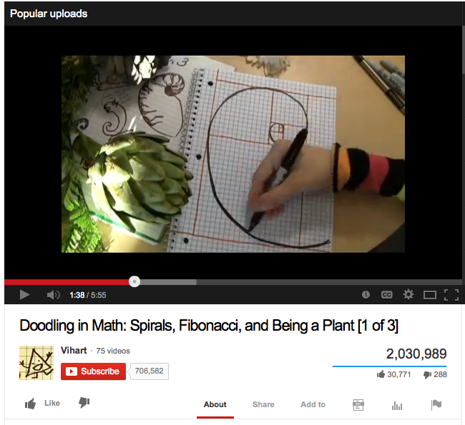
T: What would happen to this spiral if we continued our sequence?
Part 3: Watch “Doodling in Math: Spirals, Fibonacci, and Being a Plant” by Vi Hart.
Have students discuss the video and analyze any pine cones, flowers, or materials brought to the session, counting the spirals and looking for patterns.
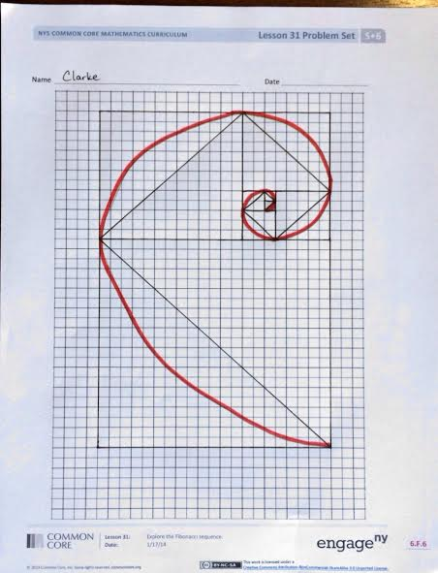
Student Debrief (10 minutes)
Lesson Objective: Explore the Fibonacci sequence.
The Student Debrief is intended to invite reflection and active processing of the total lesson experience.
Invite students to review their solutions for the Problem Set. They should check work by comparing answers with a partner before going over answers as a class. Look for misconceptions or misunderstandings that can be addressed in the Debrief. Guide students in a conversation to debrief the Problem Set and process the lesson.
You may choose to use any combination of the questions below to lead the discussion.
- The numerical sequence we studied today is called the Fibonacci sequence. Summarize to your partner the rule that generated the sequence.
- Do you remember the first few Fibonacci numbers? Try to tell the sequence to a partner.

NOTES ON
MULTIPLE MEANS OF REPRESENTATION:
Students can make art based on the spiral such as the simple design below. They can use the art to decorate the summer boxes they create in G5–M6–Lessons 33–34.

- What surprised you most when you looked at the video?
- If you have access to the Internet, you can find a lot of interesting material about the Fibonacci numbers found in art and nature. What other questions do you still have about the Fibonacci numbers?
- Compare drawing the pentagon earlier and drawing the spiral using the Fibonacci sequence.
Reflection (3 minutes)
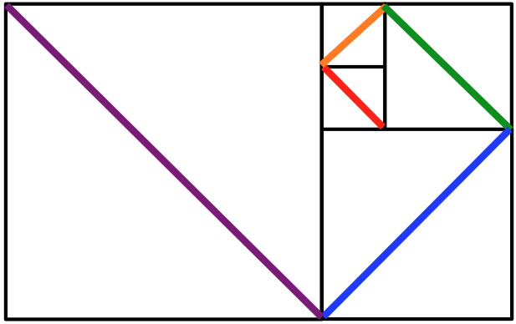
In G5–M6–Topic F, to close their elementary experience, the Exit Ticket is set aside and replaced by a brief opportunity to reflect on the mathematics done that day as it relates to the students’ broader experience of math.

Name Date

Name Date
Today when we saw a video on the Fibonacci sequence in the spiral and in nature it may have felt a bit like “math magic.” Have you ever felt math magic in your elementary school years? If so, when did you experience it? If not, did you experience it today? Explain.

Name Date
- List the Fibonacci numbers up to 21, and create a spiral of squares corresponding to each of the numbers you write on the graph paper below.

- In the space below, write a rule that generates the Fibonacci sequence.

- Write at least the first 15 numbers of the Fibonacci sequence.

