Lesson 30
Objective: Solidify the vocabulary of geometry.

Suggested Lesson Structure
 Fluency Practice (10 minutes)
 Concept Development (40 minutes)
 Student Debrief (10 minutes)
Total Time (60 minutes)
Fluency Practice (10 minutes)
- Multiply 5.NBT.5 (5 minutes)
- Unit Conversions 5.MD.1 (5 minutes)
Multiply (5 minutes)
Materials: (S) Personal white boards
Note: This fluency activity reviews year-long fluency standards.
T: Solve 57 $\text{×}$ 37 using the standard algorithm.
S: (Write 57 $\text{×}$ 37 = 2,109 using the standard algorithm.)
Continue the process for 457 $\text{×}$ 37, 68 $\text{×}$ 43, 568 $\text{×}$ 43, and 749 $\text{×}$ 72.
Unit Conversions (5 minutes)
Materials: (S) Personal white boards
Note: This fluency activity reviews G5–Module 4 concepts.
T: (Write $\frac{1}{2}$ ft = ___ in.) How many inches are in 1 foot?
S: 12 inches.
T: (Write $\frac{1}{2}$ $\text{×}$ 1 ft.) Write an equivalent expression using inches and convert.
S: (Write $\frac{1}{2}$ $\text{×}$ 12 in = 6 in.)
T: $\frac{1}{2}$ ft is how many inches?
S: 6 inches.
Repeat the process for the following possible sequence: $\frac{1}{3}$ ft, $\frac{3}{4}$ ft, and $\text{5}\frac{1}{4}$ft.
T: (Write 40 cm = ___ m.) How many centimeters in a meter?
S: 100 centimeters.
T: (Write 40 $\text{×}$ 1 cm.) Write an equivalent expression using meters and convert.
S: (Write 40 $\text{×}\frac{1}{100}$ m = $\frac{40}{100}$ m.)
T: Fill in the blank with a decimal number.
S: 0.40 meters.
T: Fill in the blank with a simplified fraction.
S: $\frac{2}{5}$ meters.
Repeat the process and procedure for 25 cm, 70 cm, 90 cm, 57 cm, and 9 cm.
Concept Development (40 minutes)
Materials: (S) Geometry pictorial vocabulary cards from G5–M6–Lesson 29, Problem Set of card stock game directions
Students use the term and definition description cards created in G5–M6–Lesson 29 to play the following games. The definition and description cards must be cut out to play Concentration. Game directions and cards should be cut out and housed in the summer activity boxes to be made in G5–M6–Lessons 33 and 34.
Game A: Three Questions to Guess my Term!
Number of players: 2–4
Description: A player selects and secretly views a term card. Other players take turns asking yes or no questions about the term.
- Players can keep track of what they know about the term on paper.
- Only yes or no questions are allowed (e.g., “What kind of angles do you have?” is not allowed).
- A final guess must be made after 3 questions, but may be made sooner. Once a player says, “This is my guess,” no more questions may be asked by that player.
- If the term is guessed correctly after 1 or 2 questions, 2 points are earned. If all 3 questions are used, only 1 point is earned.
- If the no player guesses correctly, the card holder receives the point.
- The game continues as the player to the card holder’s left selects a new card and questioning begins again.
The game ends when a player reaches a predetermined score.

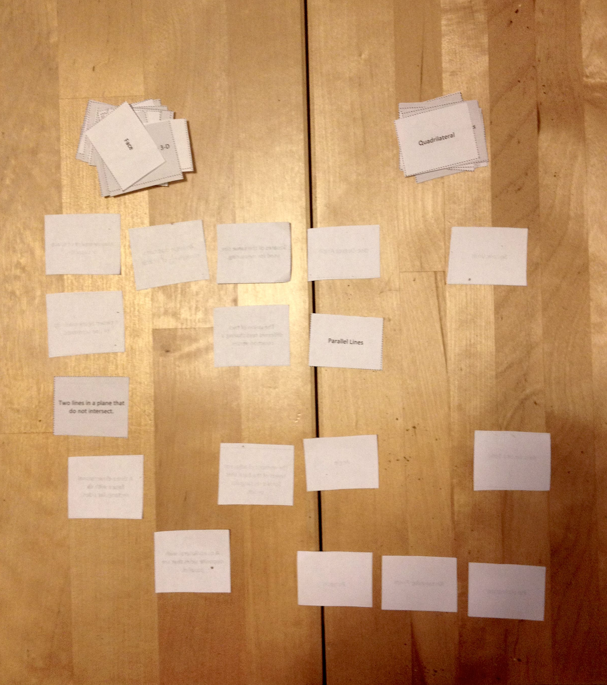
Game B: Concentration
Concentration Example
Number of players: 2–6
Description: Players persevere to match term cards with their definition and description cards.
- Create two identical arrays side by side, one of term cards and one of definition and description cards.
- Players take turns flipping over pairs of cards to find a match. A match is a vocabulary term and its definition or description card. Cards keep their precise location in the array if not matched. Remaining cards are not reconfigured into a new array.
- After all cards are matched, the player with the most pairs is the winner.
Game C: Attribute Buzz
Number of players: 2
Description: Players place geometry vocabulary cards face down in a pile and, as they select cards, name the attributes of each figure within 1 minute.
- Player A flips the first card and says as many attributes as possible within 30 seconds.

NOTES ON
MULTIPLE MEANS OF ENGAGEMENT:
Smaller groups of players allow for more students to participate in games simultaneously. This reduces wait time and also helps to keep students on task.
- Player B says, “Buzz,” when or if Player A states an incorrect attribute or time is up.
- Player B explains why the attribute is incorrect (if applicable), and can then start listing attributes about the figure for 30 seconds.
- Players score a point for each correct attribute.
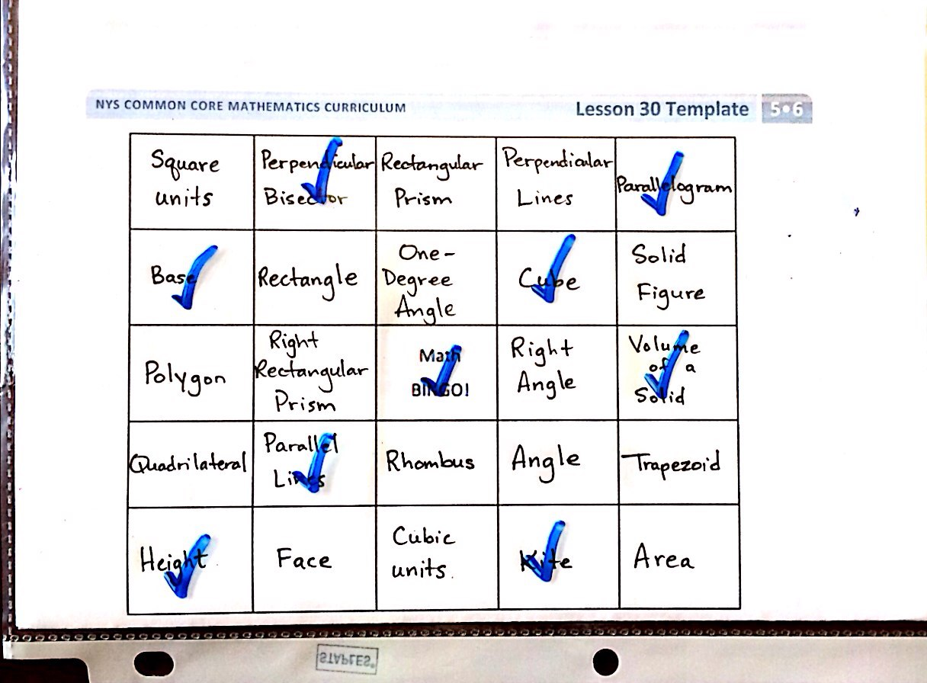
Play continues until students have exhausted the figure’s attributes. A new card is selected and play continues. The player with the most points at the end of the game wins.
Bingo Game Example
Game D: Bingo
Number of players: 4–whole class
Materials: Bingo cards
Description: Players match definitions to terms to be the first to fill a row, column, or diagonal.
- Players write a vocabulary term in each box of the math bingo game template. Each term should be used only once. The box that says math bingo is a free space.
- Players place the filled-in math bingo template in their personal boards.
- One person is the caller and reads the definition on a vocabulary card.
- Players cross off or cover the term that matches the definition.
- “Bingo!” is called when 5 vocabulary terms in a row are crossed off diagonally, vertically, or horizontally. The free space counts as 1 box towards the needed 5 vocabulary terms.
- The first player to have 5 in a row reads each crossed off word, states the definition, and gives a description or an example of each word. If all words are reasonably explained as determined by the caller, the player is declared the winner.
Student Debrief (10 minutes)
Lesson Objective: Solidify the vocabulary of geometry.
Invite students to review their solutions for the Problem Set. They should check work by comparing answers with a partner before going over answers as a class. Look for misconceptions or misunderstandings that can be addressed in the Debrief. Guide students in a conversation to debrief the Problem Set and process the lesson.
You may choose to use any combination of the questions below to lead the discussion.
- Which games did you choose to include in your summer activity box? Why?
- Which game did you enjoy the most? Why?
- Which game was most challenging? Why?
- How will playing these games during the summer help you prepare for Grade 6?
Reflection (3 minutes)
In G5–M6–Topic F, to close their elementary experience, the Exit Ticket is set aside and replaced by a brief opportunity to allow students to reflect on the mathematics done that day as it relates to their broader experience of math.

Three Questions to Guess my Term!
Number of players: 2–4
Description: A player selects and secretly views a term card. Other players take turns asking yes or no questions about the term.
- Players can keep track of what they know about the term on paper.
- Only yes or no questions are allowed (e.g., “What kind of angles do you have?” is not allowed.)
- A final guess must be made after 3 questions, but may be made sooner. Once a player says, “This is my guess,” no more questions may be asked by that player.
- If the term is guessed correctly after 1 or 2 questions, 2 points are earned. If all 3 questions are used, only 1 point is earned.
- If no player guesses correctly, the card holder receives the point.
- The game continues as the player to the card holder’s left selects a new card and questioning begins again.
- The game ends when a player reaches a predetermined score.

Attribute Buzz:
Number of players: 2
Description: Players place geometry vocabulary cards face down in a pile and, as they select cards, name the attributes of each figure within 1 minute.
- Player A flips the first card and says as many attributes as possible within 30 seconds.
- Player B says, “Buzz,” when or if Player A states an incorrect attribute or time is up.
- Player B explains why the attribute is incorrect (if applicable), and can then start listing attributes about the figure for 30 seconds.
- Players score a point for each correct attribute.
Play continues until students have exhausted the figure’s attributes. A new card is selected and play continues. The player with the most points at the end of the game wins.

Bingo:
Number of players: 4–whole class
Description: Players match definitions to terms to be the first to fill a row, column or diagonal.
- Players write a vocabulary term in each box of the math bingo game template. Each term should be used only once. The box that says Math Bingo is a free space.
- Players place the filled-in math bingo template in their personal boards.
- One person is the caller and reads the definition on a vocabulary card.
- Players cross off or cover the term that matches the definition.
- “Bingo!” is called when 5 vocabulary terms in a row are crossed off diagonally, vertically, or horizontally. The free space counts as 1 box towards the needed 5 vocabulary terms.
- The first player to have 5 in a row, reads each crossed off word, states the definition, and gives a description or an example of each word. If all words are reasonably explained as determined by the caller, the player is declared the winner.
Concentration:
Number of players: 2–6
Description: Players persevere to match term cards with their definition and description cards.
- Create two identical arrays side by side, one of term cards and one of definition and description cards.
- Players take turns flipping over pairs of cards to find a match. A match is a vocabulary term and its definition or description card. Cards keep their precise location in the array if not matched. Remaining cards are not reconfigured into a new array.
- After all cards are matched, the player with the most pairs is the winner.

Name Date
Playing math games can be a fun way to practice math skills. How will you use the games to retain these terms over the summer? Who will play with you? How can you change the games to play alone? How often will you play the games?

Name Date
Teach someone at home how to play one of the games you played today with your pictorial vocabulary cards. Then answer the questions below.

- What games did you play?

- Who played the games with you?

- What was it like to teach someone at home how to play?

- Did you have to teach the person who played with you any of the math concepts before you could play? Which ones? What was that like?

- When you play these games at home again, what changes will you make? Why?
