Lesson 29
Objective: Solidify the vocabulary of geometry.

Suggested Lesson Structure
 Fluency Practice (12 minutes)
 Concept Development (38 minutes)
 Student Debrief (10 minutes)
Total Time (60 minutes)
Fluency Practice (12 minutes)
- Sprint: Multiply Decimals 5.NBT.7 (9 minutes)
- Multiply Mentally 5.NBT.5 (3 minutes)
Sprint: Multiply Decimals (9 minutes)
Materials: (S) Multiply Decimals Sprint
Note: This fluency activity reviews G5–Module 4 concepts.
Multiply Mentally (3 minutes)

NOTES ON
MULTIPLE MEANS OF ENGAGEMENT:
To make the Multiply Mentally fluency activity directions clear to English language learners, give an example before asking students to respond. Differentiate for students working above grade level by challenging learners to respond without writing. Also, encourage them to analyze the strategy and present multiplication sentences that best suits it, such as using the distributive property to solve 7 $\text{×}$ 99.

Materials: (S) Personal white boards
Note: This fluency activity drill helps bolster students’ understanding of and automaticity with the distributive property of multiplication.
T: (Write 7 $\text{×}$ 10 = ___.) Say the multiplication sentence.
S: 7 $\text{×}$ 10 = 70.
T: (Write 7 $\text{×}$ 9 = 70 – ____ below 7 $\text{×}$ 10 = 70.) On your personal boards, write the complete number sentence.
S: (Write 7 $\text{×}$ 9 = 70 – 7.)
T: 7 $\text{×}$ 9 is…?
S: 63.
Repeat the process and procedure for 7 $\text{×}$ 99, 15 $\text{×}$ 9, and 31 $\text{×}$ 99.
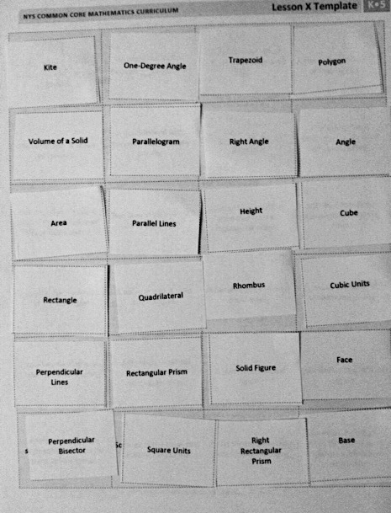
Concept Development (38 minutes)
Materials: (S) Chart paper or personal white board, scissors, Problem Set (copied on card stock), Math Pictionary directions (shown below), small envelope, 30-second timer
Today, students use the vocabulary terms of the Problem Set to play Math Pictionary.
Part 1: Match terms to definitions.
Students begin by cutting out the vocabulary terms and matching them to the intact card of definitions on the Problem Set by placing the correct term on top of its matching definition (pictured to the right). Let them review terms with each other and argue until a consensus is reached. Possibly review answers.
The definitions can then be collected and saved for use in G5−M6−Lesson 30 (later to be stored in the summer activity box).
Math Pictionary:
Number of players: 4−8
Materials: Blank paper, timer, pencils
- Players divide into 2 teams. The vocabulary term cards are placed face down in a pile.
- A player from Team A chooses a card, silently reads the card, and draws a picture to represent the term on the card.
- As soon as the player reads the card, Team B starts the 30-second timer.
- Team A players use the drawing to figure out the term before the timer sounds.
- If the members of Team A correctly guess the term, they score a point for their team.
- However, the first wrong guess from Team A passes play to Team B. Team B then draws a picture to steal the point from Team A.
- Play continues with teams taking turns drawing until all cards have been used. The team with the most points wins.

Part 2: Play Pictionary.
Students can play using the rules in the directions to the right. Demonstrating a round of the game as a whole class, then moving to play in small groups may maximize engagement.
Note on game directions: The first wrong guess from a team passes play to the other team. The purpose of this is two-fold. First of all, it encourages students to be as specific as possible when drawing to represent each vocabulary term. Secondly, it discourages teams from just running through a list of vocabulary words until they say the correct word.
MP.6
After the session, students can put the vocabulary terms in a small envelope. The terms will be used in G5−M6−Lesson 30 and will be stored in the summer activity box. Each student should also receive a copy of the game directions to put in his/her summer activity box.

Problem Set
Note: The Problem Set for G5−M6−Lesson 29 is the vocabulary definitions and terms.
Student Debrief (10 minutes)
Lesson Objective: Solidify the vocabulary of geometry.
The Student Debrief is intended to invite reflection and active processing of the total lesson experience.
Invite students to review their solutions for the Problem Set. They should check work by comparing answers with a partner before going over answers as a class. Look for misconceptions or misunderstandings that can be addressed in the Debrief. Guide students in a conversation to debrief the Problem Set and process the lesson.
You may choose to use any combination of the questions below to lead the discussion.
- Which picture or model was most difficult for you to draw? Why?
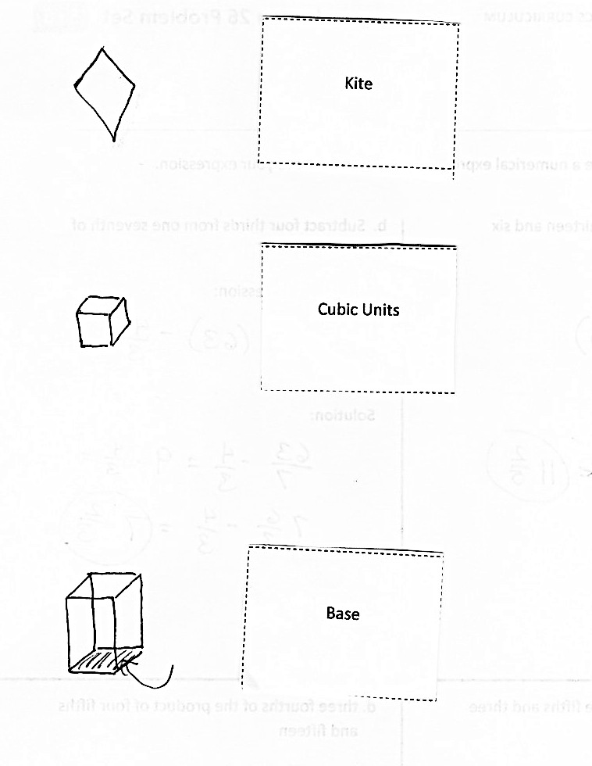
- How does drawing pictures and models help you understand and review these geometry terms?
- How can you use your pictorial vocabulary cards during the summer to review these geometry terms?
- Which terms go together? Why? (Students will have many ways of sorting these concepts.)
Reflection (3 minutes)
In G5–M6–Topic F, to close their elementary experience, the Exit Ticket is set aside and replaced by a brief opportunity to reflect on the mathematics done that day as it relates to their broader experience of math.

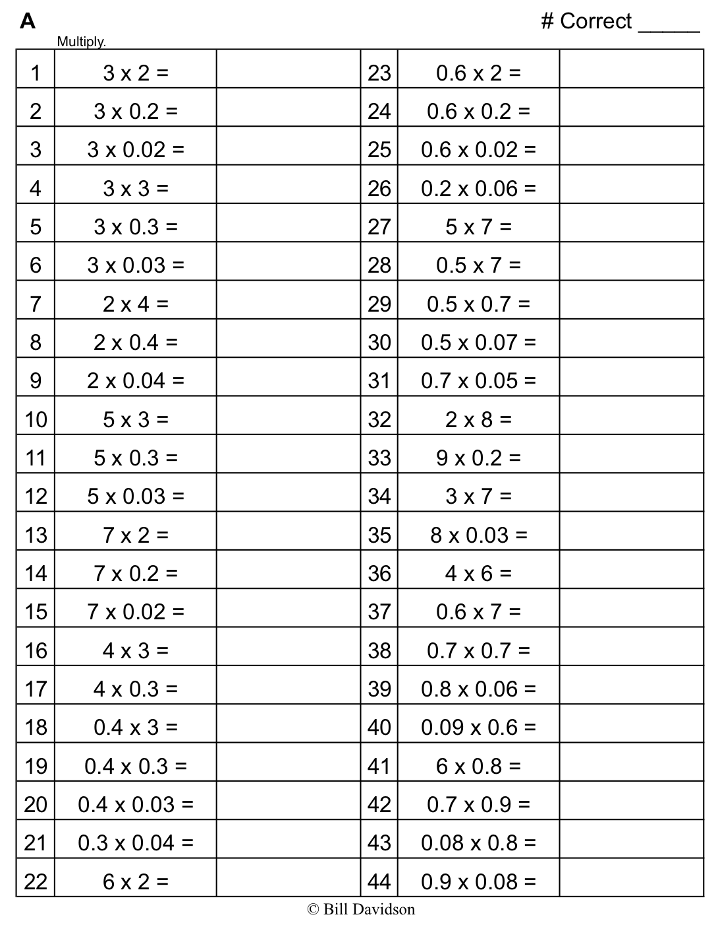
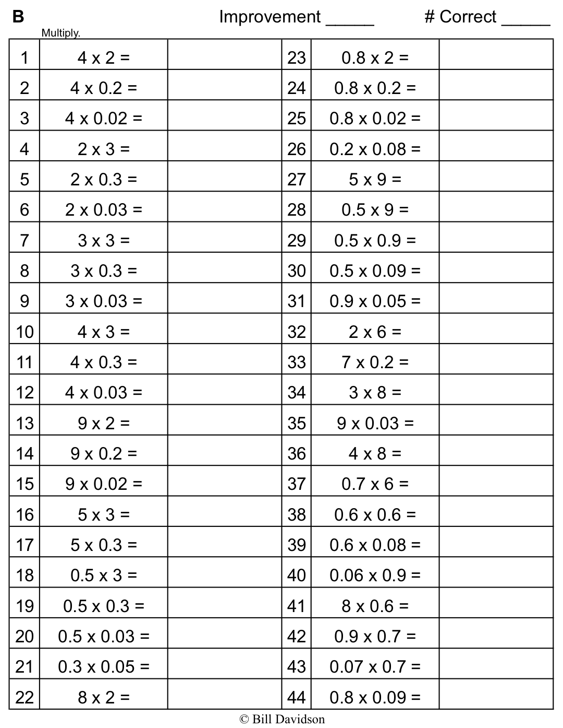
A quadrilateral with two pairs of equal sides that are also adjacent. | An angle that turns through $\frac{1}{360}$ of a circle. | A quadrilateral with at least one pair of parallel lines. | A closed figure made up of line segments.
Measurement of space or capacity. | A quadrilateral with opposite sides that are parallel. | An angle measuring 90 degrees. | The union of two different rays sharing a common vertex.
The number of square units that covers a two-dimensional shape. | Two lines in a plane that do not intersect. | The number of adjacent layers of the base that form a rectangular prism. | A three-dimensional figure with six square sides.
A quadrilateral with four 90-degree angles. | A polygon with 4 sides and 4 angles. | A parallelogram with all equal sides. | Cubes of the same size used for measuring.
Two intersecting lines that form 90-degree angles. | A three-dimensional figure with six rectangular sides. | A three-dimensional figure. | Any flat surface of a 3-D figure.
A line that cuts a line segment into two equal parts at 90 degrees. | Squares of the same size, used for measuring. | A rectangular prism with only 90-degree angles. | One face of a 3-D solid, often thought of as the surface upon which the solid rests.

Base | Volume of a Solid | Cubic Units | Kite
Height | One-Degree Angle | Face | Trapezoid
Right  Rectangular  Prism | Perpendicular  Bisector | Cube | Area
Perpendicular  Lines | Rhombus | Parallel Lines | Angle
Polygon | Rectangular Prism | Parallelogram | Rectangle
Right Angle | Quadrilateral | Solid Figure | Square Units

Name Date
It is said that the true measure of knowing something is being able to teach it to someone else. Who can you teach these terms to this summer? How will you teach these terms to your summer student?

Name Date
- Use your ruler, protractor, and set square to help you give as many names as possible for each figure below. Then, explain your reasoning for how you named each figure.
Figure | Names | Reasoning for Names
- Mark draws a figure that has the following characteristics:
- Exactly 4 sides that are each 7 centimeters long
- Two sets of parallel lines
- Exactly 4 angles that measure 35 degrees, 145 degrees, 35 degrees, and 145 degrees

- Draw and label Mark’s figure below.

- Give as many names of quadrilaterals as possible for Mark’s figure. Explain your reasoning for the names of Mark’s figure.

- List the names of Mark’s figure in Problem 2(b) in order from least specific to most specific. Explain your thinking.

Math Pictionary:
Number of players: 4–8
Materials: Blank paper, timer, pencils
- Players divide into two teams. The vocabulary term cards are placed face down in a pile.
- A player from Team A chooses a card, silently reads the card, and draws a picture to represent the term on the card.
- As soon as the player reads the card, Team B starts the 30-second timer.
- Team A players use the drawing to figure out the term before the timer sounds.
- If the members of Team A correctly guess the term, they score a point for their team.
- However, the first wrong guess from Team A passes play to Team B. Team B then draws a picture to steal the point from Team A.
- Play continues with teams taking turns drawing until all cards have been used. The team with the most points wins.

Math Pictionary:
Number of players: 4–8
Materials: Blank paper, timer, pencils
- Players divide into two teams. The vocabulary term cards are placed face down in a pile.
- A player from Team A chooses a card, silently reads the card, and draws a picture to represent the term on the card.
- As soon as the player reads the card, Team B starts the 30-second timer.
- Team A players use the drawing to figure out the term before the timer sounds.
- If the members of Team A correctly guess the term, they score a point for their team.
- However, the first wrong guess from Team A passes play to Team B. Team B then draws a picture to steal the point from Team A.
- Play continues with teams taking turns drawing until all cards have been used. The team with the most points wins.

Math Pictionary:
Number of players: 4–8
Materials: Blank paper, timer, pencils
- Players divide into two teams. The vocabulary term cards are placed face down in a pile.
- A player from Team A chooses a card, silently reads the card, and draws a picture to represent the term on the card.
- As soon as the player reads the card, Team B starts the 30-second timer.
- Team A players use the drawing to figure out the term before the timer sounds.
- If the members of Team A correctly guess the term, they score a point for their team.
- However, the first wrong guess from Team A passes play to Team B. Team B then draws a picture to steal the point from Team A.
- Play continues with teams taking turns drawing until all cards have been used. The team with the most points wins.

