Lesson 28
Objective: Solidify fluency with Grade 5 skills.
Suggested Lesson Structure
 Fluency Practice (50 minutes)
 Student Debrief (10 minutes)
Total Time (60 minutes)
Fluency Practice (50 minutes)
Mixed Review Fluency Activities

NOTES ON
MULTIPLE MEANS OF ACTION AND EXPRESSION:
Students benefit from practicing fluency areas of both strength and weakness. As they get stronger at what they are good at, they can start to see connections that empower them in their areas of weakness. Encourage them to balance their practice.
Materials: (S) Fluency activity template, Problem Set, personal white board
Part 1: Reflect on fluency.
T: This year, we devoted time each day to practicing different skills. Think about these fluency activities as you answer the questions in Problem 1.
S: (Answer the six components of Problem 1 listed below.)
Problem 1: Answer the following questions about fluency.
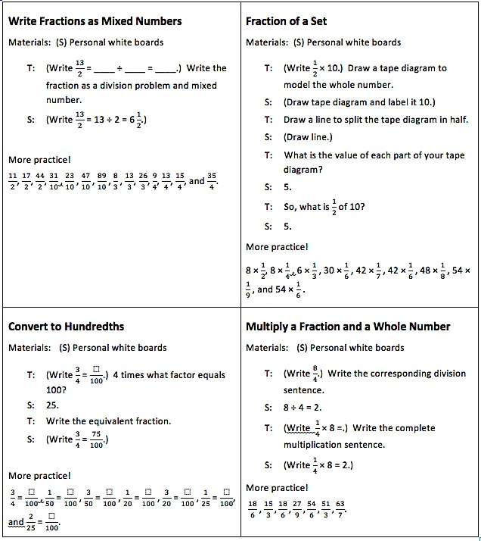
- What does being fluent with a math skill mean to you?
- Why is fluency with certain math skills important?
- With which math skills do you think you should be fluent?
- With which math skills do you feel most fluent? Least fluent?
- How can you continue to improve your fluency?
Part 2: Select and engage in fluency activities.
- Pass out the fluency activity templates. (There are a total of 16 activities. An example is shown to the right.)
- In pairs or small groups, students alternate the role of teacher and engage in the activities of their choice.
- As they play, students complete Problems 2 and 3 from the Problem Set.
Part 3: Create reference cards.
- Students cut out the 16 cards.

NOTES ON
MULTIPLE MEANS OF ACTION AND EXPRESSION:
Provide the following scaffolds for learners who may need more visual support:
For Find the Volume, provide a rectangular prism template to ease the task of drawing.
For Compare Decimal Fractions, have students represent numbers in a place value chart before comparing.
For Divide Whole Numbers by Unit Fractions, have students model with a tape diagram, number line, or another model.
For Unit Conversions, have students model using a tape diagram.

- On the back of the fluencies they have chosen for intensive summer practice, students make examples of expressions, equations, models, diagrams, and/or figures that represent the skill.
MP.6
Students will store these fluency reference cards in the summer activity boxes that they create in G5–M6–Lessons 33–34.
Student Debrief (10 minutes)
Lesson Objective: Solidify fluency with Grade 5 skills.
The Student Debrief is intended to invite reflection and active processing of the total lesson experience.
Invite students to review their Problem Sets. Guide students in a conversation to debrief the Problem Set and process the lesson.
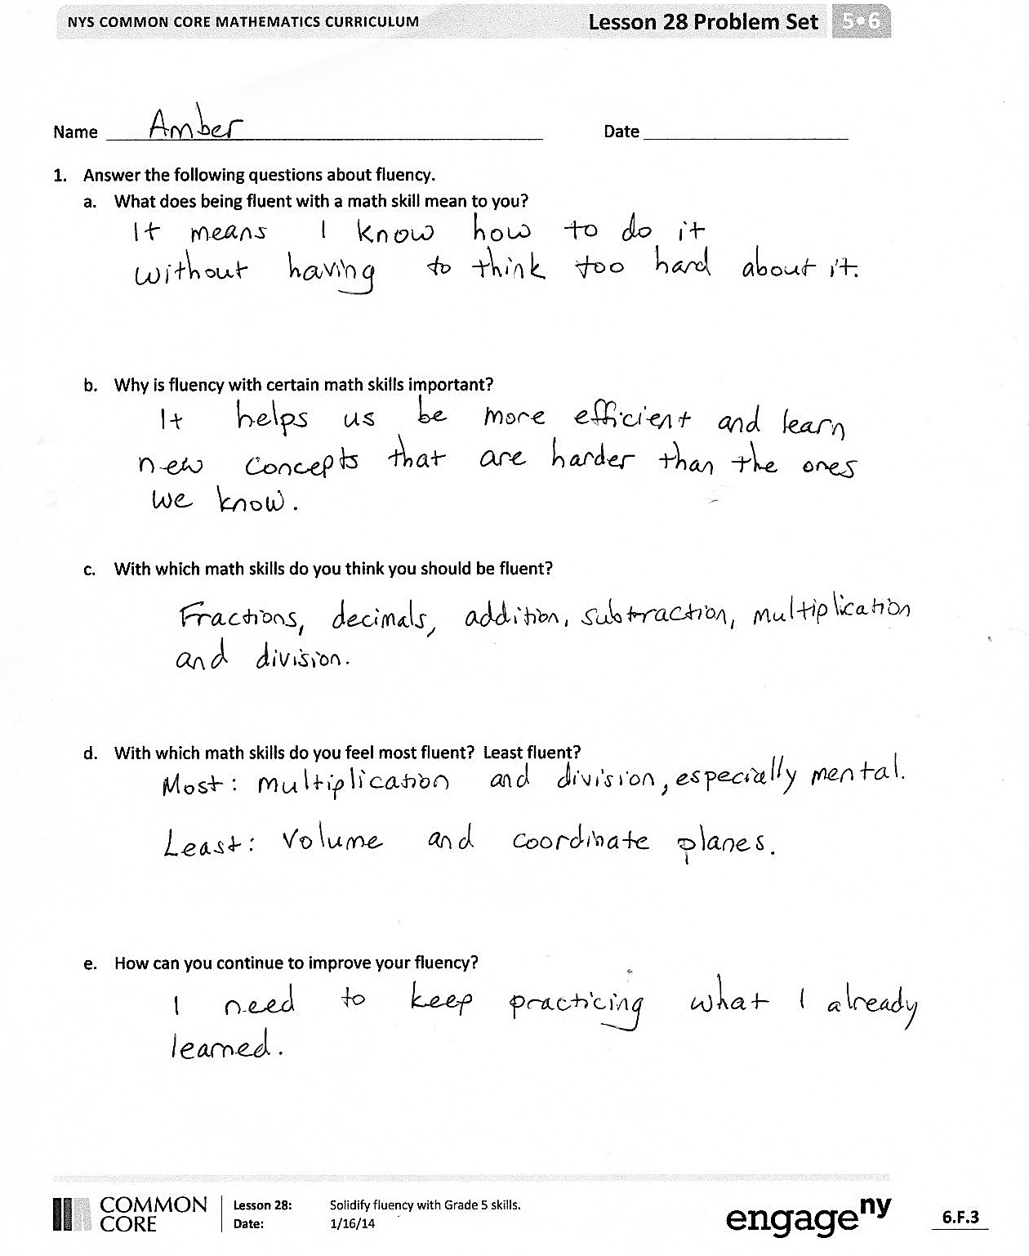
You may choose to use any combination of the questions below to lead the discussion.
- What is something you did today that you could not do before fifth grade?
- What did you learn about your fluency with different math skills today? What do you feel confident about? What do you need to continue to work on?
- Tell your partners some activities from today’s lesson that you would like to include in your summer activity box to help you maintain and build your fluency.
- Read your responses to the questions in Problem 1. Now that you have had some time to practice different fluency activities, have your answers to any of the questions changed? Which ones? Why? Be as specific as possible.

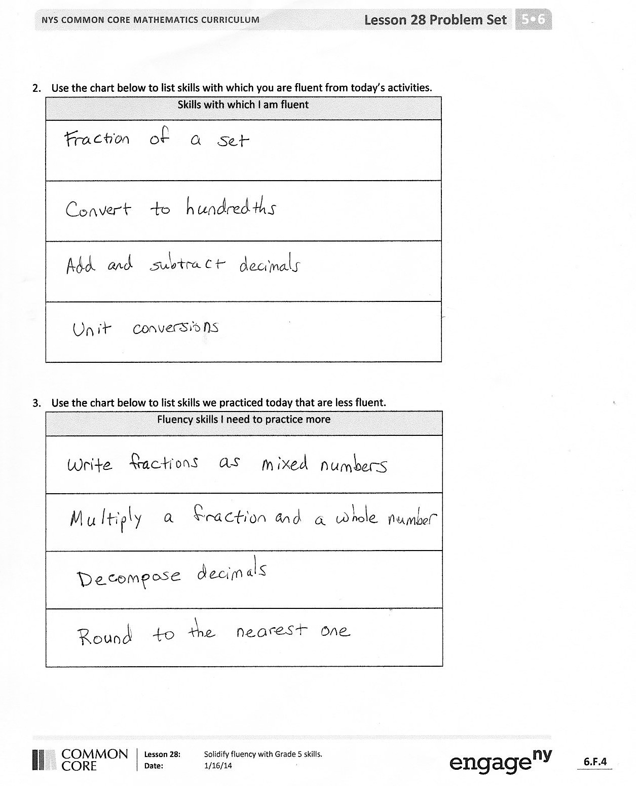
Reflection (3 minutes)
In G5–M6–Topic F, to close their elementary experience, the Exit Ticket is set aside and replaced by a brief opportunity to reflect on the mathematics done that day as it relates to their broader experience of math.

Name Date
- Answer the following questions about fluency.
- What does being fluent with a math skill mean to you?

- Why is fluency with certain math skills important?

- With which math skills do you think you should be fluent?

- With which math skills do you feel most fluent? Least fluent?

- How can you continue to improve your fluency?

- Use the chart below to list skills with which you are fluent from today’s activities.
Fluent Skills

- Use the chart below to list skills we practiced today with which you are less fluent.
Skills to Practice More

Name Date
What math skills have you improved through our fluency practice this year? How do you know you’ve improved? What math skills do you need to continue to practice this summer? Why?

Name Date
- Use what you learned about your fluency skills today to answer the questions below.
- Which skills should you practice this summer to maintain and build your fluency? Why?

- Write a goal for yourself about a skill that you want to work on this summer.

- Explain the steps you can take to reach your goal.

- How will reaching this goal help you as a math student?

- In the chart below, plan a new fluency activity that you can play at home this summer to help you build or maintain a skill that you listed in Problem 1(a). When planning your activity, be sure to think about the factors listed below:
- The materials that you’ll need.
- Who can play with you (if more than 1 player is needed).
- The usefulness of the activity for building your skills.
Skill:

Name of Activity:

Materials Needed:

Description:

Write Fractions as Mixed Numbers  Materials: (S) Personal white boards  T: (Write $\frac{13}{2}$ = ____ ÷ ____ = ____.) Write the fraction as a division problem and mixed number.  S: (Write $\frac{13}{2}$ = 13 ÷ 2 = $\text{6}\frac{1}{2}$.)  More practice!  $\frac{11}{2}$ , $\frac{17}{2}$ , $\frac{44}{2}$ , $\frac{31}{10}$ , $\frac{23}{10}$ , $\frac{47}{10}$ , $\frac{89}{10}$ , $\frac{8}{3}$ , $\frac{13}{3}$ , $\frac{26}{3}$ , $\frac{9}{4}$ , $\frac{13}{4}$ , $\frac{15}{4}$ , and $\frac{35}{4}$. | Fraction of a Set  Materials: (S) Personal white boards  T: (Write $\frac{1}{2}$ × 10$.$) Draw a tape diagram to model the whole number.  S: (Draw tape diagram and label it 10.)  T: Draw a line to split the tape diagram in half.  S: (Draw line.)  T: What is the value of each part of your tape diagram?  S: 5.  T: So, what is $\frac{1}{2}$ of 10?  S: 5.  More practice!  8 × $\frac{1}{2}$ , 8 × $\frac{1}{4}$ , 6 × $\frac{1}{3}$ , 30 × $\frac{1}{6}$ , 42 × $\frac{1}{7}$ , 42 × $\frac{1}{6}$ , 48 × $\frac{1}{8}$ , 54 × $\frac{1}{9}$ , and 54 × $\frac{1}{6}$ .
Convert to Hundredths  Materials: (S) Personal white boards  T: (Write $\frac{3}{4}$ = $\frac{}{100}$.) 4 times what factor equals 100?  S: 25.  T: Write the equivalent fraction.  S: (Write $\frac{3}{4}$ = $\frac{75}{100}$.)  More practice!  $\frac{3}{4}$ = $\frac{}{100}$, $\frac{1}{50}$ = $\frac{}{100}$, $\frac{3}{50}$ = $\frac{}{100}$, $\frac{1}{20}$ = $\frac{}{100}$ , $\frac{3}{20}$ = $\frac{}{100}$ , $\frac{1}{25}$ = $\frac{}{100}$,  and $\frac{2}{25}$ = $\frac{}{100}$. | Multiply a Fraction and a Whole Number  Materials: (S) Personal white boards  T: (Write $\frac{8}{4}$.) Write the corresponding division sentence.  S: 8 ÷ 4 = 2.  T: (Write $\frac{1}{4}$ × 8 =.) Write the complete multiplication sentence.  S: (Write $\frac{1}{4}$ × 8 = 2.)  More practice!  $\frac{18}{6}$, $\frac{15}{3},\frac{18}{6}, \frac{27}{9},\frac{54}{6},\frac{51}{3},\frac{63}{7}.$
Multiply Mentally  Materials: (S) Personal white boards  T: (Write 9 × 10.) Write the complete multiplication sentence  S: 9 × 10 = 90.  T: (Write 9 × 9 = 90 – ____ below 9 × 10 = 90.) On your personal boards, write the number sentence, filling in the blank.  S: (Write 9 × 9 = 90 – 9.)  T: 9 × 9 is?  S: 81.  More practice!  9 × 99, 15 × 9, and 29 × 99. | One Unit More  Materials: (S) Personal white boards  T: (Write 5 tenths.) Write the decimal that’s one-tenth more than 5 tenths.  S: 0.6  More practice!  5 hundredths, 5 thousandths, 8 hundredths, 2 thousandths. Specify the unit of increase.  T: (Write 0.052.) On your boards, write one more thousandth.  S: 0.053  More practice!  1 tenth more than 35 hundredths,  1 thousandth more than 35 hundredths, and  1 hundredth more than 438 thousandths.
Find the Product  Materials: (S) Personal white boards  T: (Write 4 × 3.) Complete the multiplication sentence giving the second factor in unit form.  S: 4 × 3 ones = 12 ones.  T: (Write 4 × 0.2.) Complete the multiplication sentence giving the second factor in unit form.  S: 4 × 2 tenths = 8 tenths.  T: (Write 4 × 3.2.) Complete the multiplication sentence giving the second factor in unit form.  S: 4 × 3 ones 2 tenths = 12 ones 8 tenths.  T: Write the complete multiplication sentence.  S: (Write 4 × 3.1 = 12.8.)  More practice!  4 × 3.21, 9 × 2, 9 × 0.1, 9 × 0.03, 9 × 2.13, 4.012 × 4, and 5 × 3.2375. | Add and Subtract Decimals  Materials: (S) Personal white boards  T: (Write 7258 thousandths + 1 thousandth = ____.) Write the addition sentence in decimal form.  S: 7.258 + 0.001 = 7.259.  More practice!  7 ones + 258 thousandths + 3 hundredths,  6 ones + 453 thousandths + 4 hundredths,  2 ones + 37 thousandths + 5 tenths, and  6 ones + 35 hundredths + 7 thousandths.  T: (Write 4 ones + 8 hundredths – 2 ones = ___ ones ___ hundredths.) Write the subtraction sentence in decimal form.  S: (Write 4.08 – 2 = 2.08.)  More practice!  9 tenths + 7 thousandths – 4 thousandths,  4 ones + 582 thousandths – 3 hundredths,  9 ones + 708 thousandths – 4 tenths, and  4 ones + 73 thousandths – 4 hundredths.
Decompose Decimals  Materials: (S) Personal white boards  T: (Project 7.463.) Say the number.  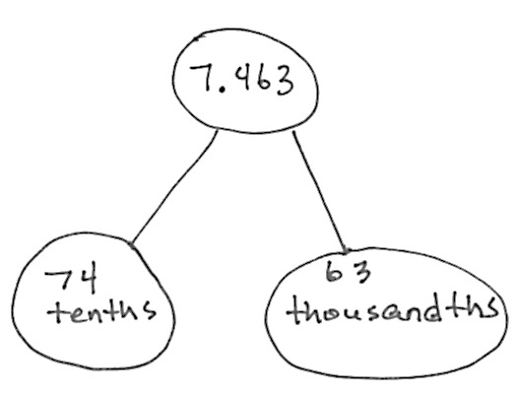  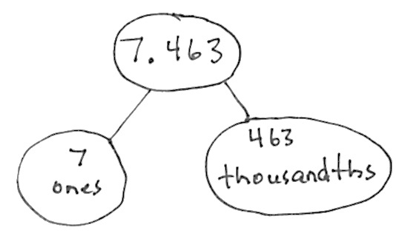  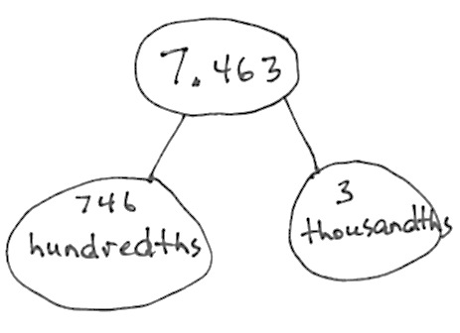  S: 7 and 463 thousandths.  T: Represent this number in a two-part number bond with ones as one part and thousandths as the other part.  S: (Draw.)  T: Represent it again with tenths and thousandths.  T: Represent it again with hundredths and thousandths.  More practice!  8.972 and 6.849. | Find the Volume  Materials: (S) Personal white boards  T: On your boards, write the formula for finding the volume of a rectangular prism.  S: (Write V = l $\text{×}$ w $\text{×}$ h.)  T: (Draw and label a rectangular prism with a length of 5 cm, width of 6 cm, and height of 2 cm.) On your boards, write a multiplication sentence to find the volume this rectangular prism.  S: (Beneath V = l × w × h, write V = 5 cm $\text{×}$ 6 cm $\text{×}$2 cm. Beneath it, write V = 60 cm³.)  More practice!  w = 9 ft, l = 7 ft, h = 3 ft  w = 6 in, l = 6 in, h = 5 in  w = 8 cm, l = 4 cm, h = 2 cm
Make a Like Unit  Materials: (S) Personal white boards  T: I’ll say two unit fractions. You make the like unit and write it on your board. Show your board at the signal.  T: $\frac{1}{3}$ and $\frac{1}{2}$. (Pause. Signal.)  S: (Show sixths.)  More practice!  $\frac{1}{4}$ and $\frac{1}{3}$ , $\frac{1}{2}$ and $\frac{1}{4}$ , $\frac{1}{6}$ and $\frac{1}{2}$ , $\frac{1}{3}$ and $\frac{1}{12}$ , $\frac{1}{6}$ and $\frac{1}{8}$ , and $\frac{1}{3}$ and $\frac{1}{9}$. | Unit Conversions  Materials: (S) Personal white boards  T: (Write 12 in = ___ ft.) 12 inches is the same as how many feet?  S: 1 foot.  More practice!  24 in, 36 in, 54 in, and 76 in.  T: (Write 1 ft = ___ in.) 1 foot is the same as how many inches?  S: 12 inches.  More practice!  2 ft, 2.5 ft, 3 ft, 3.5 ft, 4 ft 4.5 ft 9 ft, and 9.5 ft

Compare Decimal Fractions  Materials: (S) Personal white boards  T: (Write 13.78 13.86.) On your personal boards, compare the numbers using the greater than, less than, or equal sign.  S: (Write 13.78 < 13.76.)  More practice!  0.78 $\frac{78}{100}$ , 439.3 4.39, 5.08 fifty-eight tenths, and thirty-five and 9 thousandths 4 tens. | Round to the Nearest One  Materials: (S) Personal white boards  T: (Write 3 ones 2 tenths.) Write 3 ones and 2 tenths as a decimal.  S: (Write 3. 2.)  T: (Write 3.2 ≈ __.) Round 3 and 2 tenths to the nearest whole number.  S: (Write 3.2 ≈ 3.)  More practice!  3.7, 13.7, 5.4, 25.4, 1.5, 21.5, 6.48, 3.62, and 36.52.
Multiplying Fractions  Materials: (S) Personal white boards  T: (Write $\frac{1}{2}$ × $\frac{1}{3}$ = .) Write the complete multiplication sentence.  S: (Write $\frac{1}{2}$ × $\frac{1}{3}$ = $\frac{1}{6}$.)  T: (Write $\frac{1}{2}$ × $\frac{3}{4}$ = .) Write the complete multiplication sentence.  S: (Write $\frac{1}{2}$ × $\frac{3}{4}$ = $\frac{3}{8}$.)  T: (Write $\frac{2}{5}$ × $\frac{2}{3}$ = .) Write the complete multiplication sentence.  S: (Write $\frac{2}{5}$ × $\frac{2}{3}$ = $\frac{4}{15}$.)  More practice!  $\frac{1}{2}$ × $\frac{1}{5}$ , $\frac{1}{2}$ × $\frac{3}{5}$ , $\frac{3}{4}$ × $\frac{3}{5}$ , $\frac{4}{5}$ × $\frac{2}{3}$ , and $\frac{3}{4}$ × $\frac{5}{6}$. | Divide Whole Numbers by Unit Fractions  Materials: (S) Personal white boards  T: (Write 1 ÷ $\frac{1}{2}$.) How many halves are in 1?  S: 2.  T: (Write 1 ÷ $\frac{1}{2}$ = 2. Beneath it, write 2 ÷ $\frac{1}{2}$.) How many halves are in 2?  S: 4.  T: (Write 2 ÷ $\frac{1}{2}$ = 4. Beneath it, write 3 ÷ $\frac{1}{2}$.) How many halves are in 3?  S: 6.  T: (Write 3 ÷ $\frac{1}{2}$ = 6. Beneath it, write 7 ÷ $\frac{1}{2}$.) Write the complete division sentence.  S: (Write 7 ÷ $\frac{1}{2}$ = 14.)  More practice!  1 ÷ $\frac{1}{3}$ , 2 ÷ $\frac{1}{5}$ , 9 ÷ $\frac{1}{4}$ , and 3 ÷ $\frac{1}{8}$.

