Lesson 27
Objective: Solidify writing and interpreting numerical expressions.

Suggested Lesson Structure
 Fluency Practice (12 minutes)
 Concept Development (38 minutes)
 Student Debrief (10 minutes)
Total Time (60 minutes)
Fluency Practice (12 minutes)
- Multiply a Fraction and a Whole Number 5.NF.4 (4 minutes)
- Multiply Decimals 5.NBT.7 (4 minutes)
- Multiply Mentally 5.NBT.5 (4 minutes)
Multiply a Fraction and a Whole Number (4 minutes)
Materials: (S) Personal white boards

NOTES ON
MULTIPLE MEANS OF REPRESENTATION:
The Multiply a Fraction and a Whole Number fluency activity can be scaffolded for students working below grade level by coupling written equations with models, such as a tape diagram for $\frac{2}{3}\text{×} \text{9}$, or by extending the equation to find a common factor, simplify, and then multiply. For example, $\frac{2}{3}\text{×} \text{9}$ = $\frac{ 2 × 9 }{3}$ = $\frac{6}{1}$ = 6.

Note: This fluency activity reviews G5–M4–Lessons 9–11.
T: (Write 9 ÷ 3 = __.) Say the division sentence.
S: 9 ÷ 3 = 3.
T: (Write $\frac{1}{3}$ × 9 = __.) Say the multiplication sentence.
S: $\frac{1}{3}$ $\text{×}$ 9 = 3.
T: (Write $\frac{2}{3}$ × 9 = __.) On your boards, write the multiplication sentence.
S: (Write $\frac{2}{3}$ × 9 = 6.)
T: (Write 9 × $\frac{2}{3}$ = __.) On your boards, write the multiplication sentence.
S: (Write 9 × $\frac{2}{3}$ = 6.)
Continue the process with the following possible sequence: 18 ÷ 6, $\frac{1}{6}$ × 18, $\frac{5}{6}$ × 12, 12 × $\frac{5}{6}$ , $\frac{1}{8}$ × 16, 16 × $\frac{1}{8}$ , 32 × $\frac{3}{8}$ , $\frac{2}{3}$ × 15, and 16 × $\frac{3}{4}$.
Multiply Decimals (4 minutes)
Materials: (S) Personal white boards
Note: This fluency activity reviews G5–M4–Lessons 17–18.
T: (Write 3 × 3 = .) Say the multiplication sentence.
3 × 3 = 9 3 × 0.3 = 0.9 0.3 × 0.3 = 0.09 0.03 × 0.3 = 0.009
2 × 6 = 12 2 × 0.6 = 1.2 0.2 × 0.6 = 0.12 0.02 × 0.6 = 0.012
7 × 5 = 35 0.7 × 5 = 3.5 0.7 × 0.5 = 0.35 0.7 × 0.05 = 0.035
S: 3 × 3 = 9.
T: (Write 3 × 0.3 = .) On your boards, write the number sentence.
S: (Write 3 × 0.3 = 0.9.)
T: (Write 0.3 × 0.3 = .) On your boards, write the number sentence.
S: (Write 0.3 × 0.3 = 0.09.)
Continue the process for the following possible suggestions: 2 × 6, 2 × 0.6, 0.2 × 0.6, 0.02 × 0.6, 7 × 5,
0.7 × 5, 0.7 × 0.5, and 0.7 × 0.05.
Multiply Mentally (4 minutes)
Materials: (S) Personal white boards
Note: This fluency activity will help bolster the students’ understanding of and automaticity with the distributive property of multiplication.
T: (Write 8 × 10 = ___.) Say the multiplication sentence.
S: 8 × 10 = 80.
T: (Write 8 × 9 = 80 – ____ below 8 × 10 = 80.) On your personal boards, write the number sentence, filling in the blank.
S: (Write 8 × 9 = 80 – 8.)
T: What is 8 × 9?
S: 72.
Repeat the process for 8 × 100, 8 × 99, 12 × 10, 12 × 9, 25 × 100, and 25 × 99.
Concept Development (38 minutes)
Materials: (S) Blank paper, personal white boards
Write and solve word problems from a given expression.
Description:
Students work in pairs to create a word problem for a given expression, plan how to teach their word problem and solution to another pair, and then teach their solution to another pair of students.
The process is as follows:
Suggestions for expressions:
- $\text{65 × }\frac{\text{4}}{\text{5}}$
- $\text{(27} \text{+} \text{33)} \text{×}\frac{\text{2}}{\text{3}}$
- $\text{9} \text{-}\left(\frac{\text{3}}{\text{8}}\text{+}\frac{\text{1}}{\text{2}}\right)$
- $\left(\frac{\text{5}}{\text{6}}\text{+}\frac{\text{7}}{\text{12}}\right)\text{× 48}$
- $\text{7} \text{+}\left(\frac{\text{3}}{\text{4}}\text{+}\frac{\text{7}}{\text{16}}\right)$
Step 1 Give each pair of students an expression. (Suggestions are given to the right.)
Step 2 Pairs work together to write a word problem that might be solved using the given expression.
Step 3 Pairs work together to develop a plan to teach another pair of students how to solve their word problem using the RDW process.
Step 4 Pairs teach their word problem and solution to another pair of students. The student pair asks questions of the teaching pair:

NOTES ON
MULTIPLE MEANS OF REPRESENTATION:
Depending on the level of English proficiency of English language learners, try inviting students to discuss, plan, write, and teach in their first language. Alternatively, provide extra time, reduce the amount of work, or provide sentence frames for discussion.
- Why are we using that model to solve?
MP.3
- Could I solve it this way instead?
- Can you be more specific?
- I do not understand that step. Can you please explain it?
After the presentations, the teaching pair might discuss the effectiveness of their solution and make changes if necessary. Then, they can present their word problem and solution to a new pair. End the lesson with a class discussion about the changes the students made to their solutions between rounds and the reasoning behind these changes.
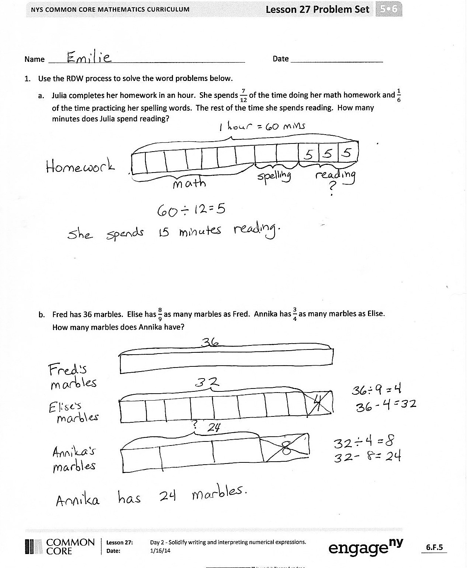
Problem Set (10 minutes)
Students should do their personal best to complete the Problem Set within the allotted 10 minutes. For some classes, it may be appropriate to modify the assignment by specifying which problems they work on first. Some problems do not specify a method for solving. Students solve these problems using the RDW approach used for Application Problems.
Student Debrief (10 minutes)
Lesson Objective: Solidify writing and interpreting numerical expressions.
The Student Debrief is intended to invite reflection and active processing of the total lesson experience.
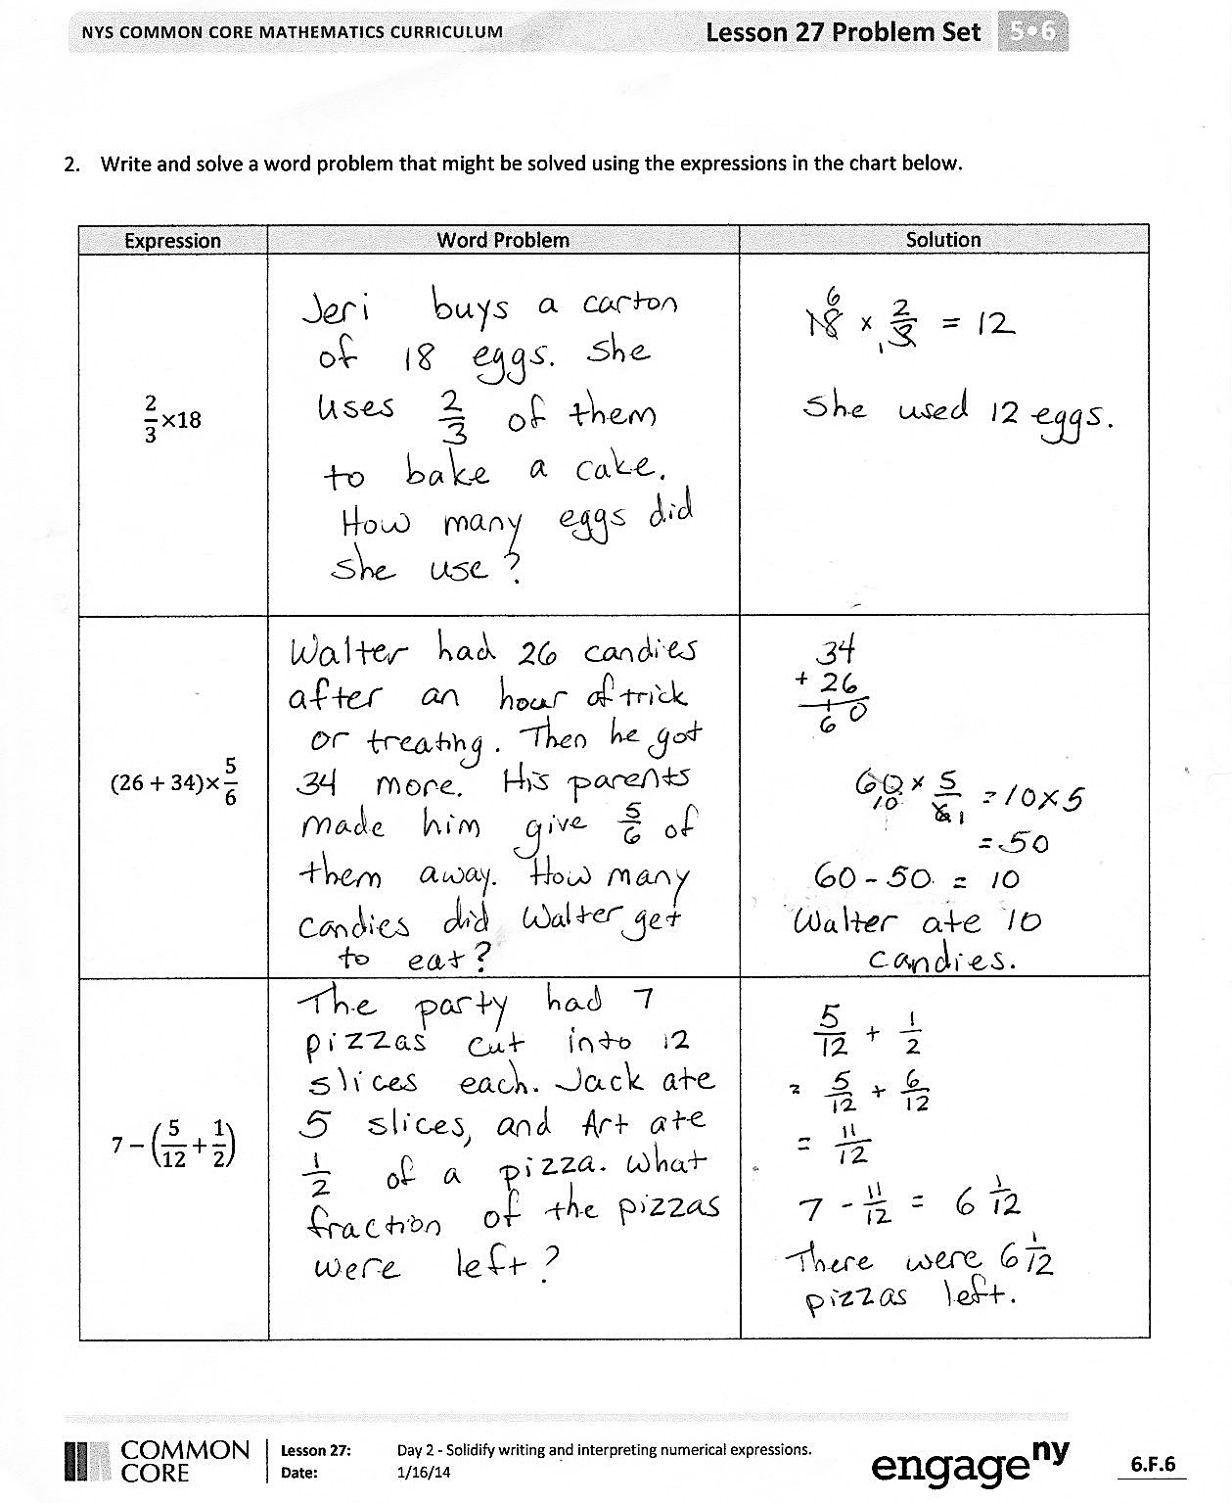
Invite students to review their solutions for the Problem Set. They should check work by comparing answers with a partner before going over answers as a class. Look for misconceptions or misunderstandings that can be addressed in the Debrief. Guide students in a conversation to debrief the Problem Set and process the lesson.
You may choose to use any combination of the questions below to lead the discussion.
- Compare your solutions for Problem 1 to a partner’s solutions. Is one of your methods for solving more efficient? How do you know?
- Share the word problems that you wrote for Problem 2.
- In Problem 2, which expression was most challenging to represent with a word problem? Why?
- What did you find more challenging today, planning how to teach a word problem solution to your classmates or writing a word problem for a given expression? Why?
- What did you learn about your problem solving skills by teaching other students how to solve a word problem?
Reflection (3 minutes)
In G5–M6–Topic F, to close their elementary experience, the Exit Ticket is set aside and replaced by a brief opportunity to reflect on the mathematics done that day as it relates to their broader experience of math.

Name Date
- Use the RDW process to solve the word problems below.
  - Julia completes her homework in an hour. She spends $\frac{7}{12}$ of the time doing her math homework and $\frac{1}{6}$ of the time practicing her spelling words. The rest of the time she spends reading. How many minutes does Julia spend reading?

  - Fred has 36 marbles. Elise has $\frac{8}{9}$ as many marbles as Fred. Annika has $\frac{3}{4}$ as many marbles as Elise. How many marbles does Annika have?

- Write and solve a word problem that might be solved using the expressions in the chart below.
Expression | Word Problem | Solution
$$\frac{\text{2}}{\text{3}} \text{×} \text{18}$$
$$\text{(26} \text{+} \text{34)} \text{× }\frac{\text{5}}{\text{6}}$$
$$\text{7} \text{–}\left(\frac{\text{5}}{\text{12}} \text{+} \frac{\text{1}}{\text{2}}\right)$$

Name Date
How did teaching other students how to solve a word problem strengthen your skills as a problem solver? What did you learn about your problem solving skills? What are your strengths and weaknesses as a problem solver?

Name Date
- Use the RDW process to solve the word problems below.
  - There are 36 students in Mr. Meyer’s class. Of those students, $\frac{5}{12}$ played tag at recess, $\frac{1}{3}$ played kickball, and the rest played basketball. How many students in Mr. Meyer’s class played basketball?

  - Julie brought 24 apples to school to share with her classmates. Of those apples, $\frac{2}{3}$ are red and the rest are green. Julie’s classmates ate $\frac{3}{4}$ of the red apples and $\frac{1}{2}$ of the green apples. How many apples are left?

- Write and solve a word problem for each expression in the chart below.
Expression | Word Problem | Solution
$$\text{144 }\text{×} \frac{\text{7}}{\text{12}}$$

$$\text{9} \text{–}\left(\frac{\text{4}}{\text{9}} \text{+} \frac{\text{1}}{\text{3}}\right)$$
$$\frac{\text{3}}{\text{4}} \text{×}\text{ (36} \text{+} \text{12)}$$

