Lesson 26
Objective: Solidify writing and interpreting numerical expressions.

Suggested Lesson Structure
 Fluency Practice (10 minutes)
 Application Problem (5 minutes)
 Concept Development (35 minutes)
 Student Debrief (10 minutes)
Total Time (60 minutes)
Fluency Practice (10 minutes)
- Order of Operations 5.OA.1 (3 minutes)
- Multiply a Fraction and a Whole Number 5.NF.4 (3 minutes)
- Multiply Decimals 5.NBT.7 (4 minutes)
Order of Operations (3 minutes)
Materials: (S) Personal white boards
Note: This fluency activity prepares students for today’s lesson.
T: (Write (6 × 3) + 2.) Write the complete number sentence.
S: (Write (6 × 3) + 2 = 20.)
T: (Write 6 × (3 + 2).) Write the complete number sentence.
S: (Write 6 × 5 = 30.)
T: (Write 28 − (8 ÷ 2).) Write the complete number sentence.
S: (Write 28 − (8 ÷ 2) = 24.)
T: (Write (28 − 8) ÷ 2.) Write the complete number sentence.
S: (Write (28 − 8) ÷ 2 = 10.)
T: When there are no parentheses, we put imaginary parentheses around multiplication and division and do them first. We don’t need the parentheses in these two expressions:
(6 × 3) + 2 and 28 − (8 ÷ 2). We would solve them the same way even without the parentheses.
Continue the process with the following possible suggestions: 5 × 3 + 4 and 5 × (3 + 4).

Multiply a Fraction and a Whole Number (3 minutes)
Materials: (S) Personal white boards
Note: This fluency activity reviews G5–M4–Lesson 8.
T: ($\frac{1}{2}\text{× }\text{6} \text{=} \frac{_____×_____ }{2}$.) On your board, complete the number sentence.
S: (Write $\frac{1}{2}$ × 6 = $\frac{ 1 × 6 }{2}$.)
T: (Write $\frac{1}{2}$ × 6 = $\frac{ 1 × 6 }{2}$ = $\frac{}{}\text{=}$ .) Complete the number sentence.
S: (Write $\frac{1}{2}$ × 6 = $\frac{ 1 × 6 }{2}$ = $\frac{6}{2}\text{=}$ 3.)
T: (Write $\frac{1}{2}$ × 6 = $\frac{ 1 × 6 }{2}$ = .) Find a common factor to simplify. Then multiply.
³
S: (Write $\frac{1}{2}$ × 6 = $\frac{ 1 × 6 }{2}$ = $\frac{3}{1}$ = 3.)
¹
Continue with the following possible suggestions: 6 × $\frac{1}{3}$ , 12 × $\frac{2}{3}$ , $\frac{3}{4}$× 12, and 18 × $\frac{5}{6}$.
Multiply Decimals (4 minutes)
Materials: (S) Personal white boards
Note: This fluency activity reviews G5–M4–Lessons 17−18.
T: (Write 3 × 2 =____.) Say the number sentence.
3 × 2 = 6 3 × 0.2 = 0.6 0.3 × 0.2 = 0.06 0.03 × 0.2 = 0.006
2 × 7 = 14 2 × 0.7 = 1.4 0.2 × 0.7 = 0.14 0.02 × 0.7 = 0.014
5 × 3 = 15 0.5 × 3 = 1.5 0.5 × 0.3 = 0.15 0.5 × 0.03 = 0.015
S: 3 × 2 = 6.
T: (Write 3 × 0.2 =____.) On your board, write the number sentence.
S: (Write 3 × 0.2 = 0.6.)
T: (Write 0.3 × 0.2 =____.) On your board, write the number sentence.
S: (Write 0.3 × 0.2 = 0.06.)
Continue the process for the following possible suggestions: 2 × 7, 2 × 0.7, 0.2 × 0.7, 0.02 × 0.7, 5 × 3,
0.5 × 3, 0.5 × 0.3, and 0.5 × 0.03.

Application Problem (5 minutes)
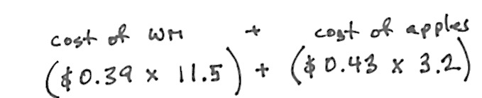
The market sells watermelons for $0.39 per pound and apples for $0.43 per pound. Write an expression that shows how much Carmen spends for a watermelon that weighs 11.5 pounds and a bag of apples that weigh 3.2 pounds.
Note: This problem reviews writing and interpreting numerical expressions within the context of money and previews the objective for today’s lesson.
Concept Development (35 minutes)
This lesson is meant to be a review. Play one or both of the following games to review both writing numerical expressions and comparing expressions without calculating their values.
Game A: Writing Expressions Using the Properties Game
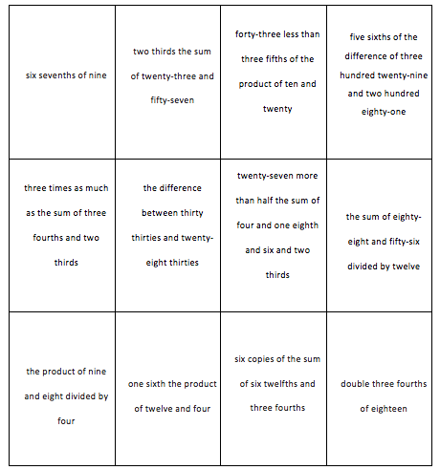
Materials: (S) Personal white boards, expression cards template (pictured below), timer
Expression Cards
Description:
Students work with a partner to compete against another team of two students. Teams work together to write numerical expressions representing the written phrase. The game follows these steps:
Step 1 Turn over an expression card and start the timer.
Step 2 Teams work together to write as many numerical expressions as they can that represent the written phrase using the properties.
Step 3 When the timer sounds, a member from each team shows their expressions to the opposing team.
Step 4 The team analyzes the expressions to make sure they represent the given written phrase on the expression card.
Step 5 Teams work together to find the value of the expression.
Teams earn a point for each numerical expression they write that represents the written phrase on the expression card, and an additional point if they find the correct value of the expression. Play continues until all expression cards have been used, or until one team reaches a predetermined score.

NOTES ON
MULTIPLE MEANS OF ENGAGEMENT:
Depending on the needs of the students, instead of a competition between teams, place emphasis on improvement and effort. For example, invite students to make a class goal for number of equivalent expressions written within a certain time frame. Celebrate efficiency, teamwork, problem solving, critical thinking, and communication.

Prepare the students:
Discuss how using the commutative, distributive, and associative properties can help teams write expressions.
For example, two-thirds the sum of twenty-three and fifty-seven can be written as $\frac{2}{3} \text{×} \left(\text{23} \text{+} \text{57}\right)$ or using the
commutative property: $\left(\text{23} \text{+} \text{57}\right) \text{×} \frac{2}{3} .$
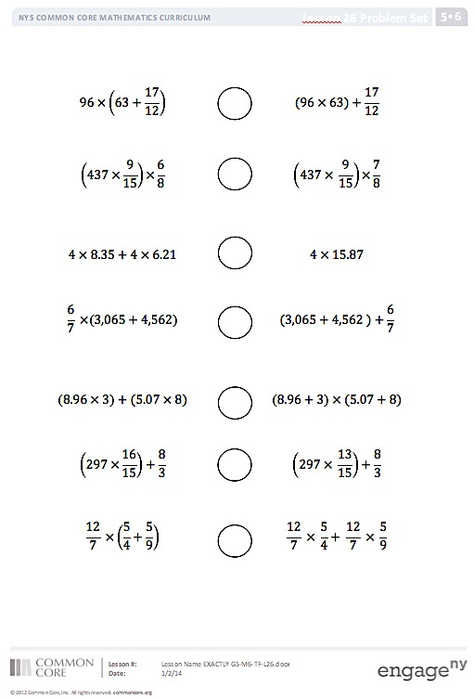
distributive property: $\frac{2}{3} \text{×} \text{23}+ \frac{2}{3} \text{×} \text{57}$.
Comparing Expressions Game Board
associative property: $\frac{1}{3} \text{×} \left(\text{2} \text{×} \left(\text{23}+\text{57}\right)\right).$
Remind students to respectfully analyze each other’s work.
Game B: Comparing Expressions Game
Materials: (S) Comparing expressions cards template (pictured at right), personal white board, piece of paper
Description:
Students race a partner to write the symbol that makes the number sentences true. The game follows these steps:
- Cover all but the top expression with a hiding paper.
- Players race to write the symbol to make the number sentence true on their personal board.

NOTES ON
MULTIPLE MEANS OF ENGAGEMENT:
Every student needs to be challenged, but not necessarily in the same way. Differentiate the degree of difficulty or complexity of the Comparing Expressions game by adjusting the numbers. Students working below grade level may benefit from scaffolded practice in which they begin with simpler expressions and work towards more complex expressions. As an alternative to competition, place emphasis on effort, collaboration, and improvement.

- The first player to write the symbol explains her reasoning to the other player without calculating.
MP.7
- If the first player is correct, she gets a point. If she is incorrect, the other player has a chance to explain and win the point instead.
The partner with the most points when the game ends wins.
Prepare the students:
Review how to compare expressions without calculating their value.

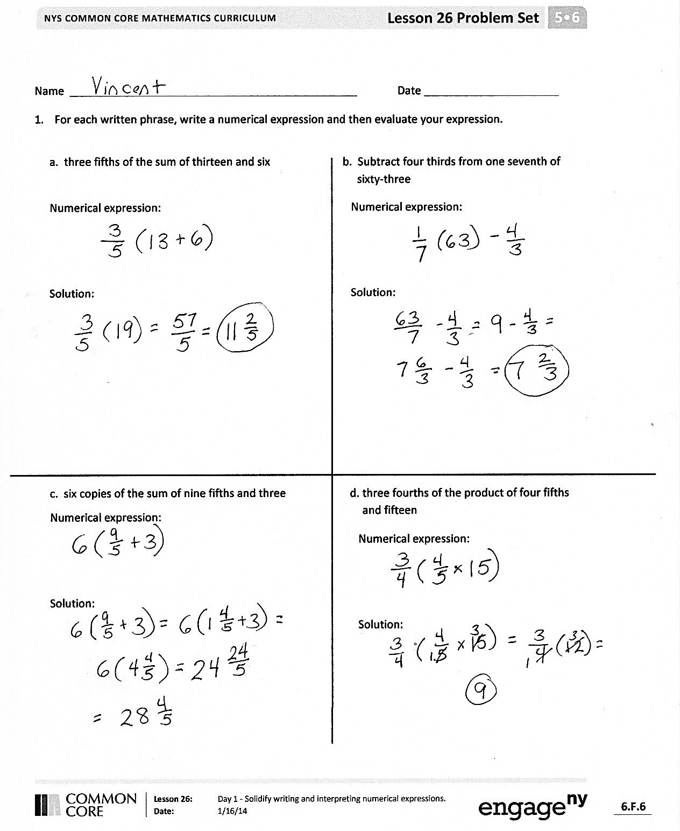
Problem Set (10 minutes)
Students should do their personal best to complete the Problem Set within the allotted 10 minutes. For some classes, it may be appropriate to modify the assignment by specifying which problems they work on first.
For this particular Problem Set consider pairing students to work on Problems 1(a)─1(d) together, asking them to share their strategies and explain their reasoning to one another before recording. To create an additional challenge for some pairs, add the requirement of recording two different, equivalent numerical expressions for each problem. Ask them to then choose only one and record their solution and reasoning. Students may need a separate piece of paper so that they have enough room to write.
Student Debrief (10 minutes)
Lesson Objective: Solidify writing and interpreting numerical expressions.
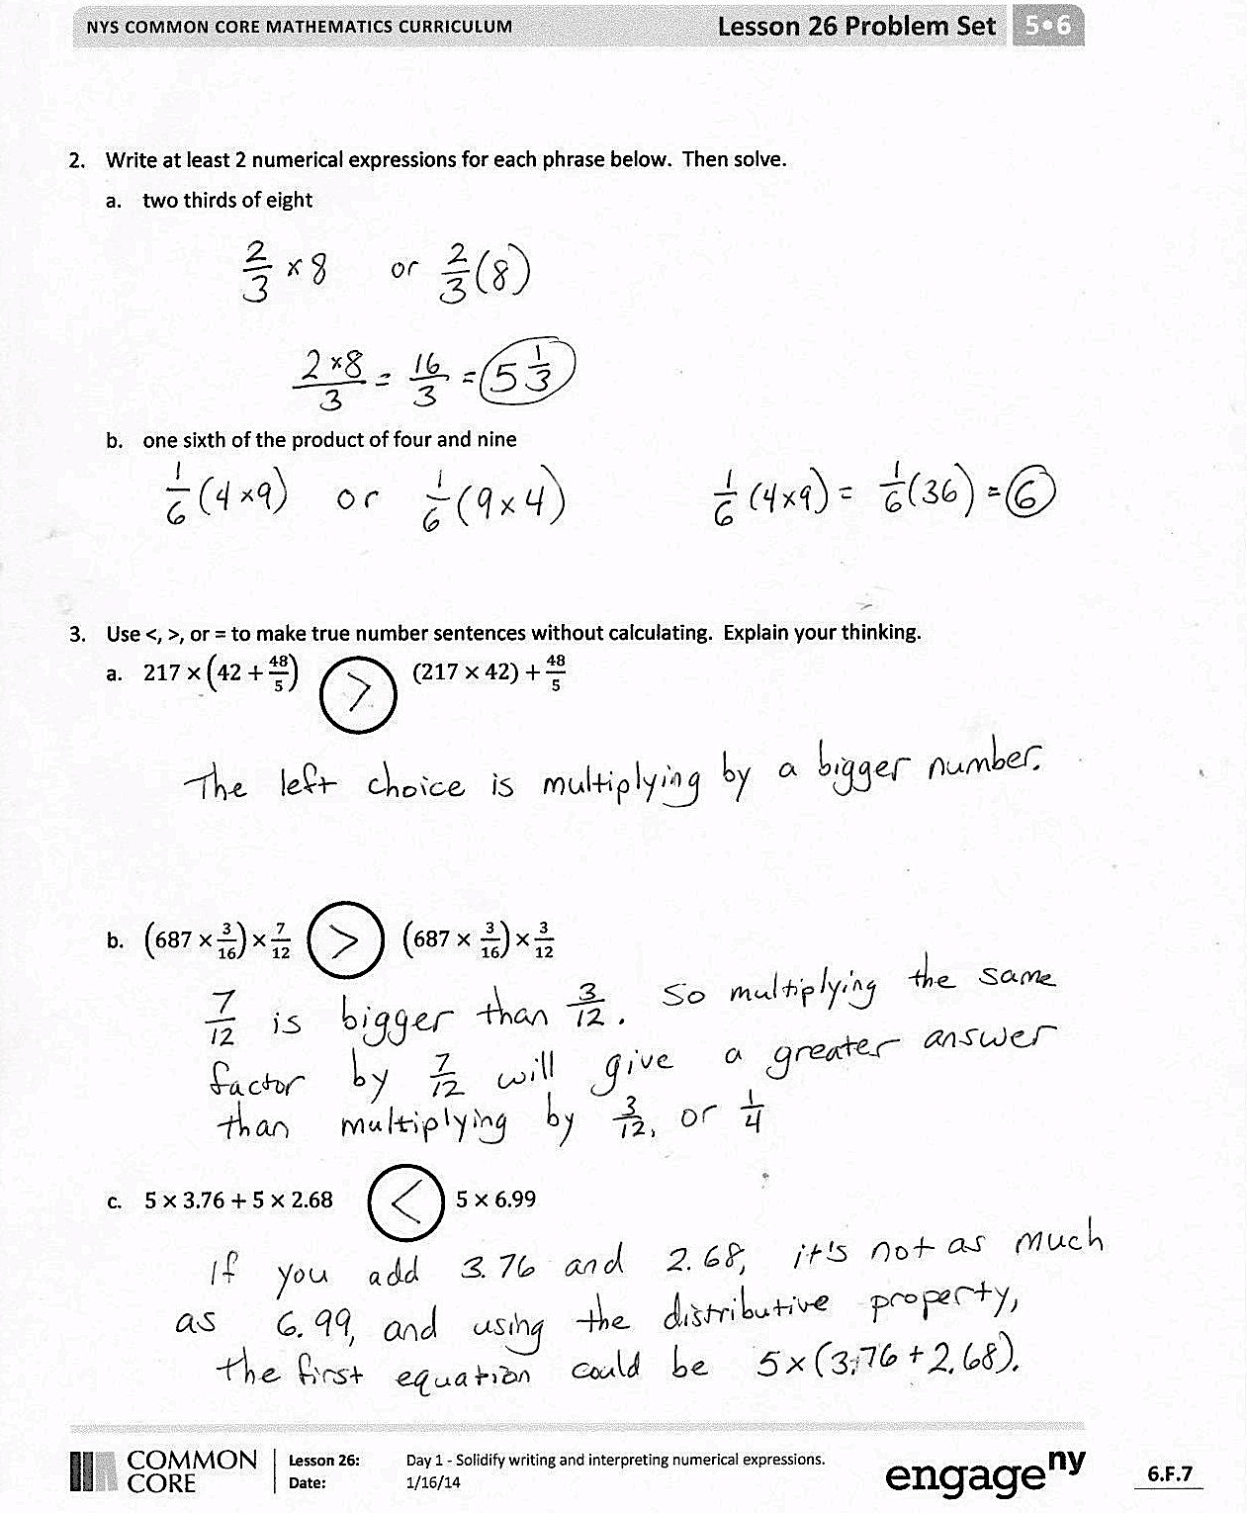
The Student Debrief is intended to invite reflection and active processing of the total lesson experience.
Invite students to review their solutions for the Problem Set. They should check work by comparing answers with a partner before going over answers as a class. Look for misconceptions or misunderstandings that can be addressed in the Debrief. Guide students in a conversation to debrief the Problem Set and process the lesson.
You may choose to use any combination of the questions below to lead the discussion.
- Compare your answers to Problem 1 to a partner’s answers. How are the strategies that you used similar? How are they different?
- Share answers to Problem 2. How is writing equivalent expressions useful?
- Which strategies did you use to help you compare the expressions in Problem 3 without calculating their values?
- Which expressions in Problem 3 were most difficult to compare without calculating the values of the expressions? Why?
- What mathematical properties were useful for completing today’s Problem Set? How were they useful?
- How did the games we played prepare you to work independently on the Problem Set?
Reflection (3 minutes)
In G5–M6–Topic F, to close their elementary experience, the Exit Ticket is set aside and replaced by a brief opportunity to reflect on the mathematics done that day as it relates to their broader experience of math.
Name Date
- For each written phrase, write a numerical expression, and then evaluate your expression.

a. Three-fifths of the sum of thirteen and six b. Subtract four thirds from one seventh of sixty-three
Numerical expression:

Solution:

Numerical expression:

Solution:

c. Six copies of the sum of nine-fifths and three d. Three-fourths of the product of four-fifths and fifteen
Numerical expression:

Solution:

Numerical expression:

Solution:

- Write at least 2 numerical expressions for each phrase below. Then solve.
  - Two-thirds of eight

  - One-sixth of the product of four and nine

- Use <, >, or = to make true number sentences without calculating. Explain your thinking.
- $\text{217} ×\left(\text{42}+\frac{48}{5}\right)$ $(\text{217} × \text{42})+\frac{48}{5}$

- $\left(\text{687} ×\frac{3}{16}\right)×\frac{7}{12}$ $\left(\text{687} × \frac{3}{16}\right)×\frac{3}{12}$

- $\text{5} \text{×} \text{3.76}\text{ + }\text{5} \text{×} \text{2.68}$ $\text{5 }\text{×}\text{ 6.99}$

Name Date
How did the games we played today prepare you to practice writing, solving, and comparing expressions this summer? Why do you think these are important skills to work on over the summer? Will you teach someone at home how to play these games with you? What math skills will you need to teach in order for someone at home to be able to play with you?

Name Date
- For each written phrase, write a numerical expression, and then evaluate your expression.
b. Divide the difference between one thousand, three hundred, and nine hundred fifty by four
  - Forty times the sum of forty-three and fifty-seven
Numerical expression:

Solution:

Numerical expression:

Solution:

c. Seven times the quotient of five and seven d. One-fourth the difference of four-sixths and three-twelfths
Numerical expression:

Solution:

Numerical expression:

Solution:

- Write at least 2 numerical expressions for each written phrase below. Then solve.
- Three fifths of seven

- One-sixth the product of four and eight

- Use <, >, or = to make true number sentences without calculating. Explain your thinking.

- 4 tenths + 3 tens + 1 thousandth 30.41

- $\left(\text{5} ×\frac{1}{10}\right)+ \left(7 ×\frac{1}{1000}\right)$ $0. 507$

- $8 × 7.20$ $8 × 4.36+8 × 3.59$

six-sevenths of nine | two-thirds the sum of twenty-three and fifty-seven | forty-three less than three-fifths of the product of ten and twenty | five-sixths the difference of three hundred twenty-nine and two hundred eighty-one
three times as much as the sum of three-fourths and two-thirds | the difference between thirty thirties and twenty-eight thirties | twenty-seven more than half the sum of four and one-eighth and six and two-thirds | the sum of eighty-eight and fifty-six divided by twelve
the product of nine and eight divided by four | one-sixth the product of twelve and four | six copies of the sum of six-twelfths and three-fourths | double three-fourths of eighteen

$$\text{96 ×}\left(\text{63} \text{+}\frac{\text{17}}{\text{12}}\right)$$ |  | $$\text{(96 × 63)} \text{+} \frac{\text{17}}{\text{12}}$$
$$\left(\text{437 ×}\frac{\text{9}}{\text{15}}\right)\text{×} \frac{\text{6}}{\text{8}}$$ |  | $$\left(\text{437 × }\frac{\text{9}}{\text{15}}\right)\text{×}\frac{\text{7}}{\text{8}}$$
$$\text{4 × 8.35} \text{+} \text{4 × 6.21}$$ |  | $$\text{4 × 15.87}$$
$$\frac{\text{6}}{\text{7}}\text{ ×} \left(\text{3,065} \text{+} \text{4,562}\right)$$ |  | $$\text{(3,065} \text{+} \text{4,562 )} \text{+}\frac{\text{6}}{\text{7}}$$
$\left(\text{8.96 × 3}\right) \text{+} \text{(5.07 × 8)}$ |  | $$\left(\text{8.96} \text{+} \text{3}\right)\text{ × (5.07} \text{+} \text{8)}$$
$\left(\text{297 ×}\frac{\text{16}}{\text{15}}\right)\text{+}\frac{\text{8}}{\text{3}}$ |  | $$\left(\text{297 × }\frac{\text{13}}{\text{15}}\right)\text{+}\frac{\text{8}}{\text{3}}$$
$$\frac{\text{12}}{\text{7}}\text{ ×}\left(\frac{\text{5}}{\text{4}} \text{+} \frac{\text{5}}{\text{9}}\right)$$ |  | $$\frac{\text{12}}{\text{7}}\text{ × }\frac{\text{5}}{\text{4}} \text{+ }\frac{\text{12}}{\text{7}}\text{ × }\frac{\text{5}}{\text{9}}$$

