Lesson 23
Objective: Make sense of complex, multi-step problems and persevere in solving them. Share and critique peer solutions.

Suggested Lesson Structure
 Fluency Practice (10 minutes)
 Concept Development (45 minutes)
 Student Debrief (5 minutes)
Total Time (60 minutes)
Fluency Practice (10 minutes)
- Sprint: Change Mixed Numbers into Improper Fractions 5.NF.3 (10 minutes)
Sprint: Change Mixed Numbers into Improper Fractions (10 minutes)
Materials: (S) Change Mixed Numbers into Improper Fractions Sprint
Note: This Sprint reviews G5–Module 3 concepts.
Concept Development (45 minutes)

NOTES ON
LESSONS 21─25:
Lesson Sequence for M6–Topic E:
- Lessons 21─22 use a protocol to solve problems within teams of four. The number of problems solved will vary between teams.
- Lesson 23 uses a protocol to share and critique student solutions from Lessons 21─22.
- Lesson 24 resumes the problem solving begun in Lessons 21─22.
- Lesson 25 uses the protocol from Lesson 23 to again share and critique student solutions.
Materials: (S) G5–M6–Lesson 21 Problem Set
1. Establish the intention and structure of today’s lesson.
Advise students that today they will revisit their solutions completed in G5–M6–Lessons 21–22 with a new team of three who also solved that problem. Depending on the class, consider doing a whole-group guided example using a simple problem such as, “Mrs. Peterson harvested 500 apples. She gave 1 seventh to her brother and 2 thirds of the remainder to the food pantry. How many apples does she have left?”
2. Organize new teams of three.
Based upon an analysis of the solutions, students’ strengths, weaknesses, and inter-relationships, organize teams of three to present solutions to the same problem.
3. Introduce the following suggested protocol to the students. (See box to the right.)

A NOTE ON
MULTIPLE MEANS OF REPRESENTATION:
To clarify the share and critique protocol for the students, you might post the process listed step by step.
- Student A presents her solution to the group.
- Students B and C analyze and discuss the solution as Student A listens.
- Students B and C each ask a question or share a thought about the solution. Student A responds first.
- Student A explains to the group what has been learned and specific changes to improve the solution.
- Repeat the process with Students B and C.

- Student A presents her solution step by step to the others in the group. (Allow two minutes.)
- Students B and C discuss and make sense of the solution while Student A listens without intervening. (Allow two minutes.)
- Students B and C each ask one question or share one thought directly related to the written solution and explanation. (Allow six minutes or three minutes per question.) Student A responds and whole-group dialogue follows.
MP.3
Suggested stems:
- Can you explain why you chose to____?
- What did you mean when you wrote (or said) ___?
- I think you omitted _____.
- It might have been easier to understand your solution if you ____.
- I would argue that ____.
- Student A explains to the group what has been learned from the process and what changes would be made to the solution, if any. (Allow one minute.)
- Repeat Steps 1─4 for each student on the team.
4. Give students about seven minutes to either revise their solution based on their peers’ input, support a peer’s revision, or continue work on a problem from the set.
Student Debrief (5 minutes)
Lesson Objective: Make sense of complex, multi-step problems and persevere in solving them. Share and critique peer solutions.
The Student Debrief is intended to invite reflection and active processing of the total lesson experience.
- How did sharing and critiquing each other’s work improve your solution?
- What emotions did you experience during the share and critique process? (Follow up with additional questions based on the responses.) When did you experience nervousness? Annoyance? Surprise? Confusion? Did those emotions change as you went through the process? Why?
- How can we improve our sharing and critiquing process, which we will be using again the day after tomorrow? (Possibly edit the steps together.)
- What did you learn today that will make you a better problem solver tomorrow?
Note: There is no Exit Ticket for this lesson.
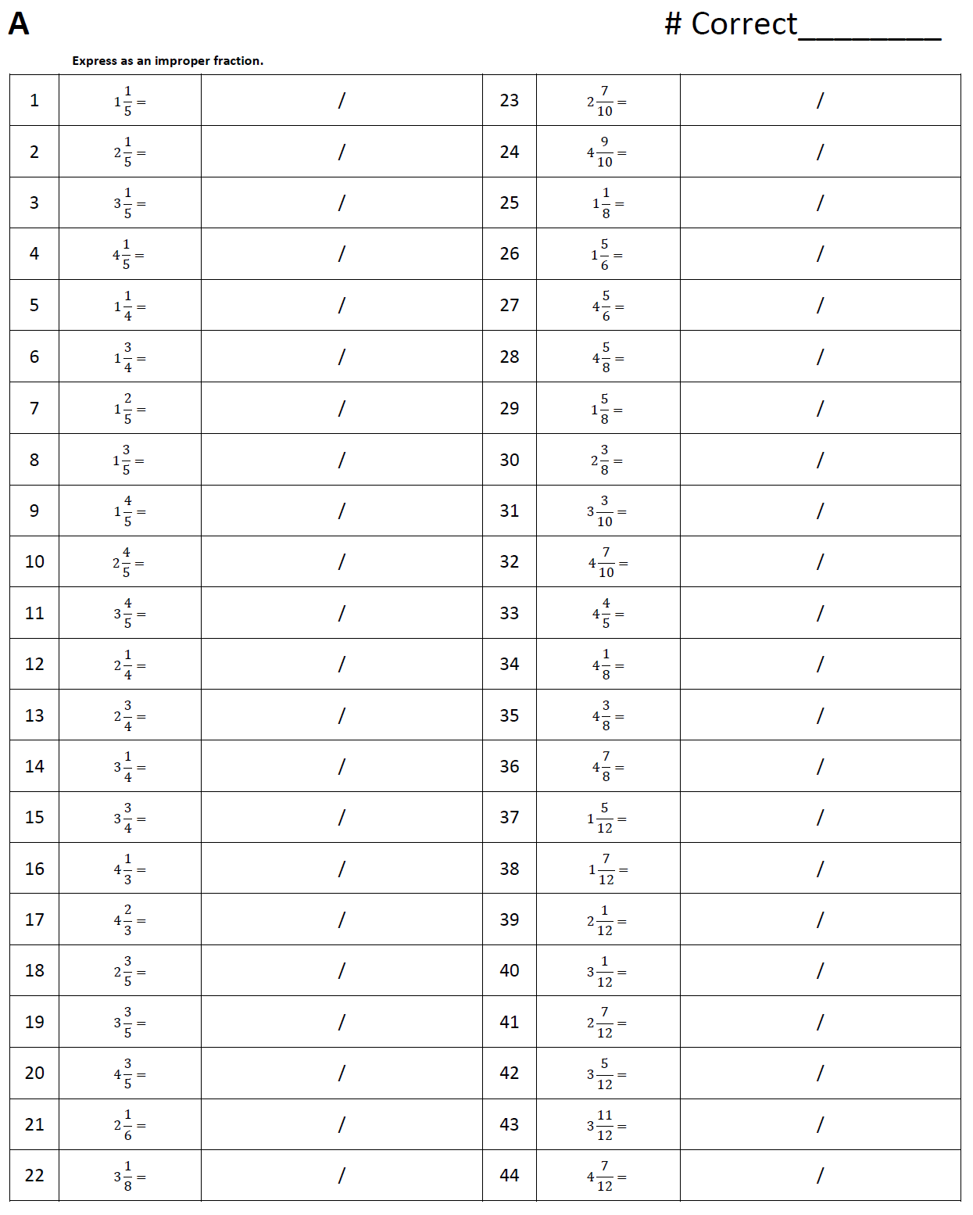
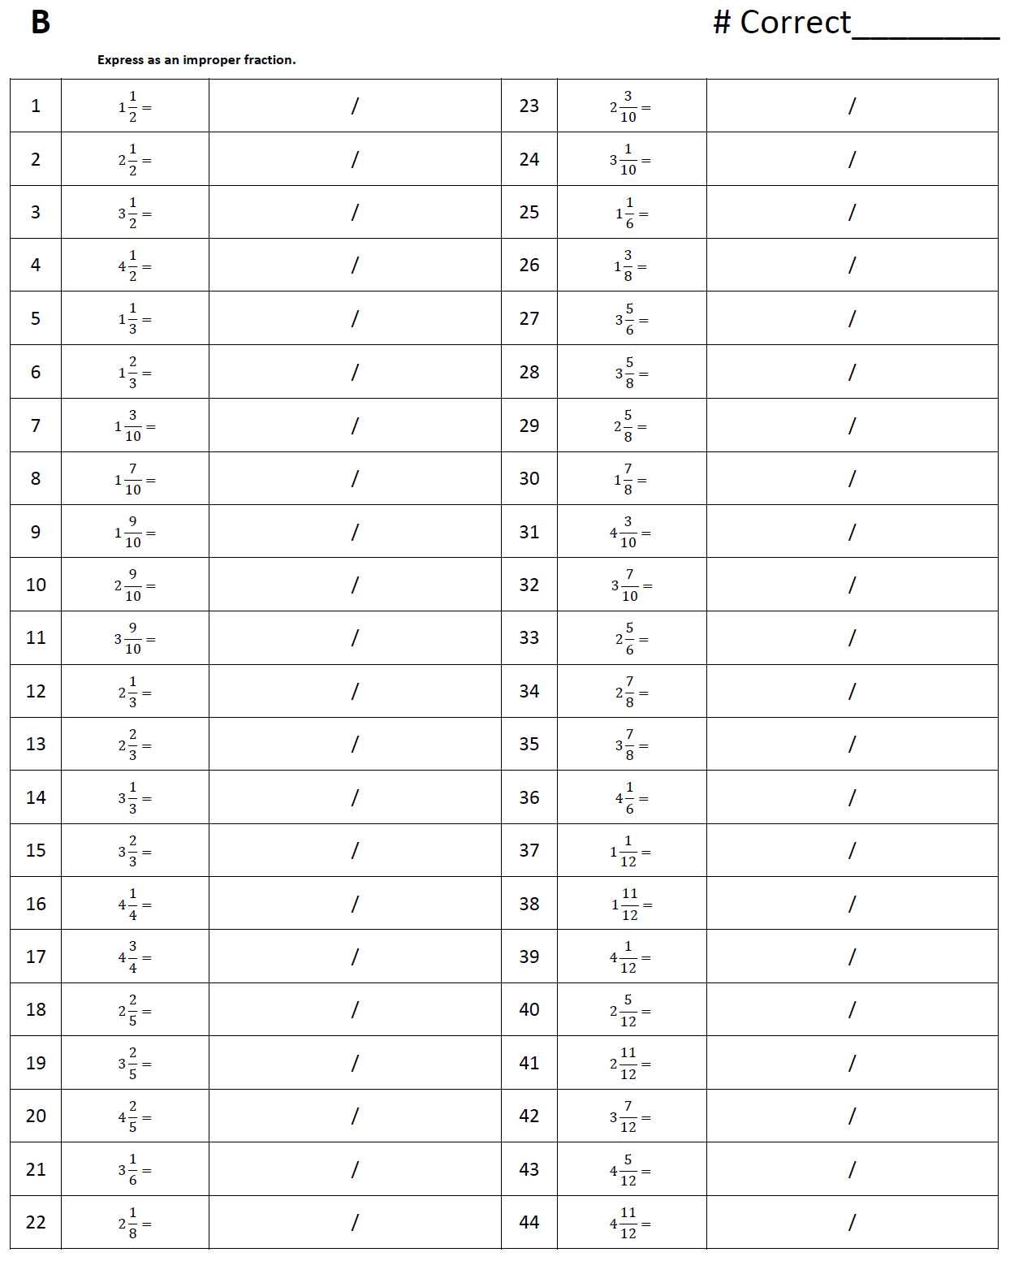

Name Date
In the diagram, the length of S is $\frac{2}{3}$ the length of T. If S has an area of 368 cm², find the perimeter of the figure.

16 cm
S
T

The following problems are puzzles for your enjoyment. They are intended to encourage working together and family problem solving fun and are not a required element of this homework assignment.
Take 12 matchsticks arranged in a grid as shown below, and remove 2 matchsticks so 2 squares remain. How can you do this? Draw the new arrangement.

Moving only 3 matchsticks, make the fish turn around and swim the opposite way. Which matchsticks did you move? Draw the new shape.

