Lesson 21
Objective: Make sense of complex, multi-step problems and persevere in solving them. Share and critique peer solutions.

Suggested Lesson Structure
 Fluency Practice (8 minutes)
 Concept Development (47 minutes)
 Student Debrief (5 minutes)
Total Time (60 minutes)
Fluency Practice (8 minutes)
- Change Mixed Numbers to Improper Fractions 5.NF.3 (4 minutes)
- Add Unlike Denominators 5.NF.1 (4 minutes)
Change Mixed Numbers to Improper Fractions
(4 minutes)

NOTES ON
LESSONS 21─25:
Lesson Sequence for M6–Topic E:
- Lessons 21–22 use a protocol to solve problems within teams of four. The number of problems solved will vary between teams.
- Lesson 23 uses a protocol to share and critique student solutions from Lessons 21–22.
- Lesson 24 resumes the problem solving begun in Lessons 21–22.
- Lesson 25 uses the protocol from Lesson 23 to again share and critique student solutions.

Materials: (S) Personal white boards
Note: This fluency activity reviews G5–Module 3 concepts.
T: (Write $\text{1}\frac{1}{2}$ .) How many halves are in 1?
S: 2 halves.
T: (Write $\text{1}\frac{1}{2}$ = $\frac{2}{2}$ + $\frac{1}{2}$.) What is $\frac{2}{2}$ + $\frac{1}{2}\text{?}$
S: 3 halves.
T: (Write $\text{1}\frac{1}{2}$ = $\frac{3}{2}.$)
T: (Write 3 + $\frac{1}{2}$ .) Write the answer as a mixed number.
S: (Write $\text{3}\frac{1}{2}.$)
T: How many halves are in 1?
S: 2 halves.
T: How many halves are in 2?
S: 4 halves.
T: How many halves are in 3?
S: 6 halves.
T: (Write $\text{3}\frac{1}{2}$ = $\frac{}{2}$ + $\frac{1}{2}$ = $\frac{}{2}.$) Write the addition sentence, filling in the missing numerators.
S: (Write $\text{3}\frac{1}{2}$ = $\frac{6}{2}$ + $\frac{1}{2}$ = $\frac{7}{2}$.)
Continue the process for the following possible suggestions: $\text{2}\frac{1}{3}$, $\text{2}\frac{2}{3}$, $\text{3}\frac{1}{5}$, $\text{3}\frac{3}{5}$, and $\text{4}\frac{3}{4}$.
Add Unlike Denominators (4 minutes)
Materials: (S) Personal white boards
Note: This activity reviews content from G5–Module 3.
T: (Write $\frac{1}{2}\text{+}\frac{1}{3}.$) Add the fractions. Simplify the sum, if possible.
S: (Add.)
Repeat the process for $\frac{1}{4}\text{+}\frac{1}{3}$ , $\frac{1}{5}\text{+}\frac{1}{3}$ , $\frac{1}{4}\text{+}\frac{1}{6}, \frac{1}{5}\text{+}\frac{1}{7}, \frac{1}{8}\text{+}\frac{1}{7}.$
Concept Development (47 minutes)

NOTES ON
MULTIPLE MEANS OF ENGAGEMENT:
Students will offer solutions that are less than perfect. Use your professional discretion when deciding whether to move a team forward to the next problem.
Reasons for persisting:
- Do they need to learn perseverance? (Will this help them to be more attentive to detail, to show their work more effectively, or to work until they get it right?)
Reasons for moving on:
- Will another return to the same problem crush their enthusiasm?
- Does the team’s current solution offer a great share and critique moment for G5–M6–Lessons 24–25?

Note: This topic culminates the year with five days dedicated to problem solving. The problems solved in G5–M6–Lessons 21, 22, and 24 and then shared and critiqued in G5–M6–Lessons 23 and 25 are non-routine and multi-step. The intent is to encourage students to integrate cross-modular knowledge, to strategize, and to persevere.
In G5–M6–Lessons 21, 22, and 24, a protocol is suggested to allow for teams (level-alike or student-selected as per the teacher’s professional discretion) to work at their own pace through the nine problems with the understanding that one group may complete two problems while another group completes them all.
Problems are handed out one at a time to each team individually as they complete work on each problem to the best of their ability. (Notes on an approach to this system are included in the UDL box to the right.)
There are no Exit Tickets for these lessons, shortening the Student Debrief. This is to allow more time for problem solving. The Homework includes one story problem similar to the problems worked in class, and one brainteaser meant to provide a fun challenge for families. Student work samples and a full Debrief are included in G5–M6–Lessons 24–25.

Materials: (S) Problem Set
Note: Print the Problem Set single-sided. Cut the problems apart, one problem per half page. As this limits the work space, consider pasting the smaller papers onto a larger 8½" × 11" sheet.
Process for G5–M6–Lessons 21, 22, and 23: Solving Word Problems in Teams of Four
1. Establish the intention of G5–M6–Lessons 21–25 with teams.
Let students know that over the next five days, they will be working in teams to solve some great problems and share their solutions with peers. Each team will work at its own pace to solve as many problems as possible. The object is not to compete with other groups, but for each team to do its personal best.
Introduce this protocol to the students: Think, pair, share, and complete.

NOTES ON
MULTIPLE MEANS OF ENGAGEMENT:
For G5–M6–Lessons 23 and 25, consider reconfiguring students into new groups of four for a more in-depth share and critique process. Possible alternatives to this arrangement are given below:
- Solve the problems for three days consecutively. Share and critique for two days consecutively.
- Solve problems for four days, closing each session with a share and critique. Day 5 might be used for a museum walk.
All materials are housed here in G5–M6–Lesson 21, so that whatever structure is chosen, this lesson will be the home base.
Think: Work independently to begin each problem. Read the problem through quietly.
Pair: Work together with a partner from within the team to complete the problem.
Share: Share with the other pair of the team of four, giving each pair an opportunity to share. (A more in-depth analysis and share and critique will be explored in G5–M6–Lessons 23 and 25.)
Complete: Return to work following the sharing in order to incorporate ideas that came from the collaboration. Finalize the solution.
2. Establish a system for teams to communicate the completion of a problem.
Throughout the session, circulate and check solutions prior to giving teams the next problem in the sequence. Celebrate success when appropriate.
3. Let students know that completed work will be collected, organized, and analyzed.
To prepare for the share and critique protocol in G5–M6–Lessons 23 and 25, compile student work for the same problem from various teams. For example, after the first day, all sets of student solutions from Problem 1 would be housed in a dedicated folder as would sets of solutions from Problem 2, and so on. This organization will allow for efficient re-distribution of solutions as students work with members from different teams to analyze and critique the solution strategies.
Following this lesson’s Debrief are analyses and possible solution strategies for each of the nine problems. The problem masters are included at the end of this lesson. The analyses and possible solutions are positioned after the Debrief to emphasize the fact that students will progress through these problems at different rates as they work within their groups.
Student Debrief (5 Minutes)
Lesson Objective: Make sense of complex, multi-step problems and persevere in solving them. Share and critique peer solutions.
- If you encountered a difficulty while solving the problem, what strategies did you use to keep going?
- What advice would you give a classmate who was having trouble with a difficult problem?
- What did you learn about yourself as a problem solver today that will help you to be a better problem solver tomorrow?
Note: There is no Exit Ticket for this lesson.

Analysis and Solution Strategies for Problems 1–9
Problem 1: Pierre’s Paper
Pierre folded a square piece of paper vertically to make two rectangles. Each rectangle had a perimeter of 39 inches. How long is each side of the original square? What is the area of the original square? What is the area of one of the rectangles?
This problem calls on student knowledge of the properties of squares and rectangles as well as their knowledge of area and perimeter. Understanding the relationships between the lengths of the rectangle’s sides is the key to solving it.
If students are having difficulty moving forward, the following questions may help them:
- How does knowing that this figure is a square help us know about the dimensions of the rectangle? How are the dimensions of the rectangle related to each other?
- What is the unit we are counting?
- Think of the rectangle’s shorter side (or longer side) as 1 unit.
Below, Solution A solves for the longer side of the rectangle and uses a more abstract representation of the thinking, while Solution B solves for the shorter side of the rectangle.
Solution A
Solution B
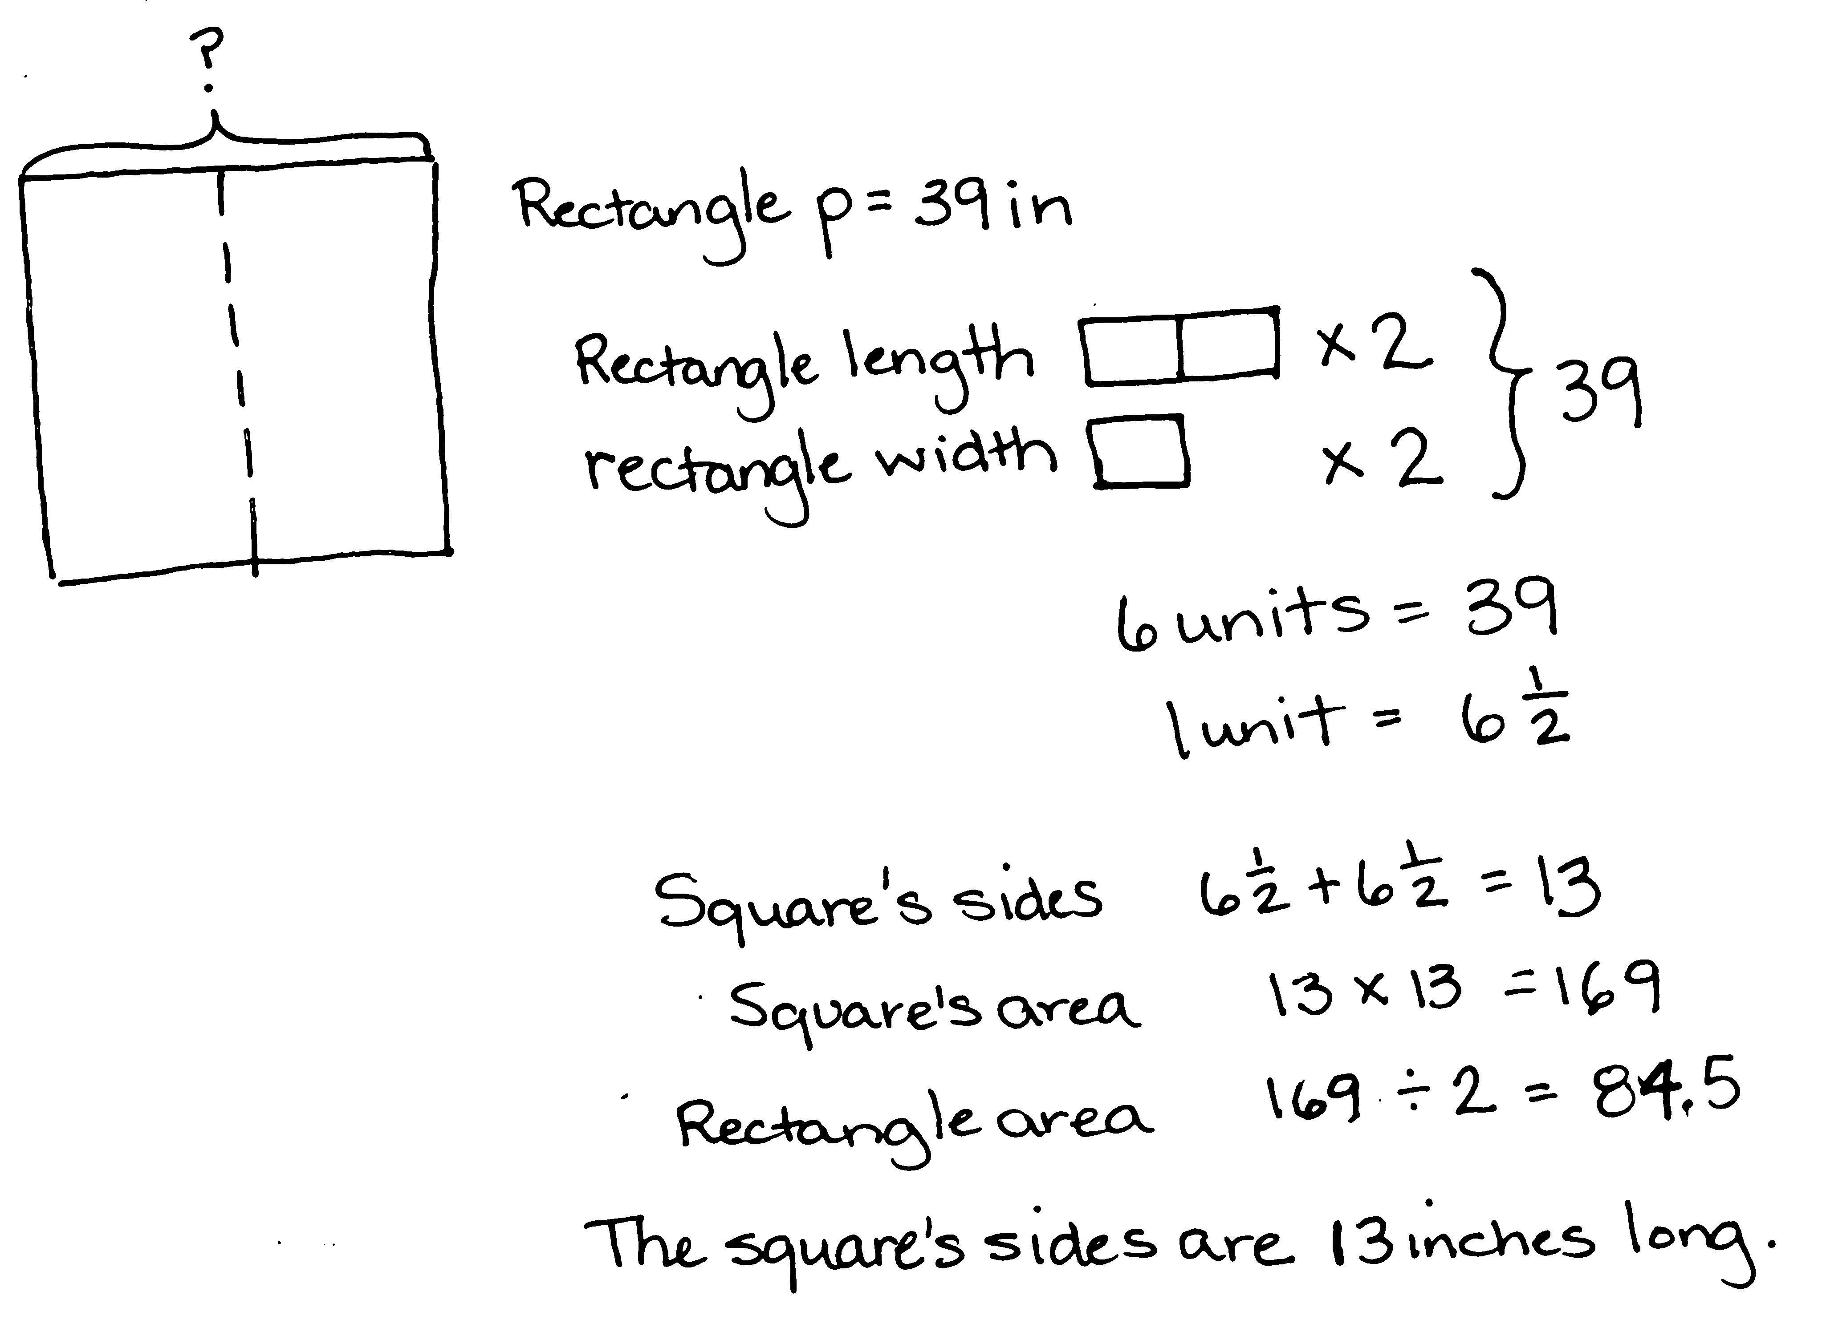
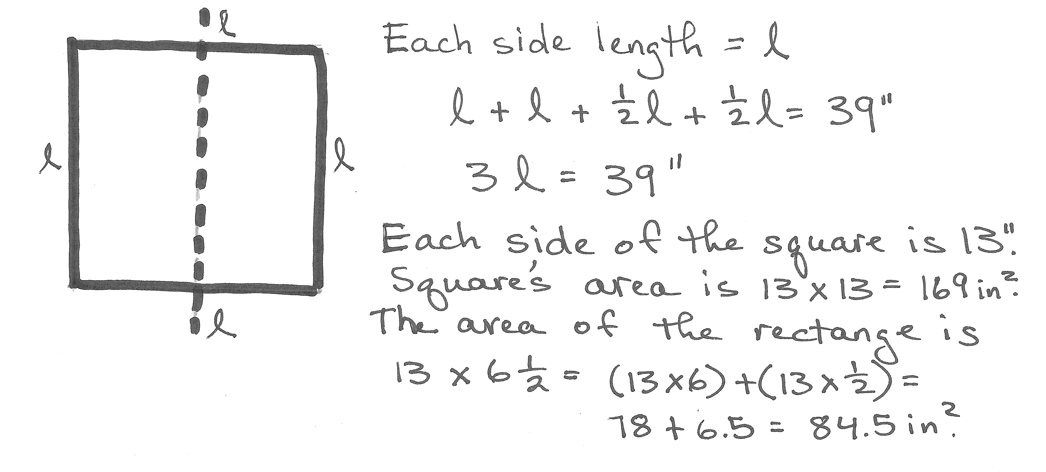
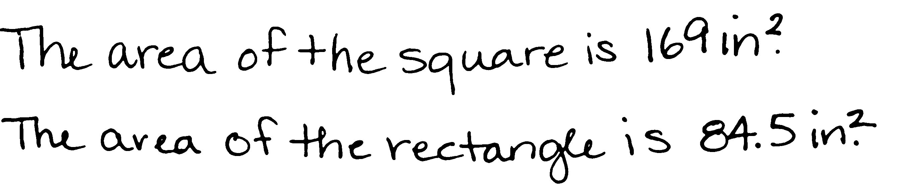
Problem 2: Shopping with Elise
Elise saved $184. She bought a scarf, a necklace, and a notebook. After her purchases, she still had $39.50. The scarf cost three-fifths the cost of the necklace, and the notebook was one-sixth as much as the scarf. What was the cost of each item? How much more did the necklace cost than the notebook?
This problem is fairly straightforward mathematically. However, students will need to find a common unit for all three items in order to determine the cost of the notebook. Once this is established, the costs of the other items may be found easily. Students may attempt to find a solution through fraction multiplication. This approach may stall when trying to determine the fraction of the money spent on the necklace. The following may provide scaffolding for students experiencing difficulty:
- Which item’s tape should be the longest? The shortest?
- How can we make these units the same size?
- Begin with the notebook as 1 unit. If the notebook is 1 sixth the cost of the scarf, then how many times as much is the scarf’s cost to the cost of the notebook?
Both solutions below begin by finding the amount spent on the three items. While both use the cost of the notebook as 1 unit, Solution A begins with the necklace and uses the fraction information to subdivide the other tapes. Solution B uses a multiplicative approach thinking of the scarf’s cost as 6 times as much as the cost of the notebook.
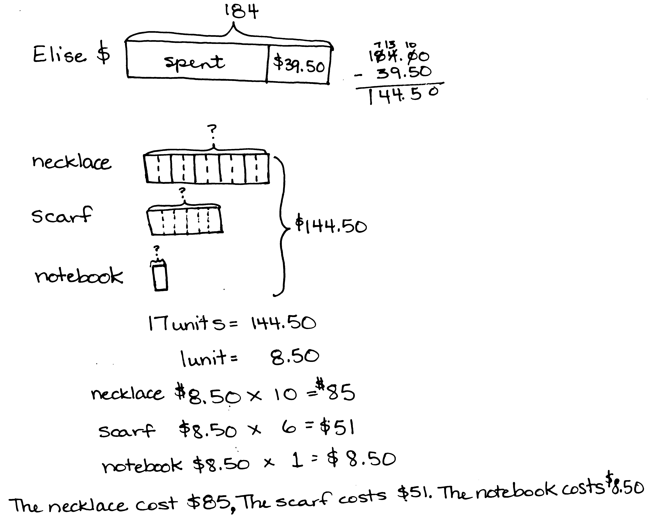
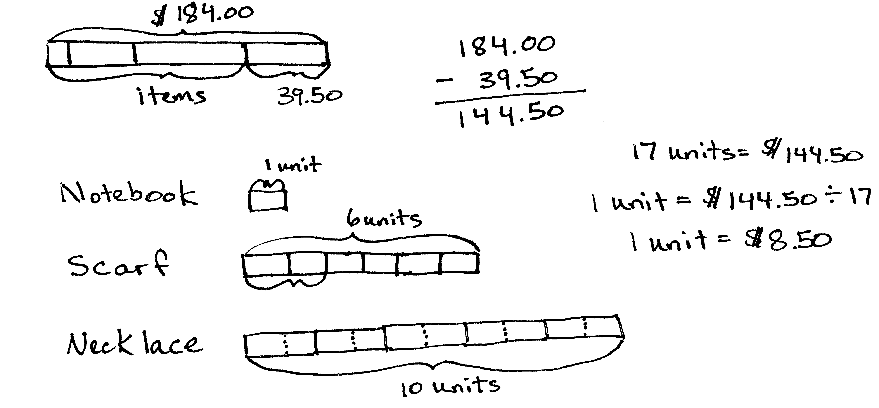
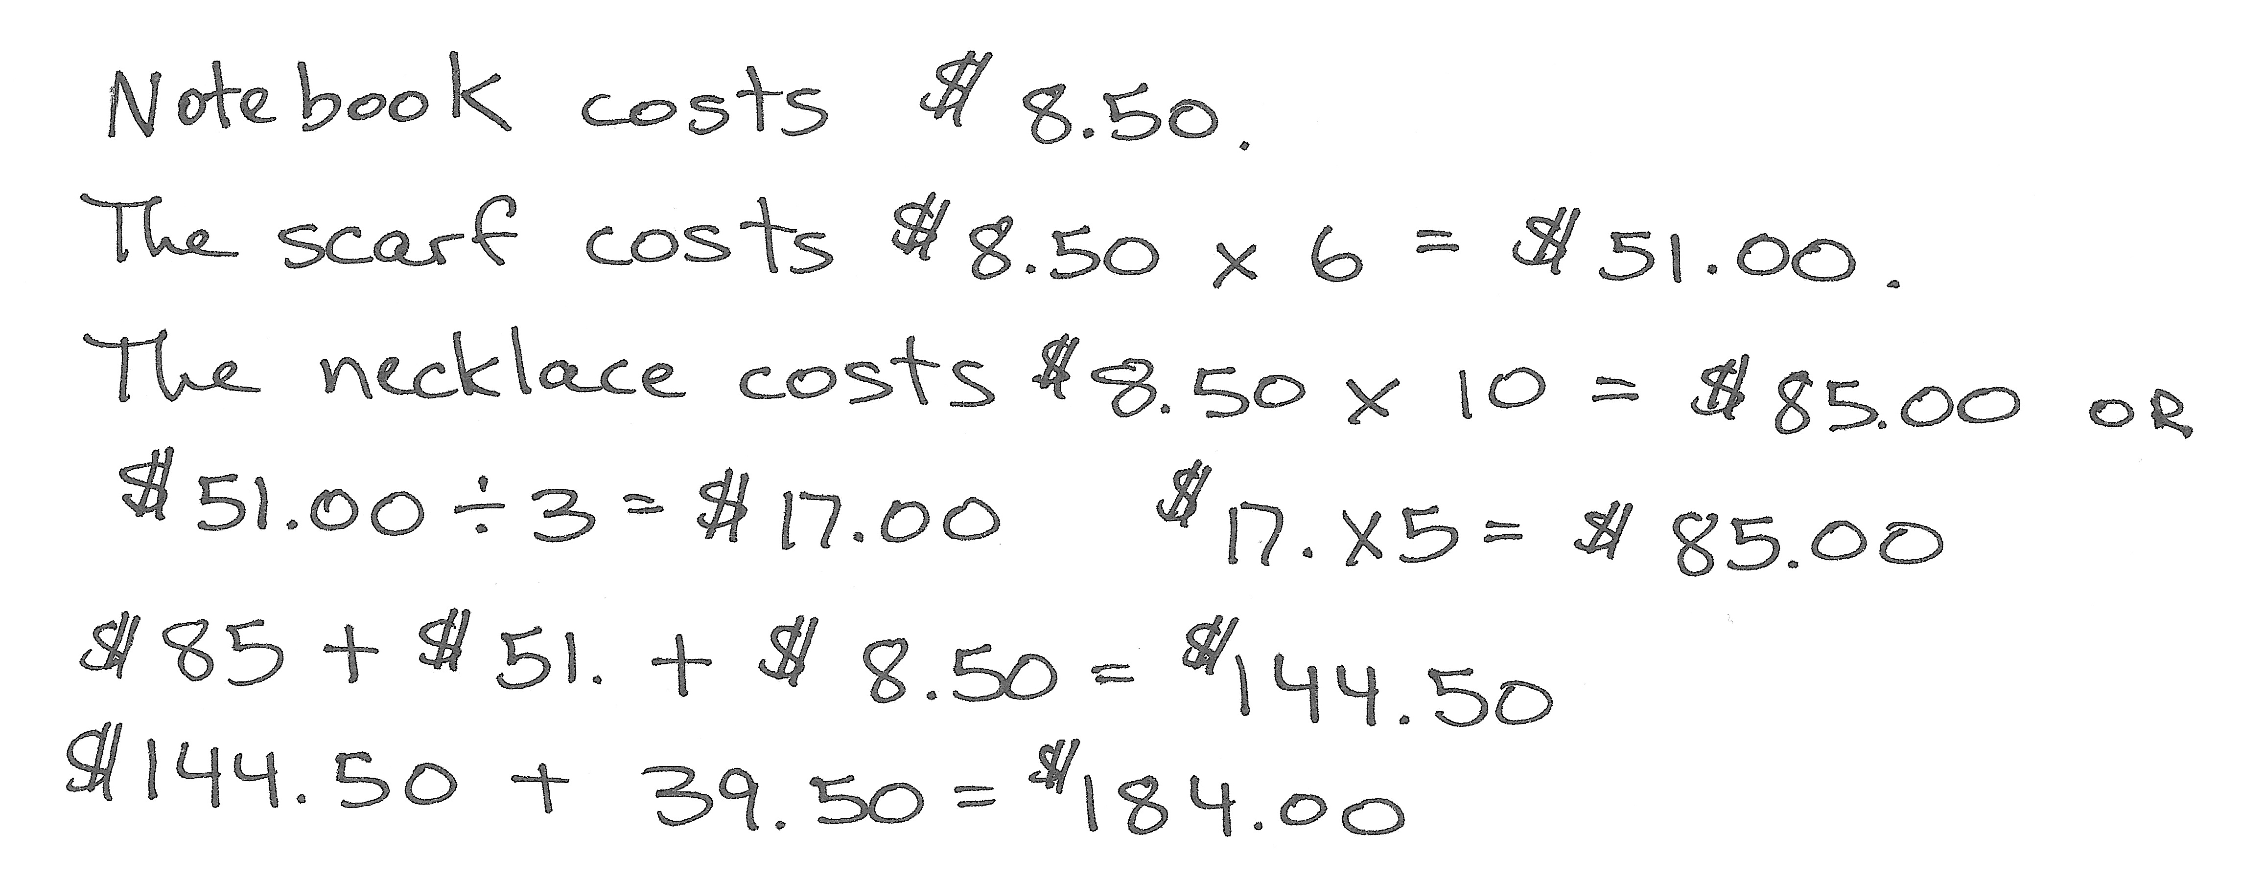
Solution B
Solution A

Problem 3: The Hewitt’s Carpet
The Hewitt family is buying carpet for two rooms. The dining room is a square that measures 12 feet on each side. The den is 9 yards by 5 yards. Mrs. Hewitt has budgeted $2,650 for carpeting both rooms. The green carpet she is considering costs $42.75 per square yard, and the brown carpet’s price is $4.95 per square foot. What are the ways she can carpet the rooms and stay within her budget?
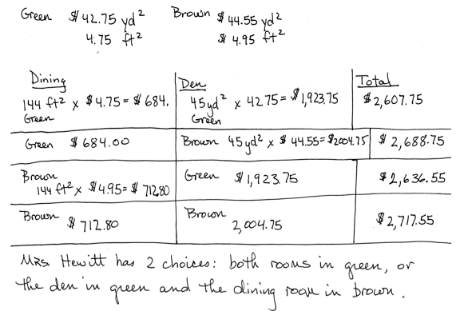
While the calculations for solving this problem are simple multiplication and addition, the path to finding the appropriate numbers on which to operate requires a high degree of organization. Students must attend not only to finding the various combinations that are possible, but they must also attend to the units in which the areas and prices are given. Students may choose to use only one unit of measure for the areas and prices, or they may use a combination. The following scaffolds may support struggling students:
MP.2
Solution A
- Are the areas expressed in the same unit? Can we use them as they are or must we convert?
- How might we organize the information so that we can keep track of our thinking?
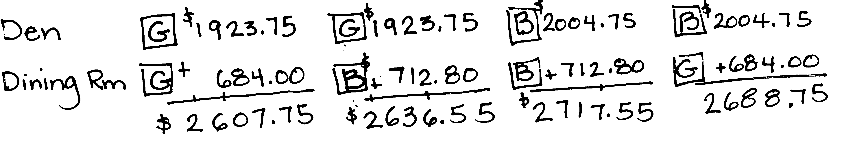
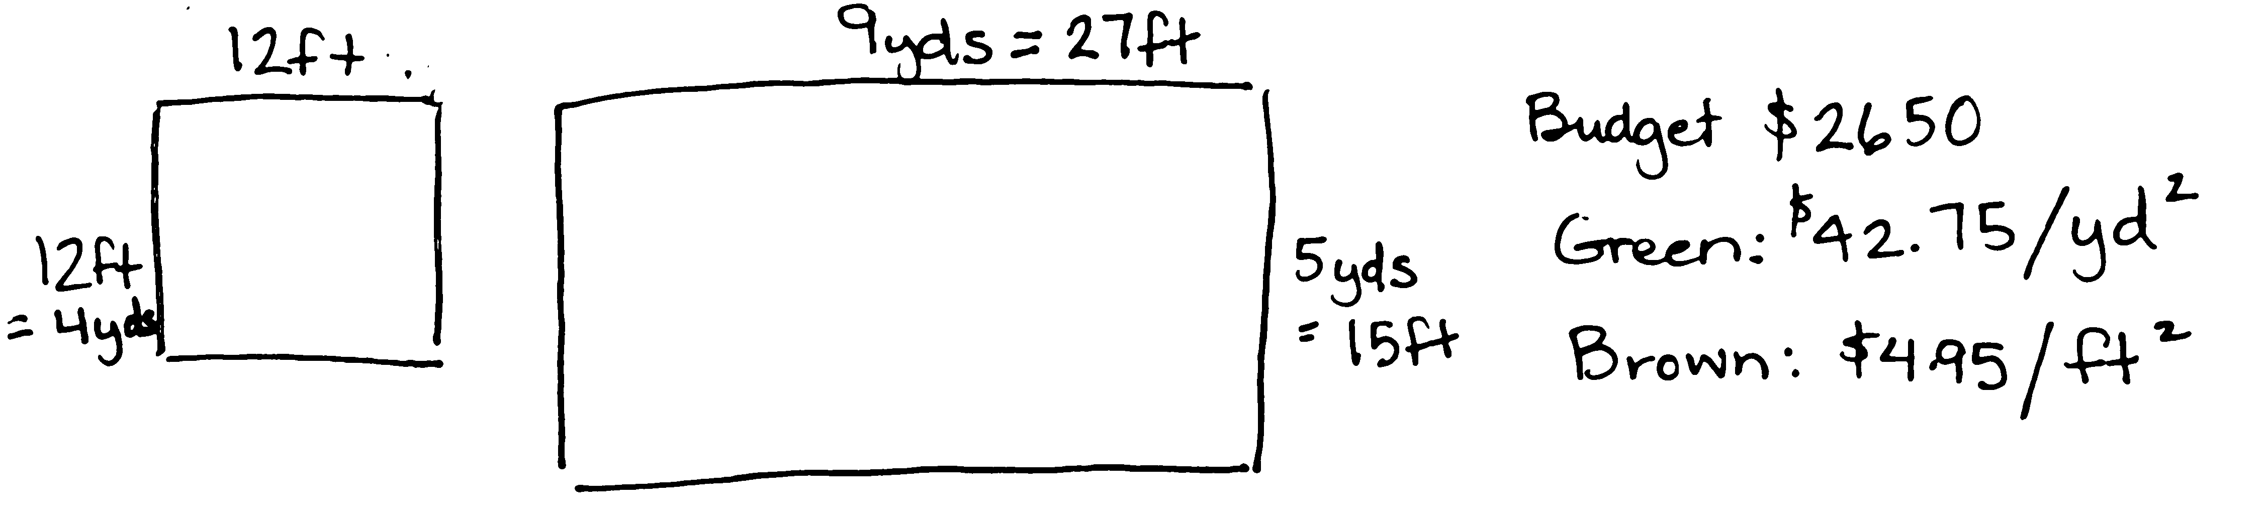
- What are the combinations of carpet that Mrs. Hewitt can choose? Predict which combination will be the most expensive? Which the least expensive? How do you know? How can that prediction help you to move forward?
Solution B
- Consider the prices per square yard and per square foot. Which of these carpets is the more expensive? How do you know? How might this information help you to organize your thoughts?
Both of the solutions to the right show good organization of the calculations used to solve. Solution A converts the carpet prices to match the area units of the rooms. Solutions B converts the dimensions of the rooms to match the units of the prices.
Problem 4: AAA Taxi
AAA Taxi charges $1.75 for the first mile and $1.05 for each additional mile. How far could Mrs. Leslie travel for $20 if she tips the cab driver $2.50?
Students encounter a part–part–whole problem with varying unit size in the AAA Taxi Problem. They must first consider the cost of the first mile and tip, and then determine how many groups of $1.05 can be made from the remaining $15.75.
To scaffold, consider the following:
- Will all of the $20 be used to pay for the mileage? Why not?
- Do all the miles cost the same? How do we account for that in our model?
- How would you solve this if all the miles cost the same? What if the tip was the same as the cost for the miles?
Solution A begins by counting on from the first mile. Solution B chooses to represent the problem with a tape diagram and divides to find how many units with a value of $1.05 there are once the sum of the tip and first mile are subtracted from the $20.
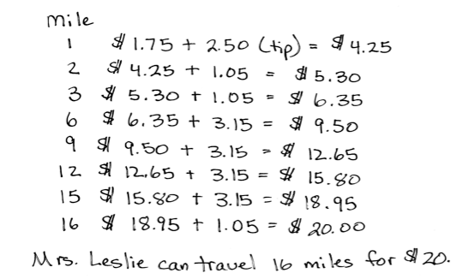
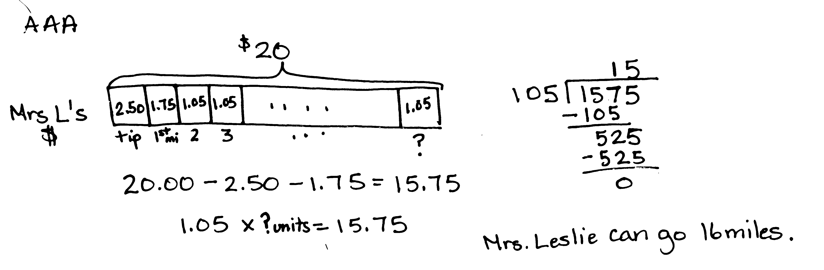
Solution B
Solution A

Problem 5: Pumpkins and Squash
Three pumpkins and two squash weigh 27.5 pounds. Four pumpkins and three squash weigh 37.5 pounds. Each pumpkin weighs the same as the other pumpkins, and each squash weighs the same as the other squash. How much does each pumpkin weigh? How much does each squash weigh?
This problem is a departure from the routine problems in most of Grade 5 in that students must unitize two different variables (1 pumpkin and 1 squash) as a single unit. Once the difference is found between the quantities, students have several avenues for finding the weights of the individual pumpkin and squash.
- Draw the tapes to represent the weights for the two situations. Which tape is longer? How much longer?
- How many more pumpkins are in the second tape? How many more squash?
- Outline the difference with a red pen. Can you find this same combination in the rest of the tape? How many can you find?
Both solutions below use tape diagrams to show that the difference between the two known facts is a combination of one pumpkin and one squash. Next, they reason that the sum of the weights of a pumpkin and squash is 10 pounds. From there, they can see two of those pumpkin and squash units in relationship to the 27.5 pound group. It is clear then that the weight of the pumpkin has to be 7.5 pounds.
Solution A
Solution B
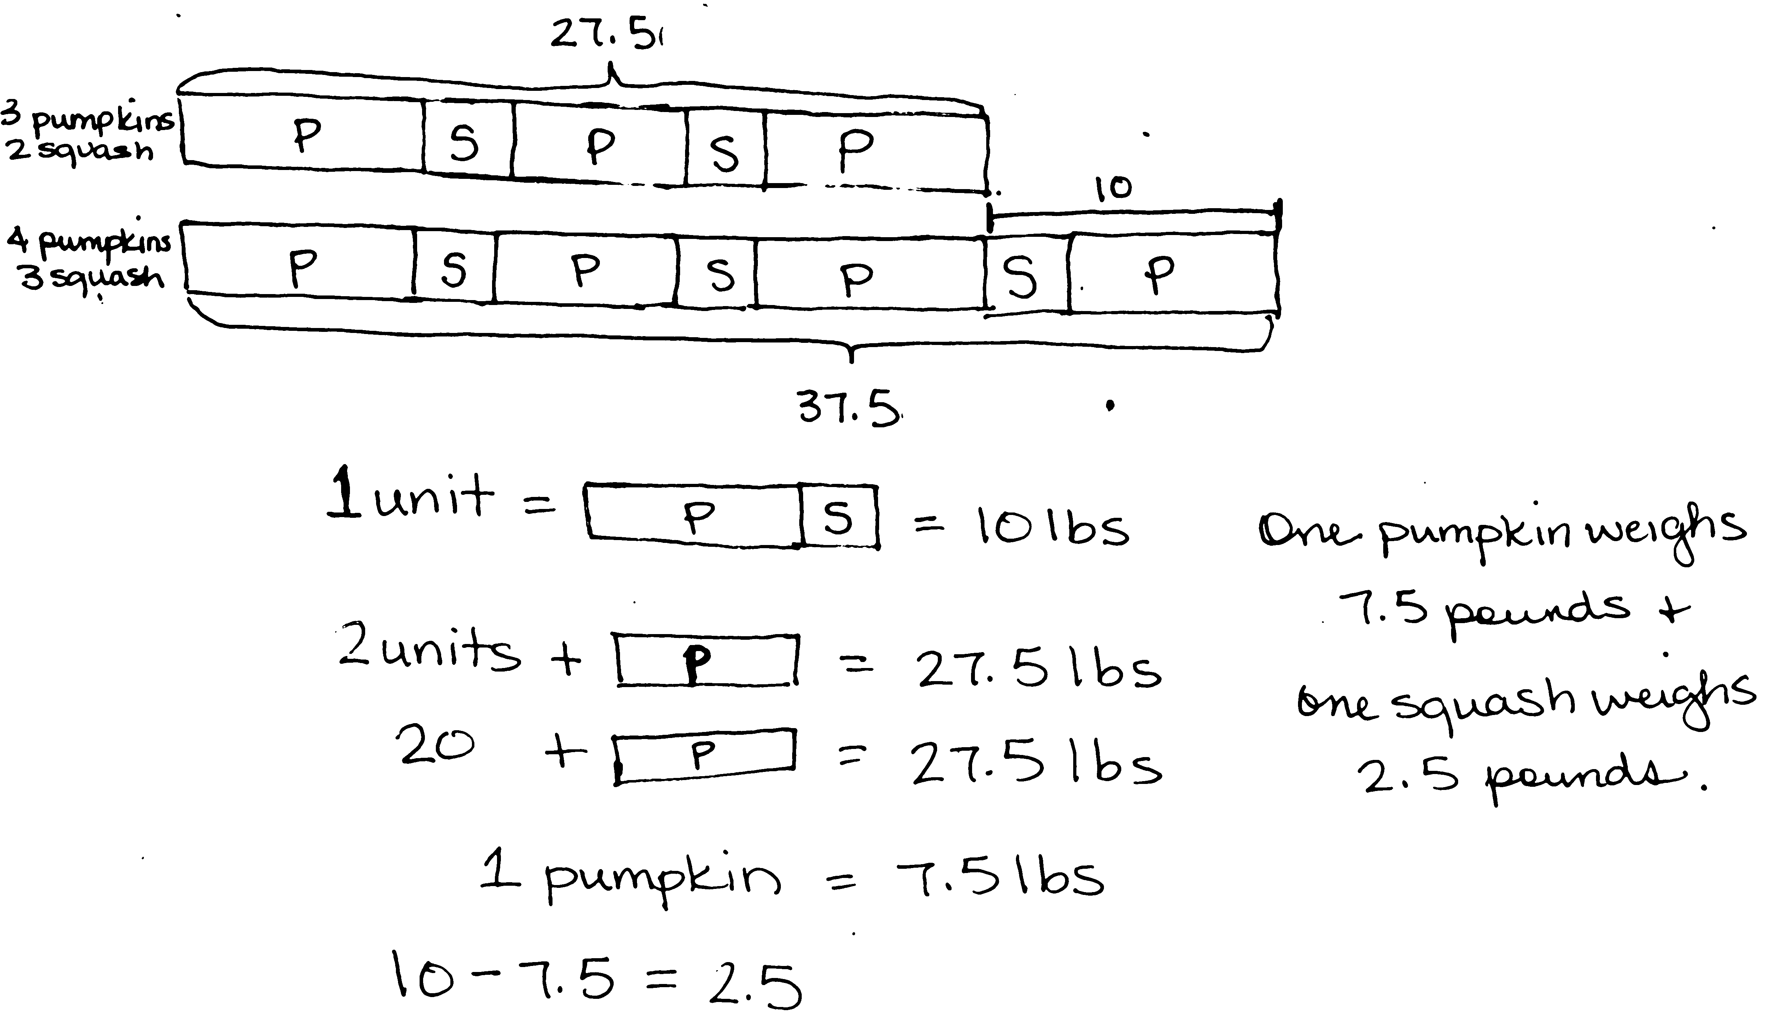

Problem 6: Toy Cars and Trucks
Henry had 20 convertibles and 5 trucks in his miniature car collection. After Henry’s aunt bought him some more miniature trucks, Henry found that one-fifth of his collection consisted of convertibles. How many trucks did his aunt buy?
This problem requires students to process a before-and-after scenario. The larger quantity in the before situation becomes the smaller quantity in the after situation. This change in fractional relationship may be depicted in various ways. Students should be careful to model only 5 fifths in the after model—1 fifth for the convertibles and 4 fifths for the trucks. Use the following to scaffold student understanding:
- Draw Henry’s convertibles and trucks before his aunt gave him more trucks. Draw the convertibles and trucks after his aunt gave him more.
- What amount stayed the same?
- Which is more, the cars or trucks? (Ask for both before and after. Have students simply draw the bars longer and shorter.)
- Refer to the convertibles tape in the after model. Ask, “If this is 1 fifth, what is the whole?”
Solution A combines the before and after models into one tape. The numbering on the top represents the before while the numbering below represents the after. Solution B also uses fraction division to determine the whole. Solution C uses a unit approach, with the number of trucks in the beginning as 1 unit.
Solution A
Solution B
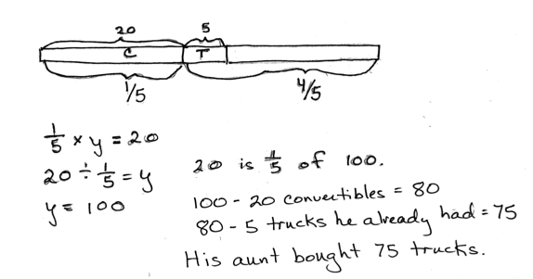
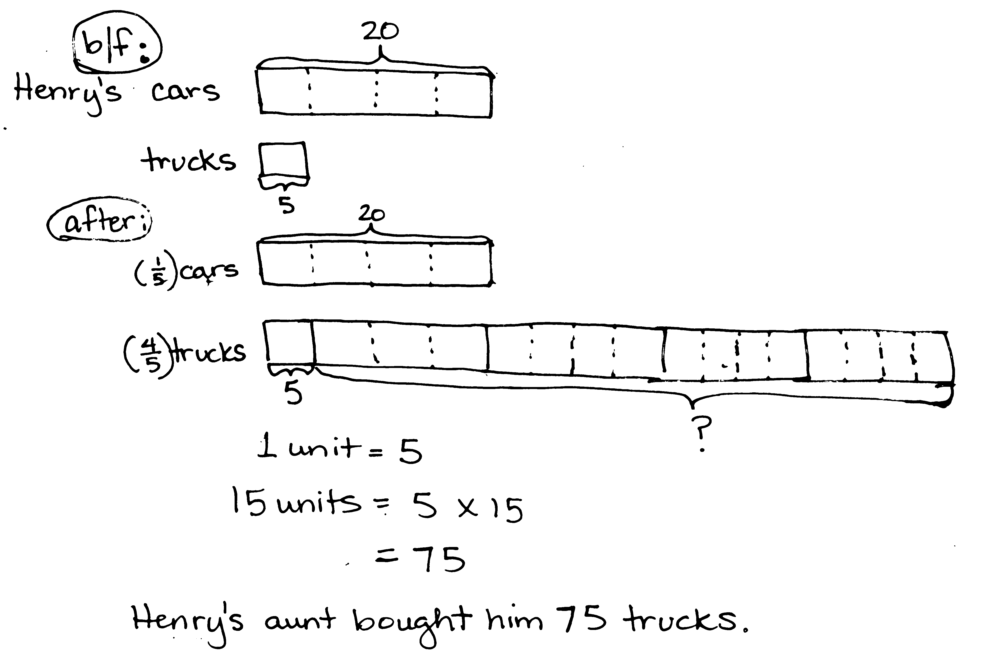
Solution C
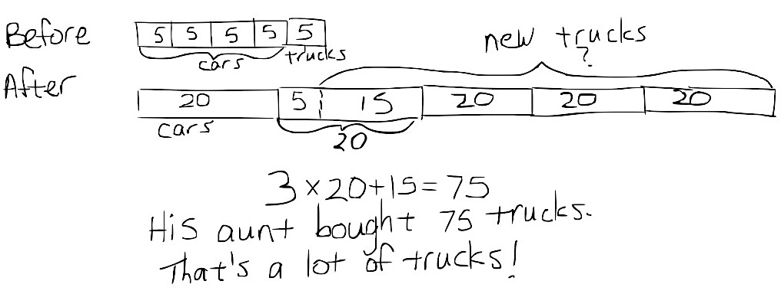

Problem 7: Pairs of Scouts:
Some girls in a Girl Scout troop are pairing up with some boys in a Boy Scout troop to practice square dancing. Two-thirds of the girls are paired with three-fifths of the boys. What fraction of the scouts is square dancing?
This problem challenges students to consider what they know about fraction equivalence. The key to this problem lies in recognizing the need for equal numbers of units. That is, equal numerators must be found! Once students can visualize that 6 of the girls’ units are the same as 6 of the boys’ units, a fraction of the total number of units can be found. Scaffold with the following:
- We know the same number of girls as boys are dancing. Are these units the same size? How can we make them the same size?
- How can 2 units be the same amount as 3 units? Only if one unit is larger than the other. For example, 2 yards equals 6 feet if we consider 1 larger unit and a smaller unit.
- Make sure that once students make 6 units in each tape for the dancing scouts, they also subdivide the remaining units in each bar. This will create the 19 total units.
Solution A uses a tape diagram to model the equal amounts and then decompose to make the boy and girls units equal. Solution B uses an array approach to match up girls and boys.
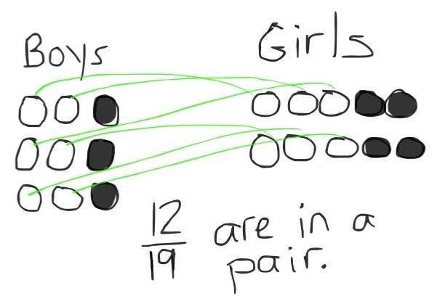
Solution B
Solution A

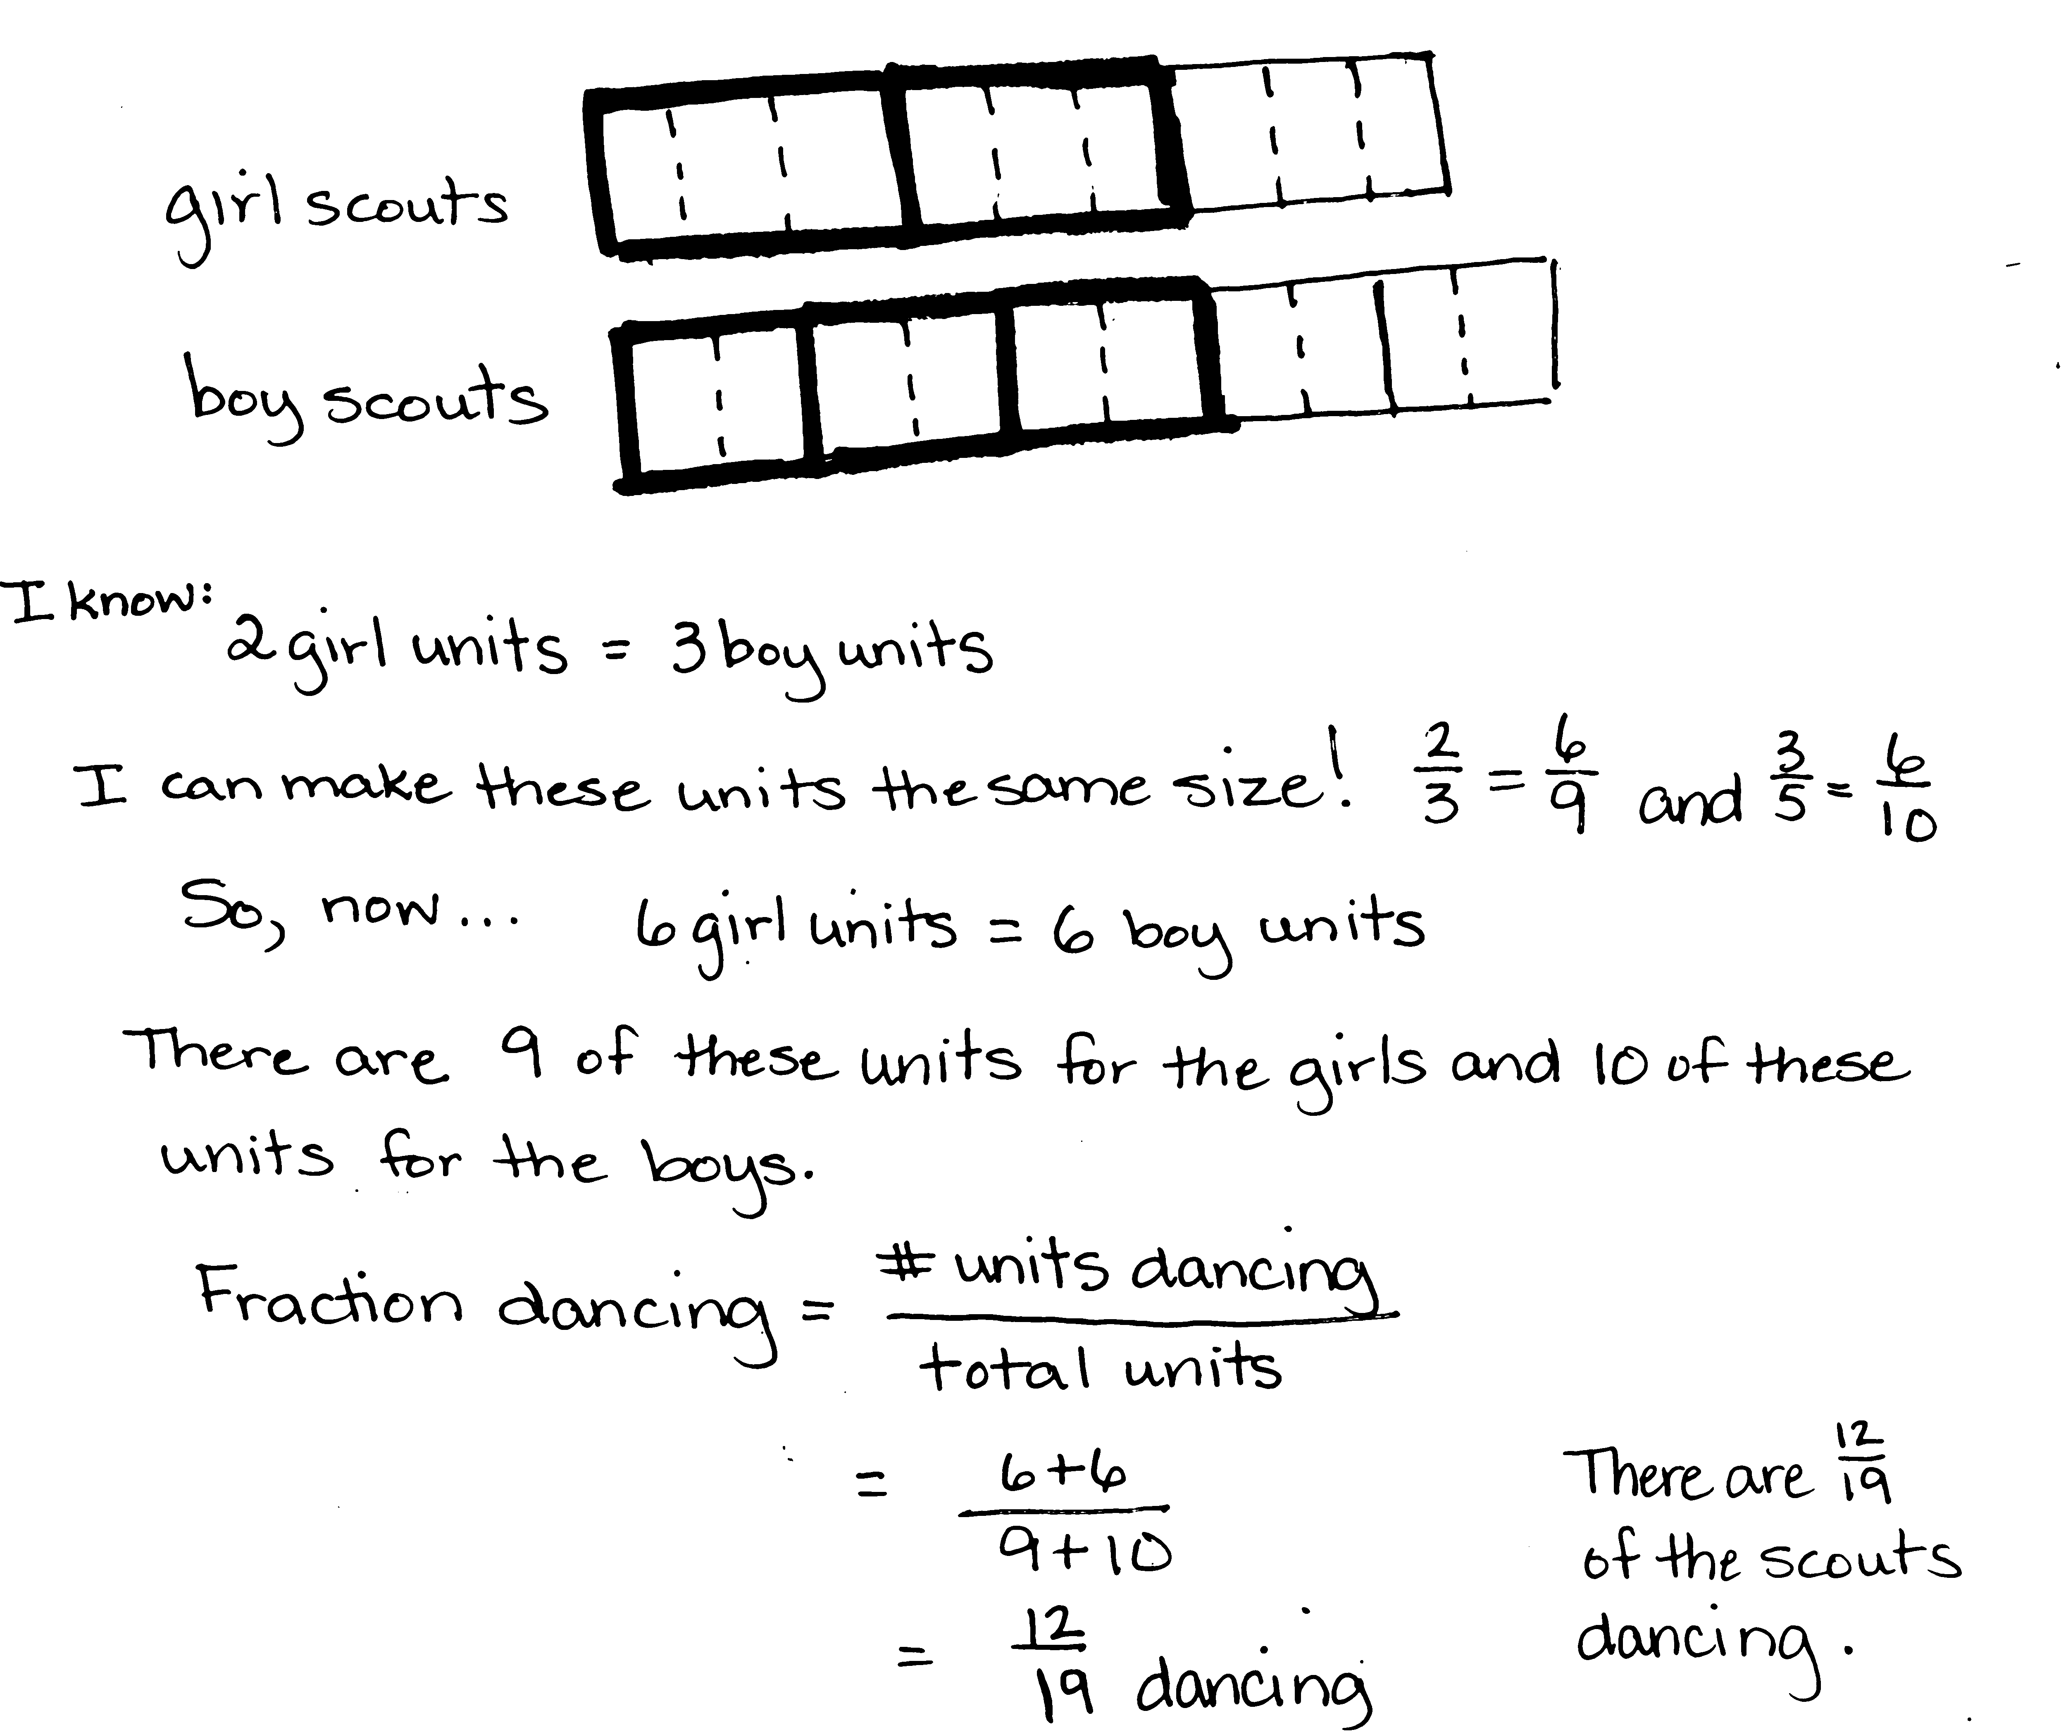

Problem 8: Sandra’s Measuring Cups
Sandra is making cookies that require $\text{5}\frac{1}{2}$ cups of oatmeal. She has only two measuring cups: a one-half cup and a three-fourths cup. What is the smallest number of scoops that she could make in order to get $\text{5}\frac{1}{2}$ cups?
Recognizing that using a larger unit will require fewer scoops is the beginning of understanding this problem. Students may try to name the total using all halves or all fourths, but will find that neither measure can be used exclusively. Using the larger measure first to scoop as much as possible, then moving to scoop the remainder with the smaller cup is the more efficient method of solving. To scaffold, ask the following questions:
- Which measuring cup is larger? How does knowing which is larger help you?
- Predict which measuring cup will do the job more quickly? How do you know?
- How many scoops will it take using just the half-cup measure? How many if only the larger cup is used? Is it possible to scoop all the oatmeal and fill the three-fourths cup every time?
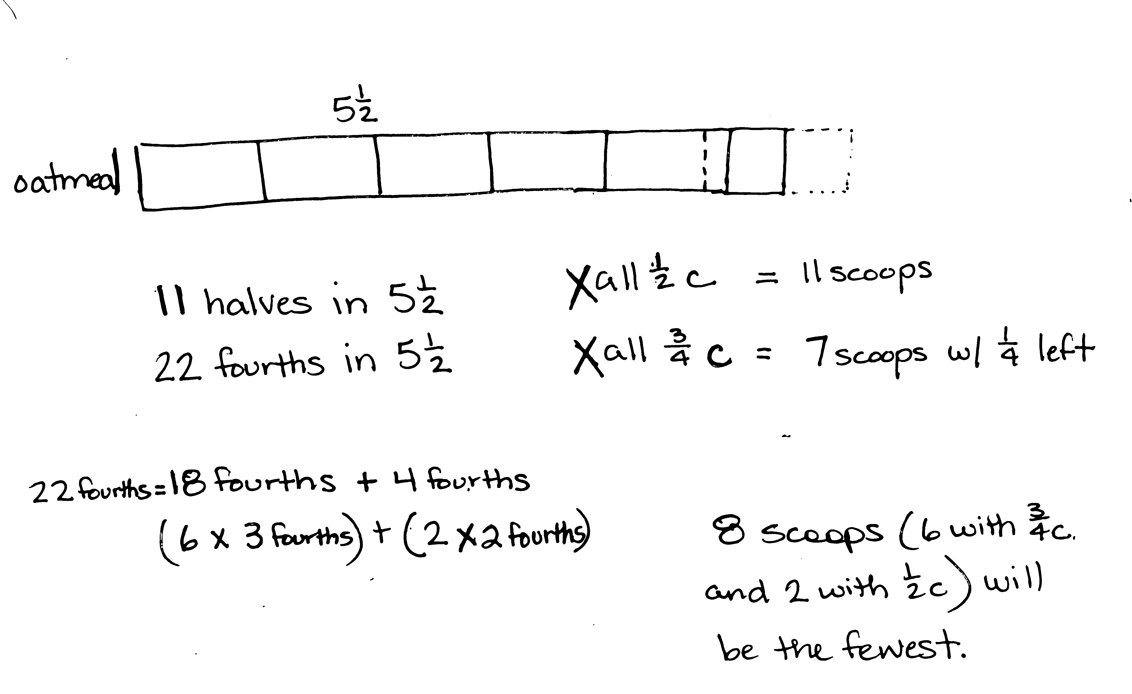
All three solutions pictured below use the strategy of beginning with the larger cup measure. However, Solution A uses a unitary approach, decomposing the fourths into a multiple of 3 and a multiple of 2. Solution B counts on by three-fourths and then by halves. Solution C works at the numerical level to guess and check.
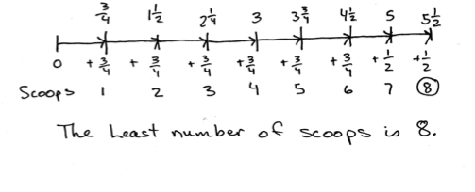
Solution B
Solution A
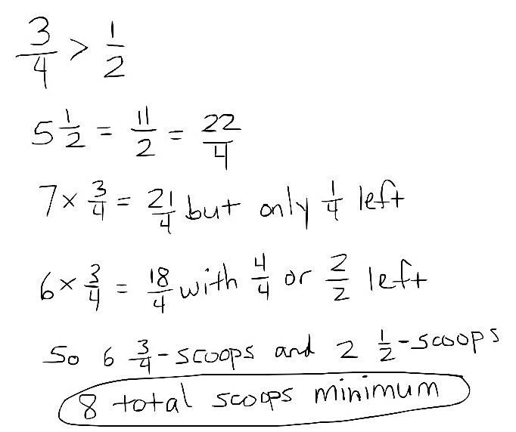
Solution C

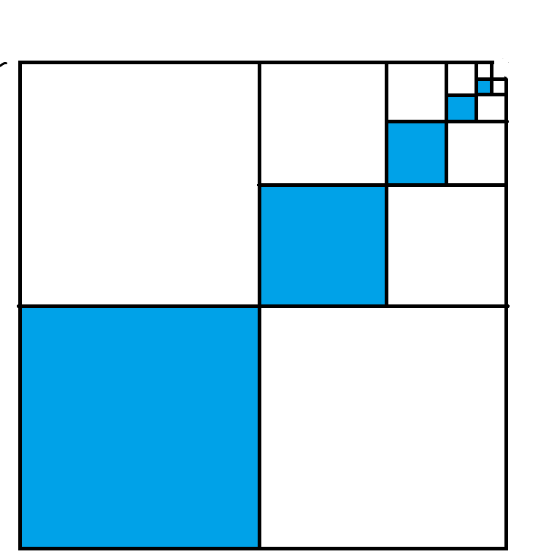
Problem 9: Blue Squares
The dimensions of each successive blue square pictured to the right are half that of the previous blue square. The lower left blue square measures 6 inches by 6 inches.
- Find the area of the shaded part.
- Find the total area of the shaded and unshaded parts.
- What fraction of the figure is shaded?
There are multiple ways to visualize this graphic, each leading to a different approach to solving. Students may see that there are 3 identical sets of graduated squares. Out of these 3 identical sets, only 1 set is shaded. Students may also do the work to find the fraction of the whole that the smallest shaded square represents and use an additive approach to finding the shaded area. The shaded area might then be used to find the total area. In contrast, the fraction that is shaded might be used in conjunction with the total area to name the area of the shaded parts. Scaffolds could include the following:
- Can you find the shaded area of just the first three squares (or L’s)?
- Cut the graphic apart into separate L’s or separate squares. What can you say about the fraction that is shaded in each one?
- How long is the side of each shaded square?
- What if the little square wasn’t missing? What would be the area of the whole square? What part of that whole is missing?
Solution A uses the additive approach mentioned above to find the shaded area, which is multiplied by 3 to find the total. Solution B works backwards to name the fraction that is shaded, then finds the total area by using subtraction from a 12 by 12 square’s area. These two pieces of information are then used to find the area of the shaded region in square inches.
Solution A
Solution B
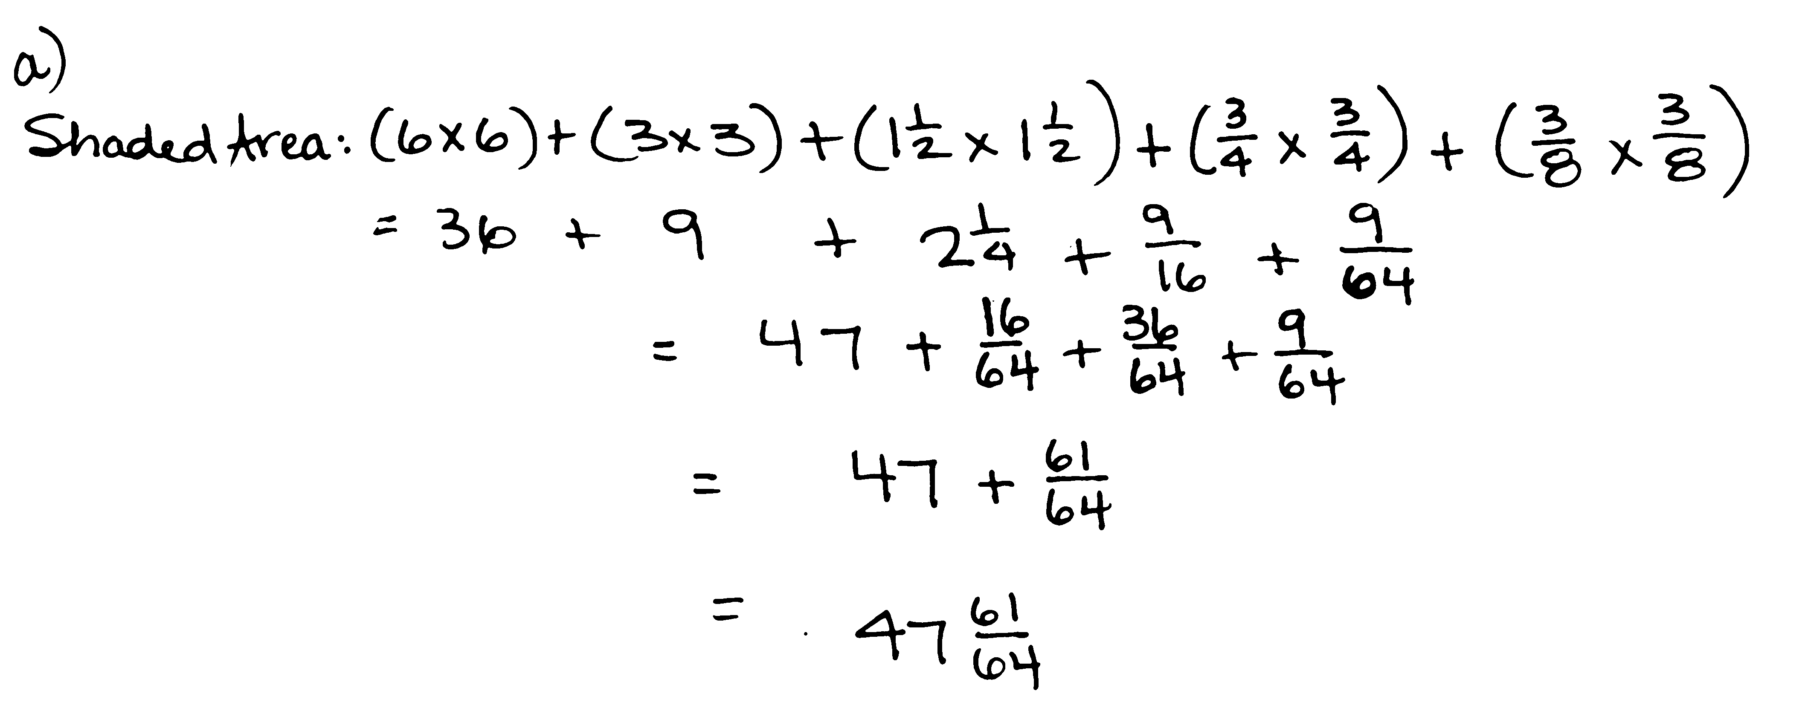
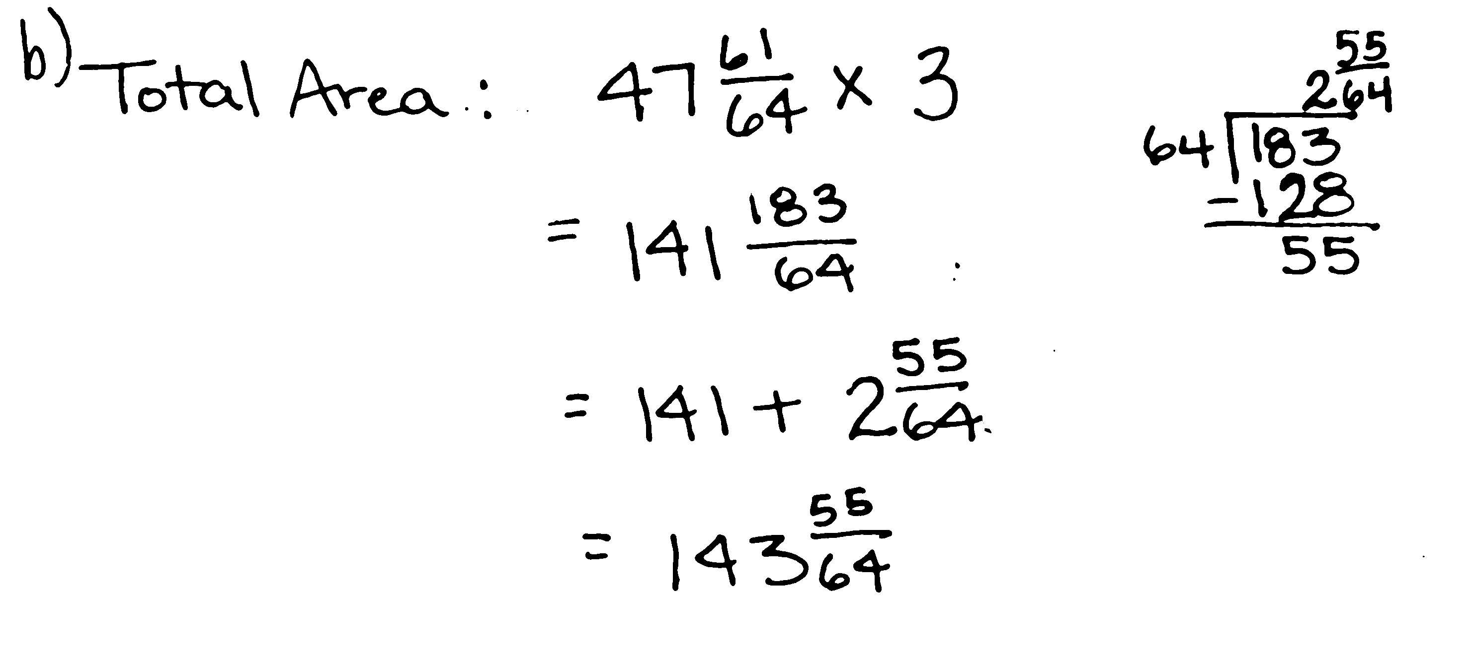
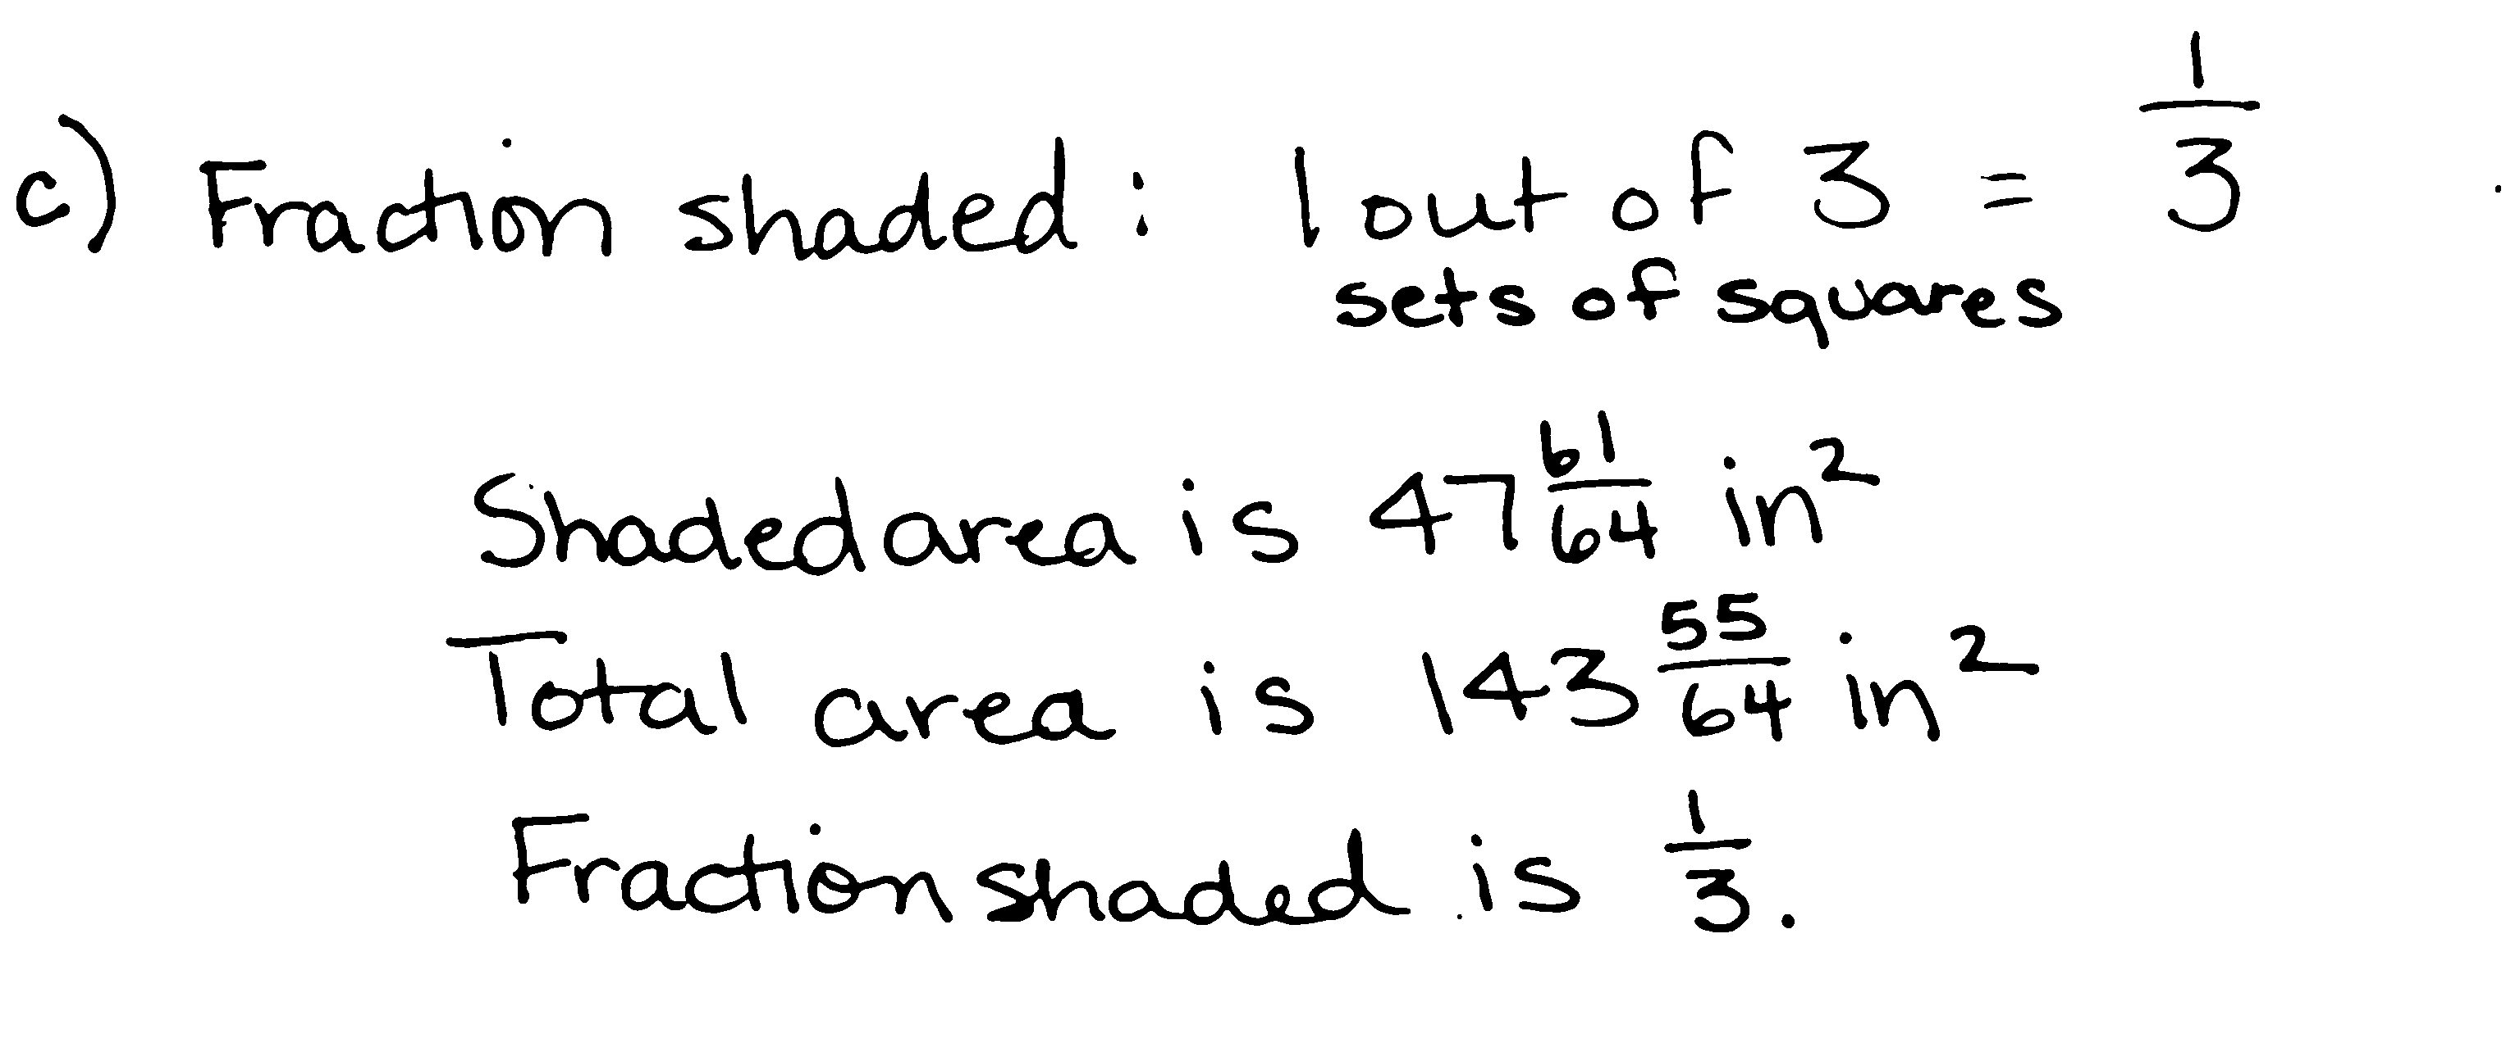
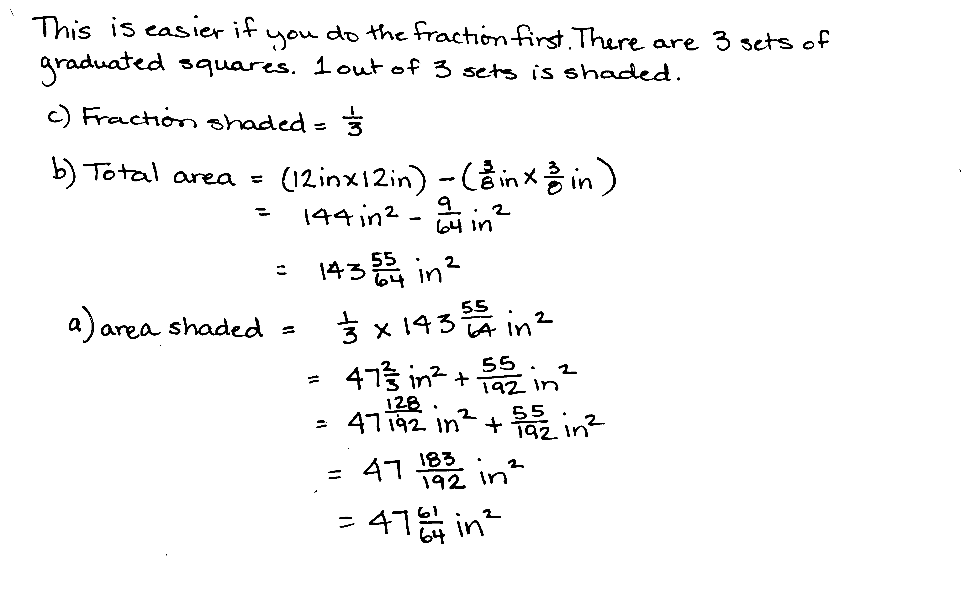

Student______________________________________Team ________________Date __________P1
Pierre’s Paper
Pierre folded a square piece of paper vertically to make two rectangles. Each rectangle had a perimeter of 39 inches. How long is each side of the original square? What is the area of the original square? What is the area of one of the rectangles?

Student______________________________________Team ________________Date __________P2
Shopping with Elise
Elise saved $184. She bought a scarf, a necklace, and a notebook. After her purchases, she still had $39.50. The scarf cost three-fifths the cost of the necklace, and the notebook was one-sixth as much as the scarf. What was the cost of each item? How much more did the necklace cost than the notebook?

Student______________________________________Team ________________Date __________P3
The Hewitt’s Carpet
The Hewitt family is buying carpet for two rooms. The dining room is a square that measures 12 feet on each side. The den is 9 yards by 5 yards. Mrs. Hewitt has budgeted $2,650 for carpeting both rooms. The green carpet she is considering costs $42.75 per square yard, and the brown carpet’s price is $4.95 per square foot. What are the ways she can carpet the rooms and stay within her budget?

Student______________________________________Team ________________Date __________P4
AAA Taxi
AAA Taxi charges $1.75 for the first mile and $1.05 for each additional mile. How far could Mrs. Leslie travel for $20 if she tips the cab driver $2.50?

Student______________________________________Team ________________Date __________P5
Pumpkins and Squash
Three pumpkins and two squash weigh 27.5 pounds. Four pumpkins and three squash weigh 37.5 pounds. Each pumpkin weighs the same as the other pumpkins, and each squash weighs the same as the other squash. How much does each pumpkin weigh? How much does each squash weigh?

Student______________________________________Team ________________Date __________P6
Toy Cars and Trucks
Henry had 20 convertibles and 5 trucks in his miniature car collection. After Henry’s aunt bought him some more miniature trucks, Henry found that one-fifth of his collection consisted of convertibles. How many trucks did his aunt buy?

Student______________________________________Team ________________Date __________P7
Pairs of Scouts:
Some girls in a Girl Scout troop are pairing up with some boys in a Boy Scout troop to practice square dancing. Two-thirds of the girls are paired with three-fifths of the boys. What fraction of the scouts is square dancing?
(Each pair is one Girl Scout and one Boy Scout. The pairs are only from these two troops.)

Student______________________________________Team ________________Date __________P8
Sandra’s Measuring Cups
Sandra is making cookies that require $\text{5}\frac{1}{2}$ cups of oatmeal. She has only two measuring cups: a one-half cup and a three-fourths cup. What is the smallest number of scoops that she could make in order to get $\text{5}\frac{1}{2}$ cups?

Student______________________________________Team ________________Date __________P9
Blue Squares
The dimensions of each successive blue square pictured to the right are half that of the previous blue square. The lower left blue square measures 6 inches by 6 inches.
- Find the area of the shaded part.
- Find the total area of the shaded and unshaded parts.
- What fraction of the figure is shaded?

Name Date
Sara travels twice as far as Eli when going to camp. Ashley travels as far as Sara and Eli together. Hazel travels 3 times as far as Sara. In total, all four travel a total of 888 miles to camp. How far do each of them travel?

The following problem is a brainteaser for your enjoyment. It is intended to encourage working together and family problem solving fun. It is not a required element of this homework assignment.
A man wants to take a goat, a bag of cabbage, and a wolf over to an island. His boat will only hold him and one animal or item. If the goat is left with cabbage, he’ll eat it. If the wolf is left with the goat, he’ll eat it. How can the man transport all three to the island without anything being eaten?

