Lesson 20
Objective: Use coordinate systems to solve real world problems.

Suggested Lesson Structure
 Fluency Practice (12 minutes)
 Concept Development (38 minutes)
 Student Debrief (10 minutes)
Total Time (60 minutes)
Fluency Practice (12 minutes)
- Sprint: Subtract a Fraction from a Whole 4.NF.3 (9 minutes)
- Express Fractions as Decimals 4.NF.3 (3 minutes)
Sprint: Subtract a Fraction from a Whole (9 minutes)
Materials: (S) Subtract a Fraction from a Whole Sprint
Note: This Sprint reviews G5─Module 3 concepts.
Express Fractions as Decimals (3 minutes)
Materials: (S) Personal white boards
Note: This fluency activity reviews G5─Module 4 content.
T: (Write $\frac{1}{2}$ on board.) Express the fraction in hundredths.
S: 50 hundredths.
T: Write this number as a decimal.
S: (Write 0.50.)
T: (Write $\frac{1}{20}$ on board.) Express the fraction in hundredths.
S: 5 hundredths.
T: Write this number as a decimal.
S: (Write 0.05.)
Repeat the process with the following possible sequence: $\frac{3}{2}, \frac{1}{4}, \frac{6}{20}, \frac{8}{20}, \frac{3}{5}, \frac{7}{5}, \frac{3}{50}, \frac{9}{50}, \frac{101}{50}, \frac{3}{4}, \frac{4}{4}, \frac{1}{25}, \frac{4}{25}, \text{and} \frac{7}{25}.$
Concept Development (38 minutes)
Materials: (S) Problem Set
Note: An Application Problem is not included in this lesson in order to provide adequate time for the Concept Development.
Suggested Delivery of Instruction for Solving Lesson 20’s Word Problems.
(All times are approximate.)
1. Read the graph or scenario. (3 minutes)
Review the following questions and have students discuss the answers before beginning the first problem.
- What data is the graph or scenario communicating?
- What information and what units are shown on the axes?
As students discuss, circulate. Reiterate the questions above. After a minute or so, have the pairs of students share their thoughts.
2. Solve the problems. (9 minutes)
Give everyone five minutes of quiet work time to answer the questions. After four minutes, invite them to work together if they so choose in order to complete all components of the problem. All students should write their equations and statements for each question.
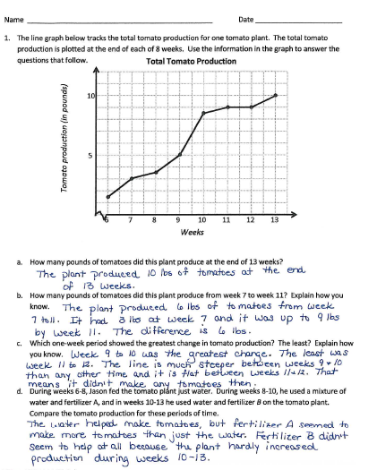
3. Assess the solution for reasonableness and review the answers. (4 minutes)
Give students the opportunity to explain the reasonableness of their solutions with a peer. Review the answers with the whole class.
4. Debrief. (3 minutes)
Each question is followed by a set of questions to support you in guiding students to think more deeply about the data.
Problem 1
The line graph below tracks the total tomato production for one tomato plant. The total tomato production is plotted at the end of each of 8 weeks. Use the information in the graph to answer the questions that follow.
- How many pounds of tomatoes did this plant produce at the end of 13 weeks?
- How many pounds of tomatoes did this plant produce between Week 7 and Week 11? Explain how you know.
- Which one-week period shows the greatest change in tomato production? The least? Explain how you know.
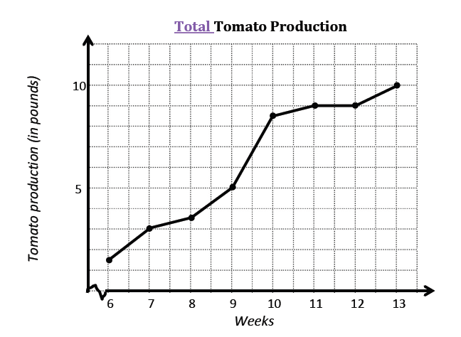
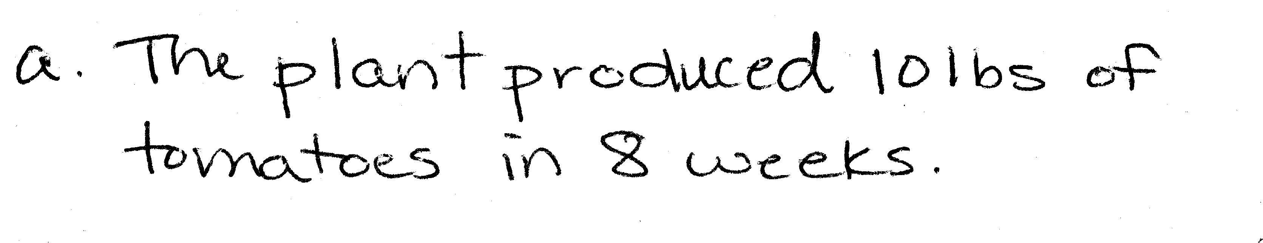
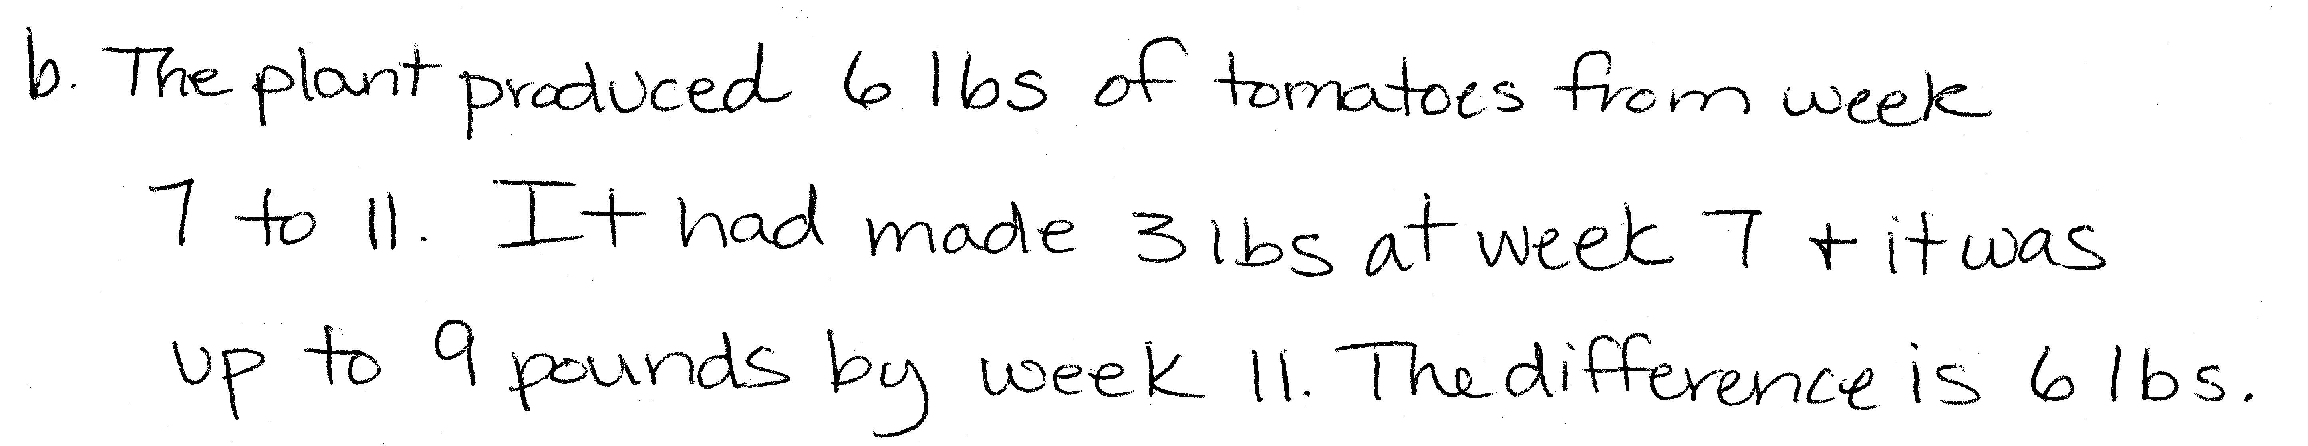
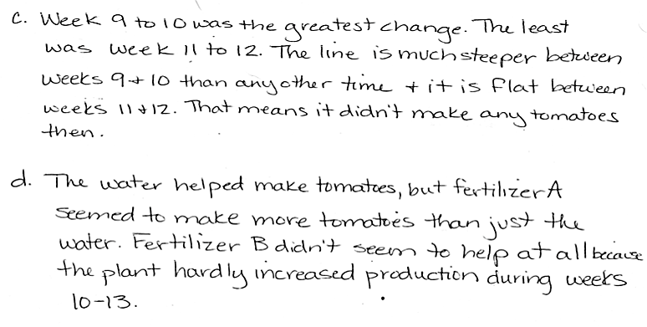
- During weeks 6─8, Jason fed the tomato plant just water. During Weeks 8─10, he used a mixture of water and Fertilizer A, and in Weeks 10─13, he used water and Fertilizer B on the tomato plant. Compare the tomato production for these periods of time.

Problem 1(a) asks students to find the total production, assuring they are reading the information correctly. Be sure students understand that each data point (including Week 6) is a cumulative data point, not a starting value. Problem 1(b), requires relating the steepness of a segment to greater production. To answer Problem 1(c), students must analyze three separate time periods within the graph. Problem 1(d) requires students to convert from pounds to ounces in order to find the number of cans Jason can make.

NOTES ON
MULTIPLE MEANS OF ENGAGEMENT:
Students may find data plotting and analysis more engaging if the data is self-generated. Consider allowing students to develop and administer simple surveys or grow and measure their own plants.
Such data might be plotted and analyzed on paper or could be entered into simple spreadsheets in a spreadsheet program and plotted using the graph features contained therein.

During the Debrief (see the protocol above), the second question challenges assumptions students may have made about the effectiveness of the fertilizers. We can speculate about why the data changed the way it did, but the line graph alone does not provide enough information to know the truth of what happened.
- Which of the feeding methods used by Jason would you recommend he use to increase his tomato production next year? Why?
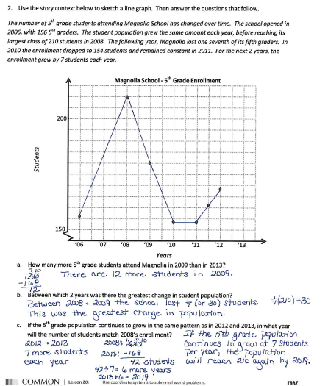
- Would your answer change if you learned that during Weeks 10─13, the temperature dropped dramatically in Jason’s town?
- What other factors may have had an impact on the tomato plant’s production?
- Why might this information be helpful? Who might be interested in seeing it?
Problem 2
Use the story context below to sketch a line graph. Then answer the questions that follow.
The number of fifth-grade students attending Magnolia School has changed over time. The school opened in 2006, with 156 students in the fifth grade. The student population grew the same amount each year before reaching its largest class of 210 students in 2008. The following year, Magnolia lost one-seventh of its fifth-graders. In 2010, the enrollment dropped to 154 students and remained constant in 2011. For the next two years, the enrollment grew by 7 students each year.
  - How many more fifth-grade students attended Magnolia in 2009 than in 2013?
  - Between which two consecutive years was there the greatest change in student population?
  - If the fifth-grade population continues to follow the same growth pattern as in 2012 and 2013, in what year will the number of students match 2008’s enrollment?
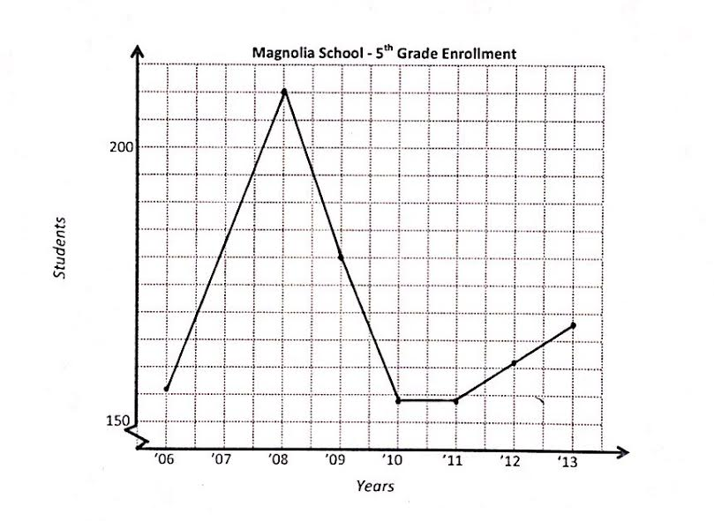
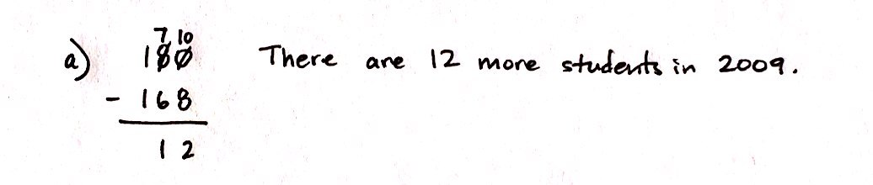
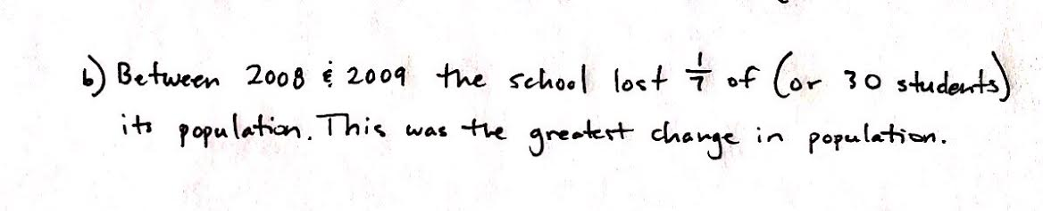
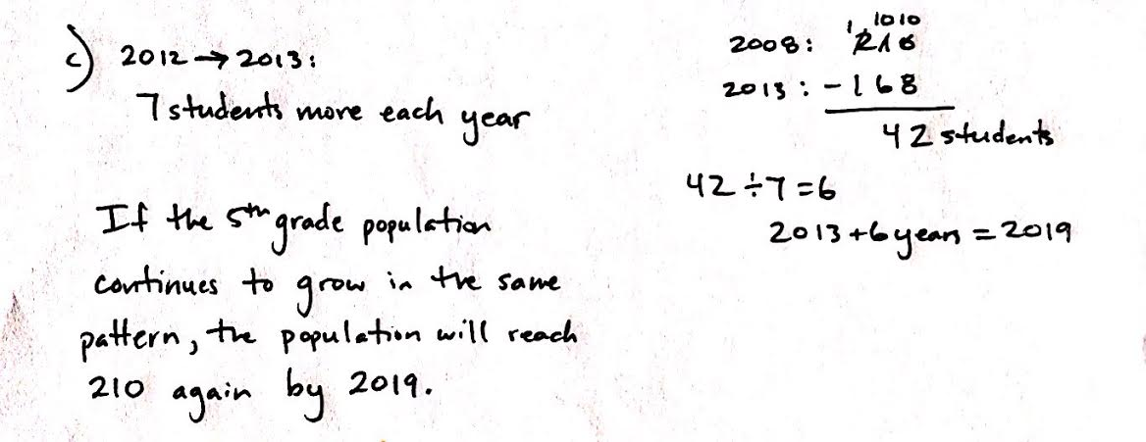

In this problem, students are given the task of reading a story context about the changing fifth-grade population of Magnolia School. They must read carefully to extract the necessary data and complete the line graph. In Problem 2(b) the phrase greatest change, could pose a challenge as students may be tempted to look for the two years in which the population increases the most. However, in this case, the greatest change is actually a large decrease in student enrollment.
Suggested Debrief Questions:
- Magnolia School won an award for excellence in teaching in 2011. Do you think that the award had an affect on the number of students attending the school? Explain.
- Magnolia School had its funding reduced. As a result, the athletic and art programs were cut. In which year or years might you guess that this occurred? Explain what lead you to that conclusion.

NOTES ON
MULTIPLE MEANS OF REPRESENTATIONS:
Creating line graphs may pose a challenge to students with fine-motor skill deficits. Consider providing larger-scale graph paper (such as 1 inch) to scaffold their efforts.

- Could there be other explanations for changes in student enrollment? Share them.
- Who might be interested in seeing the information in this graph? Why?
Student Debrief (10 minutes)
Lesson Objective: Use coordinate systems to solve real world problems.
The Student Debrief is intended to invite reflection and active processing of the total lesson experience.
Invite students to review their solutions for the Problem Set. They should check work by comparing answers with a partner before going over answers as a class. Look for misconceptions or misunderstandings that can be addressed in the Debrief. Guide students in a conversation to debrief the Problem Set and process the lesson.
You may choose to use any combination of the questions below to lead the discussion.

NOTES ON
LINE GRAPHS
As in G5–M6–Lesson 19, students must learn to be wary of jumping to conclusions when looking at data. It is important to question assumptions.
- How are the line graphs alike and different?
- How did your solutions differ from your neighbor’s solutions?
- What other scenarios might be interesting to graph?
- Can you see ways in which the data could be used to misrepresent the effectiveness of the fertilizer or the reasons for changes in the enrollment?
- When we see data used in advertisements we need to pause and think about its power to persuade us. Can you think of any ways data is used to get you or your family to buy a product?
Exit Ticket (4 minutes)
After the Student Debrief, instruct students to complete the Exit Ticket.

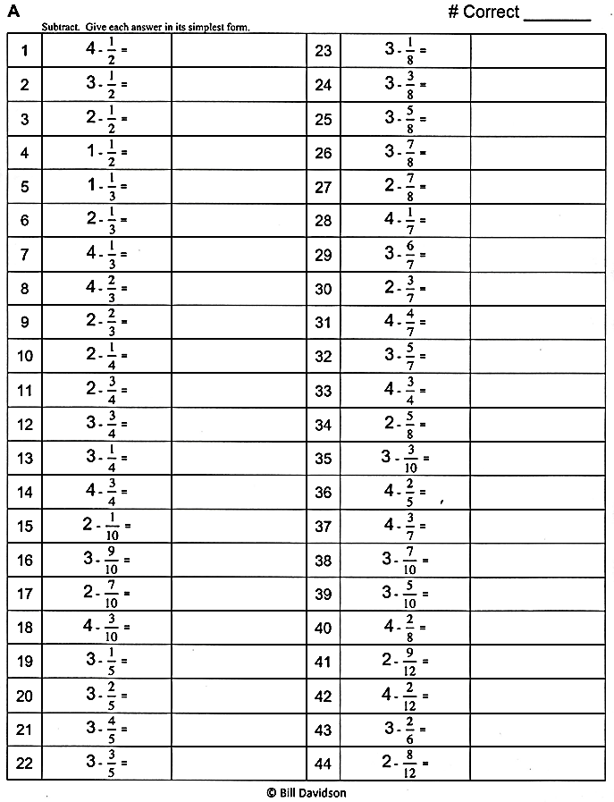
Subtract. Give each answer as a mixed number in its simplest form.

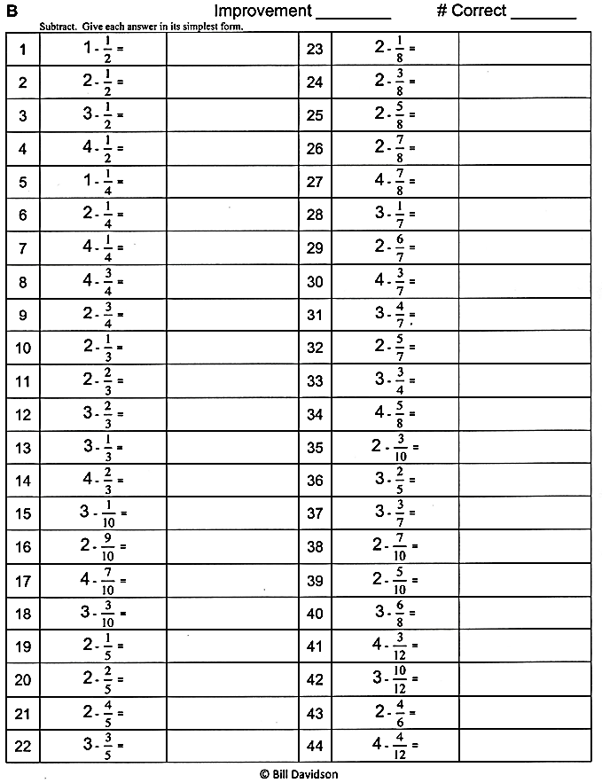
Subtract. Give each answer as a mixed
number in its simplest form.

Name Date
- The line graph below tracks the total tomato production for one tomato plant. The total tomato production is plotted at the end of each of 8 weeks. Use the information in the graph to answer the questions that follow.
Tomato production (in pounds)
Total Tomato Production
5
10
Weeks
6 7 8 9 10 11 12 13

- How many pounds of tomatoes did this plant produce at the end of 13 weeks?

- How many pounds of tomatoes did this plant produce from Week 7 to Week 11? Explain how you know.

- Which one-week period showed the greatest change in tomato production? The least? Explain how you know.

- During Weeks 6–8, Jason fed the tomato plant just water. During Weeks 8–10, he used a mixture of water and Fertilizer A, and in Weeks 10–13 he used water and Fertilizer B on the tomato plant. Compare the tomato production for these periods of time.

- Use the story context below to sketch a line graph. Then answer the questions that follow.
The number of fifth-grade students attending Magnolia School has changed over time. The school opened in 2006, with 156 students in the fifth grade. The student population grew the same amount each year before reaching its largest class of 210 students in 2008. The following year, Magnolia lost one-seventh of its fifth-graders. In 2010, the enrollment dropped to 154 students and remained constant in 2011. For the next two years, the enrollment grew by 7 students each year.
Magnolia School - 5th Grade Enrollment
150
200
Students
’06 ’07 ’08 ’09 ’10 ’11 ’12 ‘13
Years

  - How many more fifth-grade students attend Magnolia in 2009 than in 2013?

  - Between which two years was there the greatest change in student population?

  - If the fifth-grade population continues to grow in the same pattern as in 2012 and 2013, in what year will the number of students match 2008’s enrollment?

Name Date
- Use the following information to complete the line graph below. Then answer the questions that follow.
Harry runs a hot dog stand at the county fair. When he arrived on Wednesday, he had 38 dozen hot dogs on his stand. The graph shows the number of hot dogs (in dozens) that remained unsold at the end of each day of sales.
28
30
32
Harry’s Hot Dog Sales
Hot Dogs Remaining (dozen)
2
W Th F Sa Su M Tu
4
6
8
10
12
14
16
18
20
22
24
26

  - How many dozen hot dogs did Harry sell on Wednesday? How do you know?

  - Between which two-day period did the number of hot dogs sold change the most? Explain how you determined your answer.

  - During which three days did Harry sell the most hot dogs?

  - How many dozens of hot dogs were sold on these three days?

Name Date
- Use the graph to answer the questions.
Johnny left his home at 6 a.m. and kept track of the number of kilometers he traveled at the end of each hour of his trip. He recorded the data in a line graph.
Johnny’s Bike Trip
7a 8a 9a 10a 11a 12a 1p
2
14
18
0
Distance in kilometers

Time of Day
6
10

  - How far did Johnny travel in all? How long did it take?

  - Johnny took a one-hour break to have a snack and take some pictures. What time did he stop?
How do you know?

  - Did Johnny cover more distance before his break or after? Explain.

  - Between which two hours did Johnny ride 4 kilometers?

  - Which hour did Johnny ride the fastest? Explain how you know.

