Lesson 19
Objective: Plot data on line graphs and analyze trends.

Suggested Lesson Structure
 Fluency Practice (13 minutes)
 Application Problem (6 minutes)
 Concept Development (31 minutes)
 Student Debrief (10 minutes)
Total Time (60 minutes)
Fluency Practice (13 minutes)
- Sprint: Make Larger Units 4.NF.1 (9 minutes)
- Subtract a Fraction from a Whole 4.NF.3 (4 minutes)
Sprint: Make Larger Units (9 minutes)
Materials: (S) Make Larger Units Sprint
Note: This Sprint reviews G5─Module 3 concepts.
Subtract a Fraction from a Whole (4 minutes)

NOTES ON
MULTIPLE MEANS FOR ACTION AND EXPRESSION:
If students need a bit more guidance in using strategies to solve the Subtract a Fraction from a Whole fluency activity, focus on one strategy at a time. Choose between compensation, break apart, convert to fractions, or another strategy. Guide students towards skillful mastery with repetition and practice using scaffolded questioning and choral response as modeled here.

Materials: (S) Personal white boards
Note: This fluency activity reviews G5─Module 3 concepts.
T: Simplify $\frac{2}{10}$ by using larger fractional units.
S: $\frac{1}{5}$.
T: What’s $\text{1}\frac{1}{10}$ – $\frac{1}{5}$?
S: $\frac{9}{10}$.
T: (Write $\text{1}\frac{1}{10}$ – $\frac{1}{5}=\frac{9}{10}.\text{)}$
T: There are many ways to solve $\text{1}\frac{1}{10}$ ─ $\frac{1}{5}$. Maybe you used one of these strategies: (Write 1 – $\frac{2}{10}\text{+}\frac{1}{10}$, $\text{1}\frac{1}{10}\text{─}\frac{1}{10}\text{─}\frac{1}{10}$ , $\frac{11}{10}\text{─}\frac{2}{10}\text{=}\frac{9}{10}$ .) Discuss the solution methods with your partner.
S: (Discuss.)
T: Solve the following problems using any method.
T: (Beneath $\text{1}\frac{1}{10}$ – $\frac{1}{5}=\frac{9}{10}$write $\text{2}\frac{1}{10}$ – $\frac{1}{5}.$) What’s $\text{2}\frac{1}{10}$ – $\frac{1}{5}$?
S: $\text{1}\frac{9}{10}$.
Continue with larger numbers of ones before switching to another set of related differences, such as $\text{1}\frac{1}{7}\text{─}\frac{1}{14}$ and $\text{1}\frac{1}{12}\text{─}\frac{1}{6}$.
feet
yards
3 6 9 12 15 18
3
6
9
12
15
18
Application Problem (6 minutes)
Three feet are equal to 1 yard. The following table shows the conversion. Use the information to complete the following tasks:
Feet | Yards
3 | 1
6 | 2
9 | 3
12 | 4
- Plot each set of coordinates.
- Use a straightedge to connect each point.
- Plot one more point on this line and write its coordinates.
- 27 feet can be converted to how many yards? ________
- Write the rule that describes the line.
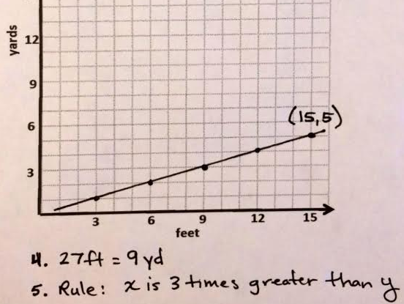
Note: This problem reviews concepts from the first topics in this module.
Concept Development (31 minutes)
Materials: (S) Line graph practice sheet
Read and interpret line graphs.
T: (Post image of Problem 1 from the line graph practice sheet on the board.) How are this coordinate plane and the one from our Application Problem different from others we’ve been looking at? Turn and talk.
S: The $x$- and $y$-axes have labels and different units on them. This new one isn’t a straight line.
T: A coordinate plane can be used to show a set of data, like you see here, in the form of a line graph. What information is this line graph showing us?
S: How much Fido weighs on certain days. Fido’s weight.
T: Right, this graph shows a German Shepherd, Fido’s, weight over a period of time. What information is shown on the $x$-axis?
S: Fido’s age.
T: What unit is being used to show Fido’s age?
S: There’s a label every 4 months. The grid squares split up the $x$-axis into units of 2 months.
T: What is shown on the $y$-axis and in what unit?
S: Fido’s weight in pounds. Each 20 pounds is labeled. The grid squares split up the $y$-axis into units of 10 pounds.
T: Look at the data contained in the graph. What can you learn about Fido’s weight by looking at the graph?
S: He weighed about a pound or two when he was born and gained weight fast! Fido gained weight until he was about 20 months old and then he stopped. Fido weighed about as much as I do when he was only a year old!

NOTES ON
MULTIPLE MEANS OF REPRESENTATION:
Support students working below grade level and others read the Fido’s Weight line graph with the following modifications:
- Use color to outline the line and its points, as well as the information on the $x$- and $y$-axes.
- Add additional labeling to the $x$- and $y$- axes, or at least check that students accurately point and count units along each axis.
- Draw additional lines or labels for points that do not intersect a clearly labeled $y$-coordinate (such as 0,1).

T: According to the graph, Fido weighed about 1, maybe 2, pounds at birth. About how much weight did Fido gain during the first 4 months of his life? How do you know?
S: About 29 or 28 pounds, because he started at 1 or 2 pounds and then his weight increased. It reached 30 pounds at 4 months. The difference between his 4-month weight and his birth-weight is 28 or 29 pounds.
MP.2
T: About how much did Fido weigh at 8 months old?
S: About 55 pounds.
T: How can you find out how much weight Fido gained between the age of 4 months and 8 months? Turn and talk.
S: I can subtract 30 pounds from 55 pounds. I could count up from 30 pounds. I can find the difference between his weight at those ages. He gained 25 pounds between 4 and 8 months.
T: So, did Fido gain more weight in the first 4 months of his life, or the second 4 months?
S: The first 4 months.
T: About how much more?
MP.2
S: About 5 pounds more.
T: Compare the segment that shows the change from 0 to 4 months with the segment that shows the change from 4 months to 8 months.
S: They’re a lot alike, because they both go up, but the line from 0 to 4 is a little steeper. The triangles that have these segments as their longest sides are different. The one I see for 0 to 4 months has a height of 3 units and the one I see for 4 to 8 months has a height of $\text{2}\frac{1}{2}$.
T: Work with a partner to find out how much weight Fido gained during the remaining 4 month increments on the graph.
T: We know that Fido gained more weight from birth to 4 months than he did from 4 months to 8 months. What do you notice about the two segments joining those points?
S: The segment for the first 4 months is steeper, because he gained more weight then.
T: Explain what happens to Fido’s weight and the line on the graph between months 20 and 28.
S: Fido’s weight stays the same, and the line doesn’t change, it just goes straight across. Fido’s weight remains constant so the line is horizontal.
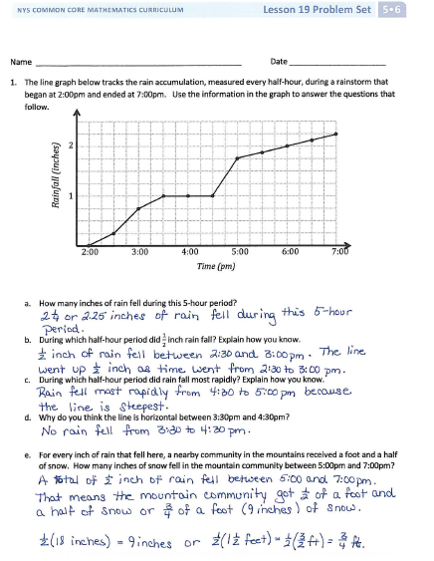
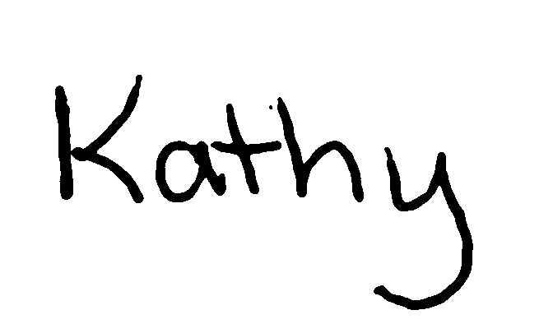
T: The line becomes horizontal to show that his weight is unchanged during that time. In this case, Fido’s weight stayed the same.
T: Can we make a prediction about what this line graph might look like if we could see the next 28 months of Fido’s life? Why or why not? Turn and talk.
S: We can’t really tell from this information. His weight might just keep staying the same. My dog was full-grown at 2 years old. If Fido gets sick he might start losing weight a bit, but there’s no way to know. Well, a lot of things could happen. He might not exercise very much and gain weight. Or, he might run away, and have a hard time finding food and lose weight.
T: All of you could be right, but the truth is, we have no way of knowing. This line graph simply shows us what Fido’s weight was at these specific times in his life. We can’t predict how or if Fido’s weight will change in the future without more information than what is contained in this graph.
Problem Set (10 minutes)
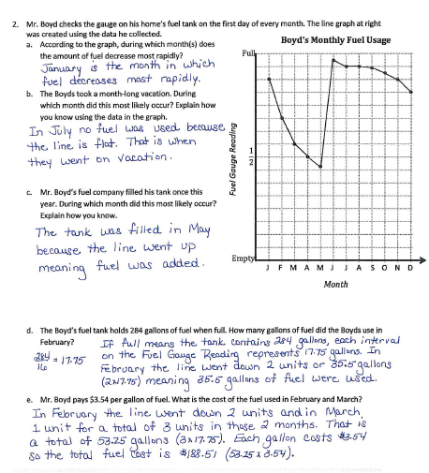
Students should do their personal best to complete the Problem Set within the allotted 10 minutes. For some classes, it may be appropriate to modify the assignment by specifying which problems they work on first. Some problems do not specify a method for solving. Students solve these problems using the RDW approach used for Application Problems.
Student Debrief (10 minutes)
Lesson Objective: Plot data on line graphs and analyze trends.
The Student Debrief is intended to invite reflection and active processing of the total lesson experience.
Invite students to review their solutions for the Problem Set. They should check work by comparing answers with a partner before going over answers as a class. Look for misconceptions or misunderstandings that can be addressed in the Debrief. Guide students in a conversation to debrief the Problem Set and process the lesson.
You may choose to use any combination of the questions below to lead the discussion.

NOTES ON
LINE GRAPHS:
The third question uses Mr. Boyd’s Fuel Usage graph to help students understand that the segments between each point on the graph serve to connect those data but do not communicate data. Mr. Boyd may have used much fuel on one day and very little on another day. There is no way of knowing. What is known is how much fuel was in his tank on the first of each month. The graph shows a sharp decrease between January and February, but perhaps if those 30 days each had a data point, the graph would look much different.
- How did you find the answer for Problem 1(c)? Did you use subtraction or just look for the steepest line? Explain your thought process.
- How did you setup your work when solving Problem 1(e)?
- In Problem 2, how much fuel was in the tank on April 5, May 5, and June 5? Why can’t we answer these questions?
- From the graph on rainfall accumulation, we see that the amount of rain falling throughout the day varied. Is this your experience of rain? Would the graph of a different rainy day have the same shape? How might it be the same? Different?
- Do you think other customers of Mr. Boyd’s fuel company in the same neighborhood might have a graph with a similar shape? Why or why not?

Exit Ticket (3 minutes)
After the Student Debrief, instruct students to complete the Exit Ticket. A review of their work will help you assess the students’ understanding of the concepts that were presented in the lesson today and plan more effectively for future lessons. You may read the questions aloud to the students.
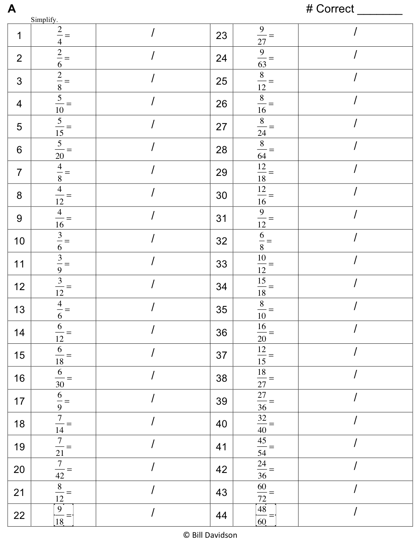
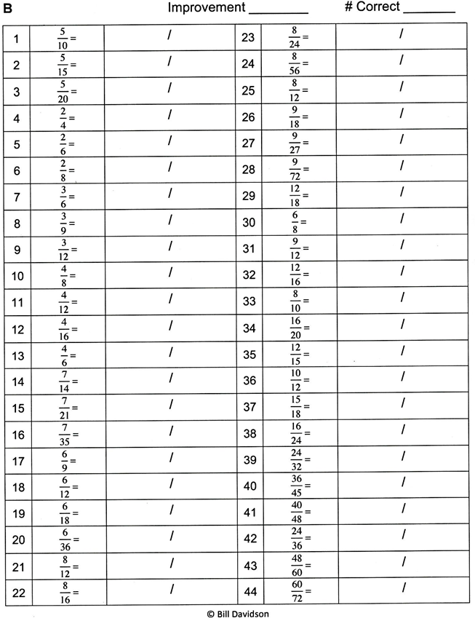

Fido’s Weight
0 4 8 12 16 20 24 28
Age (in months)
20
40
60
80
Weight (in pounds)

Fido’s Weight
0 4 8 12 16 20 24 28
Age (in months)
20
40
60
80
Weight (in pounds)

Name Date
- The line graph below tracks the rain accumulation, measured every half hour, during a rainstorm that began at 2:00 p.m. and ended at 7:00 p.m. Use the information in the graph to answer the questions that follow.
2:00 3:00 4:00 5:00 6:00 7:00
Time (p.m.)
1
2
Rainfall (inches)
Rainfall Accumulation– March 4, 2013

  - How many inches of rain fell during this five-hour period?

  - During which half-hour period did $\frac{1}{2}$ inch rain fall? Explain how you know.

  - During which half-hour period did rain fall most rapidly? Explain how you know.

  - Why do you think the line is horizontal between 3:30 p.m. and 4:30 p.m.?

  - For every inch of rain that fell here, a nearby community in the mountains received a foot and a half of snow. How many inches of snow fell in the mountain community between 5:00 p.m. and 7:00 p.m.?

- Mr. Boyd checks the gauge on his home’s fuel tank on the first day of every month. The line graph at right was created using the data he collected.
J F M A M J J A S O N D
Empty
$$\frac{1}{2}$$
Full
Boyd’s Monthly Fuel Usage
Month
Fuel Gauge Reading
- According to the graph, during which month(s) does the amount of fuel decrease most rapidly?

- The Boyds took a month-long vacation. During which month did this most likely occur? Explain how you know using the data in the graph.

- Mr. Boyd’s fuel company filled his tank once this year. During which month did this most likely occur? Explain how you know.

- The Boyd family’s fuel tank holds 284 gallons of fuel when full. How many gallons of fuel did the Boyds use in February?

- Mr. Boyd pays $3.54 per gallon of fuel. What is the cost of the fuel used in February and March?

Name Date
- The line graph below tracks the water level of Plainsview Creek, measured each Sunday, for 8 weeks. Use the information in the graph to answer the questions that follow.
3
6
9
Plainsview Creek Water Depth
1 2 3 4 5 6 7 8
Weeks
Depth (in feet)

- About how many feet deep was the creek in Week 1? ________

- According to the graph, which week had the greatest change in water depth? __________

- It rained hard throughout the sixth week. During what other weeks might it have rained? Explain why you think so.

- What might have been another cause leading to an increase in the depth of the creek?

Name Date
- The line graph below tracks the balance of Howard’s checking account, at the end of each day, between May 12 and May 26. Use the information in the graph to answer the questions that follow.
5/12 5/19 5/26 5/25
Date

12
2
Dollars (in thousands)
Howard’s Checking Account

  - About how much money does Howard have in his checking account on May 21?

  - If Howard spends $250 from his checking account on May 26, about how much money will he have left in his account?

  - Explain what happened with Howard’s money between May 21 and May 23.

  - Howard received a payment from his job that went directly into his checking account. On which day did this most likely occur? Explain how you know.

  - Howard bought a new television during the time shown in the graph. On which day did this most likely occur? Explain how you know.
The line graph below tracks Santino’s time, at the beginning and end of each length of a triathlon. Use the information in the graph to answer the questions that follow.
1:00p 2:00p 3:00p
Time (p.m.)
0
10
20
30
Distance from finish line (in km)
Santino’s Triathlon

- How long does it take Santino to finish the triathlon?

- To complete the triathlon, Santino first swims across a lake, then bikes through the city, and finishes by running around the lake. According to the graph, what was the distance of the running portion of the race?

- During the race Santino pauses to put on his biking shoes and helmet, and then later change into his running shoes. At what times did this most likely occur? Explain how you know.

- Which part of the race does Santino finish most quickly? How do you know?

- During which part of the triathlon is Santino racing most quickly? Explain how you know.

