Lesson 13
Objective: Construct a paper clock by partitioning a circle into halves and quarters, and tell time to the half hour or quarter hour.

Suggested Lesson Structure
 Fluency Practice (10 minutes)
 Concept Development (40 minutes)
 Student Debrief (10 minutes)
Total Time (60 minutes)
Fluency Practice (10 minutes)
- Rename for the Smaller Unit 2.NBT.1 (1 minutes)
- Subtraction with Renaming 2.NBT.7 (9 minutes)
Rename for the Smaller Unit (1 minute)
Note: This fluency activity reviews using place value understanding to rename units in preparation for subtraction with chips and the algorithm during Fluency Practice in G2–M8–Lessons 15 and 16.
T: I’m going to give you a number of hundreds and tens. I want you to rename 1 of the hundreds for 10 tens and then tell me how many hundreds and tens. Ready?
T: (Write 1 hundred, 1 ten = ____ tens.) Say the number sentence.
S: 1 hundred 1 ten = 11 tens.
T: (Write 2 hundreds = 1 hundred, ____ tens.) Say the number sentence.
S: 2 hundreds = 1 hundred, 10 tens.
T: (Write 2 hundreds = 1 hundred, 9 tens ____ ones.) Say the number sentence.
S: 2 hundreds = 1 hundred, 9 tens, 10 ones.
Repeat the process for 3 hundreds, 3 tens and 4 hundreds, 4 tens.
Subtraction with Renaming (9 minutes)
Materials: S) Personal white board, place value chart
Note: This fluency drill reviews the application of a chip model while recording with the algorithm. Allow students work time between each problem, and reinforce place value understandings by having students say their answer in both unit form and the regular way. Students will use their personal boards and a place value chart to solve.
T: (Write 132 – 118 horizontally on the board.) Let’s use a chip model to subtract. On your boards, record your work using the algorithm.
S: (Solve on their personal boards.)
T: 132 – 118 is…?
S: 14!
Continue with the following possible sequence: 183 – 129, 278 – 159, 347 – 183, 563 – 271, 646 – 295, and 438 – 239.
Concept Development (40 minutes)
Materials: (T) Large instructional clock with gears, partitioned circle template, document camera (if available), crayon, sentence strips to post vocabulary: half past, a quarter past, a quarter to (S) Partitioned circle template printed on cardstock, scissors, crayon, brad fastener, personal white board
Note: To allow ample time for the Concept Development, there is no Application Problem in this lesson.
Call students to the carpet. Use a geared demonstration clock to review the hour and minute hands and how they move in relation to each other, as well as the meaning of the numbers on the clock. Then review the whole hour, starting at twelve o’clock.
Part 1: Brief Review Using Geared Clock
T: (Show 12:00.) Where is the minute hand?
S: At the 12.
T: Where is the hour hand?
S: At the 12.
T: What time is it?
S: Twelve o’clock!
T: When the minute hand moves all the way around the clock, it has been 60 minutes or 1 whole hour. When 1 hour passes, what time will it be? (Move the minute hand a full rotation.)
S: One o’clock!
Show various hours on the clock, and have students name them.
T: (Show 1:00 again.) When half an hour has passed, the minute hand is halfway around the circle. (Move the minute hand.) Tell me when to stop.
S: Stop!
T: At what number did the minute hand stop?
S: At the 6!
T: And the hour hand is halfway between the 1 and…?
S: 2!
T: What fraction of the whole hour has passed?
S: Half an hour.
T: Yes. This is why we call this time half past the hour. Let’s read this time together as half past 1.
S: It is half past one.
T: Does anyone know another way to read this time?
S: One thirty!
T: Yes! What time is it one half hour later? (Move the minute hand.)
S: Two o’clock!
Repeat the process of showing a whole hour, having students name it, and then showing the half hour and having students name it both ways.
Part 2: Constructing a Paper Clock

NOTES ON
MULTIPLE MEANS OF ENGAGEMENT:
Some students who struggle with fine motor cutting skills would benefit from using a pre-cut circle. Have some ready for the lesson for these students to use.
Distribute the partitioned circle template and scissors to students seated at desks or tables.
T: Cut out the circle in front of you just outside the dark line along the dotted line. (Model as students do the same. Cutting on the dotted line leaves a small edge around the outline of the clock to write 15, 30, 45, and 60 in part 4 of the lesson.)
T: Now fold the circle in half along one set of dotted lines. (Model as students do the same.)
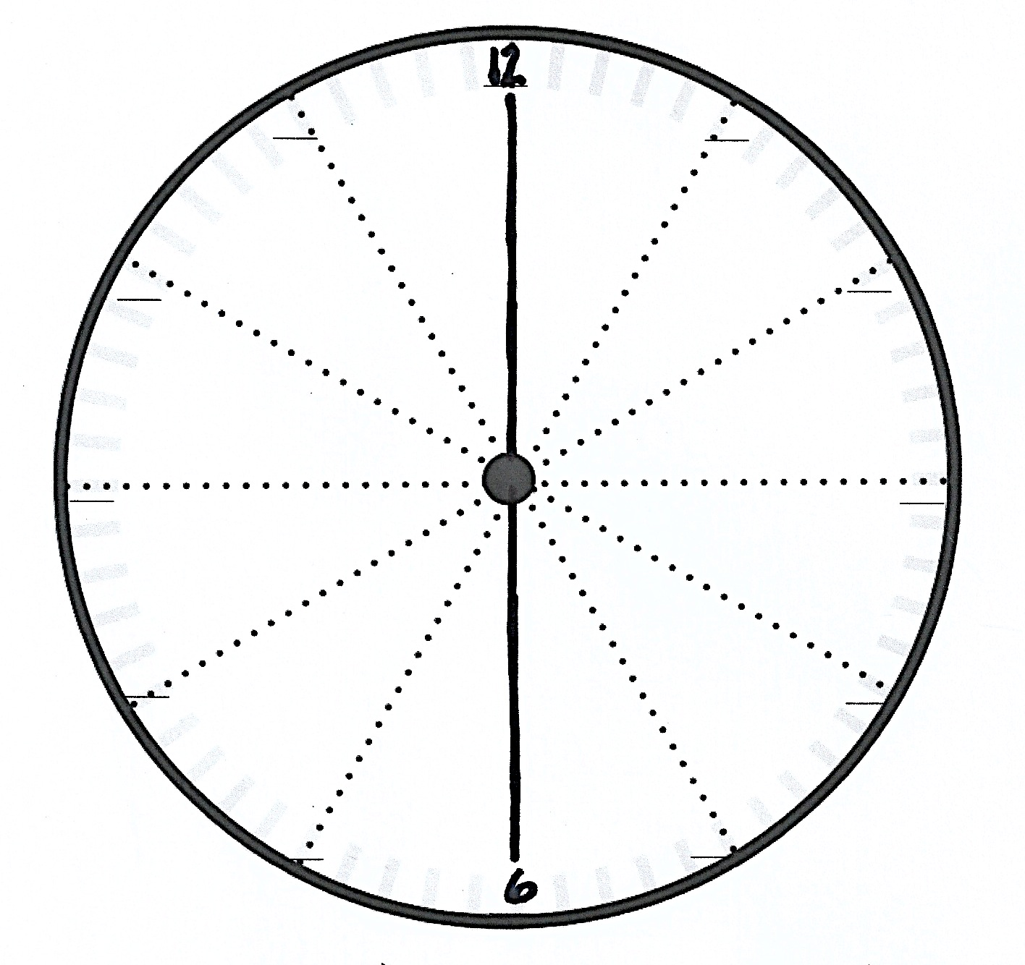
T: Unfold your circle and look at it. How many equal parts do we have now?
S: 2!
T: What fraction is each equal part?
S: One half!
T: Yes! Let’s trace along the folded line to clearly show the 2 halves. (Allow students time to trace.)
T: What number is at the top of the clock?
MP.3
S: 12!
T: Let’s write that in. (Write 12 on the top line as students do the same.)
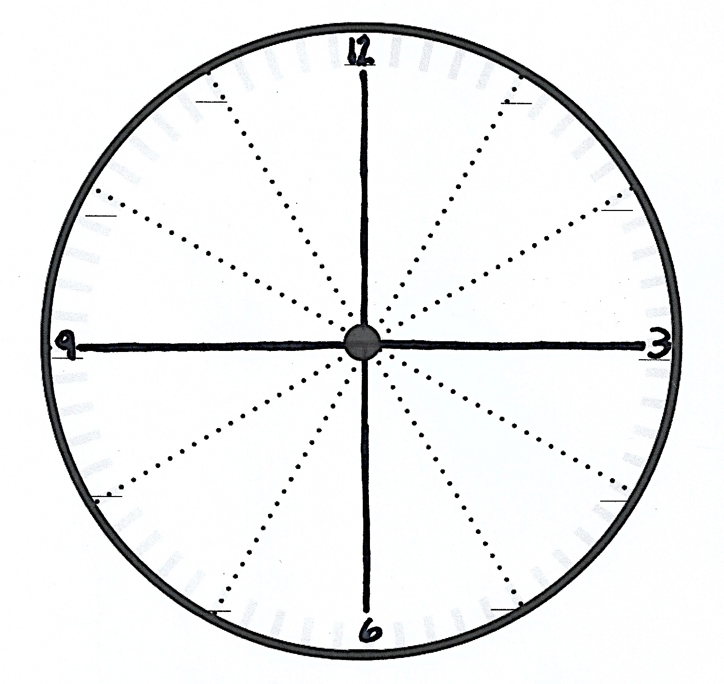
T: How about at the bottom of the clock?
S: 6!
T: Let’s fill that in. (Write 6 on the bottom line as students do the same.)
T: Now let’s take our circle and fold it in half again along the same line as before. And then let’s fold it in half one more time. That means that we will fold along the flat part so the rounded parts are matching each other. (Demonstrate.)
T: Unfold the circle. (Pause for students to unfold.) What fraction is each part now?
S: Fourths!
T: Interesting. How did we get from halves to fourths? Turn and talk.
S: When we folded the half, we split it in half again. Now we have 4 equal parts. A half cut in half makes a fourth. If you split 2 equal shares in half, then you’ll have 4 equal shares.
T: That’s right! We had 2 halves and now we have 4 fourths! Let’s trace along this second folded line. (Pause.)
T: Now that we can see the 4 quarters, let’s use them to help us tell time.
Guide students through filling in the 3 and 9. Then guide them through cutting out and attaching the clock hands with the brad fastener.

NOTES ON
MULTIPLE MEANS OF REPRESENTATION:
Highlight the critical vocabulary for English language learners. For instance, show pictures for circle, half, and fourth. Posting the vocabulary with the pictures will help students to follow the lesson as well as to engage in partner talk.

Part 3: Using a Paper Clock to Tell Time to the Half or Quarter Hour
T: Show me twelve o’clock. (Check as students do so.)
T: Now move your minute hand to the 3. (Allow students time to move the hands.)
T: What fraction of an hour passes when the minute hand moves from the 12 to the 3? Turn and talk.
S: A quarter. One-fourth.
T: Yes! It moved one-fourth, or a quarter, of an hour. So, when the minute hand points to 3, we say it’s a quarter past the hour.
Practice telling a quarter past the hour by showing various hours on the geared clock. For each new hour, move the minute hand and ask students to say stop when you reach a quarter past the hour. This reinforces the 3 as the point on the clock that denotes the first quarter hour. Have students read each time as a quarter past ___. Also, have students note the movement of the hour hand in conjunction with the minute hand.
T: Your clocks should still show a quarter past three. Move the minute hand to show where the next quarter hour ends? (Check as students do so.)
T: At what number did the minute hand stop?
S: 6!
T: Think back to what we learned earlier. What fraction of the hour has passed when the minute hand is on 6? Turn and talk.
S: A half hour. 2 quarters of an hour. 30 minutes!
T: Yes! Let’s keep going. Where does the next quarter hour end? Move the minute hand to show where the next quarter hour ends. (Check as students do so.)
T: At what number did the minute hand stop?
S: 9!
T: What fraction of the hour has passed when the minute hand is on 9? Turn and talk.
S: I see that it’s 3 quarters past the 12. I counted three equal parts, so 3 quarters.
T: Yes! 3 quarters past the hour. And, how many quarters would be left until the next hour?
S: 1 quarter!
T: Correct! So, when we tell the time, we usually call it a quarter to the hour. For example, now my clock shows one o’clock (Show on the geared clock. Then move hands to show 1:45.), and now it shows a quarter to two.
Practice telling a quarter to the hour using the geared clock. For each new hour, move the minute hand and ask students to say stop when you reach a quarter to the hour. This reinforces the 9 as the point on the clock that denotes the third quarter hour, or a quarter to the hour. Have students read each time as a quarter to ___. Also, have students note the movement of the hour hand in conjunction with the minute hand.
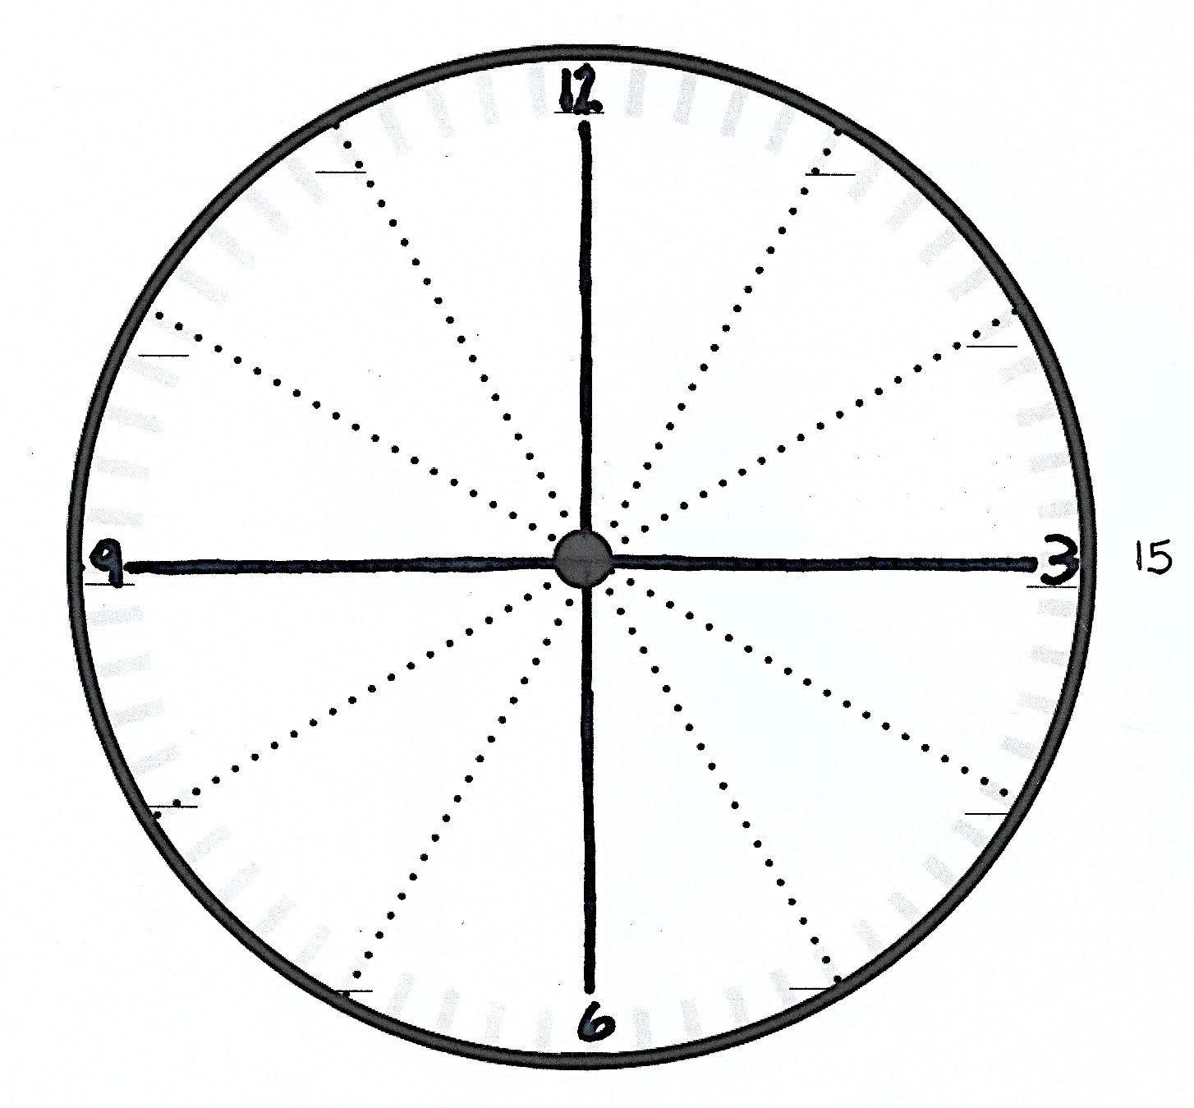
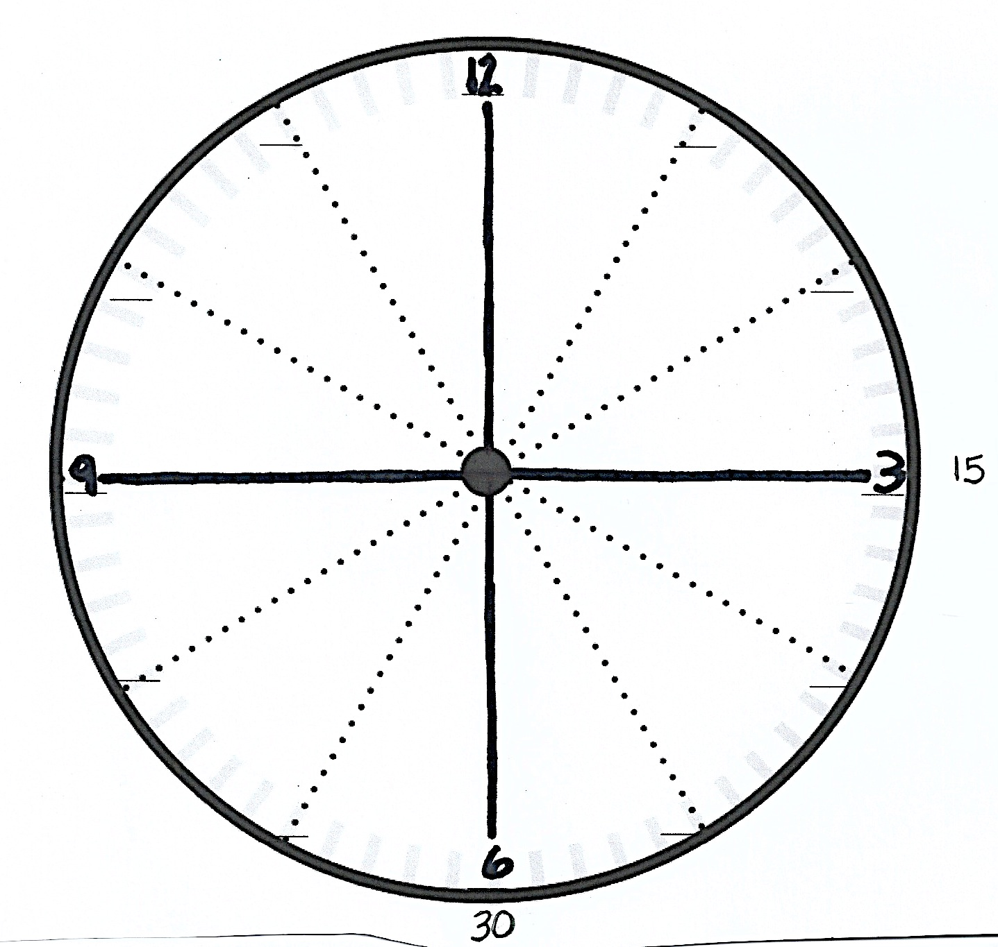
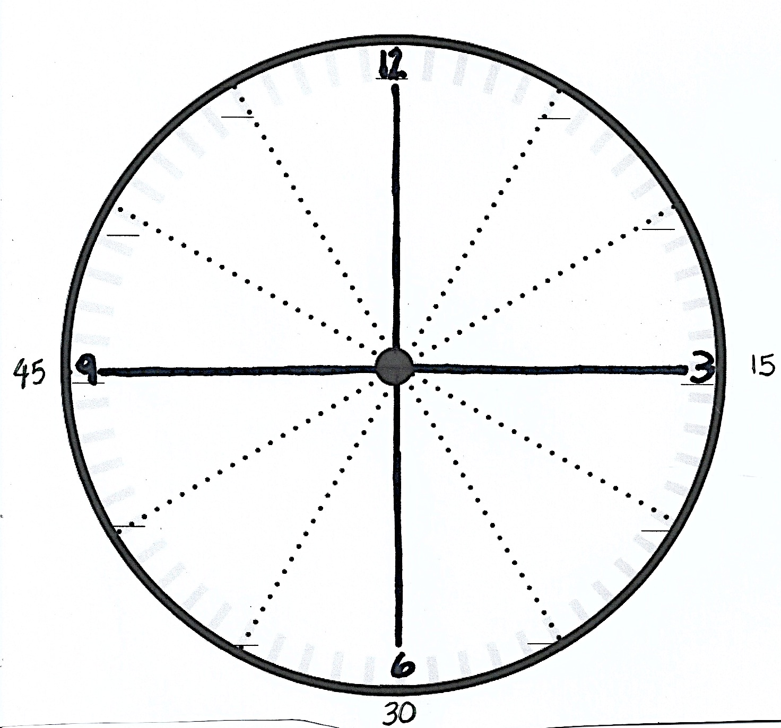
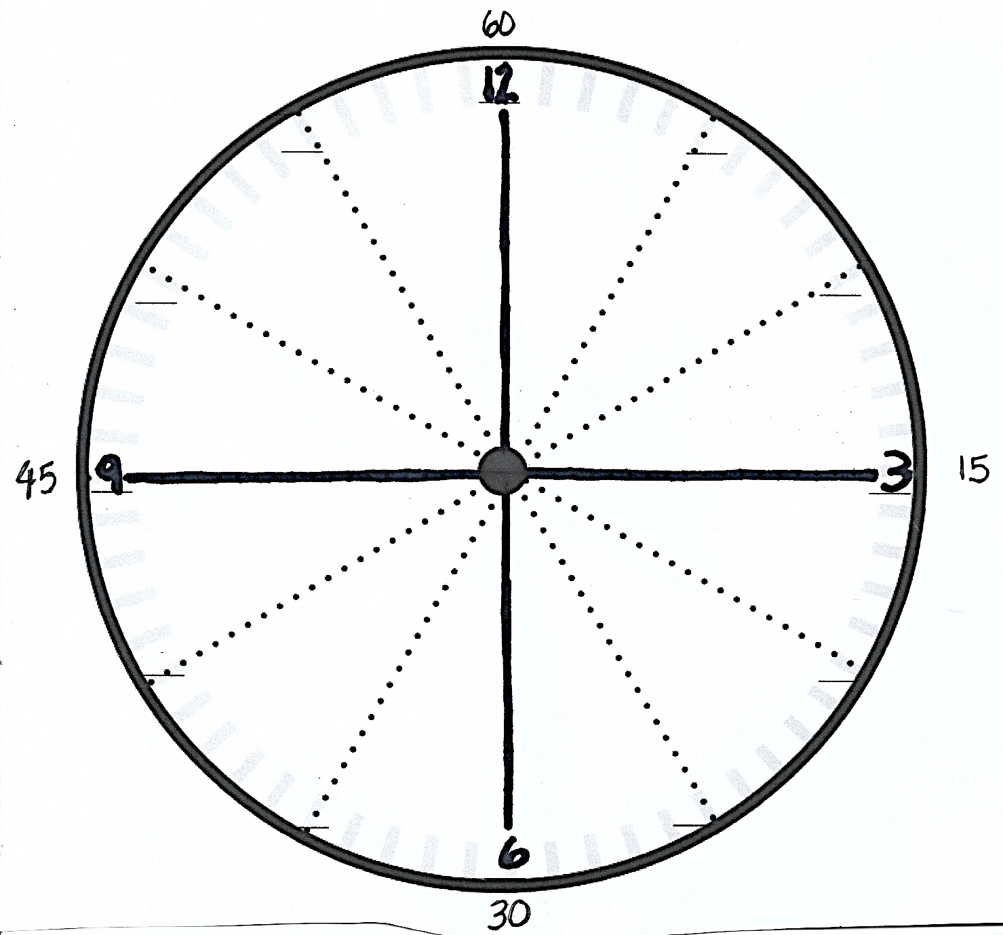
Part 4: Relating Minutes to a Half and a Quarter Hour
T: Let’s fill in the missing numbers on our clocks. (Model with your clock as students do the same.)
T: Who remembers what each little mark on the side of the clock means?
S: One minute!
T: And how many minutes are between one number and the next? (Count with the students.)
S: 5 minutes!
T: So, we can skip count by…?
S: Fives!
T: Let’s count by fives to see how many minutes are in this quarter hour. (Move finger along edge of clock and count together.)
S: 5, 10, 15.
T: Write 15 on the outside of the circle next to the number 3. (Model as students do the same.)
T: How many minutes are in a quarter hour?
S: 15 minutes!
T: Let’s keep counting by fives. (Move finger from the 3 to the 6 and count together.)
S: 20, 25, 30.
T: Write 30 below the 6. (Model as students do the same.)
T: Keep going. (Move finger from the 6 to the 9.)
S: 35, 40, 45.
T: Write 45 on the outside of the circle next to the 9. (Model as students do the same.)
T: Let’s do the last quarter hour. (Move finger from the 9 to the 12.)
S: 50, 55, 60.
T: Write 60 above the 12. (Model as students do the same.)
T: When the minute hand moves through all 4 quarters, we have completed what whole unit?
S: One hour!
T: (Show 6:15 on the geared clock.) How many minutes past the hour is it? Turn and talk.
S: It would be 5, 10, 15…, so 15 minutes. Three fives is 15, so 15 minutes. It’s 15 minutes past the hour.
T: Yes! The 3 represents 15 minutes past the hour, 3 groups of 5 minutes. And what fraction of the hour does it also represent?
S: A quarter. A fourth.
T: Yes! A quarter of an hour is also 15 minutes.
T: Turn and talk. When the minute hand points at the 6, how many minutes past the hour is it?
S: It’s another quarter, so 15 + 15 is 30, so 30 minutes. An hour is 60 minutes, and 60 is 6 tens, and half of 6 is 3, so 30 minutes. 5, 10, 15, 20, 25, 30. 30 minutes. Half of 60 is 30, so 30 minutes.
T: Yes! Half an hour is 30 minutes. Great!
Repeat for the 9 as well.
Show various times on the geared clock and have students name the time using both the posted vocabulary and the minutes (e.g., 4:15 and a quarter past four, 2:30 and half past two.) Then, name times, alternating word form and number form, and have students show the time on their clocks and write it on their boards, using both words and numbers.
T: On your boards, write the time shown on your clocks in both words and numbers. Remember, we write the hour, then a colon, then the number of minutes. (Model the first few as students do the same.)
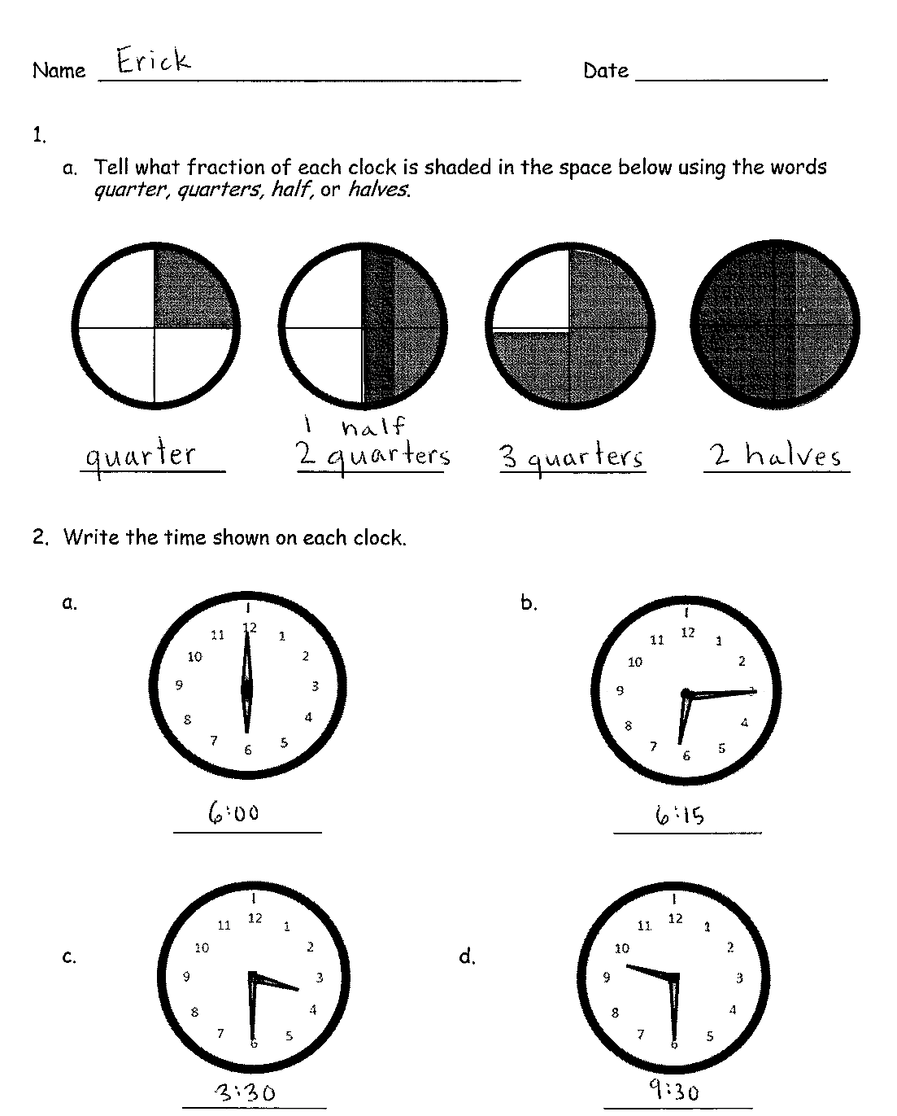
Check to ensure that the hour hands are positioned correctly, especially with a quarter to two. As they demonstrate proficiency, instruct students to work on the Problem Set. Allow early finishers to shade each quarter of their clock a different color.
Note: Teachers may want to collect the clocks after students write their names on them, as they will be used again for the next lesson.
Problem Set (10 minutes)
Students should do their personal best to complete the Problem Set within the allotted 10 minutes. For some classes, it may be appropriate to modify the assignment by specifying which problems they work on first. Some problems do not specify a method for solving. Students solve these problems using the RDW approach used for Application Problems.
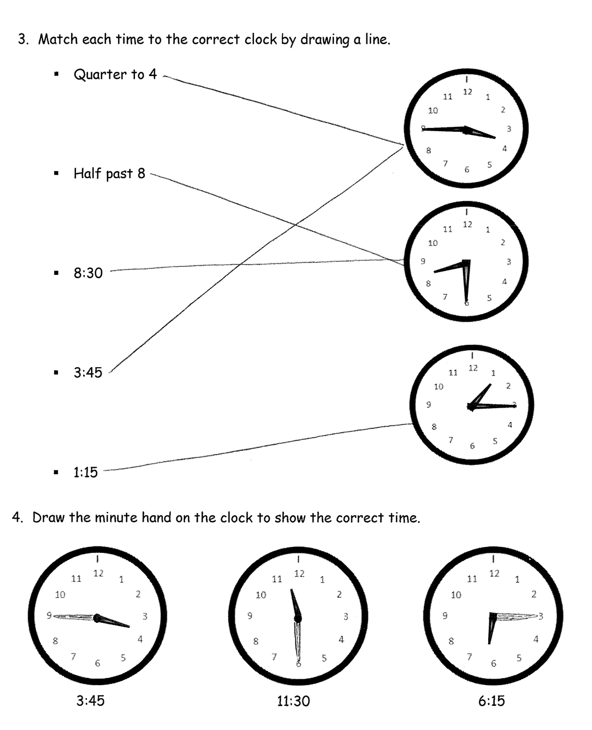
Student Debrief (10 minutes)
Lesson Objective: Construct a paper clock by partitioning a circle into halves and quarters, and tell time to the half hour or quarter hour.
The Student Debrief is intended to invite reflection and active processing of the total lesson experience.
Invite students to review their solutions for the Problem Set. They should check work by comparing answers with a partner before going over answers as a class. Look for misconceptions or misunderstandings that can be addressed in the Debrief. Guide students in a conversation to debrief the Problem Set and process the lesson.
You may choose to use any combination of the questions below to lead the discussion.
- For Problem 1, when telling time, what word(s) do you use to describe 1 fourth past the hour? What about 2 fourths past the hour? And, 3 fourths past the hour?
- For Problem 2(b), how much time has passed? What fraction of the whole hour is 15 minutes? What fraction of the hour is left?
- For Problem 2(c), if it is 3:30, why isn’t the hour hand pointed directly at the number 3?
- For Problem 3, explain how you know that 3:45 and a quarter till four represent the same time. Turn and talk.
- What is similar about describing these two times: 12:15 and 12:45?
- Using what you know about halves and quarters, how much time do you think has passed from 1:15 to 1:45?
Exit Ticket (3 minutes)
After the Student Debrief, instruct students to complete the Exit Ticket. A review of their work will help you assess the students’ understanding of the concepts that were presented in the lesson today and plan more effectively for future lessons. You may read the questions aloud to the students.
Name Date

Name Date

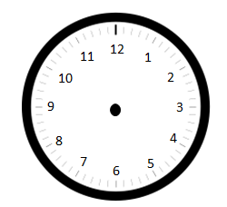
  - Tell what fraction of each clock is shaded in the space below using the words quarter, quarters, half, or halves.

- Write the time shown on each clock.

  - b.

c. d.

- Match each time to the correct clock by drawing a line.
- Quarter to 4

- Half past 8

- 8:30

- 3:45

- 1:15

- Draw the minute hand on the clock to show the correct time.

6:15
11:30
3:45

Name Date

- Draw the minute hand on the clock to show the correct time.

12:15
A quarter to 3
Half past 7

Name Date

- Tell what fraction of each clock is shaded in the space below using the words quarter, quarters, half, or halves.

- Write the time shown on each clock.

  - b.

c. d.

- Match each time to the correct clock by drawing a line.
- Quarter to 5

- Half past 5

- 5:15

- Quarter after 5

- 4:45

- Draw the minute hand on the clock to show the correct time.

6:15
11:45
3:30

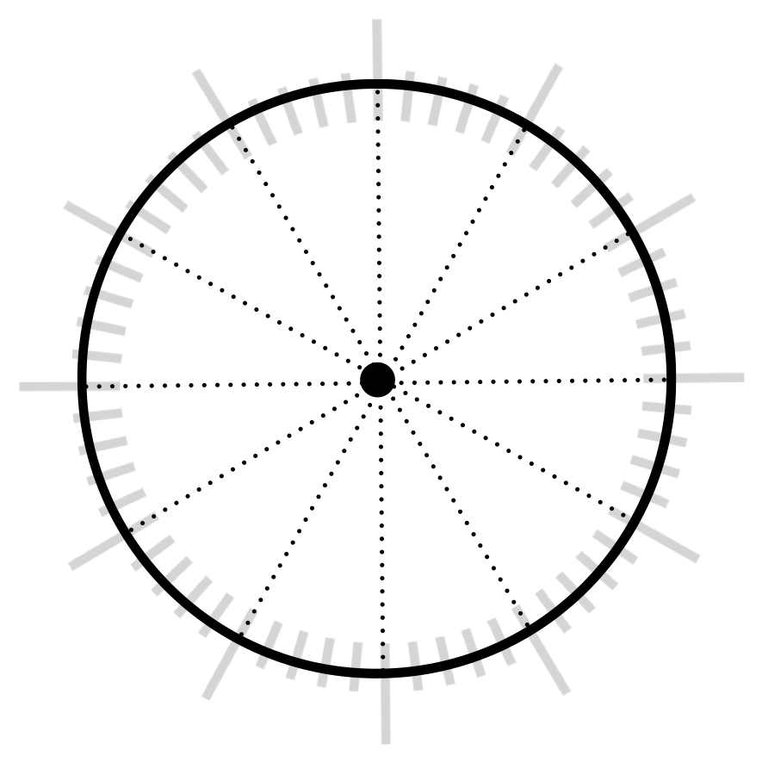
_______
_______
_______
_______
_______
_______
_______
_______
_______
_______
_______
_______

minute
minute
hour
hour

