Lesson 12
Objective: Recognize that equal parts of an identical rectangle can have different shapes.

Suggested Lesson Structure
 Fluency Practice (10 minutes)
 Application Problem (5 minutes)
 Concept Development (35 minutes)
 Student Debrief (10 minutes)
Total Time (60 minutes)
Fluency Practice (10 minutes)
- Addition with Renaming 2.NBT.5 (5 minutes)
- Grade 2 Core Fluency Differentiated Practice Sets 2.OA.2 (5 minutes)
Addition with Renaming (5 minutes)
Materials: (S) Personal white board, place value chart
Note: This fluency drill reviews the application of a chip model while recording with the algorithm. Allow students work time between each problem, and reinforce place value understandings by having students say their answer in both unit form and the regular way. Students will use their personal boards and a place value chart to solve.
T: (Write 234 + 266 horizontally on the board.) Let’s use a chip model to add. On your boards, record your work using the algorithm.
S: (Solve on their personal boards.)
T: 234 + 266 is…?
S: 500!
Continue with the following possible sequence: 123 + 189, 195 + 235, 212 + 189, 341 + 279, and 454 + 378.
Grade 2 Core Fluency Differentiated Practice Sets (5 minutes)
Materials: (S) Core Fluency Practice Sets from G2−M8−Lesson 3
Note: During G2–M8–Topic D and for the remainder of the year, each day’s Fluency Practice includes an opportunity for review and mastery of the sums and differences with totals through 20 by means of the Core Fluency Practice Sets or Sprints. The process is detailed and Practice Sets provided in G2−M8–Lesson 3.
Application Problem (5 minutes)
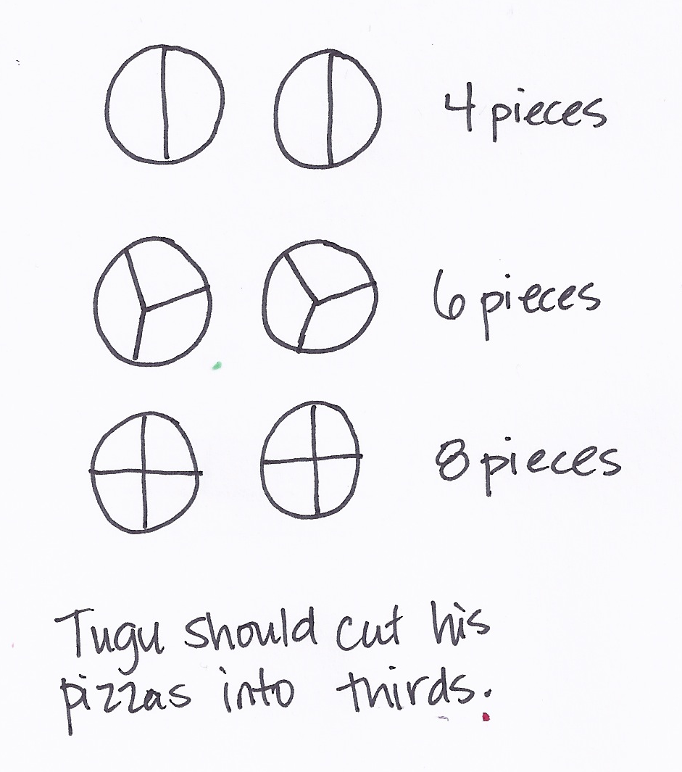
Tugu made two pizzas for himself and his 5 friends. He wants everyone to have an equal share of the pizza. Should he cut the pizza into halves, thirds, or fourths?

NOTES ON
MULTIPLE MEANS OF ENGAGEMENT:
Scaffold the Application Problem for below grade level students by helping them draw the problem a step at a time through questioning: “What would 2 pizzas look like? What if you cut them in half? What would 2 pizzas look like if they were cut in thirds?”

Note: This reinforces yesterday’s lesson that three thirds equals a whole.
Concept Development (35 minutes)
Materials: (T) 2 Problem Set shape templates, 2 equally sized construction paper squares (S) Geoboard and rubber bands, 2 construction paper square per pair in two different colors, 2 construction paper rectangles per pair in 2 different colors(cut to one half the construction paper square), Problem Set shape template
Note: Students complete the Problem Set as a class during the Concept Development.
Note: Students will need scissors to complete the homework.
Part 1: Dividing a Shape into Equal Parts in More than One Way
T: (Draw a square on the board.) This is a whole square. Student A, come up and partition, or divide, the square into halves.
S: (Student A divides the square as shown.)
T: Thumbs up if you agree with Student A. Good. 2 halves make?
S: 1 whole!
T: Here is another whole square that is the same size. (Draw a square next to the one already on the board.) Watch as I partition this square into halves.
T: (Divide the square diagonally.) Turn and talk: Is the square split into halves?
S: Yes. It’s like the parts we shaded yesterday. I think it is because there are still 2 equal halves. Yes, because if you fold it in half, the pieces are the same size.
T: This square is split into halves because there are two triangles that are the exact same size.
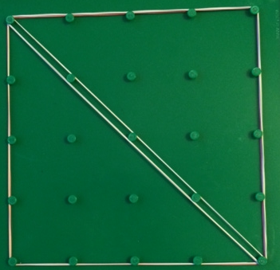
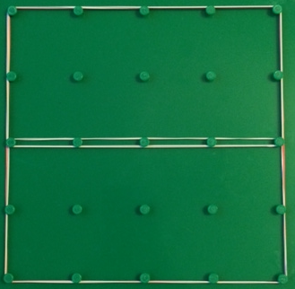
T: Use your geoboard and one rubber band to create the biggest square possible. (Allow students time to work.) This is one whole. Work with your partner to see how many different ways you can show 2 halves.
S: (Work with geoboards to produce halves as shown on right.)
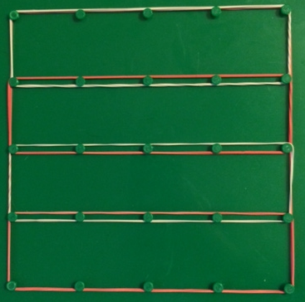
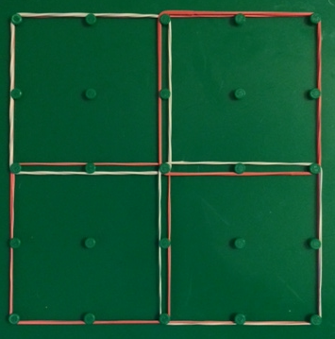
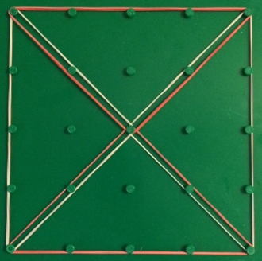
T: Now, use the same geoboard square to show fourths. Again, work with your partner to find at least two ways to show your square split into fourths.
S: (Work to create fourths as shown on right.)
T: Show me the last way you divided your square on your geoboard. Are all of your fourths the same shape?
S: We made four squares! I have rectangles, and they have squares. Look, I made triangles!
MP.1
T: Equal shares can have different shapes. What were some of the shapes you discovered?
S: Rectangles. Triangles. Squares.
T: Good. Let’s take a look at some equally sized rectangles on our Problem Set. Look at Problem 1. Draw lines to show equal halves, thirds, and fourths of a whole rectangle.
S: (Work on the Problem Set. Circulate to help those who need support.)
Part 2: Proving the Equality of Halves with Different Shapes
T: Let’s use paper squares to show halves in two different ways. (Give each student a paper square. Partners should have one of each color.) First, how can we tell if your square is the same size as your partner’s?
S: We can put one on top of the other.
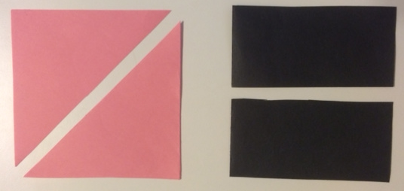
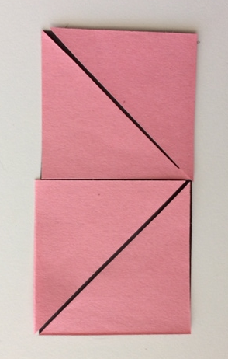
T: Do that to prove that they are the same size. (Pause as they verify the wholes are the same.)
T: If you have a pink square, fold to make triangular halves.
If you have a black square, fold to make rectangular halves. Draw a line on the fold. (Demonstrate.)
S: (Fold paper squares and draw a line on the fold.)
T: We want to know if the way each of these squares is divided shows halves, two equal pieces of equally sized squares.
T: Cut each square into halves. (Demonstrate.)
S: (Cut on the line of each square so that they have a rectangular half and a triangle half.)
T: (Hold the halves side by side.) What do you notice about the halves we cut from each square?
S: One half is a rectangle, and one half is a triangle.
T: Do these pieces show half of the same size square even though they are different shapes?
S: I don’t know. I don’t think so, because one is a rectangle and one is a triangle.
T: (Tape the rectangle to the board.) Watch as I cut the triangle into fourths. (Fold the triangle in half and in half again. Then cut along the folds.) I’m going to see if the triangle half fits on top of the rectangle half to see if they are the same. (Position the four triangular pieces so that they fit exactly on top of the rectangle.)
T: You try it.
S: (Fold and cut.)
T: How do we know the triangle half is the same as the rectangle half?

NOTES ON
MULTIPLE MEANS OF REPRESENTATION:
Guide English language learners through the lesson by being explicit with language. For instance, as you ask students to show two halves, show a picture of an apple cut into two equal pieces, and point to the halves as you give the direction.
S: It’s like magic. It’s not the same shape, but it covers the same amount of space. The four pink parts cover the black half without any gaps or overlaps. The way the triangles fit perfectly shows that the pink and black halves are the same size
T: Look at Problem 2 on your Problem Set. Build the original whole square using the rectangle half and the half represented by your four small triangles. Draw it in the space below.
S: (Work on the Problem Set.)
T: (Circulate to help those who need support.)
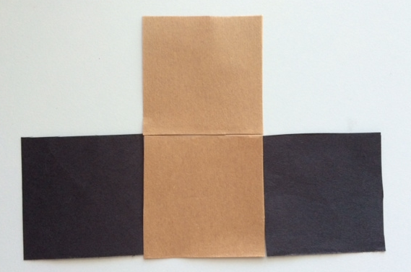
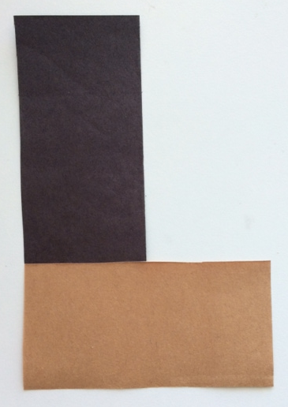
Part 3: Creating Multiple Shapes Using Equal Shares
T: Let’s use the halves of our paper squares to make new shapes. Here are some brown rectangular halves. Each partner should have a brown half and a black half.
T: Make a different polygon out of your rectangular halves. (Allow students time to work.)
T: Tell your partner what polygon you made.
S: I made a long rectangle. Mine looks like an L. It has six sides. I have an octagon!
T: How did the square change?
S: The square is now a rectangle! We cut it into halves and made new polygons.
T: What part stayed the same?
S: The 2 halves stayed the same. There’s still one brown half and one black half.
T: Yes, even though we moved the halves around to make a new polygon, the shares still show equal halves.
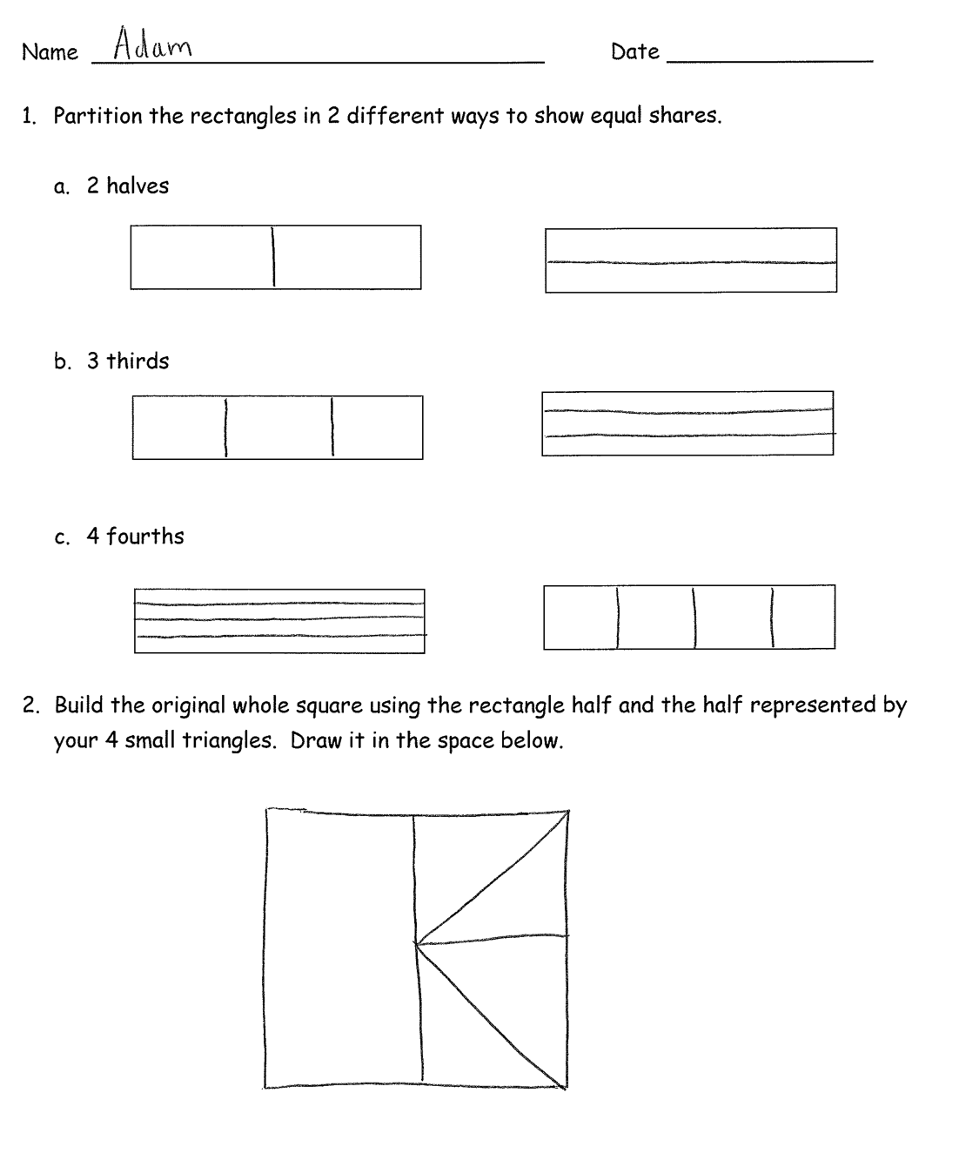
T: Now, cut each equal part in half and move them to form a new polygon. (Allow students time to work.) What fraction of the whole is one part now?
S: 1 fourth!
T: What changed when we switched from halves to fourths?
S: There are 4 fourths instead of 2 halves. The halves were rectangles, but the fourths are squares. I can make a different polygon with the fourths.
T: What stayed the same?
S: It’s still the same amount of brown and black. The whole stayed the same. We didn’t lose any parts or add any parts. We just cut them.
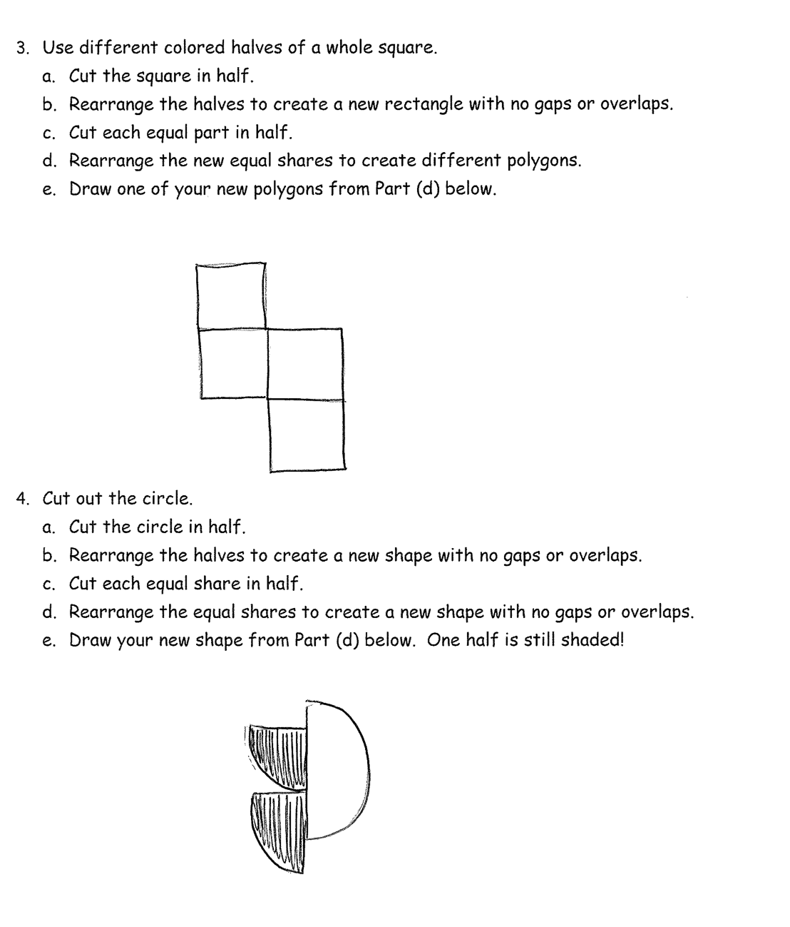
T: That’s right, we cut up the square into halves and then fourths, but the new polygon was made from the original square. Can you still see the square in your head? Could you move the pieces back so it looks like the square again? (Partners move fourths to form the original square.)
T: Good job. You will all get a chance to do this with a square and a circle from the Problem Set.
T: (Invite students to work on Problems 3 and 4 independently.)
Student Debrief (10 minutes)
Lesson Objective: Recognize that equal parts of an identical rectangle can have different shapes.
The Student Debrief is intended to invite reflection and active processing of the total lesson experience.
Invite students to review their solutions for the Problem Set. They should check work by comparing answers with a partner before going over answers as a class. Look for misconceptions or misunderstandings that can be addressed in the Debrief. Guide students in a conversation to debrief the Problem Set and process the lesson.
You may choose to use any combination of the questions below to lead the discussion.
- (Draw examples from Problem 1(c).) If you split two rectangles of the same size into fourths and make four triangles or four rectangles, which fourth is bigger?
- For Problem 1, if you were to cut out your equal shares in the left column and rearrange them, would they fit on top of the equal shares in the right column? Why?
- For Problem 4, share your drawing with your partner. How many equal shares do you have? What fraction is shaded? When you rearranged your squares to create a new shape, what fraction was shaded?
- If you split two rectangles in half, will the halves always have the same shape? What must the rectangles have in common first?
- (Draw two long, skinny rectangles. Partition one in half diagonally. ) If I moved these halves, could I make a triangle? (After students respond, draw a triangle to show how the halves could be rearranged to make a triangle.) How is it possible that this triangle takes up the same amount of space as this rectangle?
Exit Ticket (3 minutes)
After the Student Debrief, instruct students to complete the Exit Ticket. A review of their work will help you assess the students’ understanding of the concepts that were presented in the lesson today and plan more effectively for future lessons. You may read the questions aloud to the students.
Name Date

- Partition the rectangles in 2 different ways to show equal shares.
  - 2 halves

  - 3 thirds

  - 4 fourths

- Build the original whole square using the rectangle half and the half represented by your 4 small triangles. Draw it in the space below.

- Use different colored halves of a whole square.
- Cut the square in half.
- Rearrange the halves to create a new rectangle with no gaps or overlaps.
- Cut each equal part in half.
- Rearrange the new equal shares to create different polygons.
- Draw one of your new polygons from Part (d) below.

- Cut out the circle.
- Cut the circle in half.
- Rearrange the halves to create a new shape with no gaps or overlaps.
- Cut each equal share in half.
- Rearrange the equal shares to create a new shape with no gaps or overlaps.
- Draw your new shape from Part (d) below. One half is still shaded!

Name Date

- Partition the rectangles in 2 different ways to show equal shares.
- 2 halves

- 3 thirds

- 4 fourths

Name Date

- Partition the rectangles in 2 different ways to show equal shares.
- 2 halves

- 3 thirds

- 4 fourths

- 2 halves

- 3 thirds

- 4 fourths

- Cut out the square at the bottom of this page.
- Cut the square in half. Shade one half using your pencil.
- Rearrange the halves to create a new rectangle with no gaps or overlaps.
- Cut each equal part in half.
- Rearrange the new equal shares to create different polygons.
- Draw one of your new polygons from Part (d) below. One half is shaded!

- Cut out the circle at the bottom of this page. Shade one half.
- Cut the circle in half. Shade one half using your pencil.
- Rearrange the halves to create a new shape with no gaps or overlaps.
- Cut each equal share in half.
- Rearrange the equal shares to create a new shape with no gaps or overlaps.
- Draw your new shape from Part (d) below. One half is still shaded!

