Lesson 11
Objective: Describe a whole by the number of equal parts including 2 halves, 3 thirds, and 4 fourths.

Suggested Lesson Structure
 Fluency Practice (10 minutes)
 Application Problem (5 minutes)
 Concept Development (35 minutes)
 Student Debrief (10 minutes)
Total Time (60 minutes)
Fluency Practice (10 minutes)
- Addition with Renaming 2.NBT.5 (5 minutes)
- Grade 2 Core Fluency Differentiated Practice Sets 2.OA.2 (5 minutes)
Addition with Renaming (5 minutes)
Materials: (S) Personal white board, place value chart
Note: This fluency drill reviews the application of a chip model while recording with the algorithm. Allow students work time between each problem, and reinforce place value understandings by having students say their answer in both unit form and the regular way. Students will use their personal boards and a place value chart to solve.
T: (Write 112 + 159 horizontally on the board.) Let’s use a chip model to add. On your boards, record your work using the vertical method.

NOTES ON
MULTIPLE MEANS OF ACTION AND EXPRESSION:
If the students have the four parts of a square oriented like a rectangle have the discussion that four one-fourths of a rectangle still make the whole but the question was asking for a square, a special kind of rectangle. Ask, “How could we change the orientation so that the four parts make a square?”

S: (Solve on their personal boards.)
T: 112 + 159 is…?
S: 271!
Continue with the following possible sequence: 184 + 135,
385 + 108, 323 + 491, 263 + 178, 589 + 223, and 471 + 289.
Grade 2 Core Fluency Differentiated Practice Sets (5 minutes)
Materials: (S) Core Fluency Practice Sets from G2−M8−Lesson 3
Note: During G2–M8–Topic D and for the remainder of the year, each day’s Fluency Practice includes an opportunity for review and mastery of the sums and differences with totals through 20 by means of the Core Fluency Practice Sets or Sprints. The process is detailed and Practice Sets provided in G2−M8−Lesson 3.
Application Problem (5 minutes)
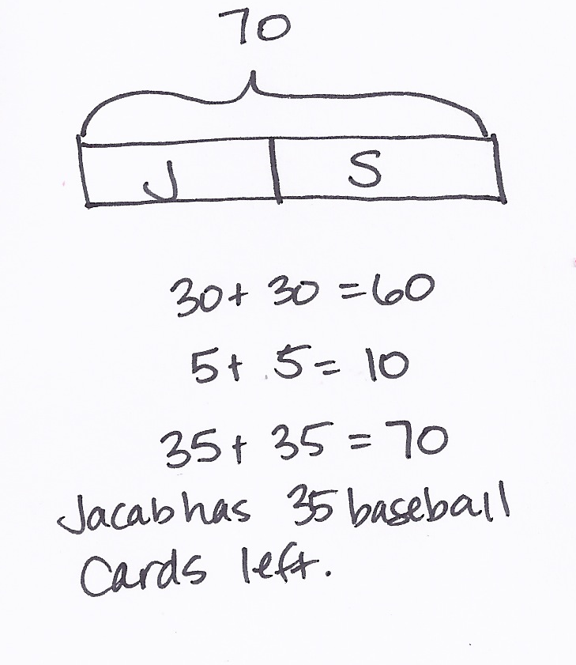
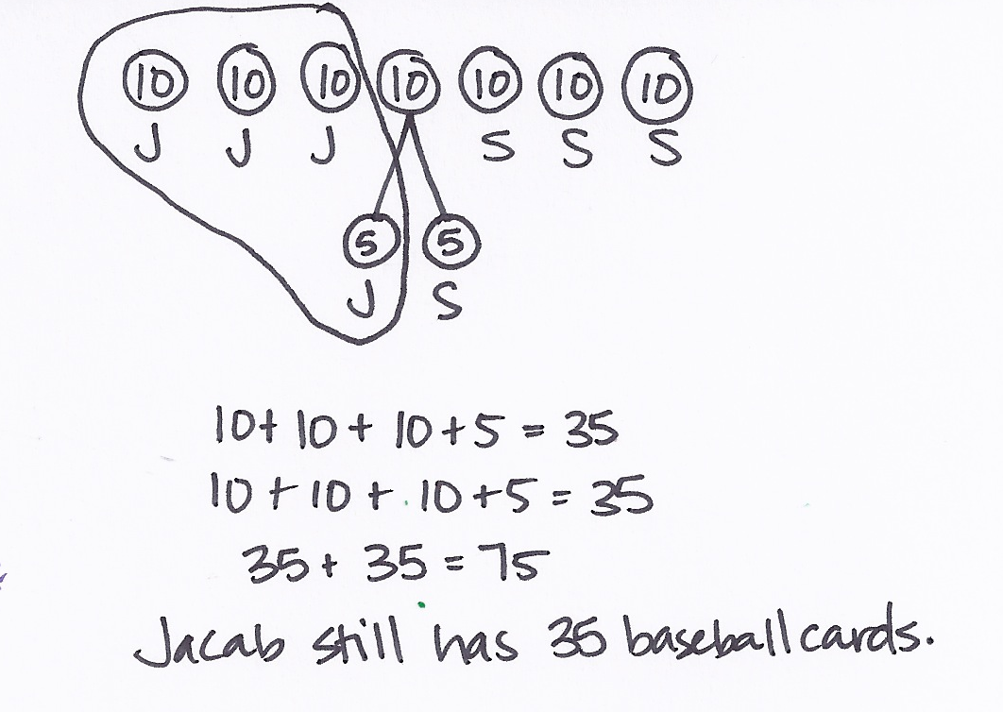
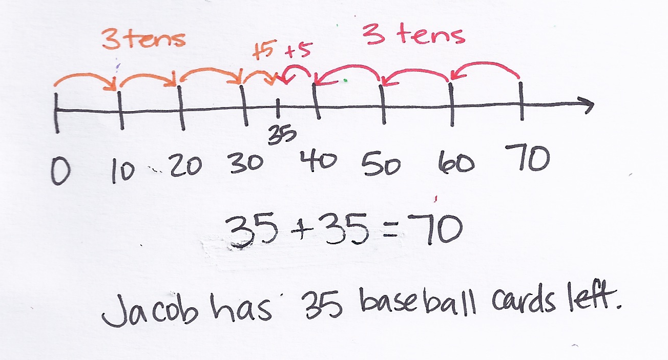
Jacob had collected 70 baseball cards. He gave half of them to his brother Sammy. How many baseball cards does Jacob have left?
Note: This Application Problem combines what students have learned about subtraction and their new knowledge of halves. It reinforces that halves are equal, and that a whole is comprised of equal parts.

NOTES ON
MULTIPLE MEANS OF ACTION AND EXPRESSION:
Offer below grade level students the following version of the Application Problem: Jacob collected 70 baseball cards. He gave half of them to his brother Sammy. Now Sammy has 35 baseball cards. How many baseball cards does Jacob have left?

Concept Development (35 minutes)
Materials: (T/S) Labeled fraction parts template, 1 piece of unlined paper, glue stick
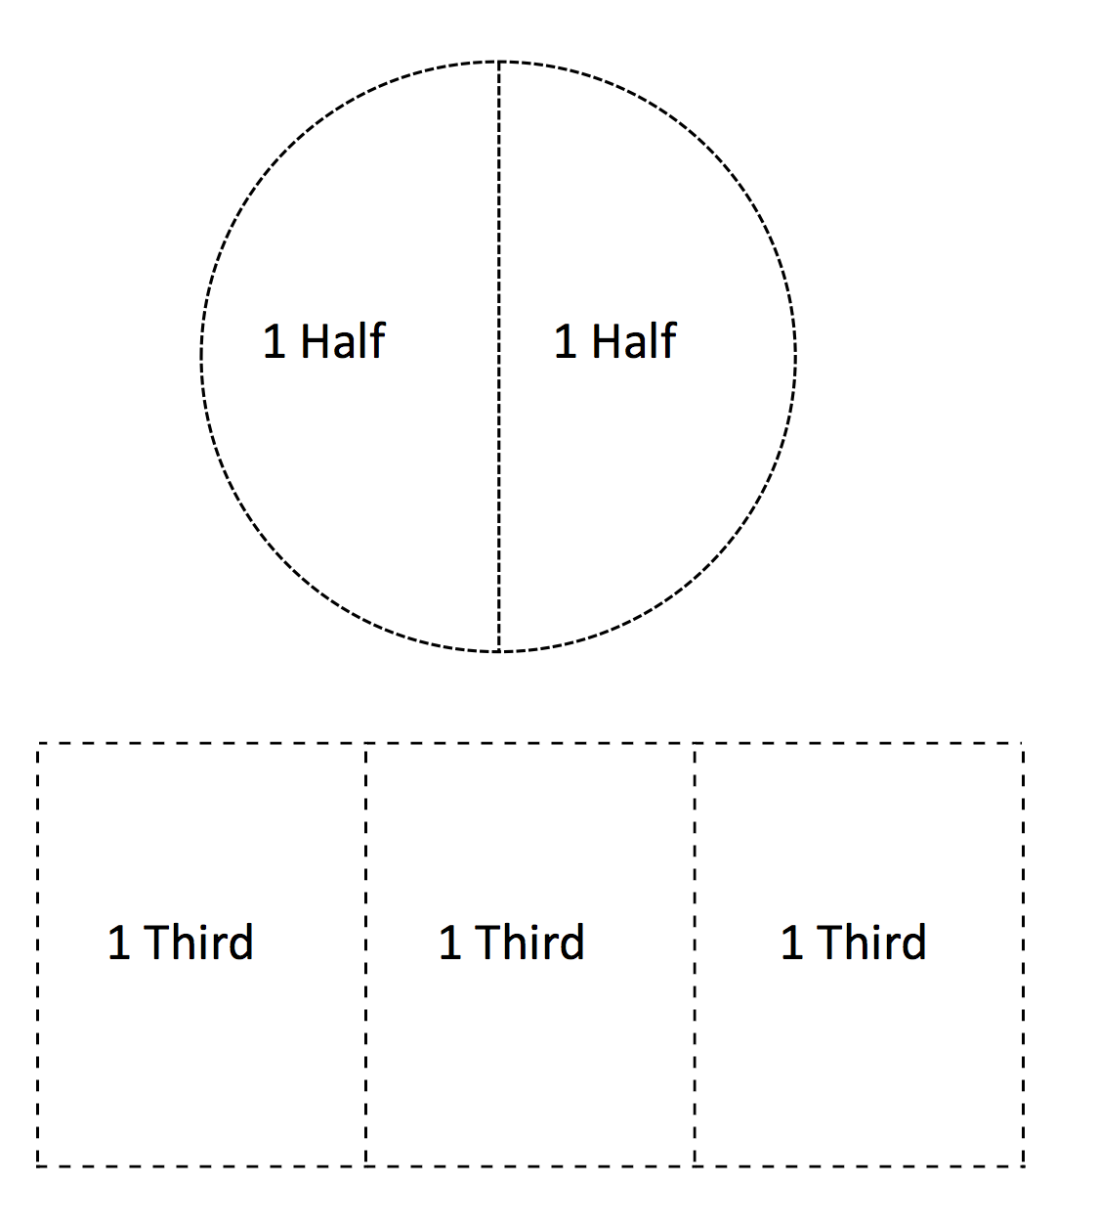
Copy and cut out enough labeled fraction parts templates to have one piece for each student. Check to be sure that there are the right number of pieces to form complete circles.
Part 1: Completing a Whole and Counting Thirds and Fourths in the Whole
T: (Call on a volunteer and give him one half of the circle template.) Look at the part that Student A is holding. Does he have a whole circle?
S: No.
T: What does he need to complete the circle?
S: Another half!
T: Good. Watch as I complete the whole. (Hold the other half of the circle next to Student A’s part.) 1 half and 1 half makes 1 whole; 2 halves make a whole! Say it with me.
S: 1 half and 1 half makes a whole. 2 halves make a whole.

NOTES ON
MULTIPLE MEANS OF ENGAGEMENT:
To help underscore for English language learners that fractional parts make a whole, get students to hold the two halves as you say, “One-half and one-half makes a whole. Two-halves make a whole.” And then have student volunteers join their halves to form a whole. Continue for thirds and fourths.

T: Good. (Call two volunteers and give them each one-third of the rectangle template.) Look at the parts of a rectangle Student B and Student C are holding. They each have 1 third of a rectangle. How many thirds do you see altogether?
S: 2 thirds.
T: What do they need to complete the whole rectangle?
S: 1 more third.
T: Yes, watch as I complete the whole. (Hold 1 third of the rectangle next to the others.) 1 third and 1 third and 1 third make a whole; 3 thirds make a whole! Say it with me.
S: 1 third and 1 third and 1 third makes a whole; 3 thirds make a whole.
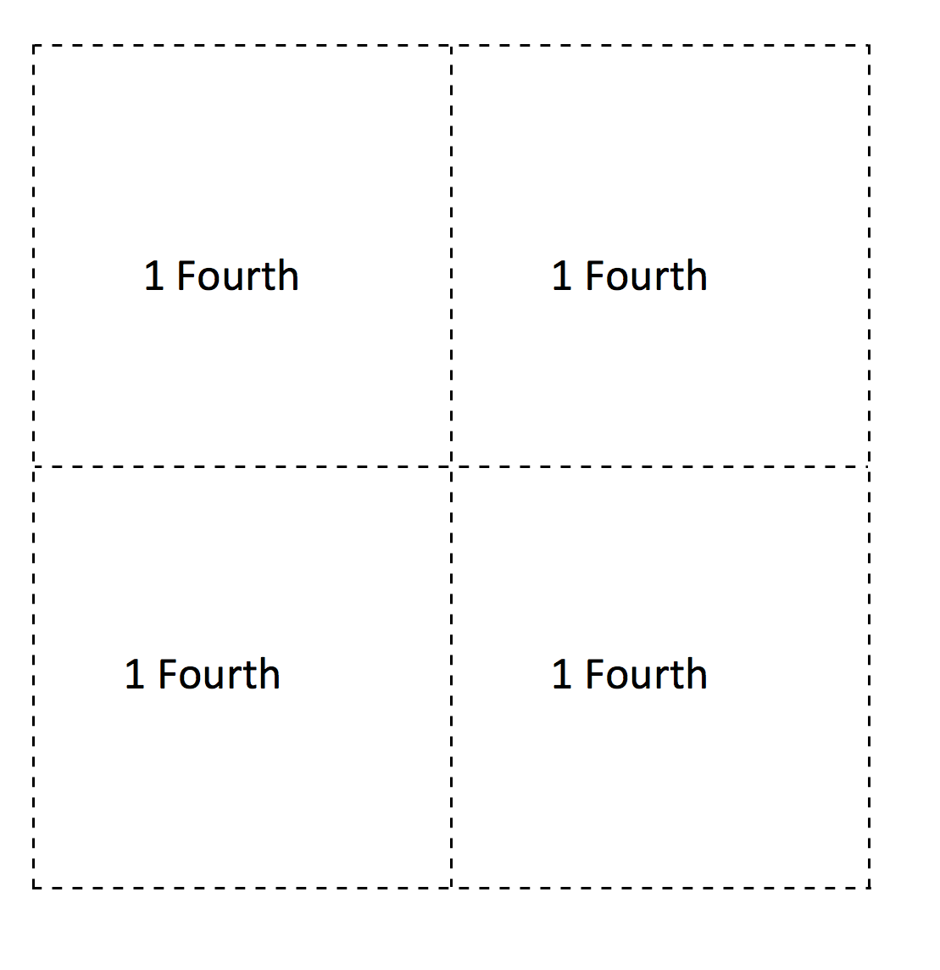
T: (Call three volunteers and give them each 1 fourth of the square template.) Look at the parts of a square that Student B, Student C, and Student D are holding. They each have 1 fourth of a square. What do they need to complete the whole square?
S: 1 more fourth.
T: Let’s complete the whole. (Finish the shape to correctly form a square.)
T: Good thinking everyone. This one was tricky. 1 fourth and 1 fourth and 1 fourth and 1 fourth make 1 whole; 4 fourths makes 1 whole. Say it with me.
S: 1 fourth and 1 fourth and 1 fourth and 1 fourth make 1 whole; 4 fourths makes 1 whole.
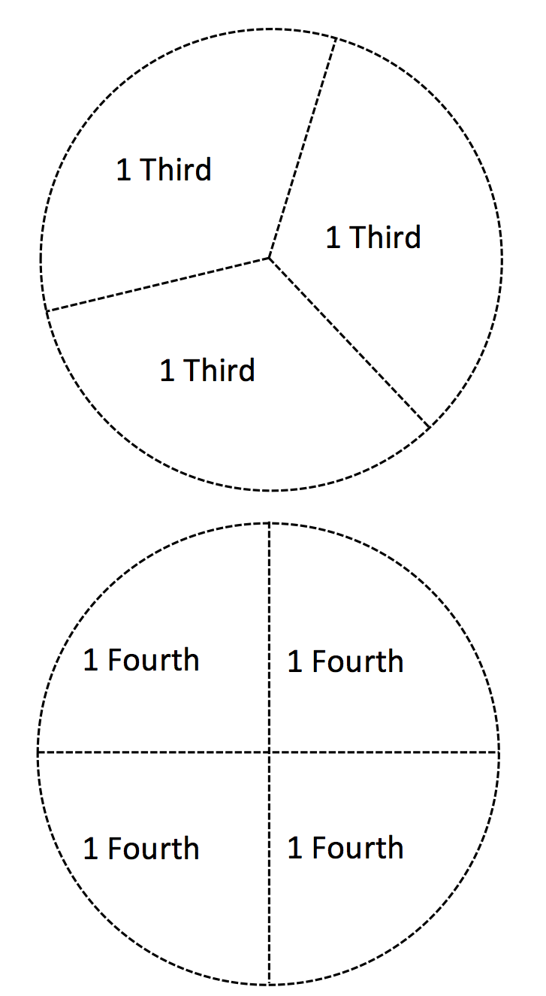
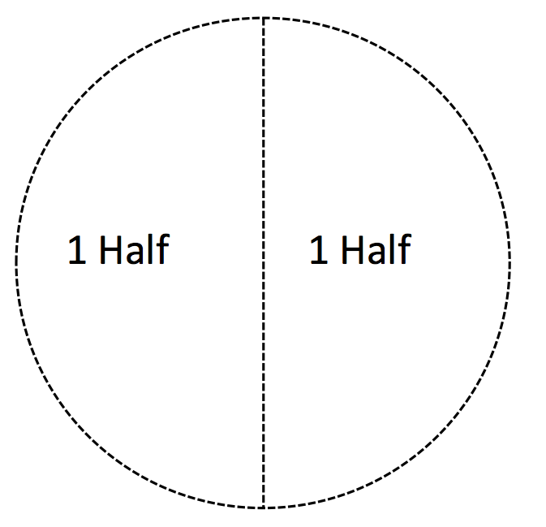
Part 2: Making a Whole Circle from Paper Cutouts
T: (From the previously cut labeled fraction parts templates, distribute one piece of a whole circle (halves, thirds, or fourths) to each student.) Each of you has a piece of a whole circle. When I say, “Find your whole,” walk around the room to complete your whole. Ready? Find your whole!
S: (Find their whole. Assist those who need help making their whole group.)
T: Very good. Let’s look at our whole groups. Do all of our groups have the same number of people?
S: No!
T: Which group has the most people? Which group has the fewest number of people?
S: The fourths have the most people, because it takes 4 fourths to make the whole square. The halves have the fewest number of people, because it only takes 2 halves to make a whole.
T: Which group has the biggest pieces? Which group has the smallest pieces?
S: The halves are the biggest. The fourths are the smallest.
T: Good. So what can we say about thirds compared to halves and fourths?
S: Thirds are bigger than fourths but smaller than halves! A shape can have more thirds than halves.
Part 3: Drawing a Whole Circle from One Part to the Whole

1 fourth
1 fourth
T: (Hold up 1 fourth of a square.) What type of part do I have?
S: 1 fourth!
T: I’m going to glue my 1 fourth on my paper. How many more fourths do I need to complete the whole square?
S: 3 more.
T: Watch as I draw 3 more fourths to complete the whole (pictured). 4 fourths make 1 whole.
T: (Pass out a half, third, or fourth piece to each student.) Tell your partner what part you have.
MP.7
S: I have a half! This is a third. Mine is the same as the teacher’s, 1 fourth.
T: (Pass out unlined paper and glue sticks.) Take your piece of a whole and glue it on your paper. Use a crayon to complete the whole.
S: (Work quietly while the teacher circulates to help those needing assistance.)
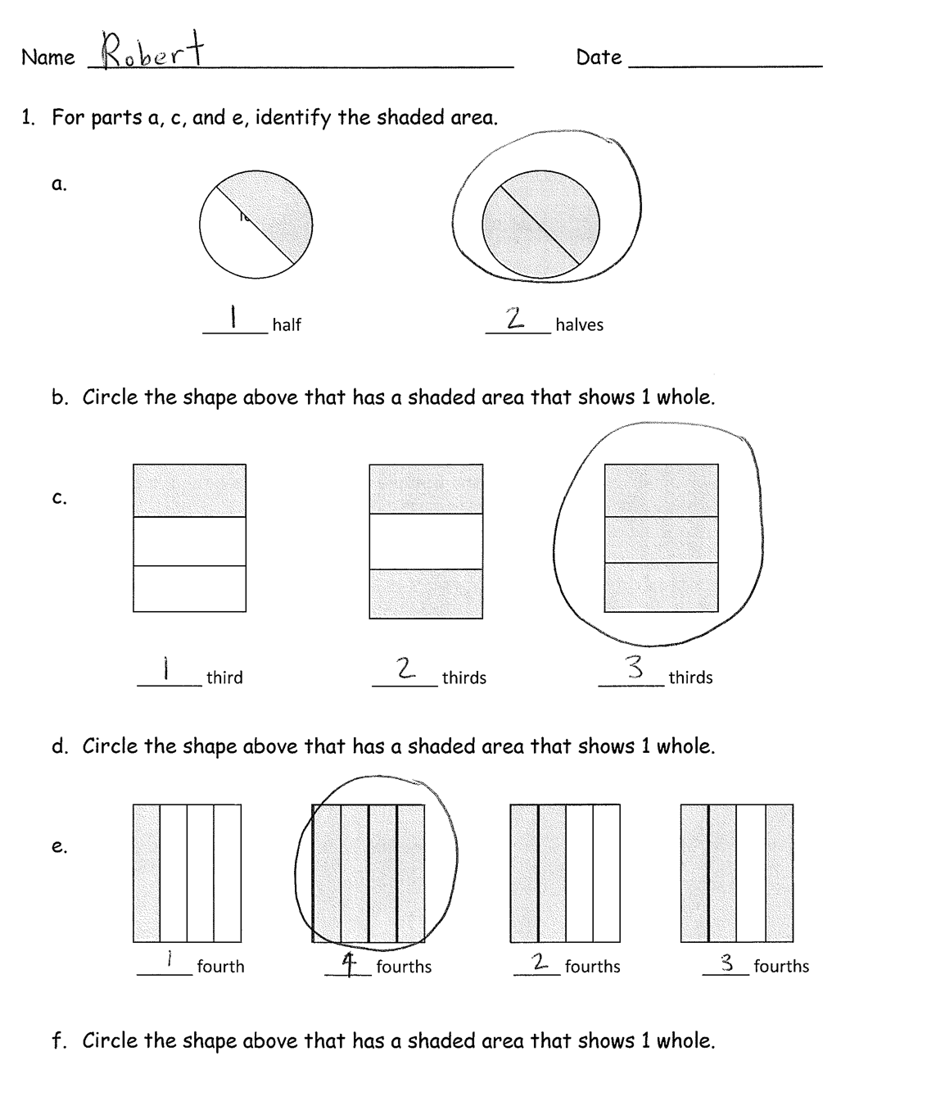
T: Great job making a whole! Show your partner your work! Let’s practice some more on our Problem Set.
Extended Practice: Have some extra cut-up, labeled fraction parts for early finishers to complete halves, thirds, and fourths.
Problem Set (10 minutes)
Students should do their personal best to complete the Problem Set within the allotted 10 minutes. For some classes, it may be appropriate to modify the assignment by specifying which problems they work on first. Some problems do not specify a method for solving. Students solve these problems using the RDW approach used for Application Problems.

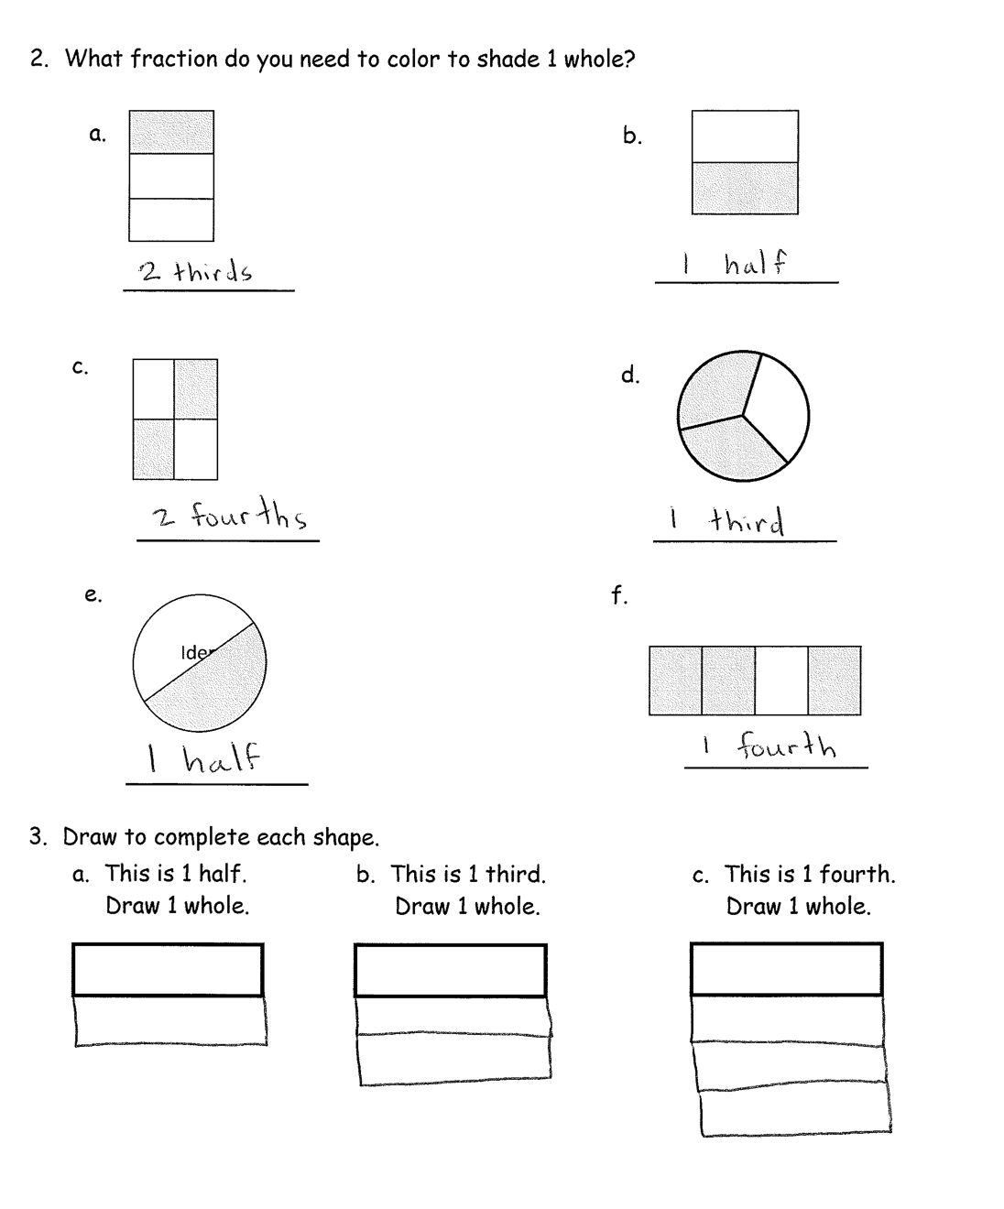
Student Debrief (10 minutes)
Lesson Objective: Describe a whole by the number of equal parts including 2 halves, 3 thirds, and 4 fourths.
The Student Debrief is intended to invite reflection and active processing of the total lesson experience.
Invite students to review their solutions for the Problem Set. They should check work by comparing answers with a partner before going over answers as a class. Look for misconceptions or misunderstandings that can be addressed in the Debrief. Guide students in a conversation to debrief the Problem Set and process the lesson.
You may choose to use any combination of the questions below to lead the discussion.
- For Problem 1(c), which is closer to one whole, 1 third or 2 thirds?
- If you shade 3 fourths of a rectangle, is it possible that 2 fourths are left unshaded?
- What is the same and different about 2 halves, 3 thirds, and 4 fourths?
- For Problem 2, how can you check to make sure your answer is correct?
- Sangeeta says that 2 halves cannot equal 3 thirds. Explain why you agree or disagree.
Exit Ticket (3 minutes)
After the Student Debrief, instruct students to complete the Exit Ticket. A review of their work will help you assess the students’ understanding of the concepts that were presented in the lesson today and plan more effectively for future lessons. You may read the questions aloud to the students.

Name Date

- For parts a, c, and e, identify the shaded area.

Iden

_______ halves
_______ half

- Circle the shape above that has a shaded area that shows 1 whole.

_______ thirds
_______ third
_______ thirds

- Circle the shape above that has a shaded area that shows 1 whole.

_____ fourths
_____ fourths
______ fourth
_____ fourths

- Circle the shape above that has a shaded area that shows 1 whole.

- What fraction do you need to color to shade 1 whole?
b.

c.
d.

f.
e.
Iden

- Draw to complete each shape.
a. This is 1 half.  Draw 1 whole. | b. This is 1 third.  Draw 1 whole. | c. This is 1 fourth.  Draw 1 whole.

Name Date

- What fraction do you need to color to shade 1 whole?
b.
Iden

c.
d.

Name Date

- For parts a, c, and e, identify the shaded area.

Iden

_______ halves
_______ half

- Circle the shape above that has a shaded area that shows 1 whole.

_______ thirds
_______ thirds
_______ third

- Circle the shape above that has a shaded area that shows 1 whole.

_____ fourths

_____ fourths

_____ fourths

_____ fourth

- Circle the shape above that has a shaded area that shows 1 whole.
- What fraction do you need to color to shade 1 whole?
b.

c.

d.

e.
f.
Iden

- Draw to complete each shape.
a. This is 1 half.  Draw 1 whole. | b. This is 1 third.  Draw 1 whole. | c. This is 1 fourth.  Draw 1 whole.

1 Half

1 Half

1 Third | 1 Third | 1 Third

1 Fourth | 1 Fourth
1 Fourth | 1 Fourth

1 Fourth

1 Fourth

1 Fourth

1 Fourth

1 Third

1 Third

1 Third

