Lesson 10

Objective: Partition circles and rectangles into equal parts, and describe those parts as halves, thirds, or fourths.

Suggested Lesson Structure

  Fluency Practice (15 minutes)

  Application Problem (5 minutes)

 Concept Development (30 minutes)

 Student Debrief (10 minutes)

**Total Time (60 minutes)**

Fluency Practice (15 minutes)

* Rename for the Larger Unit **2.NBT.1** (6 minutes)
* Sprint: Addition Patterns **2.OA.2, 2.NBT.5** (9 minutes)

Rename for a Larger Unit (6 minutes)

Note: This fluency activity reviews place value foundations needed to bundle when adding multi-digit numbers.

T: I’m going to give you a number. I want you to bundle and rename the units. Ready?

T: (Write 13 tens = ____ hundred ___ tens.)

T: Say the number sentence. (Point to the board.)

S: 13 tens = 1 hundred 3 tens.

T: Say 13 tens in standard form.

S: One hundred thirty.

T: (Write 26 tens 10 ones = ____ hundreds ____ tens.) Say the number sentence.

S: 26 tens = 2 hundreds 7 tens.

T: Say the number in standard form.

S: Two hundred seventy.

Repeat the process for the following possible sequence: 34 tens 10 ones, 56 tens 10 ones, 81 tens, 90 tens, 1 hundred 35 tens, 3 hundred 44 tens, 7 hundred 28 tens 10 ones, 5 hundred, 34 tens, 13 ones, and 3 hundred 44 tens 24 ones.

Sprint: Addition Patterns (9 minutes)

Materials: (S) Addition Patterns Sprint

Note: Students practice adding in order to gain mastery of the sums and differences within 20 and relate those facts to larger numbers.

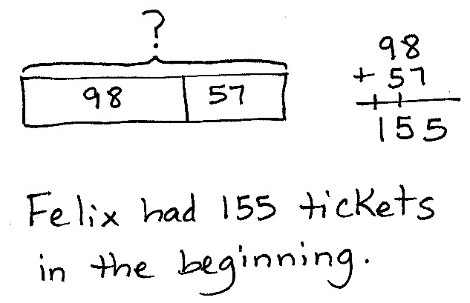Application Problem (5 minutes)

Felix is passing out raffle tickets. He passes out 98 tickets and has 57 left. How many raffle tickets did he have to start?

Note: This is an *add to with start unknown* type problem that reviews two-digit addition with two compositions.

Concept Development (30 minutes)

Materials: (T) 1 piece of 8½" × 11" paper, cut and colored circle from G2–M8–Lesson 9 (S) Rectangles and circle template, personal white board, 1 piece of 8½" × 11" paper, crayons or colored pencils, cut and colored circle from G2–M8–Lesson 9

Part 1: Making Thirds

Pass out rectangles and circle template, and have students insert it into their personal boards.

T: Yesterday, we worked with halves. Today, let’s take a look at thirds.

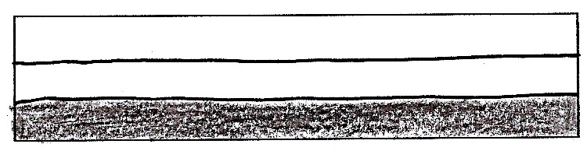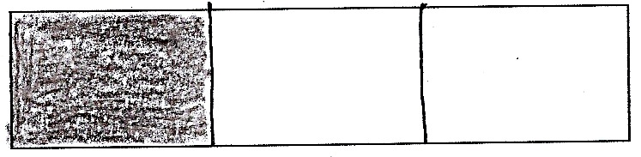

T: When something is divided in thirds, how many equal shares does it have?

S: Three!

T: Correct! Draw two lines in each rectangle to show two different ways to partition them into thirds. (Demonstrate, and then allow students time to work.)

|  |  |
| --- | --- |
|  | NOTES ON  MULTIPLE MEANS OF ENGAGEMENT: |

Some students might have difficulty partitioning a rectangle into thirds. Give them a ruler to help them find where to draw their two lines to make equal parts. They can also fold their papers into thirds, thereby making a mark for them to draw their lines.

T: Shade in one third of each rectangle. What do you notice?

S: The thirds look different. 🡪 Even though they are both thirds, one is long and skinny, and one is short and fat. 🡪 Even though they’re different shapes, they’re both one third of the whole shape. 🡪 They both have two parts unshaded.

T: Practice partitioning the rectangles into thirds. (Allow students time to work.)

T: Choose your rectangle that best shows thirds. Let’s color each third and count as we go. Point to one third, and count with me. This is one third.

S: (Point and count.) One third. (Continue, coloring to show 2 thirds and then 3 thirds, counting after each.)

T: Erase your boards. Now, use two vertical lines to partition one rectangle into thirds. Then draw one vertical line to cut another rectangle into halves.

T: Color one third of the top rectangle and one half of the bottom rectangle. (Pause as students work.)

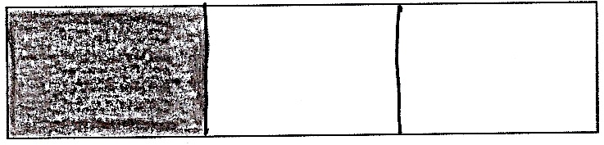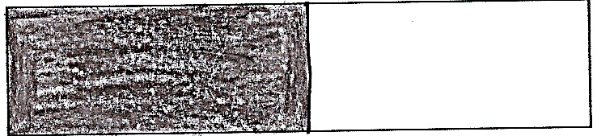

T: Which part is larger?

S: One half is larger.

T: Look at both rectangles as a whole. Which has more parts? Halves or thirds?

S: Thirds.

T: So, thirds have more parts, but the parts are smaller. Think about that for a moment. Why do you think that is?

S: The more times you cut the rectangle, the smaller the pieces. 🡪 Yeah, and if you just cut it once, the pieces will be bigger.

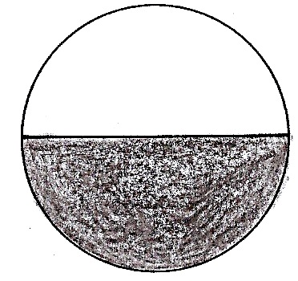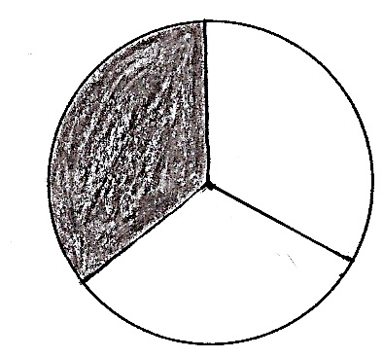

T: Let’s try that with circles. (Draw two circles of equal size on the board. Divide one in half and one into thirds. Invite students to do the same with the circles on their template.)

T: Which is more, one half or one third? Why?

S: It’s the same as with the rectangle. 🡪 One half is greater because there are only two parts. 🡪 One third is smaller because you cut the circle into more pieces.

Have students erase their boards and practice drawing thirds in the circles. Repeat the process above, inviting students to choose the circle that shows the best thirds and to count each third.

Part 2: Making Fourths

Have students take out their circle from yesterday’s lesson.

T: We already folded, colored, and labeled one half. Let’s turn the circle over and make fourths, or quarters, on the other side. When something is divided into fourths, how many equal shares does it have?

S: Four!

T: Fold your circle to partition it into four equal parts. Make sure each part is equal in size. Fold so the ends of the first line come together at the edge. (Model as students do the same.)

**MP.1**

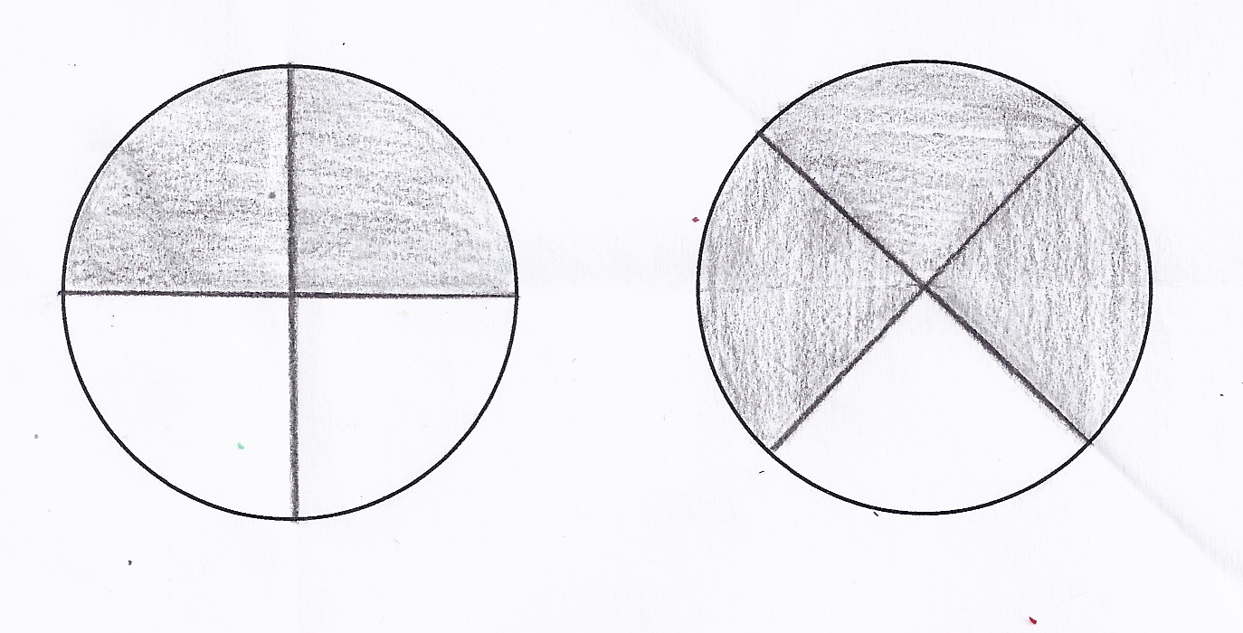

2 fourths 3 fourths

T: Color and label one fourth of your circle. (Model as students do the same.)

T: Point and count the fourths with your partner.

S: 1 fourth, 2 fourths, 3 fourths, 4 fourths.

T: Now, use your personal boards to partition your circles into fourths. (Allow students time to work.) Tell your partner how you divided the circle into equal shares.

S: I made it look like my paper circle. 🡪 I drew a cross in the middle of the circle. 🡪 You can draw an X in the circle.

**MP.1**

T: Shade in 2 fourths of the circle. (Allow students time to work.)

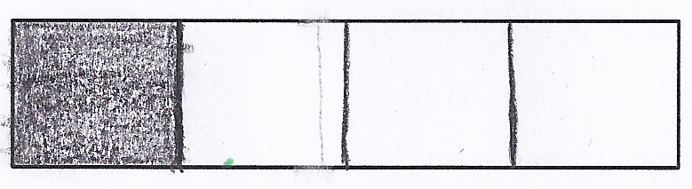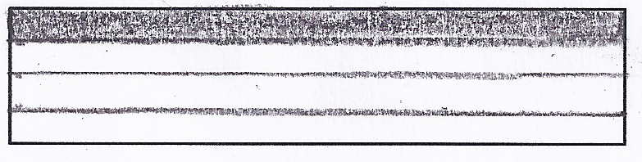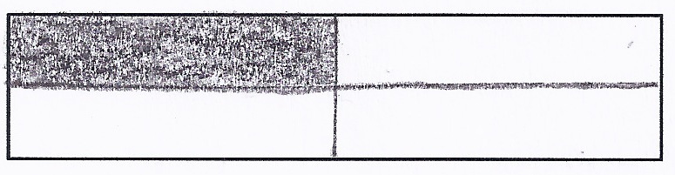

T: Now, let’s partition our rectangles into fourths, or quarters. There are a few different ways we can do this. (Demonstrate and then allow students time to work.)

Have students continue to practice partitioning rectangles into fourths and then shading the following possible patterns: 3 fourths, 4 fourths, 1 quarter, and 2 quarters.

Part 3: Partitioning to Make Thirds and Fourths of a Sheet Cake and Pizza

T: We’re going to use your personal boards and the template to show equal shares. Let’s pretend that the rectangles are sheet cakes and the circle is a pizza.

T: It’s easy to think about food when we talk about equal shares because there are so many foods we cut up to share with friends and family, like cakes, pizza, quesadillas, and candy bars!

T: You’re going to draw lines to cut the pizza and sheet cakes into halves, thirds, and fourths. Please show two different ways of partitioning when slicing the two sheet cakes. Then you’ll color your share.

T: For example, if I say, “You get 3 fourths of the cake,” show me two different ways to partition the rectangles, and color 3 fourths on each cake.

Ask students to show a variety of partitions, for example, naming 1, 2, and 3 thirds and 1, 2, 3, and 4 fourths, as students partition and color their share.

|  |  |
| --- | --- |
|  | NOTES ON  MULTIPLE MEANS OF ENGAGEMENT: |

Support English language learners during partner shares by giving them sentence frames to assist them. For instance: “The three of them shared ___,” or “They each got a _____ of the pizza.”

T: Now, listen to my story, and show me how each shape should be divided. Mary, Colleen, and Saffron share a pizza equally. Show how to slice the pizza, and label each share with their name. (Allow students time to work.)

T: Talk with your partner: What fraction of the pizza did the girls share in all?

S: They shared the whole pizza. 🡪 That’s 3 thirds!

T: Correct! What if Mary also eats Colleen’s share of the pizza? How much has she eaten?

S: Mary has eaten two thirds of the pizza. 🡪 She has eaten double her share. 🡪 She has eaten two shares now.

Allow students who have demonstrated proficiency to move on to the Problem Set.

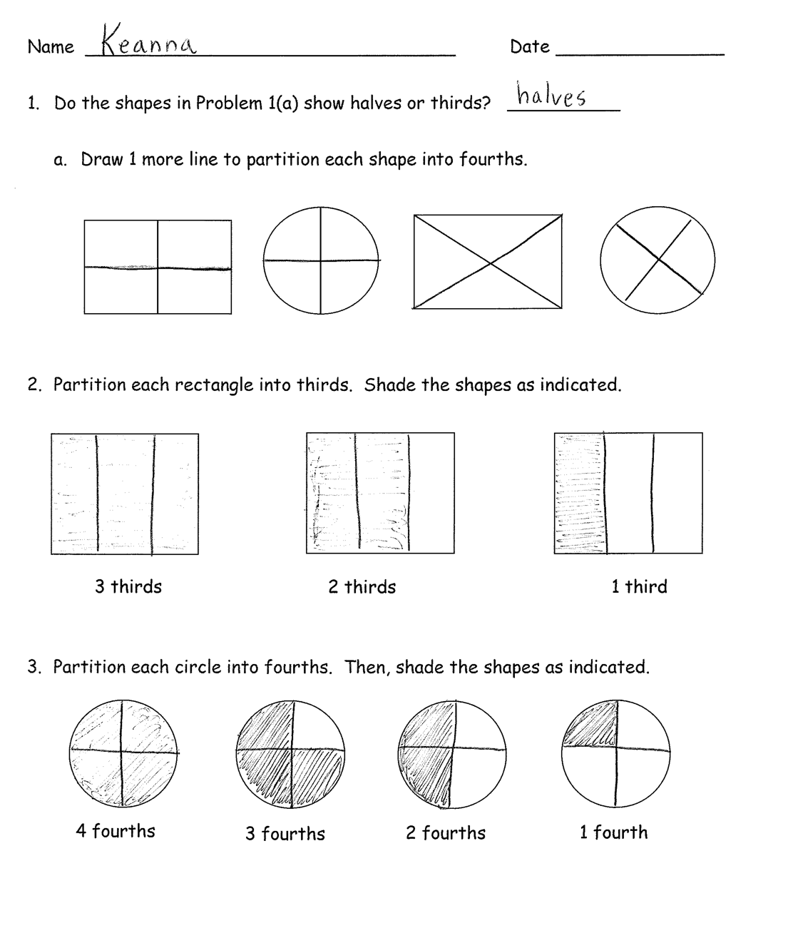Problem Set (10 minutes)

Students should do their personal best to complete the Problem Set within the allotted 10 minutes. For some classes, it may be appropriate to modify the assignment by specifying which problems they work on first. Some problems do not specify a method for solving. Students solve these problems using the RDW approach used for Application Problems.

Student Debrief (10 minutes)

**Lesson Objective:** Partition circles and rectangles into equal parts, and describe those parts as halves, thirds, or fourths.

The Student Debrief is intended to invite reflection and active processing of the total lesson experience.

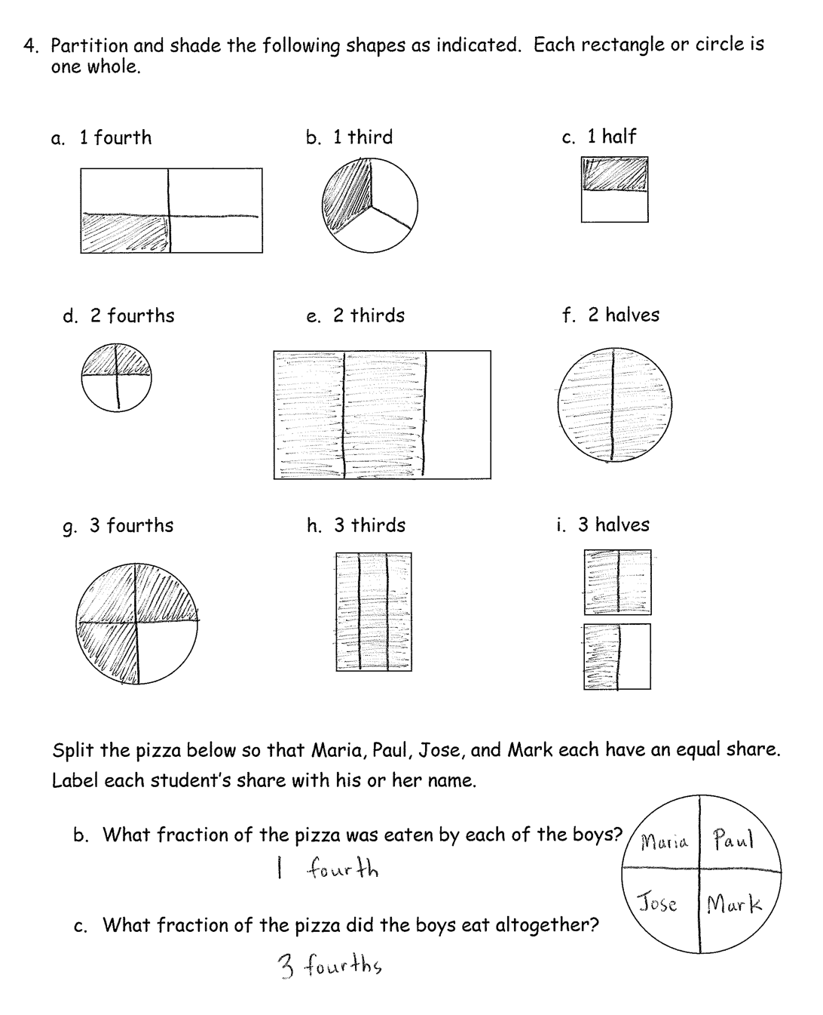Invite students to review their solutions for the Problem Set. They should check work by comparing answers with a partner before going over answers as a class. Look for misconceptions or misunderstandings that can be addressed in the Debrief. Guide students in a conversation to debrief the Problem Set and process the lesson.

You may choose to use any combination of the questions below to lead the discussion.

* For Problem 1(a), how did you determine where to draw another line to make fourths?
* For Problem 2, Jasmine looked at the shaded rectangles and exclaimed, “3 thirds equals 2 thirds plus 1 third!” Do you agree with her? Why?
* For Problem 3, what is interesting about 2 fourths? Can you relate it to halves? When you shaded 3 fourths, what part was left unshaded? How about when you shaded 1 fourth?
* Look at Problem 4(e) and (h). How can 2 thirds be greater than 3 thirds?
* How are Problems 4(a), (d), and (g) alike? How are they different? When will the fourths be exactly the same size and shape?
* For Problem 5, what fraction of the pizza did Maria get? How do you know?

Exit Ticket (3 minutes)

After the Student Debrief, instruct students to complete the Exit Ticket. A review of their work will help you assess the students’ understanding of the concepts that were presented in the lesson today and plan more effectively for future lessons. You may read the questions aloud to the students.





Name Date

1. Do the shapes in Problem 1(a) show halves or thirds? __________
   1. Draw 1 more line to partition each shape into fourths.
2. Partition each rectangle into thirds. Shade the shapes as indicated.

2 thirds

1 third

3 thirds

1. Partition each circle into fourths. Then, shade the shapes as indicated.

4 fourths

3 fourths

1 fourth

2 fourths

1. Partition and shade the following shapes as indicated. Each rectangle or circle is one whole.  
     
   1. 1 fourth b. 1 third c. 1 half

d. 2 fourths e. 2 thirds f. 2 halves

g. 3 fourths h. 3 thirds i. 3 halves

1. Split the pizza below so that Maria, Paul, Jose, and Mark each have an equal share. Label each student’s share with his or her name.
   1. What fraction of the pizza was eaten by each of the boys?
   2. What fraction of the pizza did the boys eat altogether?

Name Date

1. Partition and shade the following shapes as indicated. Each rectangle or circle is one whole.  
     
   1. 2 halves b. 2 thirds c. 1 third

d. 1 half e. 2 fourths f. 1 fourth

Name Date

1. Do the shapes below show halves or thirds? _____________
   1. Draw 1 more line to partition each shape above into fourths.
2. Partition each rectangle into thirds. Shade the shapes, as indicated.

2 thirds 1 third 3 thirds

1. Partition each circle into fourths. Then, shade the shapes as indicated.

1 fourth

3 fourths

2 fourths

4 fourths

1. Partition and shade the following shapes. Each rectangle or circle is one whole.
2. 1 half b. 1 fourth c. 1 third

d. 2 fourths e. 2 halves f. 2 thirds

g. 3 thirds h. 3 fourths i. 3 halves

1. Split the pizza below so that Shane, Raul, and John all have an equal share. Label each student’s share with his name.

What fraction of the pizza did the boys get in all?