Lesson 9

Objective: Partition circles and rectangles into equal parts, and describe those parts as halves, thirds, or fourths.

Suggested Lesson Structure

|  |  |
| --- | --- |
|  | NOTES ON  MULTIPLE MEANS OF  REPRESENTATION: |

Encourage written reflection as students share the strategies they used to arrive at their answers. Ask questions such as, “How did you use the make a ten strategy?” or “How did your use of that strategy make the job of subtracting 96 from 120 easier?”

  Fluency Practice (15 minutes)

  Application Problem (5 minutes)

 Concept Development (30 minutes)

 Student Debrief (10 minutes)

**Total Time (60 minutes)**

Fluency Practice (15 minutes)

* Rename for the Larger Unit **2.NBT.1** (6 minutes)
* Sprint: Subtraction Patterns **2.OA.2, 2.NBT.5** (9 minutes)

Rename for the Larger Unit (6 minutes)

Note: This fluency activity reviews place value foundations.

T: I’m going to tell you a number of ones. Tell me the largest units that can be made. Ready?

T: (Write 12 ones = ____ ten ___ ones.)

T: Say the number sentence. (Point to the board.)

S: 12 ones = 1 ten 2 ones.

T: (Write 29 ones = 1 ten ___ ones.) Say the number sentence.

S: 29 ones = 1 ten 19 ones.

T: (Write 29 ones = ____ tens ___ ones.) Say the number sentence.

S: 29 ones = 2 tens 9 ones.

Repeat the process for the following possible sequence: 58 ones, 97 ones, 100 ones, 130 ones, 148 ones, 254 ones, 309 ones, 880 ones, etc.

Sprint: Subtraction Patterns (9 minutes)

Materials: (S) Subtraction Patterns Sprint

Note: Students practice subtracting in order to gain mastery of the sums and differences within 20 and relate those facts to larger numbers.

Application Problem (5 minutes)

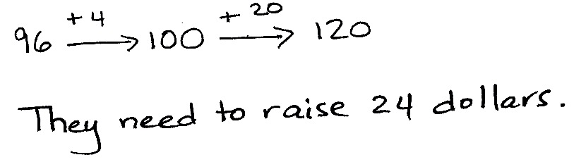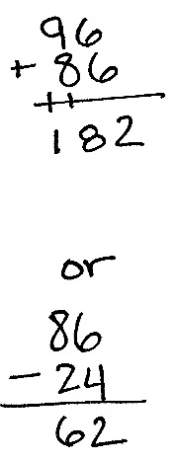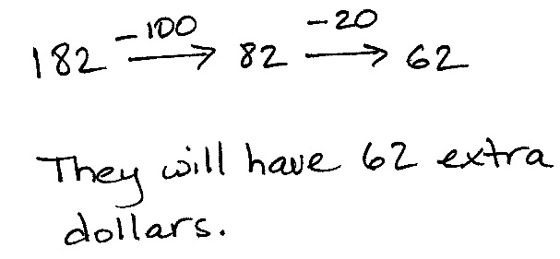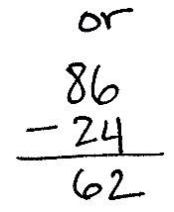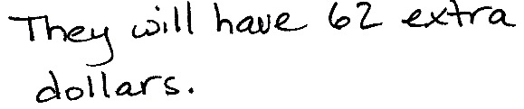

a.

b.

Mr. Thompson’s class raised 96 dollars for a field trip. They need to raise 120 dollars.

1. How much more money do they need to raise in order to reach their goal?
2. If they raise 86 more dollars, how much extra money will they have?

Note: This problem reviews multi-digit addition and subtraction and invites students to use a variety of strategies to solve.

Concept Development (30 minutes)

Materials: (T) 1 piece of 8½" × 11" paper, circle template, shaded shapes template (S) 1 piece of 8½" × 11" paper, circle template, shaded shapes template, personal white board, scissors, crayons or colored pencils

Distribute 8½" × 11" paper and crayons or colored pencils to each student.

T: (Hold up a piece of paper.) What shape is this paper?

S: A rectangle!

T: How can you prove that?

S: It has four straight sides and four right angles.

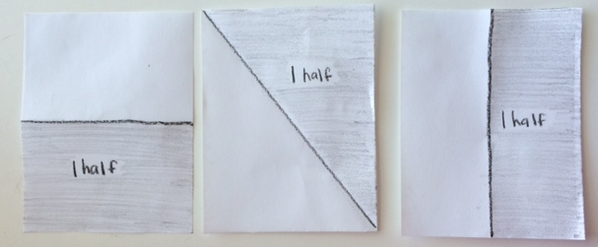T: Partner A, choose one way to fold your paper in half.

T: Partner B, fold your paper in half another way. (Circulate to ensure students are folding accurately.)

T: Once you have folded your paper, open it up and draw straight down the fold line with a crayon. Then color one half and label it. (Model as students do the same.)

T: Talk with your partner. Use math language to describe how your papers are alike and different.

S: We folded them differently, but we both have two equal parts. 🡪 We both have two halves. 🡪 We both still have a whole piece of paper.

T: Excellent! You have **partitioned**, or divided, your paper into two equal shares called halves.

T: And we can describe either part, whether shaded or unshaded, as half, true?

S: True!

T: Cut along your fold line, and then hold up your papers. (Wait as students do so.)

T: What are you holding?

S: Two halves. 🡪 Two equal shares. 🡪 Two equal parts that make a whole.

T: Put them together. Now what do you have?

S: One whole!

Pass out the circle template and scissors. At the end of this activity, have students store their circle in their personal board to use during tomorrow’s lesson.

T: Cut out the circle by cutting right on top of the black line. (Model as students do the same.)

T: Fold your circle in half. Is there more than one way to do that?

|  |  |
| --- | --- |
|  | NOTES ON  MULTIPLE MEANS OF ACTION AND EXPRESSION: |

English language learners’ cultural background can be used to build on their prior knowledge. Allow students to express their mathematical knowledge in their native language. For instance, Spanish-speaking students can answer “dos partes iguales” in response to the question about describing their shaded circle.

S: No.

T: (Hold up folded circle.) This reminds me of certain foods. Do you know which ones I’m thinking of?

S: An omelet! 🡪 A quesadilla! 🡪 A taco!

T: Sure! Whether it’s eggs or a tortilla, we sometimes take a circle and fold it in half. Yum!

**MP.3**

T: Now, open up your circle, and draw straight down the fold line with a crayon. Then, color one half and label it. (Model as students do the same.)

T: How would you describe this circle now?

S: One half is shaded and the other half is unshaded. 🡪 We have two equal shares. 🡪 We have 2 halves.

T: That is correct!

Guide students to rotate their circles to discover and discuss that halves are determined by equal parts, not by the orientation of the line.

Pass out the shaded shapes template, and have students insert it into their personal boards.

T: Look at the shapes on the page. Talk with your partner about all the reasons why each shape is or is not two equal shares with one share shaded?

Circulate as students talk in order to listen for misconceptions or identify comments to share with the class.

S: Shape A looks like a card if you fold it over. The parts would be equal and there are two of them so they’re halves.

T: What an interesting observation! We’ve said that the shapes need to be the same size, so if you can fold one side of the rectangle on top of the other side and they match, then they must be halves.

S: If Shape B were a pizza it wouldn’t be fair shares. The parts aren’t equal, so it’s not halves, even though there are two parts. 🡪 Shape C is not halves because there are three parts, not two, and it’s not thirds because the parts aren’t equal.

T: Ooh! I like your thinking! Halves means *two* equal parts make up the whole.

As students demonstrate proficiency, allow them to move on to the Problem Set.

Problem Set (10 minutes)

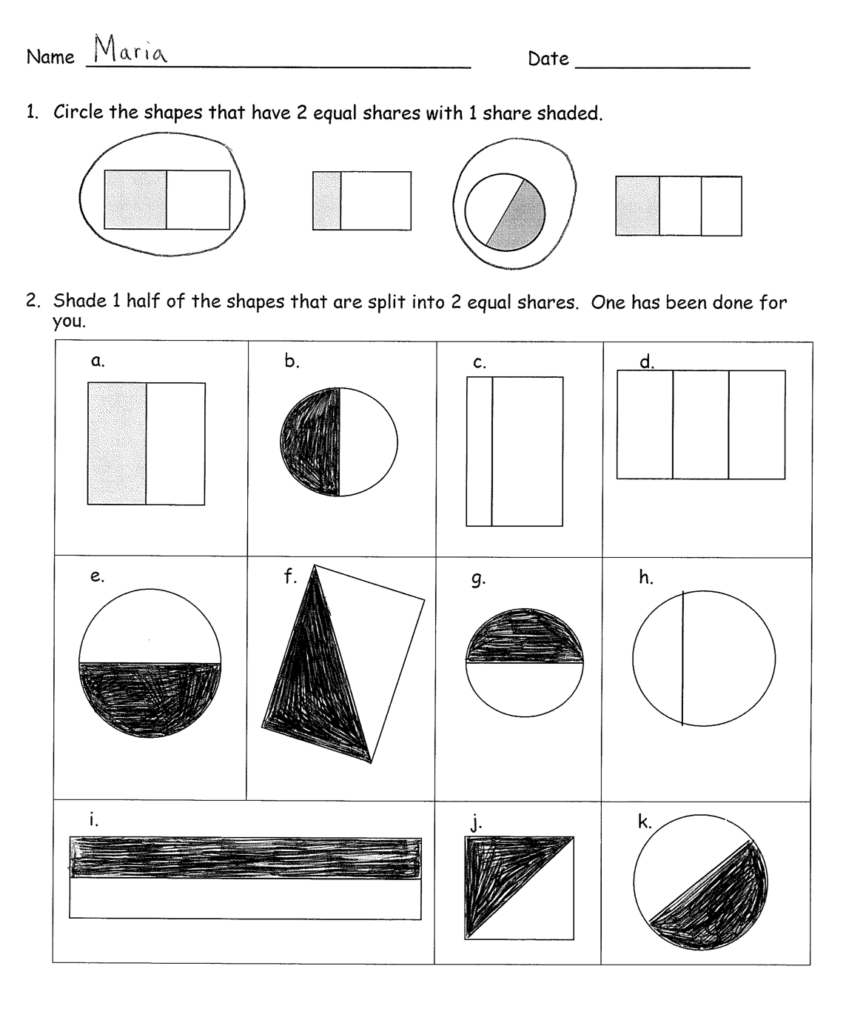Students should do their personal best to complete the Problem Set within the allotted 10 minutes. For some classes, it may be appropriate to modify the assignment by specifying which problems they work on first. Some problems do not specify a method for solving. Students solve these problems using the RDW approach used for Application Problems.

Student Debrief (10 minutes)

**Lesson Objective:** Partition circles and rectangles into equal parts, and describe those parts as halves, thirds, or fourths.

The Student Debrief is intended to invite reflection and active processing of the total lesson experience.

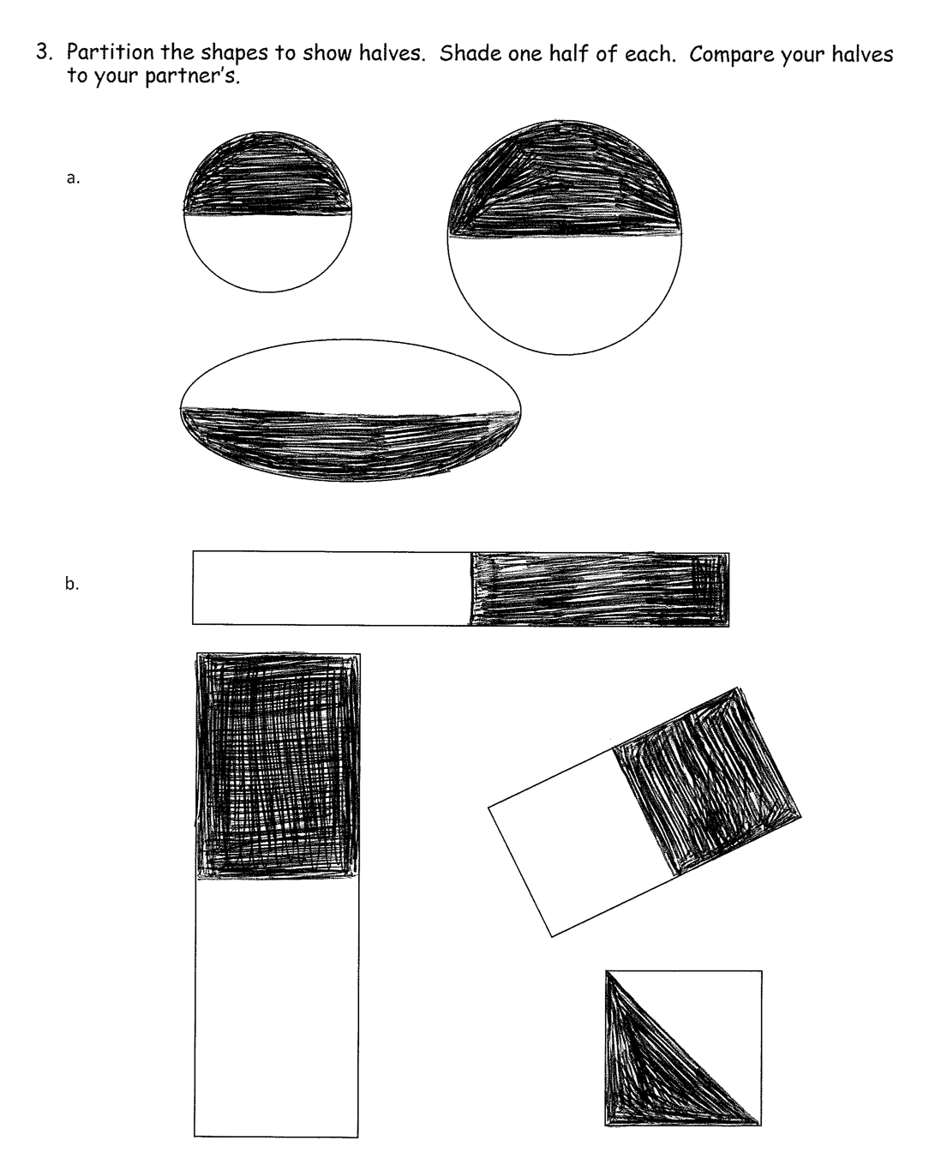Invite students to review their solutions for the Problem Set. They should check work by comparing answers with a partner before going over answers as a class. Look for misconceptions or misunderstandings that can be addressed in the Debrief. Guide students in a conversation to debrief the Problem Set and process the lesson.

You may choose to use any combination of the questions below to lead the discussion.

* For Problem 2, are shapes (g) and (h) split into two equal shares? How do you know?
* For Problem 2(c) and (h), why didn’t you shade in one part?
* What similarities and differences do you notice between Problems 2(b), (e), and (k)?
* Can all the shapes in Problem 2 be split into two equal shares? How would Problem 2(d) change?
* Turn and talk. For Problem 3, what mental strategy did you use to split the shapes into halves? How does your work compare to your partner’s?
* For Problem 3, how many ways can you split the shapes into halves? Do you notice anything interesting about circles?

Exit Ticket (3 minutes)

After the Student Debrief, instruct students to complete the Exit Ticket. A review of their work will help you assess the students’ understanding of the concepts that were presented in the lesson today and plan more effectively for future lessons. You may read the questions aloud to the students.





Name Date

1. Circle the shapes that have 2 equal shares with 1 share shaded.
2. Shade 1 half of the shapes that are split into 2 equal shares. One has been done for you.

|  |  |  |  |
| --- | --- | --- | --- |
|  |  |  |  |
|  |  |  |  |
|  | |  |  |

1. Partition the shapes to show halves. Shade one half of each. Compare your halves to your partner’s.

Name Date

1. Shade 1 half of the shapes that are split into 2 equal shares.

|  |  |  |  |
| --- | --- | --- | --- |
|  |  |  |  |
|  |  |  |

Name Date

1. Circle the shapes that have 2 equal shares with 1 share shaded.
2. Shade 1 half of the shapes that are split into 2 equal shares. One has been done for you.
3. Partition the shapes to show halves. Shade one half of each.

a.

f.

b.

e.

c.

d.