Lesson 8
Objective: Interpret equal shares in composite shapes as halves, thirds, and fourths.

Suggested Lesson Structure
 Fluency Practice (15 minutes)
 Application Problem (5 minutes)
 Concept Development (30 minutes)
 Student Debrief (10 minutes)
Total Time (60 minutes)
Fluency Practice (15 minutes)
- Rename for the Smaller Unit 2.NBT.1 (3 minutes)
- Subtraction with Renaming 2.NBT.7 (7 minutes)
- Grade 2 Core Fluency Differentiated Practice Sets 2.OA.2 (5 minutes)
Rename for the Smaller Unit (3 minutes)
Note: This fluency activity reviews place value foundations.
T: (Write 121 = ____ tens, _____ ones.)
T: Rename 1 hundred for 10 tens and then tell me how many hundreds, tens, and ones. Ready?
S: 12 tens, 1 one.
T: (Write 158 = _____ tens, ____ ones.) Say the number sentence.
S: 158 = 15 tens, 8 ones.
T: 203.
S: 203 = 1 hundred, 10 tens, 3 ones.
T: 213.
S: 213 = 1 hundred, 11 tens, 3 ones.
Repeat the process for the following possible sequence: 305, 315; 204, 224; 108, 158; and 908, 968.
Subtraction with Renaming (7 minutes)
Materials: (S) Personal white board, place value chart
Note: This fluency drill reviews the application of a chip model while recording with the algorithm. Allow students work time between each problem, and reinforce place value understandings by having students say the answer in both unit form and the regular way. Students will use their personal boards and a place value chart to solve.
T: (Write 123 – 47 horizontally on the board.) Let’s use a chip model to subtract. On your boards, record your work using the algorithm.
S: (Solve on their personal white boards.)
T: 1 hundred, 2 tens, 3 ones minus 4 tens, 7 ones is…?
S: 7 tens, 6 ones!
T: 123 – 47 is…?
S: 76!
Continue with the following possible sequence: 132 – 59, 231 – 65, 300 – 26, 446 – 77, and 506 – 187.
Grade 2 Core Fluency Differentiated Practice Sets (5 minutes)
Materials: (S) Core Fluency Practice Sets from G2–M8–Lesson 3
Note: During G2–8–Topic B and for the remainder of the year, each day’s Fluency Practice includes an opportunity for review and mastery of the sums and differences with totals through 20 by means of the Core Fluency Practice Sets or Sprints. The process is detailed and Practice Sets provided in G2–M8–Lesson 3.
Application Problem (5 minutes)
The students were making larger shapes out of triangles and squares. They put away all 72 triangles. There were still 48 squares on the carpet. How many shapes were on the carpet when they started?

NOTES ON
MULTIPLE MEANS OF REPRESENTATION:
Scaffold the Application Problem for below grade level students by walking them through the calculation one step at a time. Ask questions such as, “How can we make this problem easier? How many tens are in 72 and 48? What do 2 ones and 8 ones make?” Continue until students come up with the answer.
Note: This is a take from with start unknown type problem. Encourage students to draw a tape diagram to visualize the relationships within the problem.
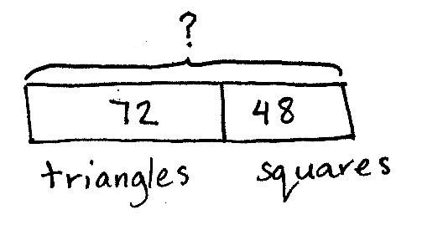
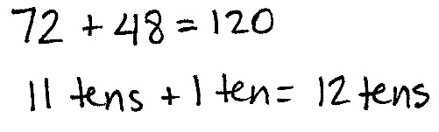
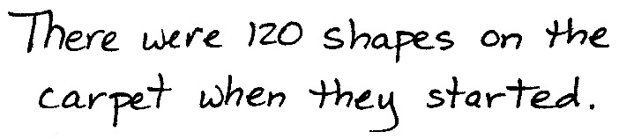
Concept Development (30 minutes)
Materials: (T) Pattern blocks, Problem Set, document camera (S) Problem Set, pattern blocks in individual plastic bags per pair (set of 1 hexagon, 6 squares, 6 triangles, 2 trapezoids, 3 wide, not thin, rhombuses)
Note: The Problem Set is completed throughout the Concept Development.
Note: In this lesson, students work in pairs to encourage math conversations as they explore equal shares using pattern blocks. Students identify and use one pattern block to cover a half, a third, or a fourth of a given shape. They then draw a picture of the composite shape formed by the halves, thirds, and fourths, and shade the smaller polygon within the composite shape.
For each problem, questions are supplied to support the objective. Post the questions so students can discuss their work in greater detail with a partner or at their tables. Encourage them to close their eyes and visualize how they moved the smaller polygons to create the new shape. Have them describe how they used flips, slides, or turns to move the pieces. This discussion, linked with action, develops spatial visualization skills.
Pass out the Problem Set and the individual bags of pattern blocks.
Problem 1: Use one pattern block to cover half the rhombus.

NOTES ON
MULTIPLE MEANS OF ACTION AND EXPRESSION:
Support English language learners’ ability to follow the lesson when giving directions during the lesson by pointing to the rhombus, the hexagon, the trapezoid, and the square. Provide them with appropriate sentence frames to discuss their work with a partner.
T: Complete Problem 1. Share your thinking with your partner. Close your eyes and visualize how you moved the smaller polygons to create the rhombus. Describe how you flip, slide, or turn the pieces.
Ask questions such as the following to support deeper analysis of halves:
MP.1
- How can looking at angles and sides help you find the block that is half a rhombus?
- If the rhombus was made from a piece of paper, how many different ways could you cut it to get two halves? Draw the different ways you could cut the rhombus into two halves.
Problem 2: Use one pattern block to cover half the hexagon.
Ask questions such as the following to encourage interpreting different representations of a half:
- Cover the bottom half of the hexagon with three triangles. Is it still half covered? Why or why not?
- Cover the bottom half of the hexagon with a rhombus and a triangle. Is it still half covered?
Problem 3: Use one pattern block to cover one-third of the hexagon.
Ask questions such as the following to encourage deeper understanding of thirds:
- How many thirds do you need to fill the whole hexagon?
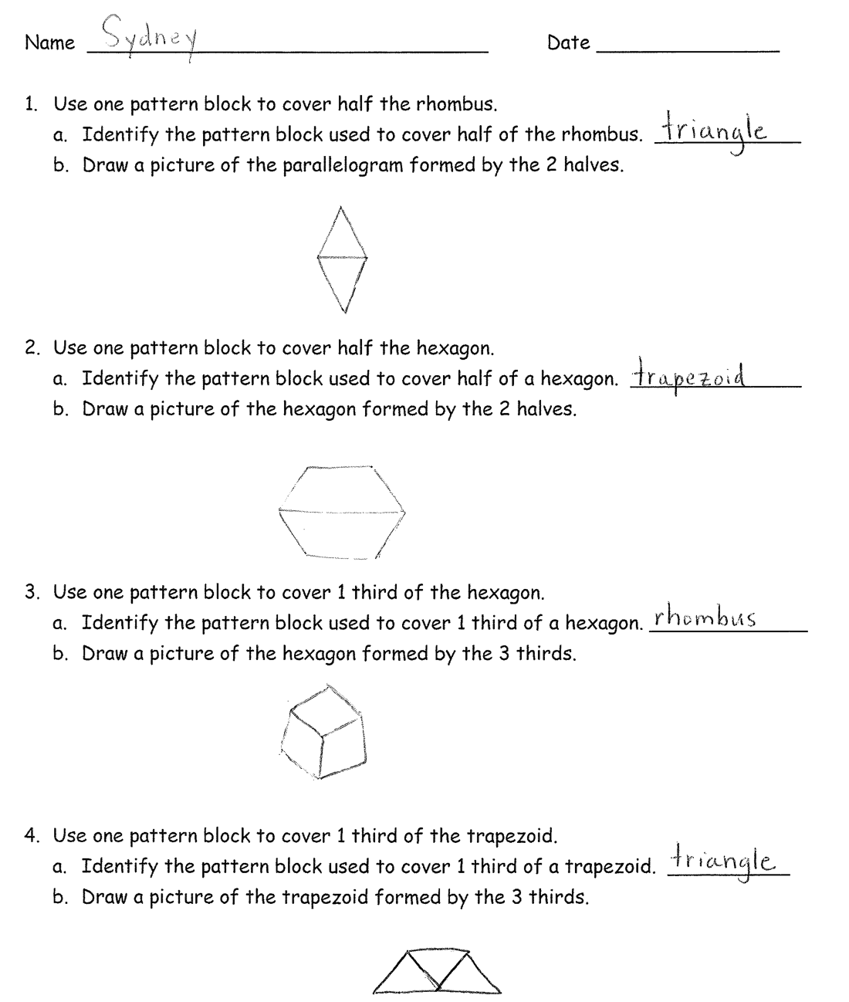
- Cover one third with two triangles. Is the hexagon one third covered?
- What fraction is not covered?
Problem 4: Use one pattern block to cover one-third of the trapezoid.
Prompt students to interpret thirds in relationship to a whole:
- Use your drawing of the trapezoid formed by thirds to talk about how many small triangles would make a whole hexagon.
- How many thirds are in the trapezoid? In the hexagon?
Problem 5: Use four pattern blocks to make one larger square.
Prompt students to support different understandings of fourths:
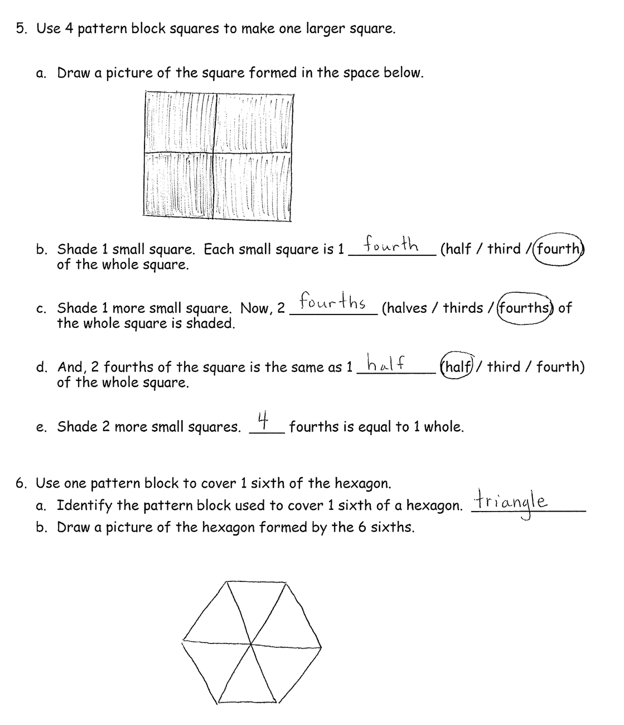
- How many equal shares does the large square have?
- How many fourths make up the large square?
- How many fourths equal one whole square?
- Use your blocks to show that 2 fourths is the same as a half of the large square.
Problem 6: Use one pattern block to cover one-sixth of the hexagon.
Ask questions such as the following to support thinking about sixths:
- How many equal parts does the hexagon have?
- How many sixths make up the hexagon?
Student Debrief (10 minutes)
Lesson Objective: Interpret shares in composite shapes as halves, thirds, and fourths.
The Student Debrief is intended to invite reflection and active processing of the total lesson experience.
Invite students to review their solutions for the Problem Set. They should check work by comparing answers with a partner before going over answers as a class. Look for misconceptions or misunderstandings that can be addressed in the Debrief. Guide students in a conversation to debrief the Problem Set and process the lesson.
You may choose to use any combination of the questions below to lead the discussion. Consider using some of the discussion questions posed to pairs during the Concept Development as part of the Student Debrief. This will give students an opportunity to share their learning and to solidify their understanding if they overcame a misconception.
- Which problem was most difficult to solve? What strategies did you use to solve it? What made you keep trying even when it was hard?
- How did knowing the attributes of each shape help you solve the problems?
- (Show a hexagon covered by a triangle.) Look at Problem 3. What part of the hexagon am I showing? How many more triangles do I need to fill the hexagon?
- (Hold up a pattern block triangle.) Can this triangle be a half, a third, or a fourth? Explain.
Exit Ticket (3 minutes)
After the Student Debrief, instruct students to complete the Exit Ticket. A review of their work will help you assess the students’ understanding of the concepts that were presented in the lesson today and plan more effectively for future lessons. You may read the questions aloud to the students.

Name Date

- Use one pattern block to cover half the rhombus.
- Identify the pattern block used to cover half of the rhombus. ____________
- Draw a picture of the parallelogram formed by the 2 halves.

- Use one pattern block to cover half the hexagon.
- Identify the pattern block used to cover half of a hexagon. ______________
- Draw a picture of the hexagon formed by the 2 halves.

- Use one pattern block to cover 1 third of the hexagon.
- Identify the pattern block used to cover 1 third of a hexagon. _____________
- Draw a picture of the hexagon formed by the 3 thirds.

- Use one pattern block to cover 1 third of the trapezoid.
- Identify the pattern block used to cover 1 third of a trapezoid. __________
- Draw a picture of the trapezoid formed by the 3 thirds.

- Use 4 pattern block squares to make one larger square.

- Draw a picture of the square formed in the space below.

- Shade 1 small square. Each small square is 1 __________ (half / third / fourth) of the whole square.

- Shade 1 more small square. Now, 2 __________ (halves / thirds / fourths) of the whole square is shaded.

- And, 2 fourths of the square is the same as 1 _________ (half / third / fourth) of the whole square.

- Shade 2 more small squares. ____ fourths is equal to 1 whole.

6. Use one pattern block to cover 1 sixth of the hexagon.
- Identify the pattern block used to cover 1 sixth of a hexagon. _____________
- Draw a picture of the hexagon formed by the 6 sixths.

Name Date

  - Name the pattern block used to cover half the rectangle. __________________

Use the shape below to draw the pattern blocks used to cover 2 halves.

Name Date

  - Name the pattern block used to cover half the rhombus. __________________
Sketch the 2 pattern blocks used to cover both halves of the rhombus.

- Name the pattern block used to cover half the hexagon. _________________
Sketch the 2 pattern blocks used to cover both halves of the hexagon.

- Name the pattern block used to cover 1 third of the hexagon._______________
Sketch the 3 pattern blocks used to cover thirds of the hexagon.

- Name the pattern block used to cover 1 third of the trapezoid. _____________
Sketch the 3 pattern blocks used to cover thirds of the trapezoid.

- Sketch 4 pattern block squares used to make one larger square.

- Shade 1 small square. Each small square is 1 __________ (half / third / fourth) of the whole square.

- Shade 1 more small square. Now, 2 __________ (halves / thirds / fourths) of the whole square are shaded.

- And, 2 fourths of the square is the same as 1 _________ (half / third / fourth) of the whole square.

- Shade 2 more small squares. ____ fourths is equal to 1 whole.

- Name the pattern block used to cover 1 sixth of the hexagon. _____________
Sketch the 6 pattern blocks used to cover 6 sixths of the hexagon.

