Lesson 6

Objective: Combine shapes to create a composite shape; create a new shape from composite shapes.

Suggested Lesson Structure

 Fluency Practice (12 minutes)

 Application Problem (5 minutes)

 Concept Development (33 minutes)

 Student Debrief (10 minutes)

**Total Time (60 minutes)**

Fluency Practice (12 minutes)

* Rename for the Smaller Unit **2.NBT.1** (3 minutes)
* Sprint: Addition and Subtraction Patterns **2.OA.2** (9 minutes)

Rename for the Smaller Unit (3 minutes)

Note: This fluency activity reviews place value foundations.

T: (Write 101 = ____ tens, _____ ones.)

T: Rename 1 hundred for 10 tens, and then tell me how many hundreds, tens, and ones. Ready?

S: 10 tens, 1 one.

T: (Write 121 = _____ tens, ____ one.) Say the number sentence.

S: 121 = 12 tens, 1 one.

T: 203.

S: 203 = 1 hundred, 10 tens, 3 ones.

T: 213.

S: 213 = 1 hundred, 11 tens, 3 ones.

Repeat the process for 305, 315; 204, 224; 108, 158; and 908, 968.

Sprint: Addition and Subtraction Patterns (9 minutes)

Materials: (S) Addition and Subtraction Patterns Sprint

Note: Students practice adding and subtracting in order to gain mastery of the sums and differences within 20.

Application Problem (5 minutes)

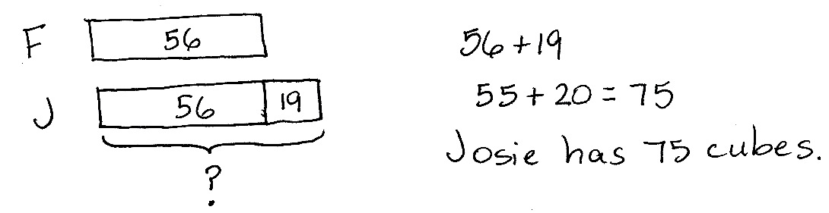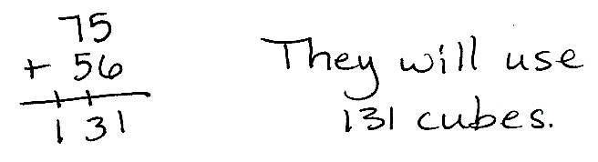

Frank has 19 fewer cubes than Josie. Frank has 56 cubes. They want to use all of their cubes to build a tower. How many cubes will they use?

Note: This is a two-step problem with a *compare with bigger unknown* type problem as one step. Encourage students to draw a tape diagram to help visualize the comparison.

Concept Development (33 minutes)

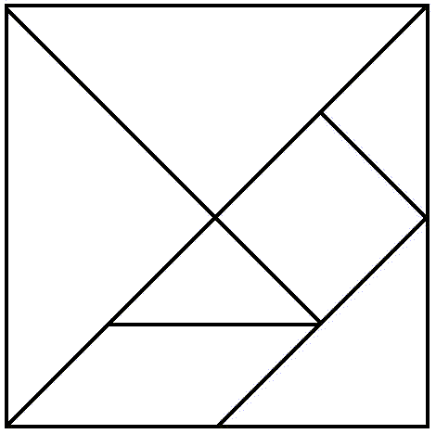Materials: (T) Tangram sheet (template), scissors, document camera (if available) (S) Tangram sheet (template), scissors, personal white board

Note: Students previously worked with tangrams in G1−M5−Lesson 5. If time allows, refresh students’ memory by reading *Grandfather Tang’s Story* by Ann Tompert during story time.

Distribute materials. (Students will also need the cut-out tangram pieces for G2−M8−Lesson 8.)

Part 1: Cutting the Tangram and Analyzing the Polygons

T: (Hold up tangram sheet.) Who remembers what this is called?

S: A tangram!

T: Let’s describe the polygons as we cut them out.

T: First, cut out the large square. (Cut out large square from tangram sheet as students do the same.)

T: (Hold up tangram backwards so students do not see the lines within.) As you cut, talk to your partner: What are the attributes, or characteristics, of a square?



S: A square has four straight sides and four square corners. 🡪 It’s a special rectangle because its sides are all the same length. 🡪 It’s a quadrilateral. 🡪 It has parallel sides.

T: Good descriptions! Watch how I fold my large square down the diagonal line that goes through the middle. (Fold paper.) What polygon do you see in the top half?

S: A triangle!

T: As you cut out the triangle, tell your partner the attributes of a triangle.

S: A triangle has three straight sides. 🡪 It has three angles, or corners. 🡪 This triangle has a square corner.

T: (Hold up the triangle.) How many triangles make up this whole triangle?

S: Two!

T: So we can make larger polygons, out of smaller ones.

T: Cut apart the two smaller triangles, and set them aside. (Model as students do the same.)



T: Look at the other half. (Hold up the other large triangle, pictured to the right.) What polygons do you see inside this triangle?

S: I see two smaller triangles and one bigger triangle. 🡪 I see two trapezoids. 🡪 There’s a square. 🡪 There’s a parallelogram.

T: Which of the shapes are quadrilaterals? Hold them up as you say their names.

S: The square. 🡪 The parallelogram. 🡪 The trapezoids.

**MP.6**

T: Let’s cut off the triangle on top and place that with the other two. (Model as students do the same.)

T: Now we have the large trapezoid. What are the attributes of *this* trapezoid?

|  |  |
| --- | --- |
|  | NOTES ON  MULTIPLE MEANS OF ENGAGEMENT: |

Support English language learners’ oral language production by providing sentence frames such as, “I see _____ parallelograms because I see a ______,” to use in partner turn and talks.

S: It has four straight sides, but they’re not all the same length. 🡪 This trapezoid has four corners, but they’re not square corners. 🡪 It has just one pair of parallel sides.

Next, cut off the parallelogram and trace, touch, and count its sides and angles. Cut out the remaining square and two triangles.

T: How many polygons make up the tangram?

S: Seven!

Part 2: Creating Composite Shapes

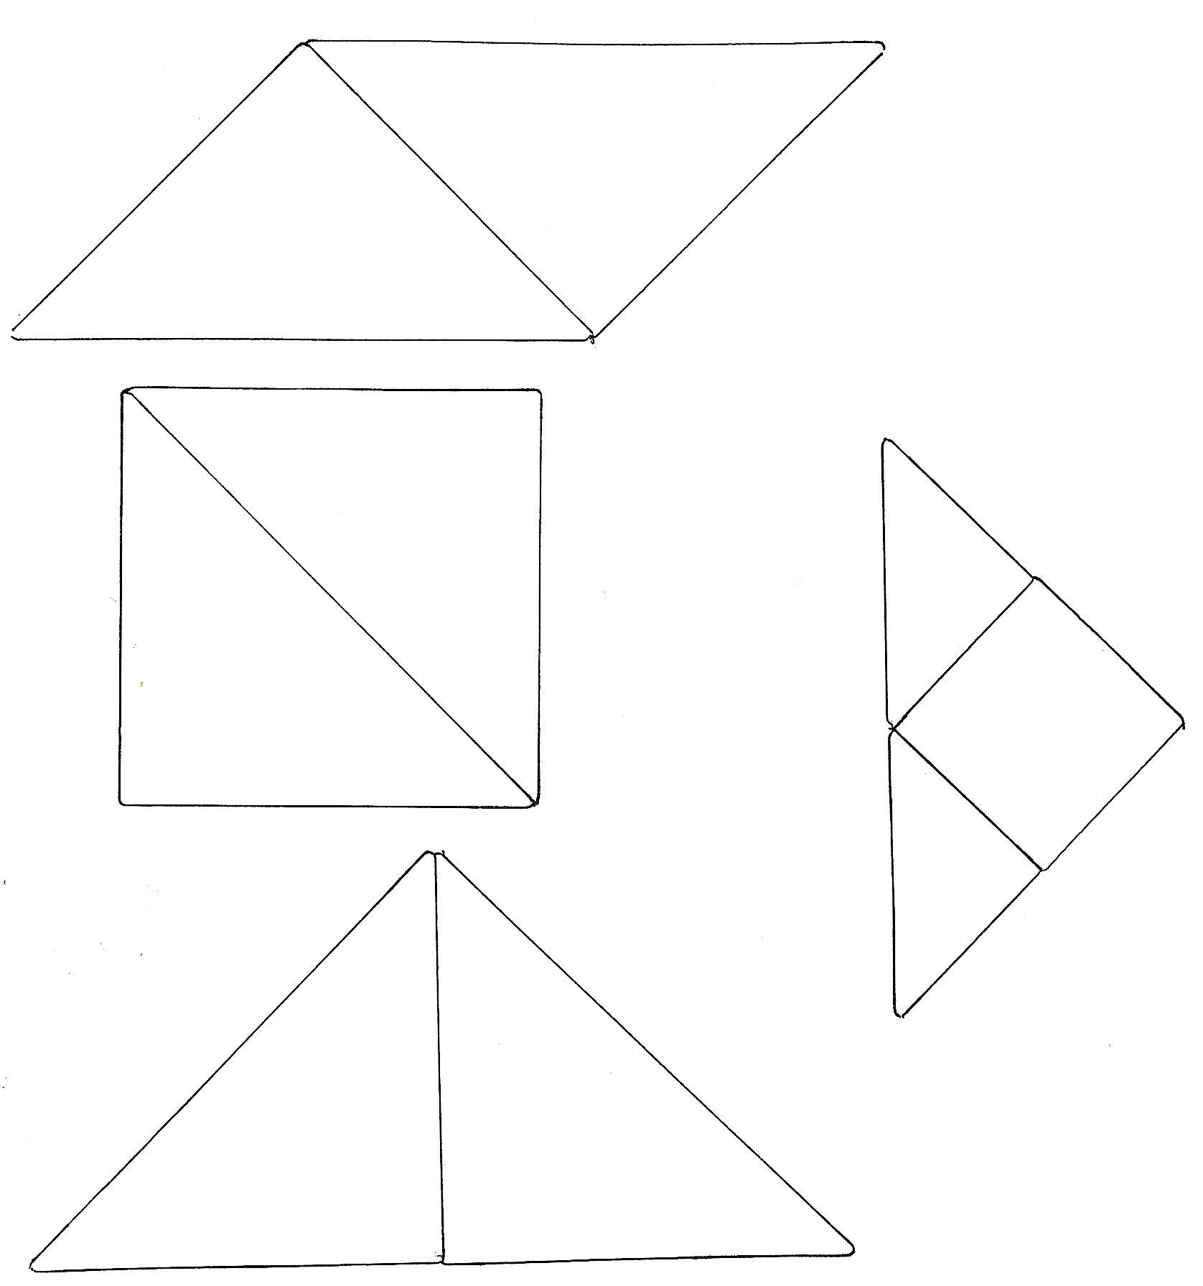

Allow time for students to explore ways to create new shapes. They do not have to be shapes that students can name. Remind students that they can flip, slide, and turn the pieces to make the new shapes.

Next, direct student pairs to create three shapes, a triangle, a square, and a parallelogram with no square corners (as pictured to the right), using the two largest triangles. After creating the shapes, students should draw them on their personal boards. Circulate to check for understanding, and encourage students to persevere, providing the least direction possible.

Have students gather their square and the two smallest triangles and move to the carpet.

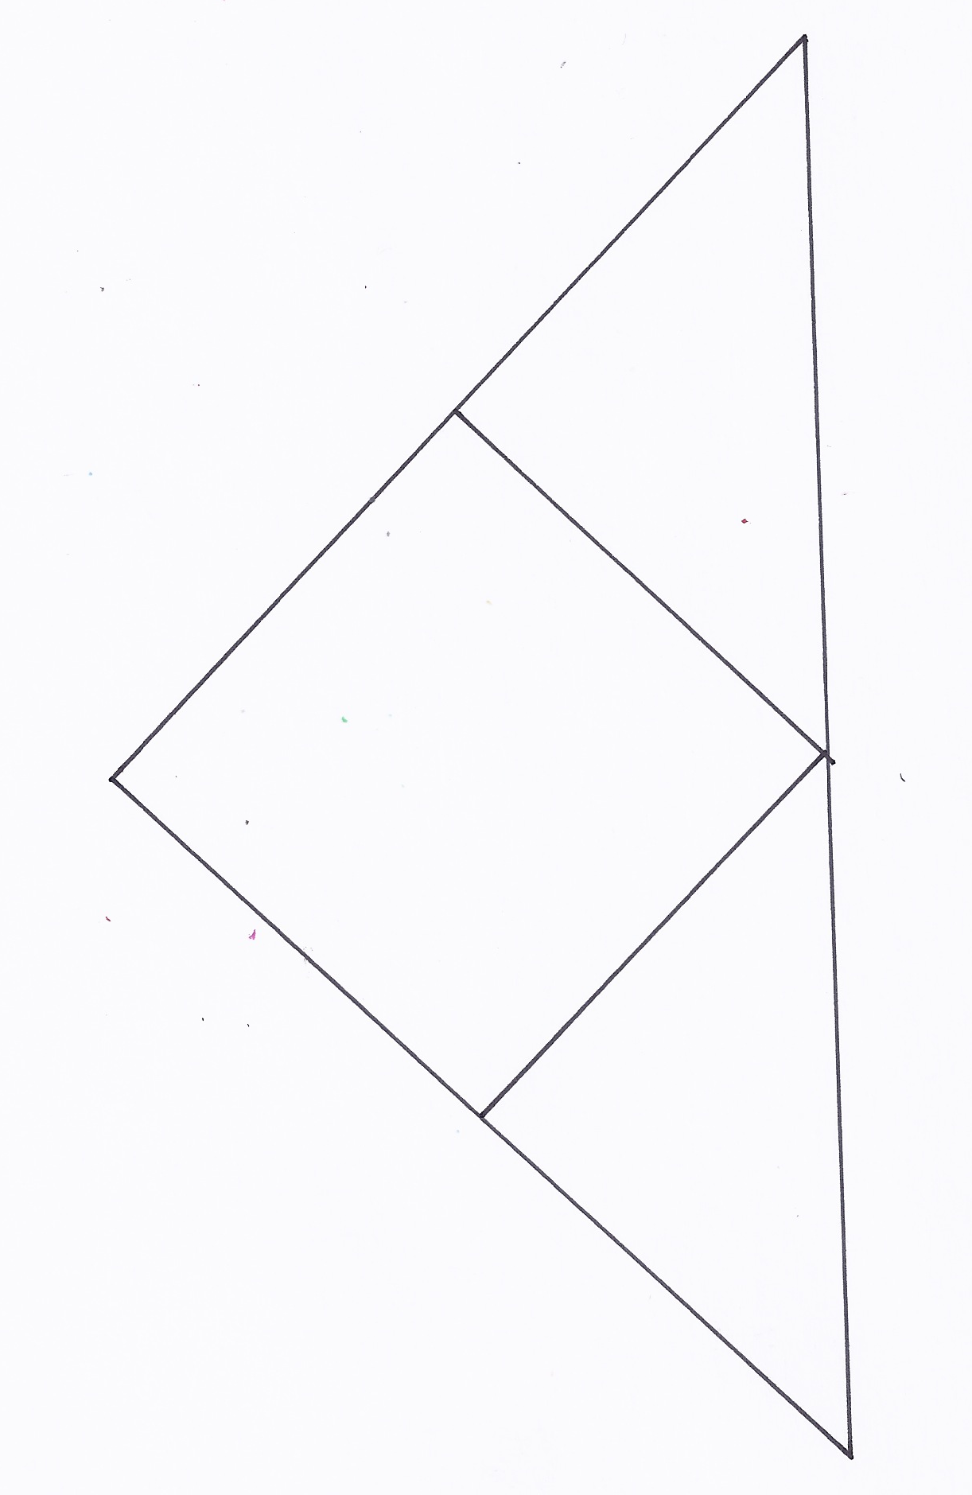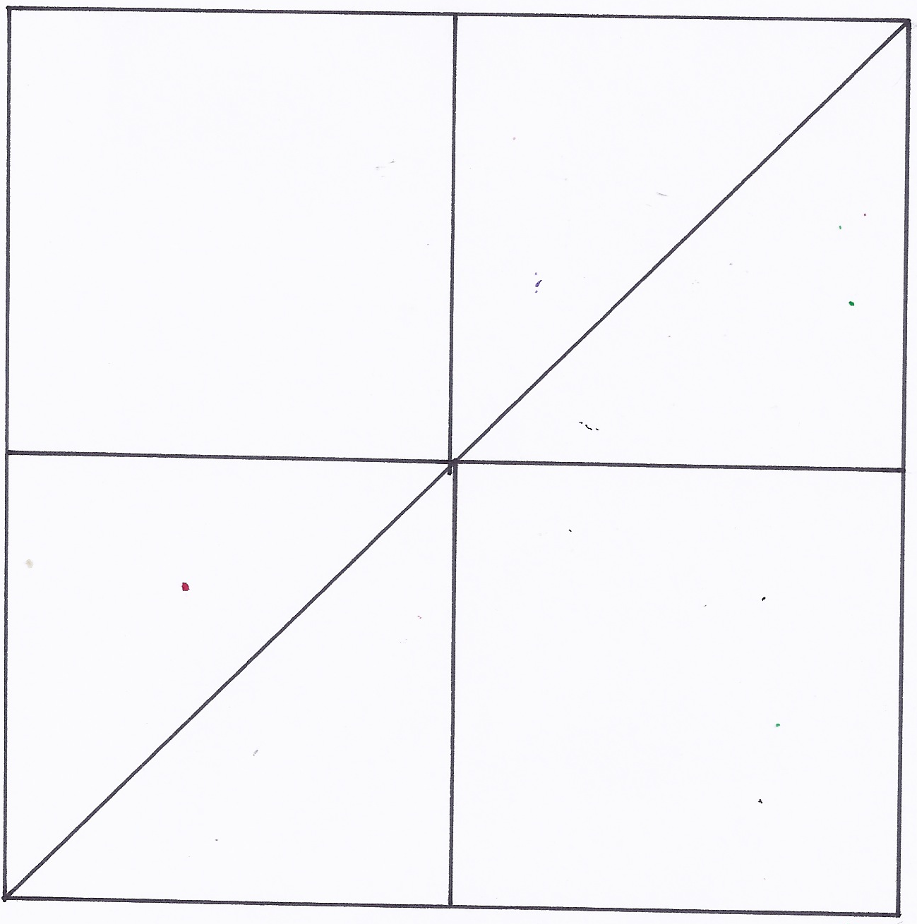

T: Try this! Can you create a triangle out of a square and the two smallest triangles? (Allow students time to work.)

T: Now, combine the triangle you just made with your partner’s to make a square. (Allow students time to work.)

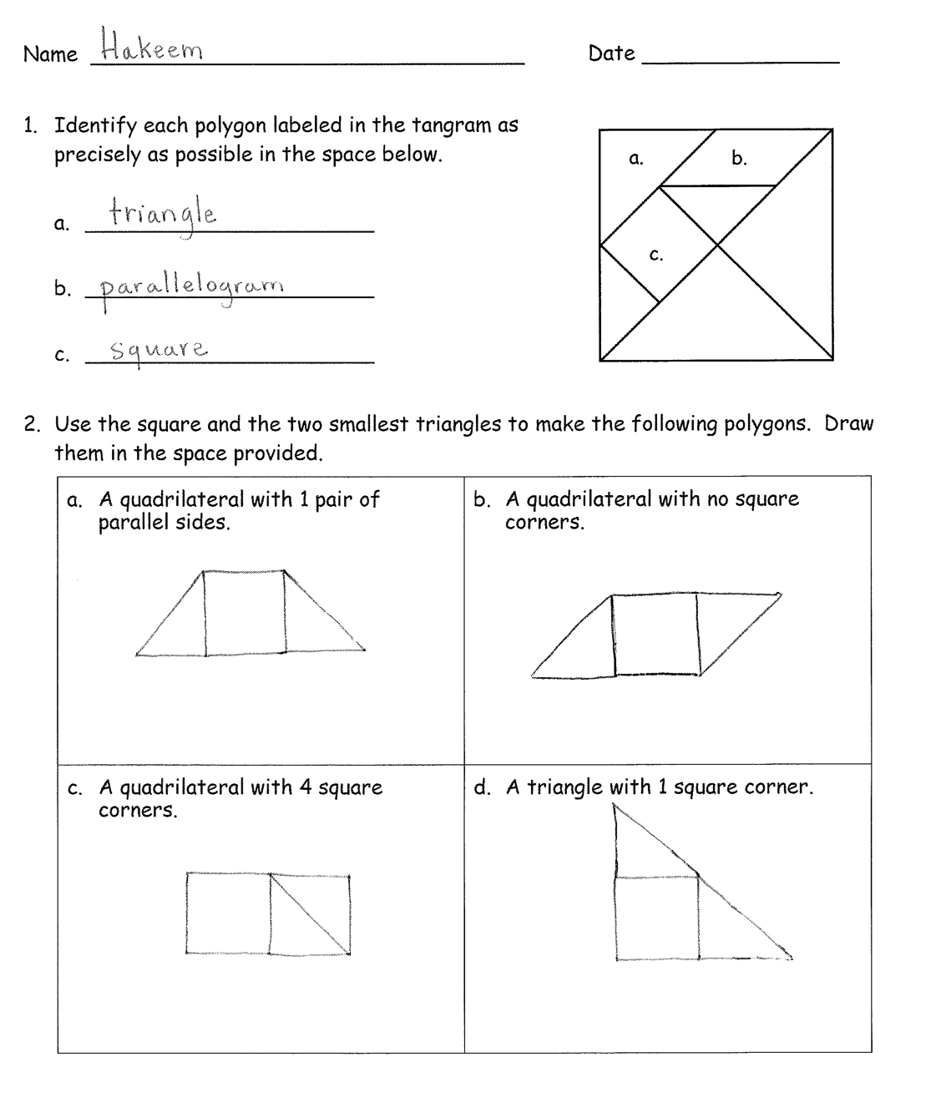T: Is it possible for us to make a really big square with all of the squares you just made?

S: I think so. Let’s try! 🡪 I don’t think we have enough.

T: Let’s try. (Allow time for students to make the attempt. Ability to make a square will depend on the number of students in the class. If it is not possible to make a square, ask what shape could be made, and allow time to make a rectangle.)

Problem Set (10 minutes)

Students should do their personal best to complete the Problem Set within the allotted 10 minutes. For some classes, it may be appropriate to modify the assignment by specifying which problems they work on first. Some problems do not specify a method for solving. Students solve these problems using the RDW approach used for Application Problems.

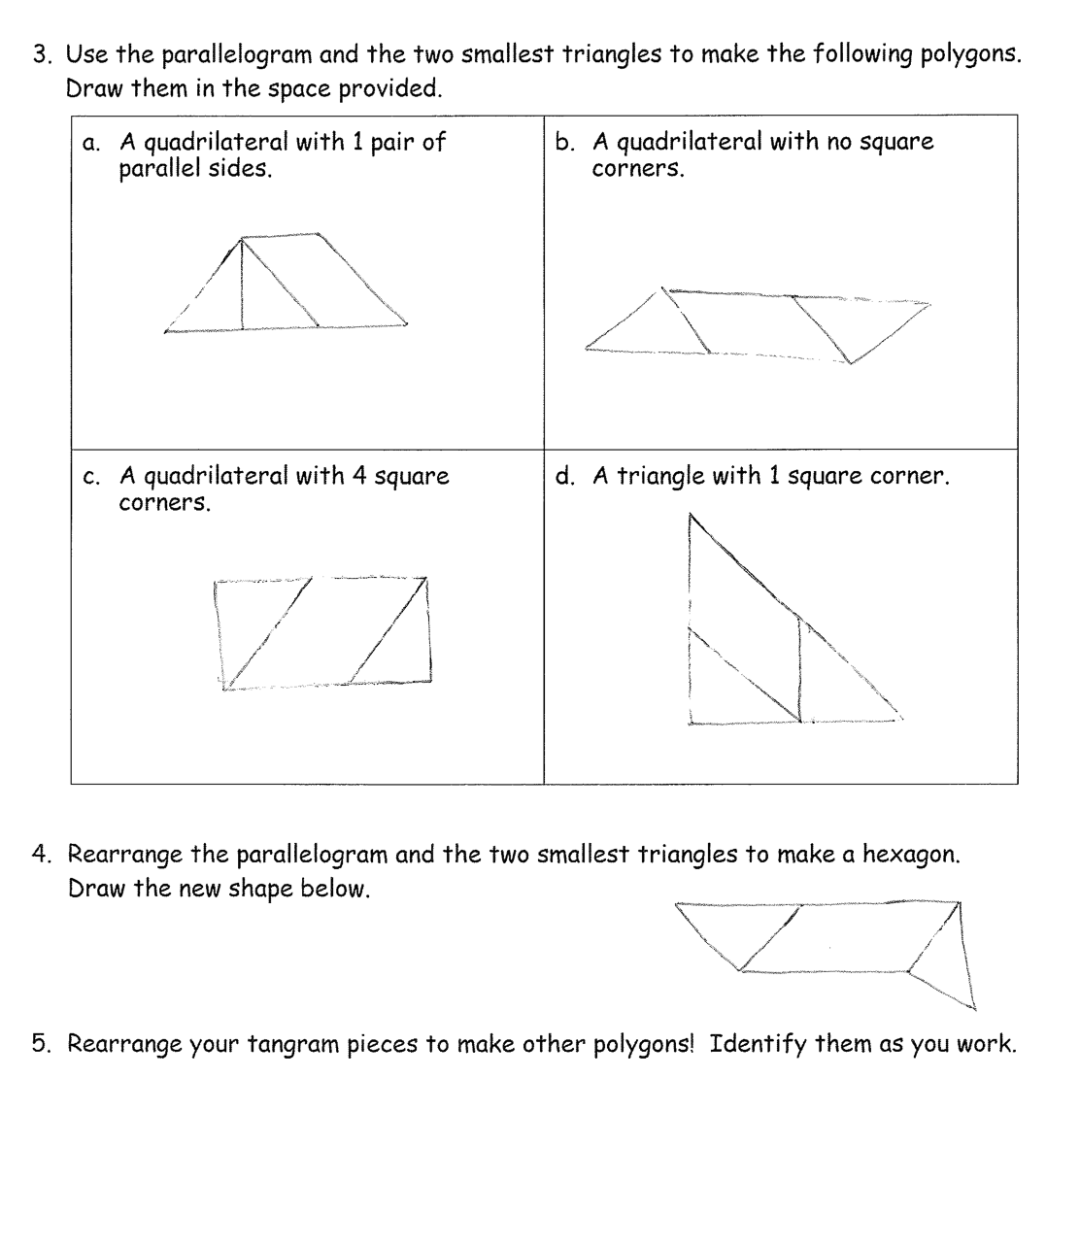Note: Challenge early finishers to reassemble the tangram.

Student Debrief (10 minutes)

**Lesson Objective:** Combine shapes to create a composite shape; create a new shape from composite shapes.

The Student Debrief is intended to invite reflection and active processing of the total lesson experience.

Invite students to review their solutions for the Problem Set. They should check work by comparing answers with a partner before going over answers as a class. Look for misconceptions or misunderstandings that can be addressed in the Debrief. Guide students in a conversation to debrief the Problem Set and process the lesson.

You may choose to use any combination of the questions below to lead the discussion.

* Share the polygons you made in Problem 5 with your partner. Describe the attributes of each polygon.
* Why do you think we used tangrams for this lesson?
* Can you think of any real world objects that are made up of lots of smaller shapes? (Provide an example to get students started if needed: tile floor, window blinds, chain-link fence, Legos, brick wall.)
* How is breaking big shapes into smaller shapes kind of like decomposing numbers? Pennies and dimes? Centimeters and meters?

|  |  |
| --- | --- |
|  | NOTES ON  MULTIPLE MEANS OF ACTION AND EXPRESSION: |

Challenge above grade level students by asking them to reconstruct the original square using the seven tangram pieces. A further challenge would be for them to use all seven pieces to make one large rectangle.

* Are all squares parallelograms? How can you prove that? Are all parallelograms squares?
* How is Frank and Josie’s tower of cubes from the Application Problem similar to what we did today?

Exit Ticket (3 minutes)

After the Student Debrief, instruct students to complete the Exit Ticket. A review of their work will help you assess the students’ understanding of the concepts that were presented in the lesson today and plan more effectively for future lessons. You may read the questions aloud to the students.





Name Date

1. Identify each polygon labeled in the tangram as precisely as possible in the space below.

a.

b.

* 1. ______________________

c.

1. ______________________
2. ______________________
3. Use the square and the two smallest triangles to make the following polygons. Draw them in the space provided.

|  |  |
| --- | --- |
| 1. A quadrilateral with 1 pair of parallel sides. | 1. A quadrilateral with no square corners. |
| 1. A quadrilateral with 4 square corners. | 1. A triangle with 1 square corner. |

1. Use the parallelogram and the two smallest triangles to make the following polygons. Draw them in the space provided.

|  |  |
| --- | --- |
| 1. A quadrilateral with 1 pair of parallel sides. | 1. A quadrilateral with no square corners. |
| 1. A quadrilateral with 4 square corners. | 1. A triangle with 1 square corner. |

1. Rearrange the parallelogram and the two smallest triangles to make a hexagon.  
   Draw the new shape below.
2. Rearrange your tangram pieces to make other polygons! Identify them as you work.

Name Date

Use your tangram pieces to make two new polygons. Draw a picture, and identify them.

|  |
| --- |
| 1. |
| 2. |

Name Date

* 1. Identify each polygon labeled in the tangram as precisely as possible in the space below.

b.

a.

* 1. ______________________
  2. ______________________

c.

* 1. ______________________

1. Use the square and the two smallest triangles to make the following polygons. Draw them in the space provided.

|  |  |
| --- | --- |
| * 1. A triangle with 1 square corner. | * 1. A quadrilateral with 4 square corners. |
| * 1. A quadrilateral with no square corners. | * 1. A quadrilateral with only 1 pair of parallel sides. |

1. Rearrange the parallelogram and the two smallest triangles to make a hexagon.  
   Draw the new shape below.
2. Rearrange your tangram pieces to make at least 6 other polygons! Draw and identify your favorites below.

|  |  |
| --- | --- |
|  |  |
|  |  |
|  |  |

Cut out the tangram into 7 puzzle pieces.

