Lesson 26
Objective: Draw a line plot to represent a given data set; answer questions and draw conclusions based on measurement data.

Suggested Lesson Structure
 Fluency Practice (12 minutes)
 Application Problem (6 minutes)
 Concept Development (32 minutes)
 Student Debrief (10 minutes)
Total Time (60 minutes)
Fluency Practice (12 minutes)
- Making the Next Hundred 2.NBT.5, 2.NBT.7 (3 minutes)
- Making the Next Hundred to Add 2.NBT.5, 2.NBT.7 (4 minutes)
- Grade 2 Core Fluency Differentiated Practice Sets 2.OA.2 (5 minutes)
Making the Next Hundred (3 minutes)
Note: This fluency activity reviews foundations that lead into today’s lesson.
T: (Post 170 + ___ = 200 on the board.) Let’s find missing parts to make the next hundred.
If I say 170, you would say 30. Ready? 170.
S: 30.
T: Give the number sentence.
S: 170 + 30 = 200.
Continue with the following possible sequence: 190, 160, 260, 270, 370, 380, 580, 620, 720, 740, 940, 194, 196, 216, 214, and 224.
Making the Next Hundred to Add (4 minutes)
Note: This fluency activity reviews foundations that lead into today’s lesson.
Post on board:

90 + 40 = _____
/\
10 30

100 + 30 = _____
T: When I say 9 tens + 4 tens, you say 10 tens + 3 tens. Ready?
9 tens + 4 tens.
S: 10 tens + 3 tens.
T: Answer.
S: 130.
T: 90 + 40.
S: 130.
Continue with the following possible sequence: 19 tens + 4 tens, 29 tens + 4 tens, 29 tens + 14 tens, 9 tens + 6 tens, 19 tens + 6 tens, 19 tens + 16 tens, 29 tens + 16 tens, 8 tens + 3 tens, 18 tens + 3 tens, 18 tens + 13 tens, 28 tens + 13 tens, 8 tens + 5 tens, 18 tens + 15 tens, and 28 tens + 15 tens.
Grade 2 Core Fluency Differentiated Practice Sets (5 minutes)
Materials: (S) Core Fluency Practice Sets (Lesson 1 Core Fluency Practice Sets)
Note: During Topic F and for the remainder of the year, each day’s Fluency Practice includes an opportunity for review and mastery of the sums and differences with totals through 20 by means of the Core Fluency Practice Sets or Sprints. The process is detailed and Practice Sets are provided in Lesson 1.
Application Problem (6 minutes)
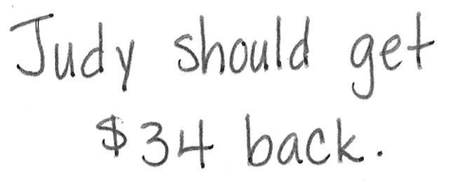
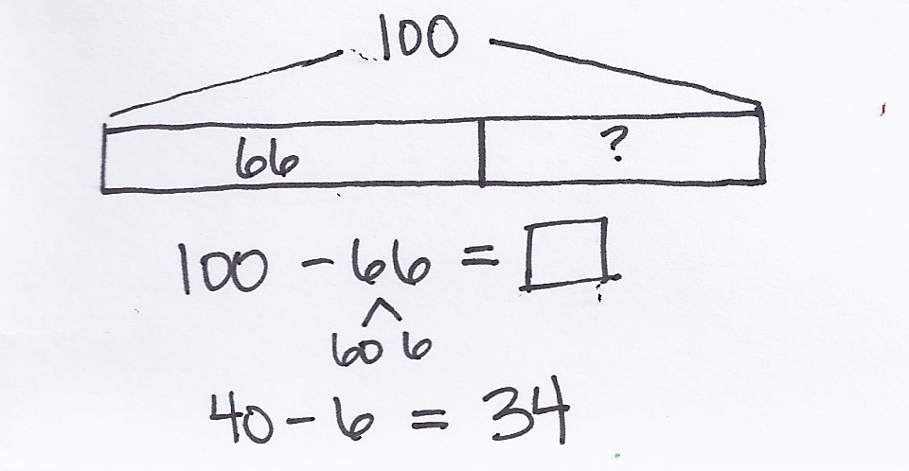
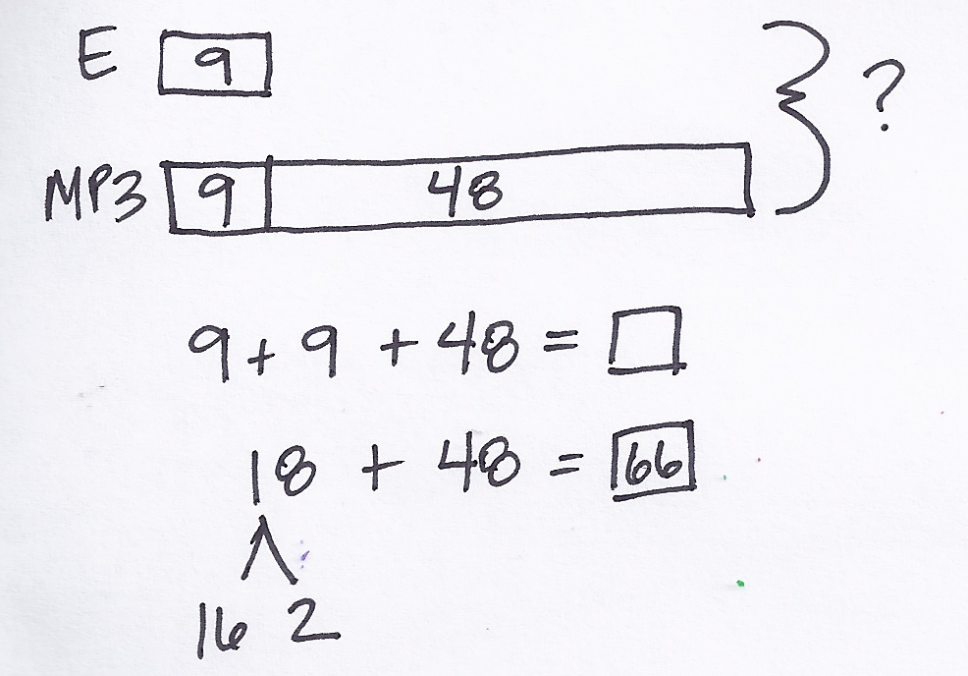
Judy bought an MP3 player and a set of earphones. The earphones cost $9, which is $48 less than the MP3 player. How much change should Judy get back if she gave the cashier a $100 bill?

Note: This two-step problem encourages students once again to use the RDW process and make a tape diagram to visualize the relationships within the problem and correctly identify the question being asked.
Concept Development (32 minutes)
Materials: (T/S) Length and temperature tables (Template 1), 2 pieces of grid paper (Template 2), thermometer (Template 3), ruler
Project or draw the length table from the length and temperature Template, as shown on the next page.

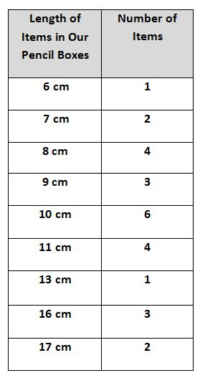
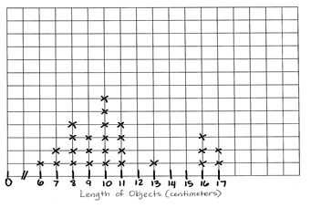
Part 1: Plot the length of items in our pencil boxes.

NOTES ON
MULTIPLE MEANS
OF ACTION AND EXPRESSION:
Encourage students who have trouble measuring objects to first draw a line the length of the object using the object as a guide and then use a ruler to measure the line.
Length of Objects in Our Pencil Boxes
The students in Mrs. Washington’s class each chose an item from her pencil box and measured its length. The table shows their results.
T: (Read the scenario, and then pass out the grid paper Template and rulers.) Let’s create a line plot to display this data.
T: Talk with your partner: What do we need to draw?
S: A number line!
T: Turn your paper horizontally, and let’s use rulers to draw a straight line. (Draw a line across the bottom of the paper as students do the same.)
MP.6
T: Let’s write 0 at the beginning of our scale and then put two diagonal hash marks between that and the next hash mark. (Model as students do the same.)
T: What’s the smallest length measurement in our data set?
S: 6 centimeters.
T: Write 6 below the hash mark that follows 0. (Model as students do the same.)
T: Remember, the double hash mark means that the numbers between 0 and 6 are not shown on the scale.
T: What is the greatest measurement in our data set?
S: 17 centimeters.
T: Yes. So, our number line needs to continue on to 17. Remember to draw the hash marks on the count scale where the gridlines meet. (Model as students do the same.)
T: We label our scale based on the measurement tool used. Look at the table. What is the measurement unit?
S: Centimeters!
T: Yes, so let’s label that. (Write Length of Objects (centimeters) as students do the same.)
T: Talk with your partner: What do we do now?
S: We have to show the data. We need to record the data by putting Xs above the number line.
T: Go ahead and record the data. (Circulate and provide support as students work.)
T: Check your line plot with a partner. Do you have the same number of Xs for each measurement? (Allow students time to compare.)
T: Now, let’s use our line plots to answer questions about the data. (The following is a list of suggestions.)

NOTES ON
MULTIPLE MEANS
OF ENGAGEMENT:
Scaffold the lesson for students working below grade level by placing the grid paper in their personal white boards. This allows students to practice marking the right number of Xs onto the number line. Make sure they are transferring the data accurately by watching and asking questions as necessary: “How many items measured 10 cm? How many Xs will you place above the 10 cm marker on the number line?”
- What observations can you make about the data?
- What measurement occurred most often?
- What is the difference between the smallest measurement and the greatest measurement?
- Do you think the data would look different if the students each chose a different item in their pencil box to measure? Why?
Part 2: Plot temperatures in May.
Project or draw the temperature table from the length and temperature Template, as shown to the right.
Mr. Enriquez’s class measured the temperature each day during the month of May. The table shows the results.
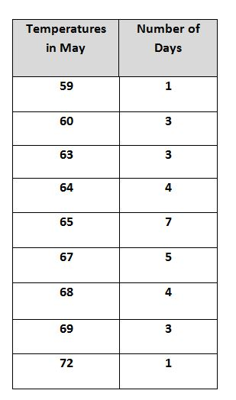
T: (Read the scenario, and then show the thermometer Template.) Talk with your partner: Have you ever seen a thermometer before? What does this tool measure?
S: My mom and dad use a thermometer to take my temperature when I’m sick. When you send me to the nurse, she takes my temperature. The problem is talking about weather like when you watch the weather on TV.
You use a thermometer to know how hot or cold it is outside.
T: Yes, a thermometer is a tool that measures temperature.
T: We measure temperature in degrees, so today, for example, it’s ___ (insert today’s actual temperature) degrees outside.
T: Look at this thermometer and talk with your partner. What do you notice about the count scale?
S: The numbers are vertical, not horizontal!
T: Yes! Watch how I start the scale. (Model where to write the 0 and the double hash marks.)
T: Talk with your partner: Where will you mark the data points?
S: We have to put the Xs next to the numbers. This time, the number line will be vertical, and the Xs will be horizontal.
T: Correct! Now, use the table to make a line plot of the temperatures during the month of May.
T: Remember to label it. (Circulate and provide support while students work.)
T: Now, check your line plot with a partner. Did you have the same start point and endpoint? How did you label your plot? How many Xs did you mark for each degree?
S: (Check and compare line plots for essential elements.)
Temperatures in May
T: Let’s use our line plots to answer questions about the data. (The following is a list of suggestions.)
- What observations can you make about the data?
- Which temperature occurred most often?
- Which temperatures occurred least often?
- What is the difference between the highest temperature and the lowest temperature?
- How would a line plot recording data look next month? In a different season?
As students demonstrate proficiency creating and interpreting line plots, allow them to move on to the Problem Set.
Problem Set (10 minutes)
Students should do their personal best to complete the Problem Set within the allotted 10 minutes. For some classes, it may be appropriate to modify the assignment by specifying which problems they work on first. Some problems do not specify a method for solving. Students should solve these problems using the RDW approach used for Application Problems.
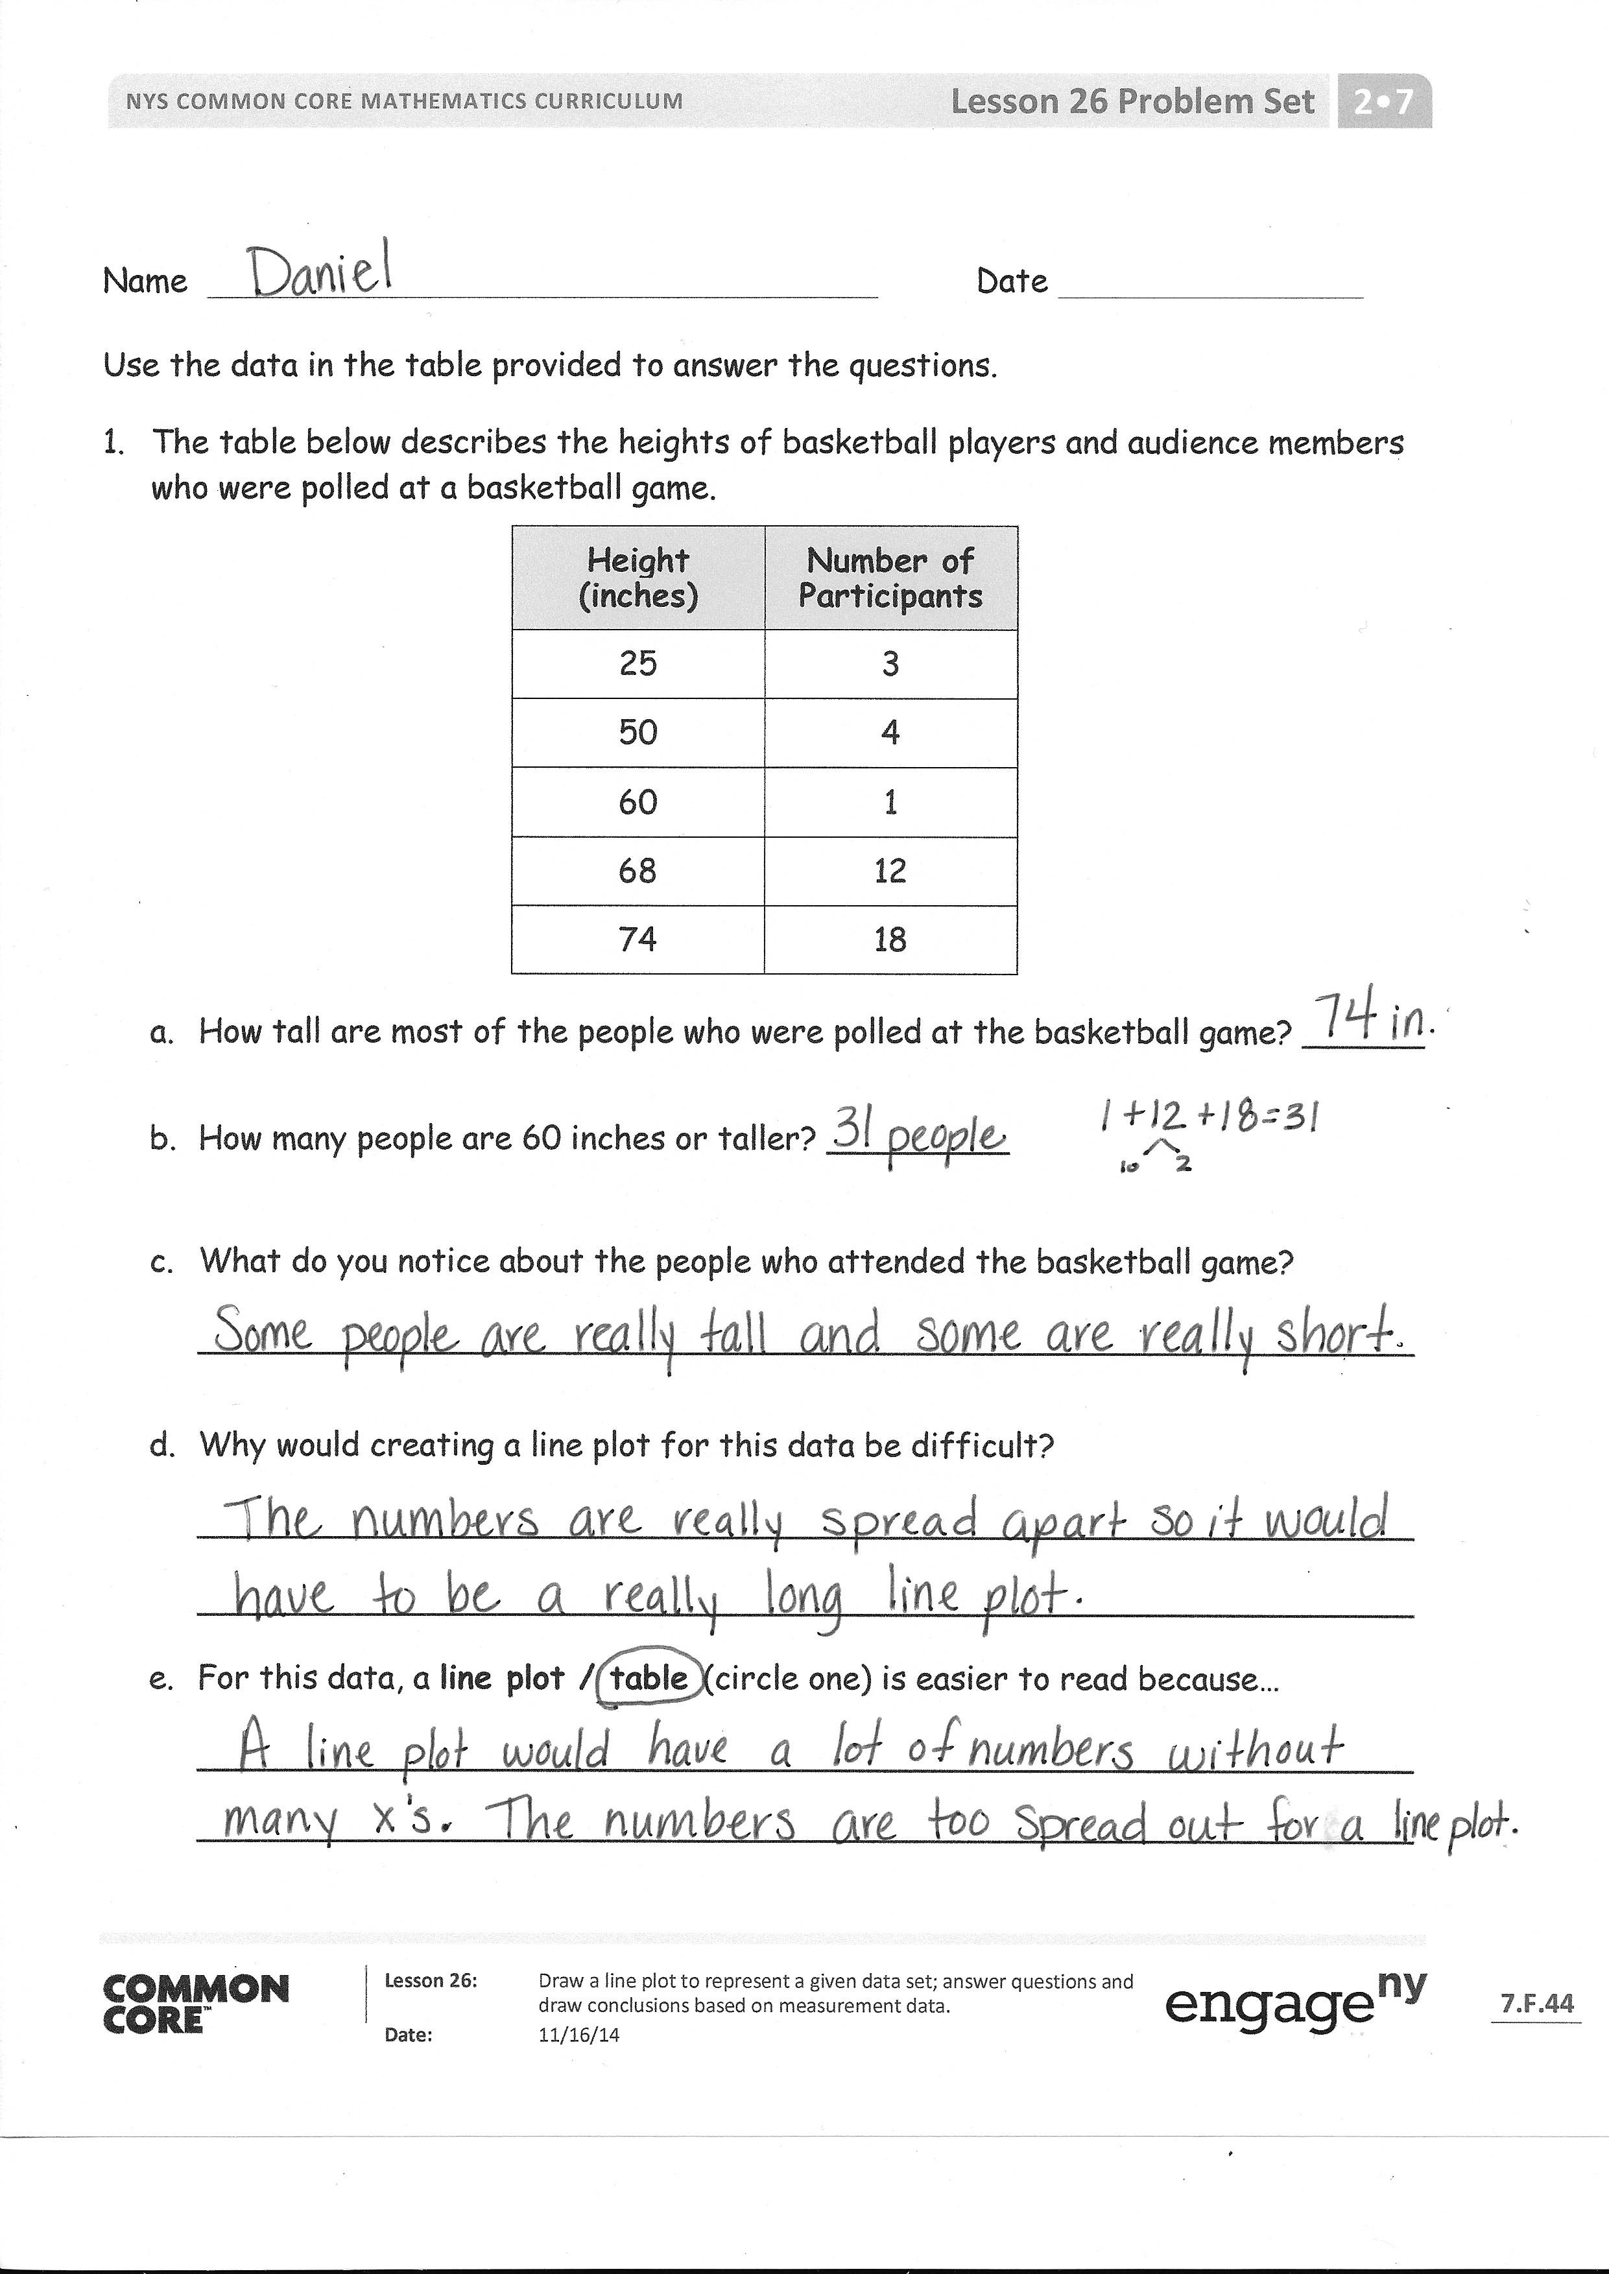
Student Debrief (10 minutes)
Lesson Objective: Draw a line plot to represent a given data set; answer questions and draw conclusions based on measurement data.
The Student Debrief is intended to invite reflection and active processing of the total lesson experience.
Invite students to review their solutions for the Problem Set. They should check work by comparing answers with a partner before going over answers as a class. Look for misconceptions or misunderstandings that can be addressed in the Debrief. Guide students in a conversation to debrief the Problem Set and process the lesson.
Any combination of the questions below may be used to lead the discussion.
- Look at the table made at a basketball game. If you had to guess how many basketball players and how many audience members there were, how would you make the groups based on the data in the chart?
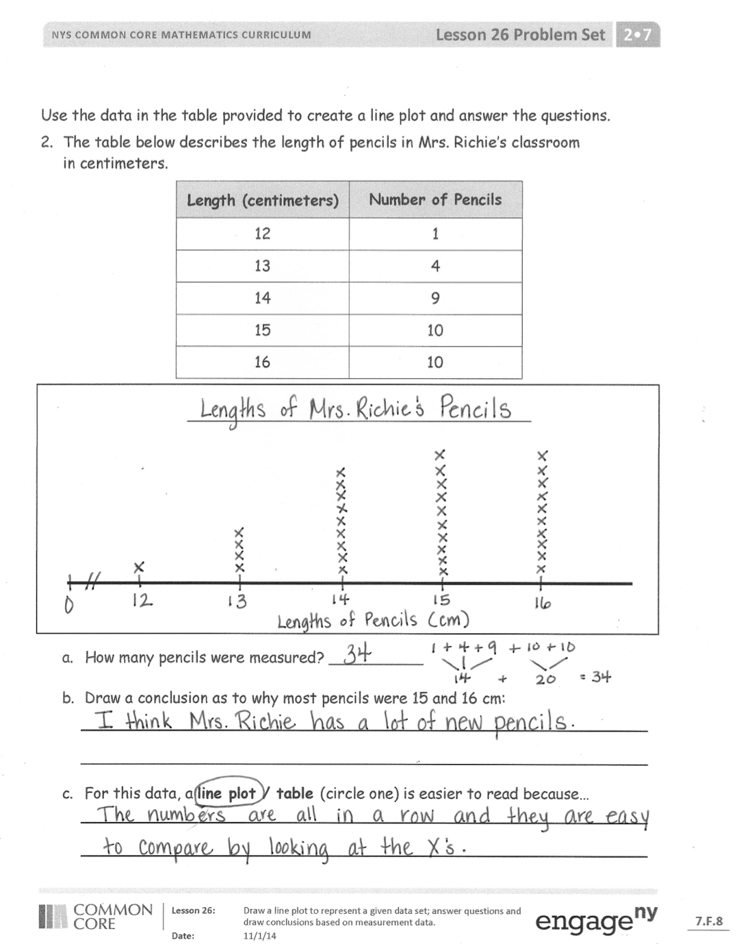
- Look at the pencil table on your Problem Set. Share with your partner why you thought so many pencils were 15 cm or 16 cm.
- Why did all of our line plots in today’s lesson about the pencil box items look the same? (The whole class recorded the same data.)
- Can we make line plots horizontally and vertically? Does it change the data in any way? Talk to your partner about when you would use each. Why?
- Discuss with your partner a time in your life when you would need or want to organize information in a table or a line plot. How would it help you or make your life easier?
Exit Ticket (3 minutes)
After the Student Debrief, instruct students to complete the Exit Ticket. A review of their work will help with assessing students’ understanding of the concepts that were presented in today’s lesson and planning more effectively for future lessons. The questions may be read aloud to the students.

Name Date
Use the data in the table provided to answer the questions.
- The table below describes the heights of basketball players and audience members who were polled at a basketball game.
Height (inches) | Number of Participants
25 | 3
50 | 4
60 | 1
68 | 12
74 | 18
- How tall are most of the people who were polled at the basketball game? ____________
- How many people are 60 inches or taller? _______________
- What do you notice about the people who attended the basketball game?
____________________________________________________________
- Why would creating a line plot for this data be difficult?
____________________________________________________________
____________________________________________________________
- For this data, a line plot / table (circle one) is easier to read because…
____________________________________________________________
____________________________________________________________
Use the data in the table provided to create a line plot and answer the questions.
- The table below describes the length of pencils in Mrs. Richie’s classroom
in centimeters.
Length (centimeters) | Number of Pencils
12 | 1
13 | 4
14 | 9
15 | 10
16 | 10
__________________________________________________

- How many pencils were measured? __________
- Draw a conclusion as to why most pencils were 15 and 16 cm:
____________________________________________________________
____________________________________________________________
- For this data, a line plot / table (circle one) is easier to read because…
____________________________________________________________
____________________________________________________________
Name Date
Use the data in the table provided to create a line plot.
The table below describes the heights of second-grade students on the soccer team.
Height (inches) | Number of Students
35 | 3
36 | 4
37 | 7
38 | 8
39 | 6
40 | 5

__________________________________________________

Name Date
Use the data in the table provided to create a line plot and answer the questions.
Plot only the lengths of shoelaces given.
- The table below describes the lengths of student shoelaces in Ms. Henry’s class.
Length of Shoelaces (inches) | Number of Shoelaces
27 | 6
36 | 10
38 | 9
40 | 3
45 | 2
__________________________________________________

- How many shoelaces were measured? ____________
- How many more shoelaces are 27 or 36 inches than 40 or 45 inches? ________
- Draw a conclusion as to why zero students had a 54-inch shoelace.
____________________________________________________________
- For this data, a line plot / table (circle one) is easier to read because…
_______________________________________________________________
Use the data in the table provided to create a line plot and answer questions.
- The table below describes the lengths of crayons in centimeters in Ms. Harrison’s crayon box.
Length (centimeters) | Number of Crayons
4 | 4
5 | 7
6 | 9
7 | 3
8 | 1

__________________________________________________

- How many crayons are in the box? __________
- Draw a conclusion as to why most of the crayons are 5 or 6 centimeters:
________________________________________________________________
________________________________________________________________
________________________________________________________________

Length of Items in Our Pencil Boxes | Number of Items
6 cm | 1
7 cm | 2
8 cm | 4
9 cm | 3
10 cm | 6
11 cm | 4
13 cm | 1
16 cm | 3
17 cm | 2
Temperatures in May | Number of Days
59 |  | 1
60 |  | 3
63 |  | 3
64 |  | 4
65 |  | 7
67 |  | 5
68 |  | 4
69 |  | 3
72 |  | 1

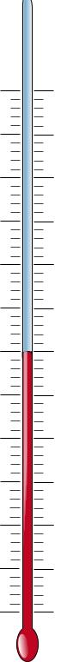

length and temperature tables
grid paper
thermometer

