Lesson 25
Objective: Draw a line plot to represent a given data set; answer questions and draw conclusions based on measurement data.

Suggested Lesson Structure
 Fluency Practice (10 minutes)
 Application Problem (7 minutes)
 Concept Development (33 minutes)
 Student Debrief (10 minutes)
Total Time (60 minutes)
Fluency Practice (10 minutes)
- Decomposition Tree 2.OA.2 (5 minutes)
- Grade 2 Core Fluency Differentiated Practice Sets 2.OA.2 (5 minutes)
Decomposition Tree (5 minutes)
Materials: (S) Decomposition tree (Lesson 6 Fluency Template)
Note: Students are given 90 seconds to decompose 36 inches.
T: (Distribute tree Template.)
T: You are going to break apart 36 inches on your Deco Tree for 90 seconds. Do as many problems as you can. Go!
S: (Work for 90 seconds.)
T: Now, exchange your tree with your partner and check each other’s work. (Allow students 30–45 seconds to check.)
T: Return each other’s papers. Did you see another way to make 36 inches on your partner’s paper? (Allow students to share for another 30 seconds.)
T: Turn your paper over. Let’s break apart 36 inches for another minute.
Grade 2 Core Fluency Differentiated Practice Sets (5 minutes)
Materials: (S) Core Fluency Practice Sets (Lesson 1 Core Fluency Practice Sets)
Note: During Topic F and for the remainder of the year, each day’s Fluency Practice includes an opportunity for review and mastery of the sums and differences with totals through 20 by means of the Core Fluency Practice Sets or Sprints. The process is detailed and Practice Sets are provided in Lesson 1.
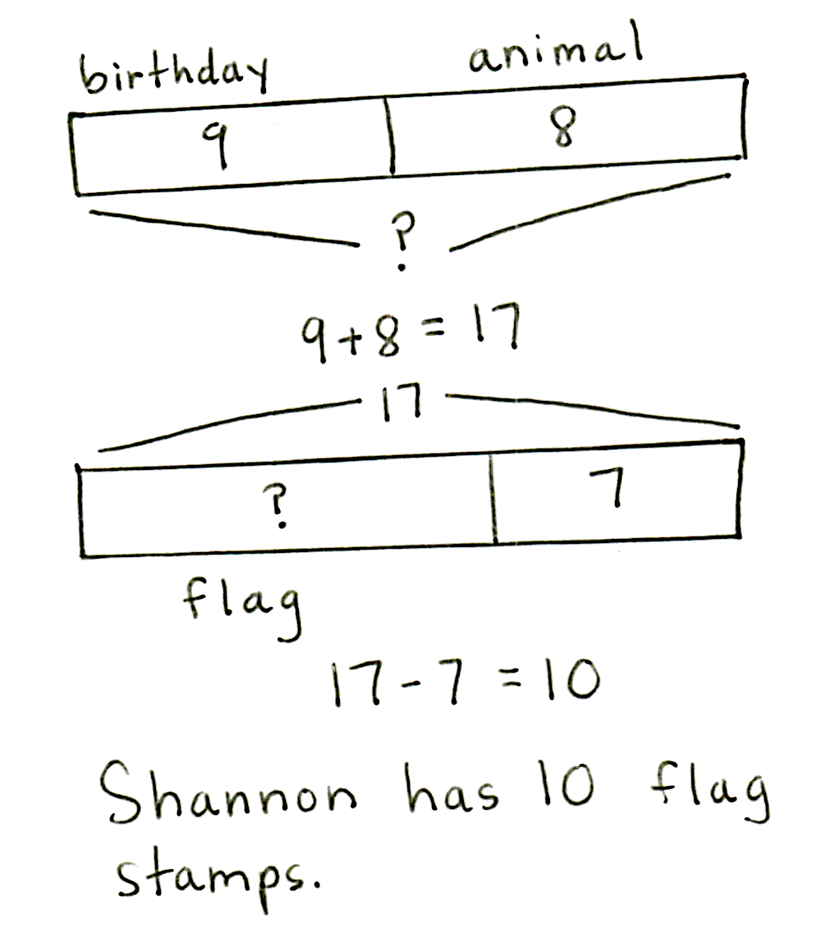
Application Problem (7 minutes)

NOTES ON
MULTIPLE MEANS
OF ACTION AND EXPRESSION:
The Application Problem can easily be extended for students working above grade level. Here are some examples:
- How many stamps does Shannon have altogether?
- What is the value of the holiday and the famous singers stamps?
- What is the value of all of Shannon’s stamps?
These are the types and numbers of stamps in Shannon’s stamp collection.
Type of Stamp | Number of Stamps
Holiday | 16
Animal | 8
Birthday | 9
Famous singers | 21
Her friend Michael gives her some flag stamps. If he gives her 7 fewer flag stamps than birthday and animal stamps together, how many flag stamps does she have?
Extension: If the flag stamps are worth 12 cents each, what is the total value of Shannon’s flag stamps?
Note: This two-step problem involves interpreting and comparing data using a table. Encourage students to use the RDW process and to draw a picture to visualize the fewer than situation.
Concept Development (33 minutes)
Materials: (T) Document camera to project tables and line plots
(S) Personal white board, centimeter grid paper
Height of Bean Plant (cm) | Number of Students
9 cm | 1
11 cm | 4
12 cm | 6
13 cm | 7
14 cm | 5
15 cm | 3
Project or show the Bean Plant data table, as shown to the right. Distribute one piece of grid paper per student.
Part 1: Plot measures of bean plant height.
The students in Mr. Shield’s science class are growing bean plants. After five days, they measured the height of their bean plants in centimeters. The table shows their results.
MP.4
T: (Read the scenario.) Let’s create a line plot to display this data.
T: Turn and talk: What do you need to draw?
S: A number line. X’s above a number line to show the data from the table. A number line that starts at 9 cm and ends at 15 cm.

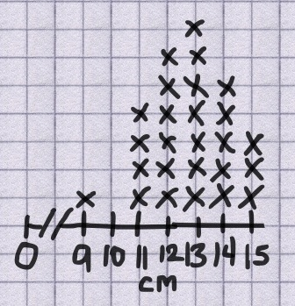
T: Great! Get to work! Use the table to draw your line plot on the grid paper, just like you did yesterday (as shown to the right). Don’t forget to label it.
MP.4

NOTES ON
MULTIPLE MEANS
OF ACTION AND EXPRESSION:
Support English language learners by pointing to visuals of key terms such as line plot, start point, endpoint, and intervals, if these are already on the word wall. If not, find visuals for the terms and post them as continued reference for English language learners during the lesson.
Bean Plant Height (cm)
T: (Circulate and provide support while students work.)
T: Check your line plot with a partner. Did you have the same start point and endpoint? How did you label? How many X’s did you draw for each height?
S: (Check and compare line plots for essential elements.)
T: Now, let’s use our line plots to answer questions about the data. (The following is a list of suggestions.)
- Which bean plant height occurred most often?
- What is the difference between the tallest and shortest bean plant? How do you know?
- How many students are in this science class?
- Are there any measurements outside the main grouping? Why might this have happened?
- What do you think would happen in five more days if we watered and gave extra vitamins to the plants?
T: Yes! Now, let’s look at data from students in a gym class. Here we go…
Part 2: Plot sit and reach distance.
Sit and Reach (Distance  in cm) | Number of Students
22 cm | 1
23 cm | 1
25 cm | 1
26 cm | 2
27 cm | 3
28 cm | 4
29 cm | 3
30 cm | 3
31 cm | 1
34 cm | 1
In gym class, Mrs. Rincon measured the students’ flexibility with the Sit and Reach test. The table shows how far the students were able to reach in centimeters.
T: (Read the scenario.) Go ahead and create a line plot to display the data.
S: (Draw line plot, as shown on next page.)
T: Check your line plot with a partner. Did you have the same start point and endpoint? How did you label your plot? How many X’s did you draw for each distance?
S: (Check and compare line plots for essential elements.)
T: Now, let’s use our line plots to answer questions about the data. (The following is a list of suggestions.)
- How many students were the most flexible?
- What was the difference between the longest and shortest sit and reach distance? How do you know?
- How many distances were reached by only one student?
Which distances?
- How many students can reach farther than 28 cm?
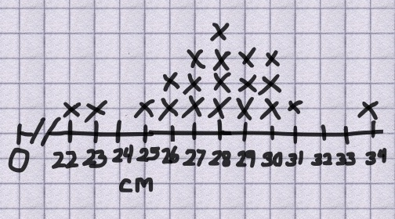
- Why aren’t 24 cm, 32 cm, and 33 cm listed in the table?
Sit and Reach Distance
- What did you do on the line plot?
- How might this data be different for third graders?
- What can we do to become more flexible? If we do those things, how might our data set change?
T: I heard some thoughtful responses today! You’re ready for the Problem Set.
Problem Set (10 minutes)
Students should do their personal best to complete the Problem Set within the allotted 10 minutes. For some classes, it may be appropriate to modify the assignment by specifying which problems they work on first. Some problems do not specify a method for solving. Students should solve these problems using the RDW approach used for Application Problems.
Student Debrief (10 minutes)
Lesson Objective: Draw a line plot to represent a given data set; answer questions and draw conclusions based on measurement data.
The Student Debrief is intended to invite reflection and active processing of the total lesson experience.
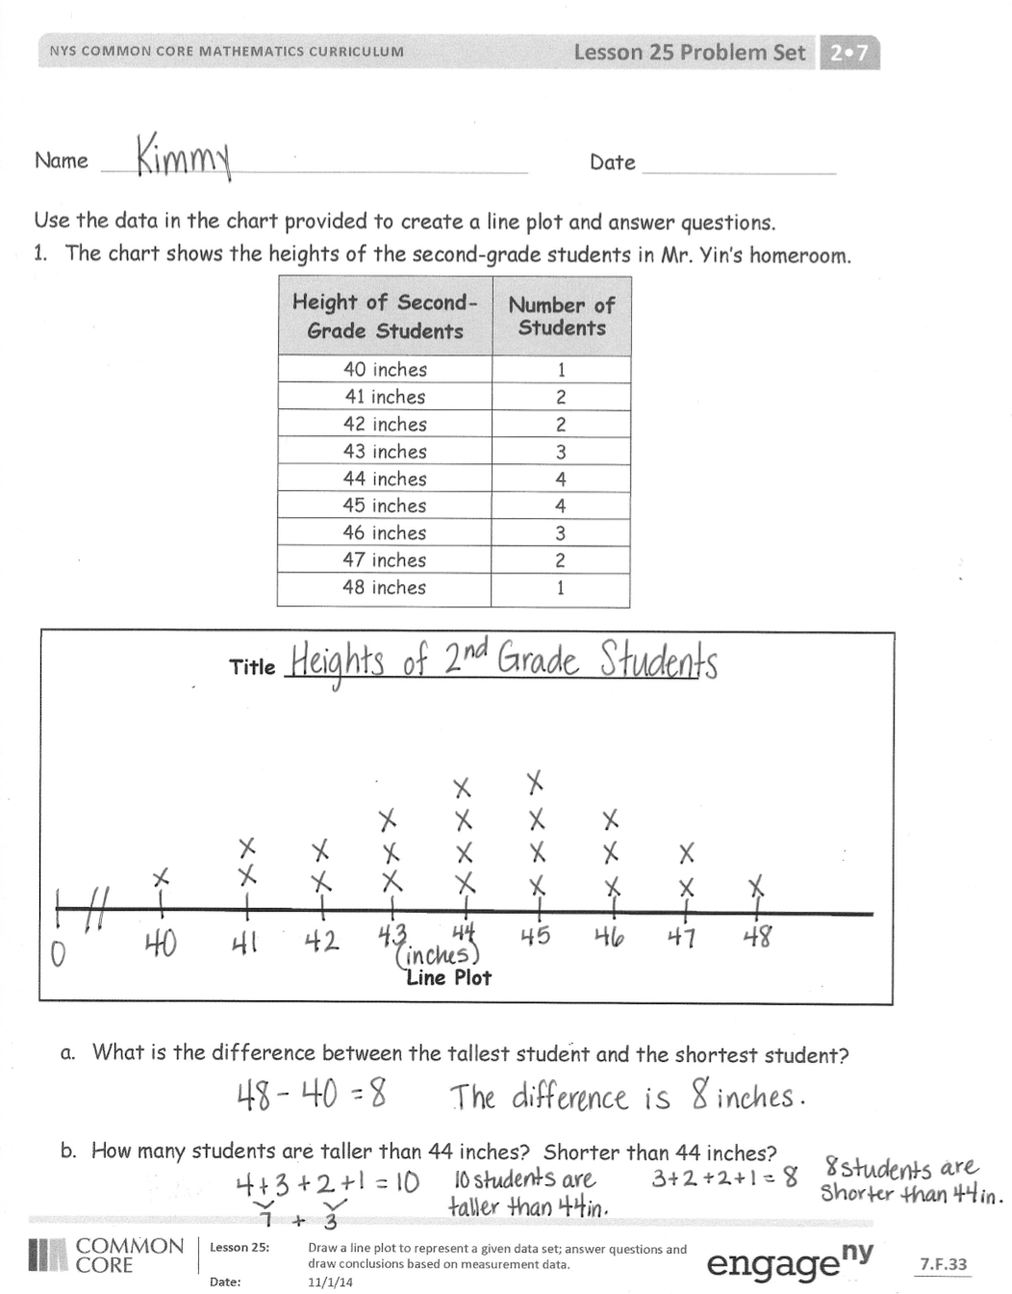
Invite students to review their solutions for the Problem Set. They should check work by comparing answers with a partner before going over answers as a class. Look for misconceptions or misunderstandings that can be addressed in the Debrief. Guide students in a conversation to debrief the Problem Set and process the lesson.
Any combination of the questions below may be used to lead the discussion.
- Look at the line plots on your Problem Set. What are the units of the heights in Mr. Yin’s class measured in? Is it important to label the line plot units? Why?
- What do you notice about the X’s on the first line plot with student heights and the X’s on the second-grade art paper line plot? (The first one is shaped like a curve, a small number of X’s on each end like a pattern. The second grade heights have more measurements than the second grade art paper line plot.) Why do you think this happened?
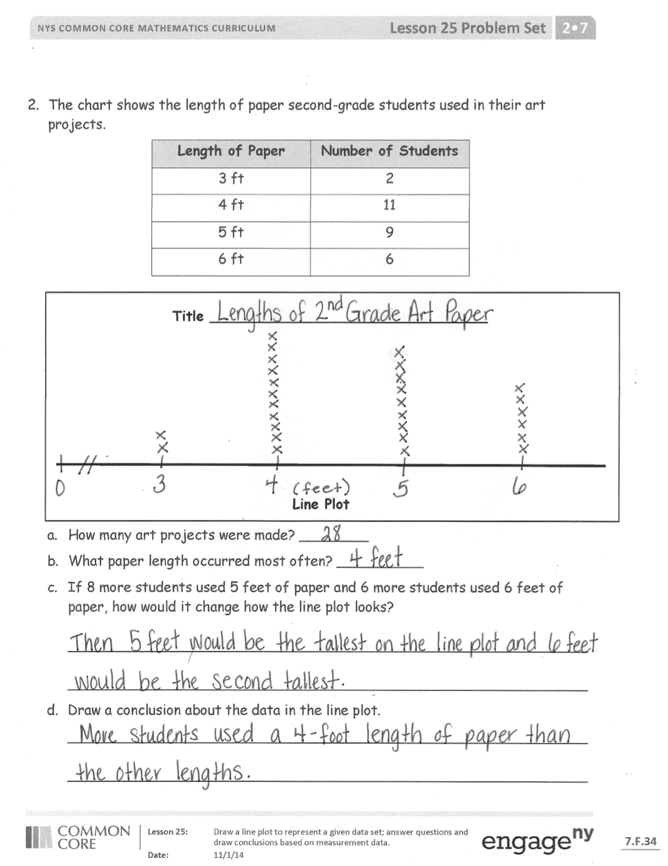
- Choose one line plot and ask your partner a question about the data that is not on the Problem Set.
- Explain to your partner why using tables and line plots are both important ways to look at data.
(A table is useful for organizing data, but a line plot allows for visual comparisons of the different quantities.)
Exit Ticket (3 minutes)
After the Student Debrief, instruct students to complete the Exit Ticket. A review of their work will help with assessing students’ understanding of the concepts that were presented in today’s lesson and planning more effectively for future lessons. The questions may be read aloud to the students.

Name Date
Use the data in the chart provided to create a line plot and answer questions.
- The chart shows the heights of the second-grade students in Mr. Yin’s homeroom.
Height of Second-Grade Students | Number of Students
40 inches | 1
41 inches | 2
42 inches | 2
43 inches | 3
44 inches | 4
45 inches | 4
46 inches | 3
47 inches | 2
48 inches | 1
Line Plot
Title ________________________________

- What is the difference between the tallest student and the shortest student?

- How many students are taller than 44 inches? Shorter than 44 inches?
- The chart shows the length of paper second-grade students used in their art projects.
Length of Paper | Number of Students
3 ft | 2
4 ft | 11
5 ft | 9
6 ft | 6
Line Plot
Title ________________________________

- How many art projects were made? ________
- What paper length occurred most often? __________
- If 8 more students used 5 feet of paper and 6 more students used 6 feet of paper, how would it change how the line plot looks?
____________________________________________________________
____________________________________________________________
- Draw a conclusion about the data in the line plot.
____________________________________________________________
____________________________________________________________

Name Date
Answer the questions using the line plot below.
Number of Students in Each Grade at the School Baseball Game
X
X
X
X
X
X
X
X
X
X
X
X

X
X
X
X
X
X
X
X
X

X
X
X
X
X
X
X

X
X
X

X
X
X
X

X
X
X
X

Second Grade
Fifth Grade
Third Grade
Fourth Grade
Kindergarten
First Grade

Grade
- How many students went to the baseball game? ____________

- What is the difference between the number of first-grade students and the number of fourth-grade students who went to the baseball game? _________

- Come up with a possible explanation for why most of the students who attended are in the upper grades. ____________________________________________________________
____________________________________________________________

Name Date
Use the data in the charts provided to create line plots and answer questions.
- The chart shows the lengths of the necklaces made in arts and crafts class.
Length of Necklaces | Number of Necklaces
16 inches | 3
17 inches | 0
18 inches | 4
19 inches | 0
20 inches | 8
21 inches | 0
22 inches | 9
23 inches | 0
24 inches | 16

Line Plot
Title ________________________________

- How many necklaces were made? ___________

- Draw a conclusion about the data in the line plot:

____________________________________________________________
- The chart shows the heights of towers students made with blocks.
Height of Towers | Number of Towers
15 inches | 9
16 inches | 6
17 inches | 2
18 inches | 1
Line Plot
Title ________________________________

- How many towers were measured? __________
- What tower height occurred most often? __________
- If 4 more towers were measured at 17 inches and 5 more towers were measured at 18 inches, how would it change how the line plot looks?
____________________________________________________________
____________________________________________________________
- Draw a conclusion about the data in the line plot:
___________________________________________________________
____________________________________________________________

