Lesson 24
Objective: Draw a line plot to represent the measurement data; relate the measurement scale to the number line.

Suggested Lesson Structure
 Fluency Practice (11 minutes)
 Application Problem (7 minutes)
 Concept Development (32 minutes)
 Student Debrief (10 minutes)
Total Time (60 minutes)
Fluency Practice (11 minutes)
- Find the Difference 2.NBT.5 (2 minutes)
- Sprint: Subtraction Patterns 2.OA.2, 2.NBT.5 (9 minutes)
Find the Difference (2 minutes)
Materials: (S) Personal white board
Note: Students review using mental strategies to solve subtraction problems.
T: (Write 24 – 16 =____.) Solve using a mental math strategy and write your answer on your personal white board.
Continue with the following possible sequence: 34 – 6, 44 – 16, 20 – 5, 21 – 5, 21 – 15, 31 – 25, 22 – 8,
32 – 18, and 42 – 19.
Sprint: Subtraction Patterns (9 minutes)
Materials: (S) Subtraction Patterns Sprint
Note: Students practice subtraction to gain mastery of the sums and differences within 20 and identify relationships with higher numbers.

Application Problem (7 minutes)

NOTES ON
MULTIPLE MEANS
OF ACTION AND EXPRESSION:
Challenge students working above grade level by asking them to find the value of the coins that Mike, Dennis, and April collected. Ask them to explain in writing how they arrived at their solution.
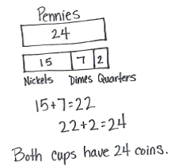
Mike, Dennis, and April all collected coins from a parking lot. When they counted their coins, they had 24 pennies, 15 nickels, 7 dimes, and 2 quarters. They put all the pennies into one cup and the other coins in another. Which cup has more coins? How many more?

Note: This two-step problem involves data comparisons, which is a skill that is used by the students in their data work. Encourage students to use the RDW process and make a tape diagram to visualize their work.
Concept Development (32 minutes)
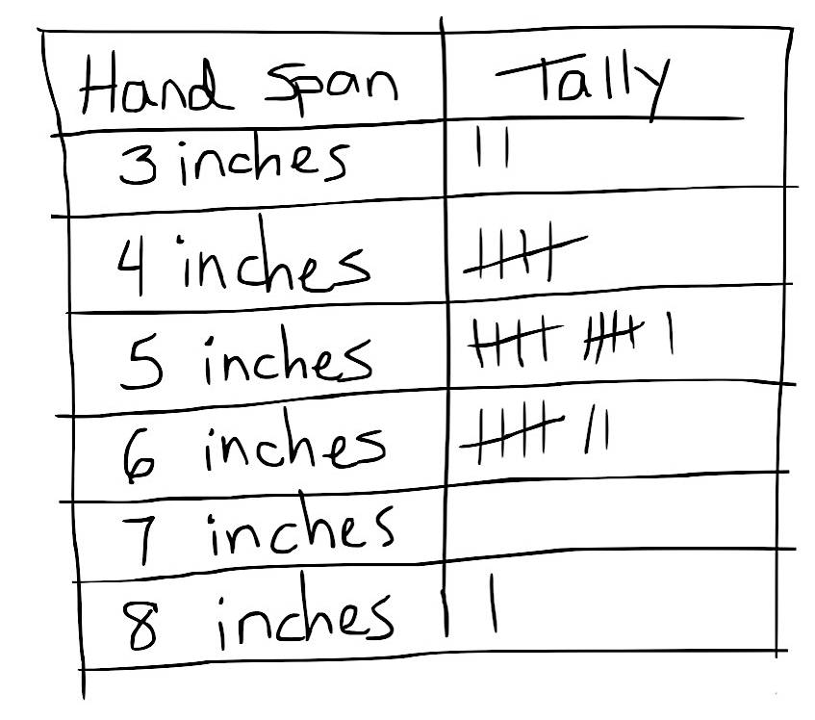
Materials: (T) Data table and Recording Sheet with student data from
Lesson 23 (S) Recording Sheet from Lesson 23, rulers,
centimeter grid paper
Part 1: Plot yesterday’s data on a line plot.
Project or show the data from Lesson 23, as shown to the right.
T: This is our data table from yesterday, with all the handspan measurements from our class.
Inches

NOTES ON
MULTIPLE MEANS
OF REPRESENTATION:
Support English language learners by pointing to the number line, the range of 3 to 8 on the number line, line plot, tally marks, etc., when referring to them during the lesson. Label everything and post on the word wall so that English language learners can refer to them as they do their math work.
T: (Project or show number line from recording sheet.) What is this?
S: A number line!
T: Yes. We used the number line to help us with addition and subtraction problems the other day by sliding up and down the number line. We can also use a number line in a different way to show data.
T: Turn and talk: What do you notice about this number line?
S: It goes from 3 to 8. It doesn’t start at 1. There is a zero and then some slashes and then a 3. It says inches.
T: That’s right! Our data doesn’t start at 0, so we make two slashes to show that we are skipping some numbers.
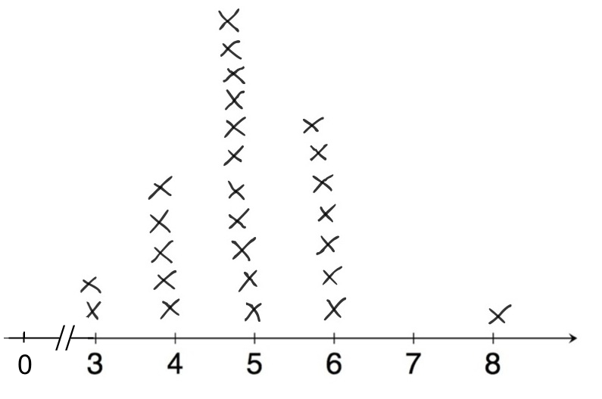
T: The same way we give bar graphs a title, we always give a line plot a title. Let’s call this one Class Handspans.
Inches
Class Handspans
T: To show our data, we put an X for each of our tally marks above the number of inches our handspans were and write the unit of measure. (Demonstrate as shown in the graph at right.)
T: Now, it’s your turn. (Distribute recording sheets.) Transfer the class data from yesterday’s tally table onto your recording sheet. (Circulate among the students as they complete this activity.)
T: You have just made a graph called a line plot! Compare your line plots with a partner. What information can you see in your line plot?
S: I see that most people have a 5-inch handspan. There are a lot more people with a 5- or 6-inch handspan than 7- or 8-inch handspans. The starting point of the labels is the shortest measurement, and the endpoint is the longest measurement.
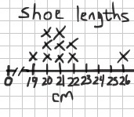
Part 2: Collect, organize, and plot shoe measurements in a table.
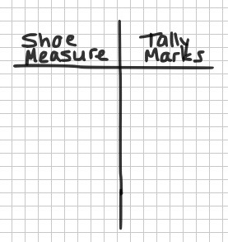
T: Let’s measure how long our shoes are. This time, we’re going to use centimeters instead of inches. (Distribute rulers and grid paper.)
T: Measure your shoe length by placing your ruler flat on the bottom of your shoe. Write the centimeter measurement down on the top of your page. (Model how to do this. Allow time for students to measure.)
T: Now, we’re going to make a collection table for our data. First, make your chart with the labels shoe measure and tally marks. (Model as shown at right.)
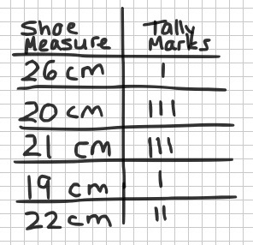
T: Next, on the table, make a tally mark to record your shoe measurement. I’m going to write 26 cm (use your own measure) and make the tally mark.
T: Next, collect 9 more shoe measurements from your friends. Just be sure to add a tally mark if you get the same measurement more than once. (Circulate among the students, and facilitate the data collection.)
T: We now have a table with 10 measurements tallied on it. How many of you have 10 different measurements on your collection table? (Acknowledge student responses.)
T: How many of you found at least 5 people with the same shoe measure? (Acknowledge responses.)
Part 3: Reorganize shoe measurement data on a line plot.
T: Let’s turn our data into a line plot.
T: This time, instead of a number line that I give you, I’m going to have you create your own line plot using grid paper.
MP.4
T: Take your ruler and measure the width of one of the boxes on your grid paper. (Pause for students to do this.)
T: What is the measure?
S: 1 centimeter!
T: Turn and talk: How might this help make the number line for our line plots?
S: I can use the grids to make it easier to draw my lines. The centimeter grids are just like the centimeters on my ruler. We can make our line plots match our rulers. A ruler is just like a number line!
MP.4
T: I heard someone say that a ruler is just like a number line! That’s true. In this case, though, we don’t have to make our number line start at zero.
T: Let’s draw the number line base. Turn and talk: How do you know how to label your number line?
S: We do it in order from shortest to longest. We need to go from 19 centimeters to
26 centimeters, the longest. If we don’t have any shoes that measure 23 or 24 centimeters, do we label them, too?
T: Good question. Yes, we need to show all the numbers between the shortest and the longest given lengths, even if no items measure those lengths. For example, no shoes measured 23 or 24 centimeters, but we need to include those measurements on our line plot.
T: Label your line plots and mark an X for each tally of the measurements in your graph. Make sure that each X is the same size.
Circulate and help students draw their line plots. As they finish their plots, release them to work on the Problem Set.
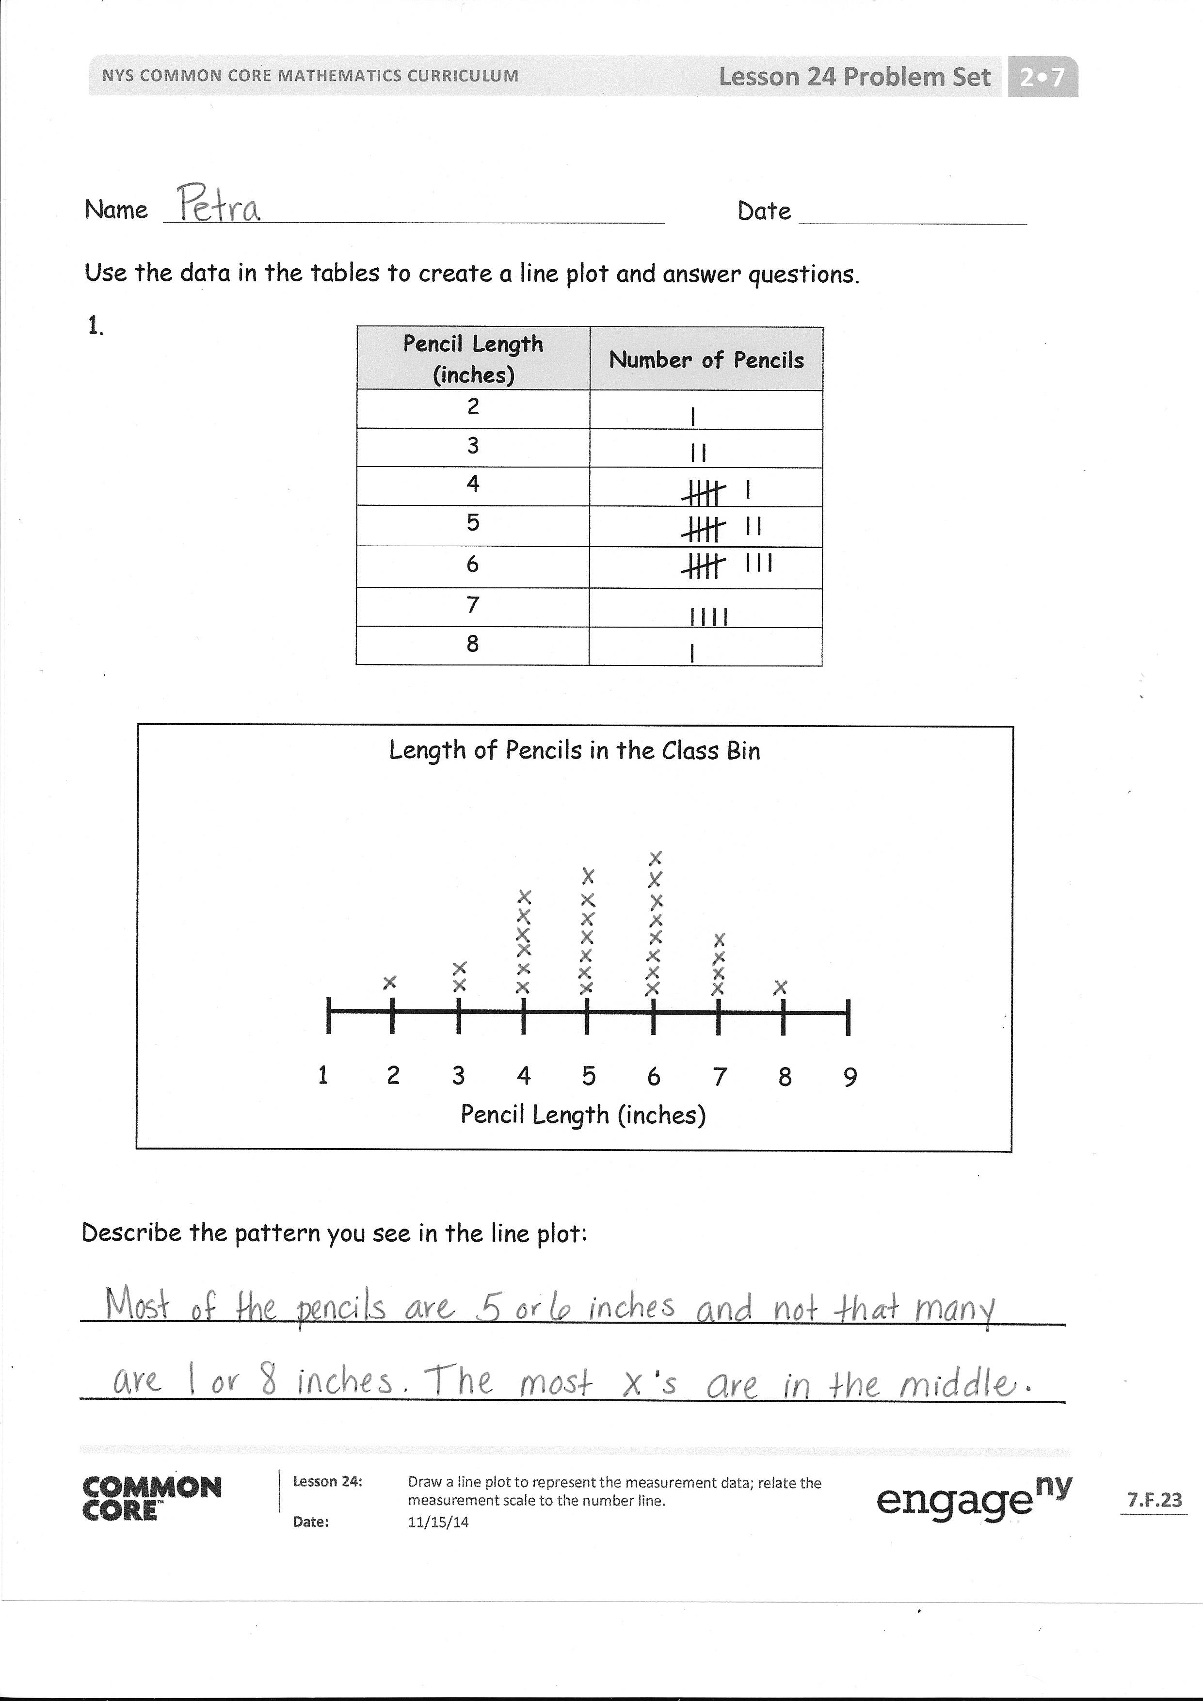
Problem Set (10 minutes)
If the Concept Development lesson takes the entire amount of time, use the Problem Set for homework or early finishers instead.
Student Debrief (10 minutes)
Lesson Objective: Draw a line plot to represent the measurement data; relate the measurement scale to the number line.
The Student Debrief is intended to invite reflection and active processing of the total lesson experience.
Invite students to review their solutions for the Problem Set. They should check work by comparing answers with a partner before going over answers as a class. Look for misconceptions or misunderstandings that can be addressed in the Debrief. Guide students in a conversation to debrief the Problem Set and process the lesson.

Any combination of the questions below may be used to lead the discussion.
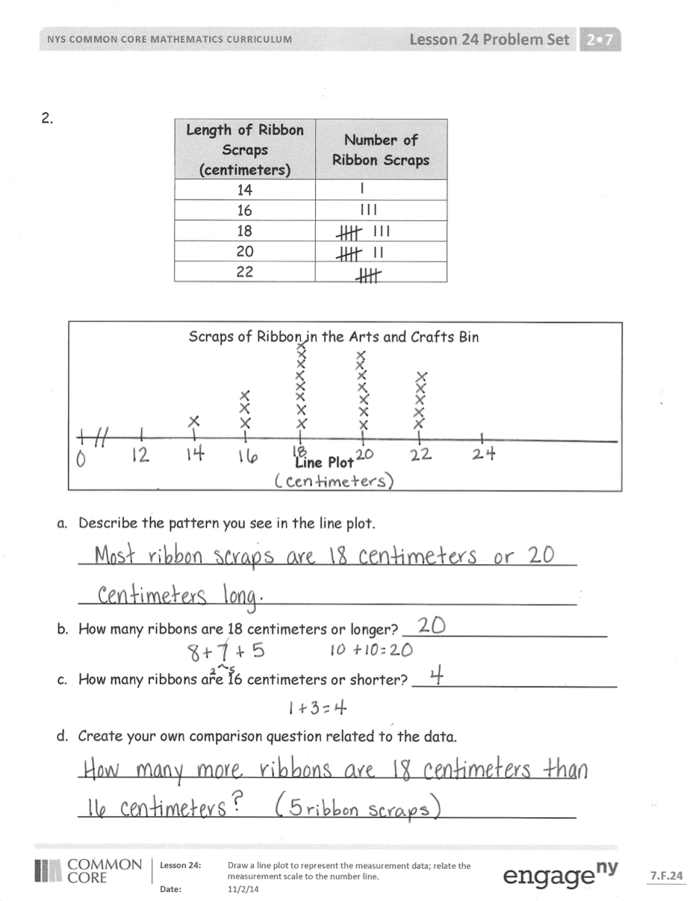
- What other types of graphs do the line plots remind you of that you used to compare and record data?
- Compare the shape of the handspan plot and the shoe plot. What do you notice? Why do you think there is a curvy shape to it starting low, going up, and then coming down again?
- Which way did you like looking at the data, the tally chart, or the line plot? Talk to your partner about the advantages and disadvantages of each.
- When we made our number line for our handspans in the lesson today, why didn’t we start at 0 or 1? What happened when we measured our shoes? Did you make a number line that started with 1? Talk to your partner about why or why not.
- Look at the intervals on your number line for the shoe measurement data. Could we have just made intervals at 19, 20, 21, 22, and 26 since those were the only shoe measurements that we had in our class?
- Explain to your partner why we needed to put 23, 24, and 25 centimeter hash marks on the
number line even though there was no data for these measurements. (All intervals on a number line must be equal. It helps us to see that there is a gap in shoe sizes and to wonder about it like scientists.)
Exit Ticket (3 minutes)
After the Student Debrief, instruct students to complete the Exit Ticket. A review of their work will help with assessing students’ understanding of the concepts that were presented in today’s lesson and planning more effectively for future lessons. The questions may be read aloud to the students.

Number Correct: _______
A
Subtraction Patterns
 | 3 – 1 = |  |  |  | 8 – 7 =
 | 13 – 1 = |  |  |  | 18 – 7 =
 | 23 – 1 = |  |  |  | 58 – 7 =
 | 53 – 1 = |  |  |  | 62 – 2 =
 | 4 – 2 = |  |  |  | 9 – 8 =
 | 14 – 2 = |  |  |  | 19 – 8 =
 | 24 – 2 = |  |  |  | 29 – 8 =
 | 64 – 2 = |  |  |  | 69 – 8 =
 | 4 – 3 = |  |  |  | 7 – 3 =
 | 14 – 3 = |  |  |  | 17 – 3 =
 | 24 – 3 = |  |  |  | 77 – 3 =
 | 74 – 3 = |  |  |  | 59 – 9 =
 | 6 – 4 = |  |  |  | 9 – 7 =
 | 16 – 4 = |  |  |  | 19 – 7 =
 | 26 – 4 = |  |  |  | 89 – 7 =
 | 96 – 4 = |  |  |  | 99 – 5 =
 | 7 – 5 = |  |  |  | 78 – 6 =
 | 17 – 5 = |  |  |  | 58 – 5 =
 | 27 – 5 = |  |  |  | 39 – 7 =
 | 47 – 5 = |  |  |  | 28 – 6 =
 | 43 – 3 = |  |  |  | 49 – 4 =
 | 87 – 7 = |  |  |  | 67 – 4 =
Number Correct: _______
Improvement: _______
B
[KEY]

Subtraction Patterns
 | 2 – 1 = |  |  |  | 8 – 7 =
 | 12 – 1 = |  |  |  | 18 – 7 =
 | 22 – 1 = |  |  |  | 68 – 7 =
 | 52 – 1 = |  |  |  | 32 – 2 =
 | 5 – 2 = |  |  |  | 9 – 8 =
 | 15 – 2 = |  |  |  | 19 – 8 =
 | 25 – 2 = |  |  |  | 29 – 8 =
 | 65 – 2 = |  |  |  | 79 – 8 =
 | 4 – 3 = |  |  |  | 8 – 4 =
 | 14 – 3 = |  |  |  | 18 – 4 =
 | 24 – 3 = |  |  |  | 78 – 4 =
 | 84 – 3 = |  |  |  | 89 – 9 =
 | 7 – 4 = |  |  |  | 9 – 7 =
 | 17 – 4 = |  |  |  | 19 – 7 =
 | 27 – 4 = |  |  |  | 79 – 7 =
 | 97 – 4 = |  |  |  | 89 – 5 =
 | 6 – 5 = |  |  |  | 68 – 6 =
 | 16 – 5 = |  |  |  | 48 – 5 =
 | 26 – 5 = |  |  |  | 29 – 7 =
 | 46 – 5 = |  |  |  | 38 – 6 =
 | 23 – 3 = |  |  |  | 59 – 4 =
 | 67 – 7 = |  |  |  | 77 – 4 =

Recording Sheet for Part 1. Copy and cut one per student.
Inches
Inches
Inches

Name Date
Use the data in the tables to create a line plot and answer questions.
Pencil Length (inches) | Number of Pencils
2
3
4
5
6
7
8
1.

Length of Pencils in the Class Bin

1 2 3 4 5 6 7 8 9
Pencil Length (inches)

Describe the pattern you see in the line plot:
_________________________________________________________________
_________________________________________________________________
Length of  Ribbon Scraps (centimeters) | Number of Ribbon Scraps
14
16
18
20
22
2.

Scraps of Ribbon in the Arts and Crafts Bin

Line Plot

- Describe the pattern you see in the line plot.
____________________________________________________________
____________________________________________________________
- How many ribbons are 18 centimeters or longer? _______________________

- How many ribbons are 16 centimeters or shorter? ______________________

- Create your own comparison question related to the data.
____________________________________________________________
____________________________________________________________
Name Date
Use the data in the table to create a line plot.

Length of Crayons in a Class Bin
Crayon Length (inches) | Number of Crayons
1
2
3
4

1 2 3 4
Crayon Length (inches)

Name Date
- Use the data in the table to create a line plot and answer the question.

Handspan (inches) | Number of Students
2
3
4
5
6
7
8

Handspans of Students in Ms. DeFransico’s Class

1 2 3 4 5 6 7 8 9

Handspan (inches)
Describe the pattern you see in the line plot:
_________________________________________________________________
_________________________________________________________________
_________________________________________________________________
- Use the data in the table to create a line plot and answer the questions.
Length of Right Foot (centimeters) | Number of Students
17
18
19
20
21
22
23

Lengths of Right Feet of Students in Ms. DeFransico’s Class

Line Plot
- Describe the pattern you see in the line plot.

____________________________________________________________
____________________________________________________________

- How many feet are longer than 20 centimeters? _______________________

- How many feet are shorter than 20 centimeters? ______________________

- Create your own comparison question related to the data.
____________________________________________________________

