Lesson 23
Objective: Collect and record measurement data in a table; answer questions and summarize the data set.

Suggested Lesson Structure
 Fluency Practice (11 minutes)
 Concept Development (39 minutes)
 Student Debrief (10 minutes)
Total Time (60 minutes)
Fluency Practice (11 minutes)
- How Many More Hundreds? 2.NBT.7 (2 minutes)
- Sprint: Adding Across a Ten 2.OA.2 (9 minutes)
How Many More Hundreds? (2 minutes)
Note: Practicing subtracting multiples of a hundred prepares students for today’s lesson.
T: If I say 300 – 200, you say 100. To say it in a sentence, you say, “100 more than 200 is 300.” Ready?
T: 300 – 200.
S: 100.
T: Say it in a sentence.
S: 100 more than 200 is 300.
Continue with the following possible sequence: 405 – 305, 801 – 601, 650 – 350, 825 – 125, and 999 – 299.
Sprint: Adding Across a Ten (9 minutes)
Materials: (S) Adding Across a Ten Sprint
Note: This Sprint gives practice with the grade level fluency of adding within 20.
Concept Development (39 minutes)
Materials: (T) Ruler, document camera (if available) (S) Ruler, Recording Sheet
Note: The Concept Development today might be time consuming because it involves data collection from the entire class. For this reason, and because the lesson itself is within a real world context, the Application Problem has been omitted for today.
Part 1: Collect and record data.
T: Everyone hold up your right hand.
S: (Hold up right hand.)
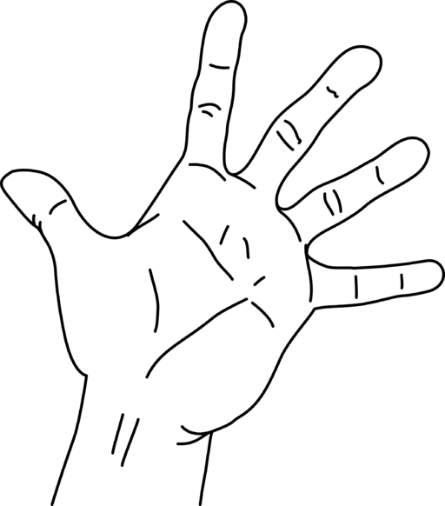T: How do you know if it’s your right or left hand? Turn and talk.
S: Because my left hand makes an L. I write with my right hand.
I write with my other hand. I just do.
T: Now, stretch your fingers all the way out. (Demonstrate.)
MP.5
T: Talk to a partner. How many inches do you think it is from the tip of your pinky to the tip of your thumb?
S: (Various guesses.)
T: This measurement from the tip of our pinky to the tip of our thumb is called our handspan. We will be measuring that today.
T: (Hold ruler with right hand and show ruler against handspan, as in picture at right, mirroring what the students will do.) Look at how I measure my handspan. What are some important things I need to remember when I measure this?
S: Start measuring at zero on the ruler. Remember what unit you are using. Notice where your handspan starts and ends.
T: Very good! I just measured my handspan, and it is
___ inches. Even though it was not exactly that many inches, I said it was about ___ inches because it was closer to the next whole inch. (Write the measurement on the board.)

NOTES ON
MULTIPLE MEANS
OF REPRESENTATION:
Scaffold the lesson for English language learners by posting key vocabulary after introducing it in the lesson. Post terms such as handspan, table, data, and tally marks with a visual for each that captures its meaning. Having such a reference will help English language learners to talk with a partner and complete the activities in the lesson.
Put students in groups of four or five. Hand out Recording Sheets and rulers. Project the Recording Sheet or have a copy of the table on the board to fill in.
T: Look at your Recording Sheet. Notice that the top of the first page has a chart where we can record our measurements in inches. Let’s start with my hand measure. (Tally it on your table for students to copy.)
T: Now, work with a partner. Measure your handspan, and have your partner help you make sure your measurement is correct. Then, record your measurement on the line. (Give students time to complete this task.)
T: Now switch. When you have finished with your partner, record the handspans of the other people in your group.
Circulate among the students as they complete this activity.
T: Now, take the data in your chart and fill in the table. Use a tally mark to record each person’s measurement in the appropriate box. (Provide work time.)
T: You have now recorded data in a table! Real scientists collect and record information like this when they do research.
T: Now that we have this information, we can use it to learn some things. Look at your data set in your table and the questions that are next to it. Count the tally marks to answer the questions.
Circulate among the students and provide support as they complete this activity.
T: Tell your partner what you think the most common handspan will be for the whole class. (Pause for sharing.) Let’s check your predictions.
Part 2: Create a larger data set.
T: Now, we’re going to look at the information we can get by looking at all the handspans in our class.
Collect the measurements from each group and make a tally mark for each student, or have students record their own tally marks on the board.
T: Let’s count up and answer the questions on our recording sheet. (Add and write the totals of the handspans next to the tallies for each measurement.)

NOTES ON
MULTIPLE MEANS
OF ACTION AND REPRESENTATION:
Before asking students working below grade level to move on to the final activity, ask them to restate what they learned in the last part of the lesson. Ask guiding questions like, “How did we record our handspan data? What kind of questions did we ask about data?” to encourage them to think about and express their learning from the lesson.
T: Which handspan was the most common in our class?
S: (Answer.)
T: And the least common?
S: (Answer.)
T: Now, write a comparison question about the class data for your friend to answer. For example, “How many more students’ handspans measured 5 inches than measured 8 inches?” (Pause for students to write a question.)
T: Now, share your question with a partner, and answer your partner’s question. (Provide work time.)
T: Let’s listen to and answer some of the questions you came up with about this data set.
Solicit questions from the students and facilitate a discussion about them.
Problem Set (5 minutes)
Note: Students should complete the Problem Set in 5 minutes, as it is only one page.

Student Debrief (10 minutes)
Lesson Objective: Collect and record measurement data in a table; answer questions and summarize the data set.
The Student Debrief is intended to invite reflection and active processing of the total lesson experience.
Invite students to review their solutions for the Recording Sheets. They should check their work by comparing answers with a partner before going over answers as a class. Look for misconceptions or misunderstandings that can be addressed in the Debrief. Guide students in a conversation to debrief the Recording Sheets and process the lesson.
Any combination of the questions below may be used to lead the discussion.
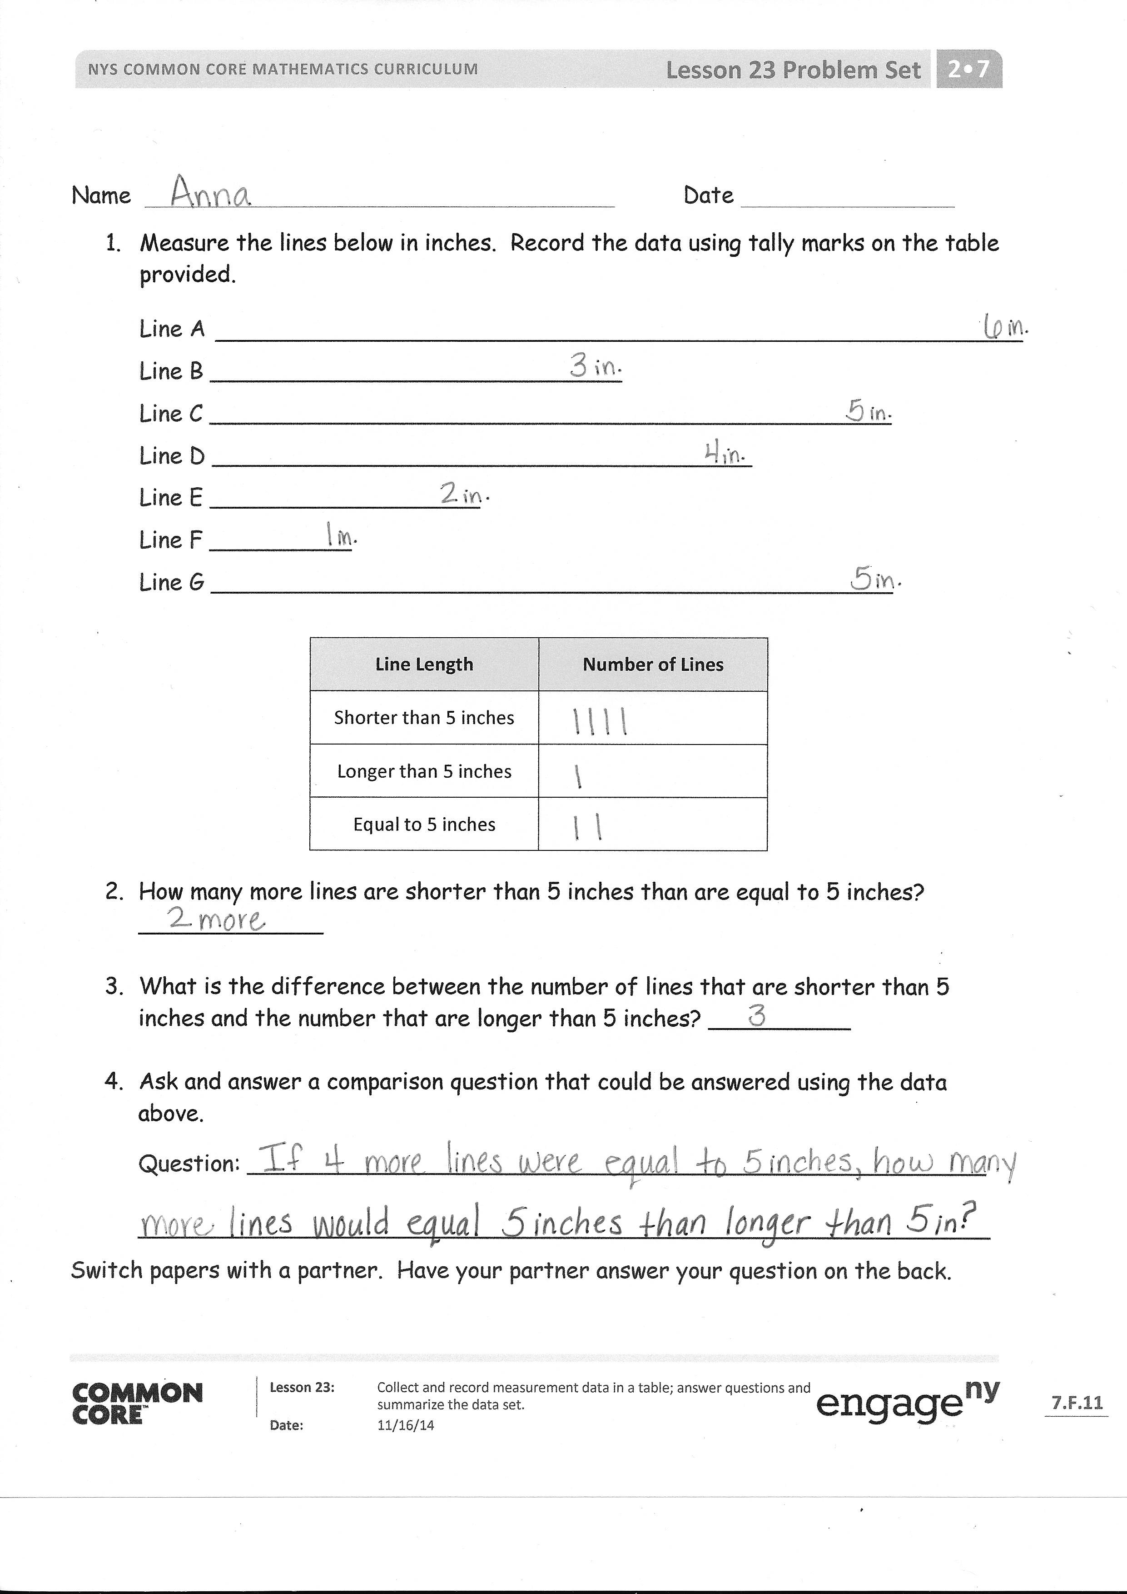
- Why doesn’t the whole class data set match your individual data sheet?
- Do you think having more or fewer data points is better in science? Why? Turn and talk.
- Why do you think ____ was the most common handspan length in our class? If we collected data from all the second-grade classes, do you think this would change? Why or why not?
- What if we collected data in the fifth-grade classroom, do you think ___ will still be the most common handspan length? Why or why not?
- Talk to your partner about what you think would happen to our data if we measured the handspan length of everyone at our school from the kindergartners to the fifth graders, and even the adults. Why is it good to have as much data as possible?
- When you used the handspan data to make your comparison problem, did you use addition or subtraction? Show your partner your solution to your comparison problem.
Exit Ticket (3 minutes)
After the Student Debrief, instruct students to complete the Exit Ticket. A review of their work will help with assessing students’ understanding of the concepts that were presented in today’s lesson and planning more effectively for future lessons. The questions may be read aloud to the students.

Number Correct: _______
A
Adding Across a Ten
 | 9 + 2 = |  |  |  | 4 + 7 =
 | 9 + 3 = |  |  |  | 4 + 8 =
 | 9 + 4 = |  |  |  | 5 + 6 =
 | 9 + 7 = |  |  |  | 5 + 7 =
 | 7 + 9 = |  |  |  | 3 + 8 =
 | 10 + 1 = |  |  |  | 3 + 9 =
 | 10 + 2 = |  |  |  | 2 + 9 =
 | 10 + 3 = |  |  |  | 5 + 10 =
 | 10 + 8 = |  |  |  | 5 + 8 =
 | 8 + 10 = |  |  |  | 9 + 6 =
 | 8 + 3 = |  |  |  | 6 + 9 =
 | 8 + 4 = |  |  |  | 7 + 6 =
 | 8 + 5 = |  |  |  | 6 + 7 =
 | 8 + 9 = |  |  |  | 8 + 6 =
 | 9 + 8 = |  |  |  | 6 + 8 =
 | 7 + 4 = |  |  |  | 8 + 7 =
 | 10 + 5 = |  |  |  | 7 + 8 =
 | 6 + 5 = |  |  |  | 6 + 6 =
 | 7 + 5 = |  |  |  | 7 + 7 =
 | 9 + 5 = |  |  |  | 8 + 8 =
 | 5 + 9 = |  |  |  | 9 + 9 =
 | 10 + 6 = |  |  |  | 4 + 9 =
Number Correct: _______
Improvement: _______
B
[KEY]

Adding Across a Ten
 | 10 + 1 = |  |  |  | 5 + 6 =
 | 10 + 2 = |  |  |  | 5 + 7 =
 | 10 + 3 = |  |  |  | 4 + 7 =
 | 10 + 9 = |  |  |  | 4 + 8 =
 | 9 + 10 = |  |  |  | 4 + 10 =
 | 9 + 2 = |  |  |  | 3 + 8 =
 | 9 + 3 = |  |  |  | 3 + 9 =
 | 9 + 4 = |  |  |  | 2 + 9 =
 | 9 + 8 = |  |  |  | 5 + 8 =
 | 8 + 9 = |  |  |  | 7 + 6 =
 | 8 + 3 = |  |  |  | 6 + 7 =
 | 8 + 4 = |  |  |  | 8 + 6 =
 | 8 + 5 = |  |  |  | 6 + 8 =
 | 8 + 7 = |  |  |  | 9 + 6 =
 | 7 + 8 = |  |  |  | 6 + 9 =
 | 7 + 4 = |  |  |  | 9 + 7 =
 | 10 + 4 = |  |  |  | 7 + 9 =
 | 6 + 5 = |  |  |  | 6 + 6 =
 | 7 + 5 = |  |  |  | 7 + 7 =
 | 9 + 5 = |  |  |  | 8 + 8 =
 | 5 + 9 = |  |  |  | 9 + 9 =
 | 10 + 8 = |  |  |  | 4 + 9 =

Name Date
- Gather and record group data.
Write your teacher’s handspan measurement here: __________
Measure your handspan and record the length here: _________
Measure the handspans of the other people in your group and write them here. We will be using the data tomorrow.
Name: |  | Handspan:

Handspan | Tally of Number of People
3 inches
4 inches
5 inches
6 inches
7 inches
8 inches

What is the most common handspan length? _____
What is the least common handspan length? _____
What do you think the most common handspan length will be for the whole class? Explain why.
2. Record class data.

Record the class data using tally marks on the table provided.
Handspan | Tally of Number of People
3 inches
4 inches
5 inches
6 inches
7 inches
8 inches

What handspan length is the most common? _____________
What handspan length is the least common? _____________
Ask and answer a comparison question that can be answered using the data above.

Question: ____________________________________________________
____________________________________________________________
Answer: _____________________________________________________
____________________________________________________________

Name Date
- Measure the lines below in inches. Record the data using tally marks on the table provided.
Line A

Line B _____________________________

Line C ________________________________________________

Line D ______________________________________

Line E ___________________

Line F __________

Line G ________________________________________________

Line Length | Number of Lines
Shorter than 5 inches
Longer than 5 inches
Equal to 5 inches

- How many more lines are shorter than 5 inches than are equal to 5 inches? _____________
- What is the difference between the number of lines that are shorter than
5 inches and the number that are longer than 5 inches? __________
- Ask and answer a comparison question that could be answered using the data above.
Question: ____________________________________________________
____________________________________________________________
Switch papers with a partner. Have your partner answer your question on the back.
Name Date
- The lines below have been measured for you. Record the data using tally marks on the table provided and answer the questions below.
Line A
Line B
Line C
Line D
Line E
6 inches
5 inches
4 inches
6 inches
3 inches

Line Length | Number of Lines
Shorter than 5 inches
5 inches or longer

- If 8 more lines were measured to be longer than 5 inches and 12 more lines were measured to be shorter than 5 inches, how many tallies would be in the chart?

____________________________________________________________

Name Date
Measure your handspan and record the length here: ___________
Then, measure the handspans of your family members and write the lengths below.
Name: |  | Handspan:

- Record your data using tally marks on the table provided.
Handspan | Tally of Number of People
3 inches
4 inches
5 inches
6 inches
7 inches
8 inches

- What is the most common handspan length? ___

- What is the least common handspan length? ___

- Ask and answer one comparison question that can be answered using the data above.

Question:
________________________________________
________________________________________
Answer: ________________________________________
________________________________________

- a. Use your ruler to measure the lines below in inches. Record the data using tally marks on the table provided.
Line A ______________________________

Line B

Line C _________________________________________________

Line D ______________________________________

Line E _______________

Line F ______________________________

Line G ___________
Line Length | Number of Lines
Shorter than 4 inches
Longer than 4 inches
Equal to 4 inches

- How many more lines are shorter than 4 inches than equal to 4 inches? _____________

- What is the difference between the number of lines that are shorter than
4 inches and those that are longer than 4 inches? __________

- Ask and answer one comparison question that could be answered using the data above.
Question: ____________________________________________________
____________________________________________________________
Answer: _____________________________________________________
____________________________________________________________

